Generative adversarial networks in medicine, cybersecurity and creative sketching

Name: Sonia Suvarna Dokala
Student ID: 24085938
Github Repo: https://github.com/Dokalasoniasuvarna/GAN_Assignment

1. Introduction
The architecture of a generative adversarial network (GAN) is that a generator is trained on the loss of a discriminator, and at the point that the discriminator cannot distinguish between real and synthetic samples, the generator has learned the data distribution (Goodfellow et al., 2014). This report gives four case studies to that concept and, as far as it will report what was done by the models, it speculates what their results may and may not be relied on to tell. Part 1 assembles the machinery on controllable 2D data to ensure that the mechanics remain in view, whereas Part 2 uses GANs on three medical imaging issues, network security and creative sketching. There is a common theme in the report: a GAN can only ever be trained to appear truthful, it will never be truthful, and a special section is then compelled to gather together the responsible-use question that the brief is asking through its duck prompt. Its null and contradictory results are also honestly reported in the report, as they are informative as its successes. The 2D and tabular models were coded in PyTorch and the two image issues in TensorFlow/Keras and the seeds are set to 5050 (PyTorch and NumPy), and 6060 (TensorFlow) to ensure the numbers and figures are reproducible.
2. Method in brief
Each of the models has the same adversarial goal, which is non-saturating loss, minimised using Adam, and a difference in architecture based on the data. The evaluation is aligned with the type of data: the Frechet Inception Distance (Heusel et al., 2017) with the image and sketch models and low-dimensional projections with per-feature alignment gaps with the tabular model, as a feature vector is not visualized to examine. In Part 1 the generator and critic are both MLPs regularised with layer normalisation (Ba, Kiros and Hinton, 2016) and spectral normalisation (Miyato et al., 2018), and a latent dimension of 24 dimensions is used because in small 2D tasks the unregulated critic wins all the time, and spectral normalisation is the least costly principled method to balance the two networks; both apply one-sided label smoothing (Salimans et al., 2016). The convolutional GANs that we use as image models (Radford, Metz and Chintala, 2015) are the convolutional GAN, whose convolutions learn the spatial structure directly, and the tabular GAN, because there is nothing that can be exploited with a convolution in a device number group.
3. Case studies
3.1 Foundations on 2D data
The initial case study recreates the tutorial sine-wave GAN on points randomly sampled on a sine curve, which is trained over 6,000 steps. Figure 1 illustrates how the points generated are falling along the curve and thus the generator has sampled one dimensional manifold in 2D space. The critic loss converges to 1.378 and the generator to 0.800 and both converge (critic loss 1.3765, generators 0.8009). The value is 1.386 (just under 2ln2) when it can no longer distinguish between the two distributions thus indicating a healthy equilibrium rather than stalled optimiser.
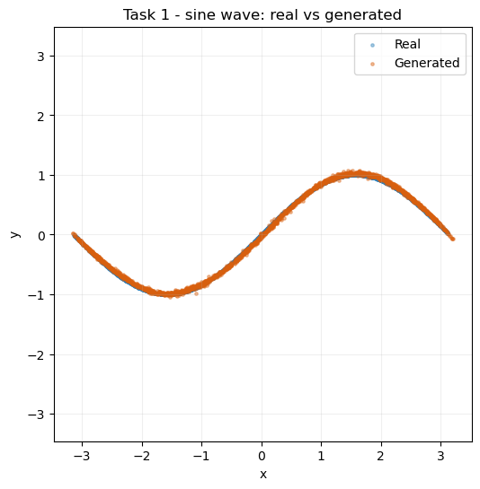
Figure 1. Sine-wave GAN: real versus generated 2D points.
To compute the new distribution I used a combination of Gaussians that occurred on a 3x3 grid with nine modes, the traditional stress test of mode collapse since the modes are independent. Figure 2 demonstrates how the generator cascaded to all 9 modes and did not collapse to one or two modes, the success criterion here. The losses stabilise at the sine levels (critic about 1.35, generator about 0.82 final critic 1.3458), and make the set up stable on a multi-modal target; the scatter between clusters is difficult to avoid, since a continuous generator has to traverse the empty space between the disconnected blobs and the spectral-normalised critic is what avoids collapse.
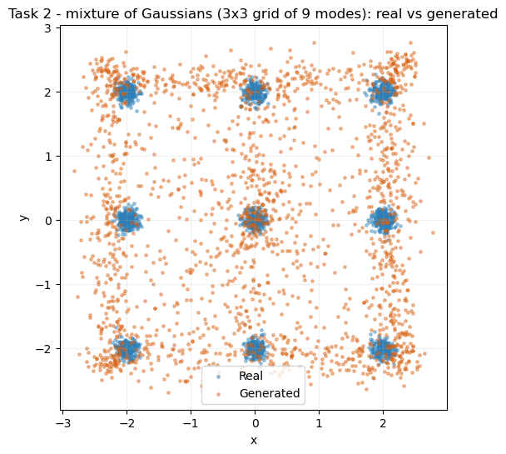
Figure 2. Mixture-of-Gaussians GAN: real versus generated samples for the 3x3 grid of nine modes.
Task three fixes the target and modifies only the generator: two-layered LeakyReLU baseline vs. three-layered GELU version with the same budget. This is the first legitimate null result of the report. The losses are also comparably close (both critic around 1.36 to 1.37, generator around 0.80, modified final critic, 1.3671 generator, 0.8025: pointwise), and the samples are also more generally similar: each variant is using all nine modes with similar inter-mode scatter, and the cleaner GELU generator is generally only a little cleaner. On this simple target the additional depth and change of activation has minimal effect, and the loss curves and the samples concur that the difference is small: it is only a more difficult target that would allow the two architectures to be distinguished.
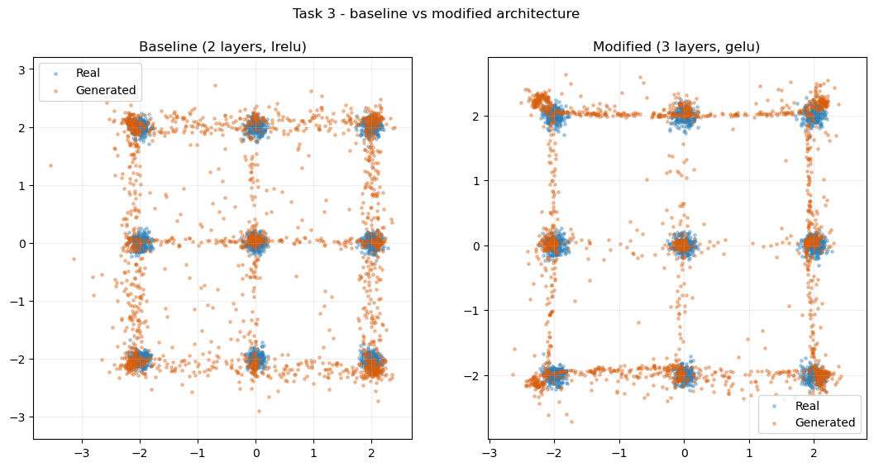
Figure 3. Architecture comparison: baseline (two-layer LeakyReLU) versus modified (three-layer GELU) generator.
3.2 Retinal images with OCTMNIST
The case study uses a deep convolutional GAN trained on the OCTMNIST (Yang et al., 2023), which has 97,477 grayscale scans of four types of diagnoses, which are rescaled to 32x32 and normalised to the tanh-terminated generator in the range of -1, 1. Figure 4 displays that the four categories are anything but evenly distributed a skew that would later reappear since the categories akin to the majority of the training counts are those that the conditional model makes most believably. The generator projects latent vectors of 128 dimensions to a 4x4 feature map, duplicated three times up to a 32x32 feature map by using strided transposed convolutions to upsample the image, the standard DCGAN upsampling layers, but these may introduce subtle checkerboard artefacts (Odena, Dumoulin and Olah, 2016); and the critic is a strided-convolution stack, with batch normalisation, trained over 40 epochs.
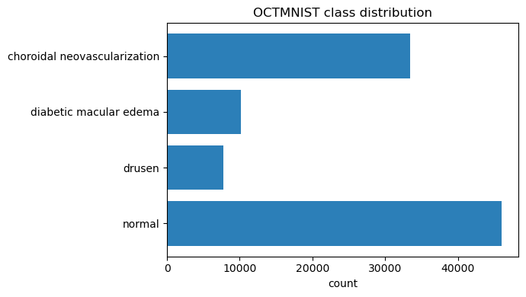
Figure 4. Number of OCTMNIST training scans in each diagnostic category.
Figure 5 indicates that the oscillating two losses have a confined band in the 40 epochs rather than collapsing as a stable DCGAN should. The comparison of real and generated scans (Figure 6) is supported by a Frechet Inception Distance (Heusel et al., 2017) of 17.89, the smallest value of the image models in this case. The scans formed reproduce the necessary anatomy, a bright curved retinal band on a dark background, and differ in the form and location of the band, that is, the generator is not recording one model. Major weakness Fine texture The fakes are too smooth, which is consistent with a good, although non-zero FID, and in a medical context this smoothing is not benign, as the fine speckle itself may have diagnostic content.
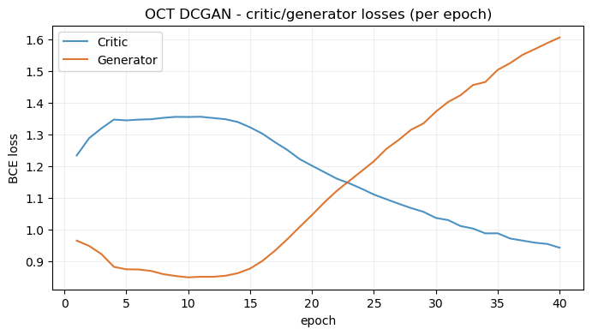
Figure 5. OCT DCGAN training losses over 40 epochs.
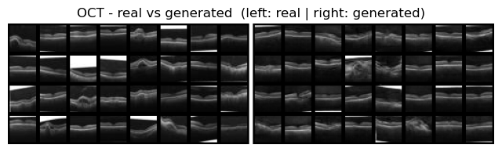
Figure 6. OCT DCGAN: real (left) versus generated (right) retinal scans, FID 17.89.
The DCGAN was augmented to a conditional GAN (Mirza and Osindero, 2014) to make a class upon request and this was the most difficult model to stabilise. An initial test that had put the label down the critic as a complete channel, 32x32, had overpowering cue; therefore, its loss crashed as the generator took off. The fix integrated late-fusion conditioning, in which the label embedding only joins in the final dense layer of the critic, with instance noise (Arjovsky and Bottou, 2017), a two-time-scale rule with a slower critic (Heusel et al., 2017), and two steps of the generator per critic step. The resultant losses are also released to trade softly, the critic evolving between approximately 1.29 and 1.05 and the generator between approximately 0.94 and 1.42 throughout 40 epochs. Figure 7 towards confirms conditioning works, since every row is different, and the most common classes clean up the best; the bigger point is that conditioning is primarily about starving the critic of the easy signal.
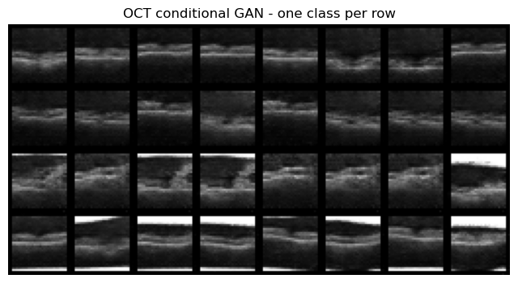
Figure 7. Conditional GAN: one OCT diagnostic class per row.
3.3 Synthetic network traffic with CICIDS 2017
CICIDS 2017 was used to obtain synthetic traffic feature vectors in this case study (Sharafaldin, Lashkari and Ghorbani, 2018). Since all flows are numbers, not images, a convolutional model cannot be used, hence my model is a fully-connected GAN implemented in PyTorch with a noise dimension of 56. The eight CSVs a day were aggregated into 2,830, 743 flows, and 78 numeric characteristics were retained after eliminating 4,376 infinite and 1,358 missing cells. Figure 8 plots on a log scale, as a large BENIN traffic (2,273,097 flows) overshadows all the attack classes, with the infrequent families like Heartbleed and Infiltration having no more than tens of flows, which is a tradeoff that prevents the learning of much by the generator. After the short, GAN with Wednesday file (BENIGN vs DoS) scaled using RobustScaler and scaled to plus or minus 5 to remove outliers) trained on 20,000 flows.
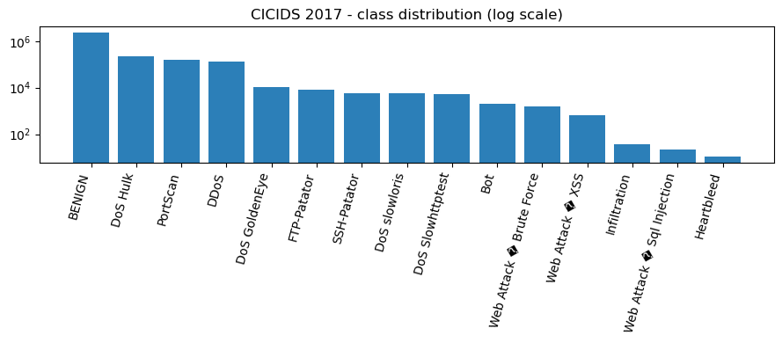
Figure 8. CICIDS 2017 class distribution across all days (log scale).
Comparison of PCA flows with the real and synthetic flows may be seen in Figure 9; a t-SNE projection (van der Maaten and Hinton, 2008) was viewed and told the same story. The resulting flows fall inside a body of the real data rather than constituting a separate island, so the generator has found the right section of the feature space although variability of the synthetic points is quite suppressed compared to the real ones. This is measured by the alignment metrics with a mean of per-feature difference of 0.2435 on the means and a mean of per-feature difference of 0.2395 on the standard deviations, a moderate fit that models both location and scale but not heavy tails. The retraining on the full eight days increases the gaps to 0.2955 on the means and 0.5277 on the standard deviations, approximately doubling the standard-deviation gap: one unconditional generator captures the large volume families (BENIGN, DoS, DDoS and PortScan) effectively, just less effectively on the long tail, and should be interpreted as a model of typical traffic.
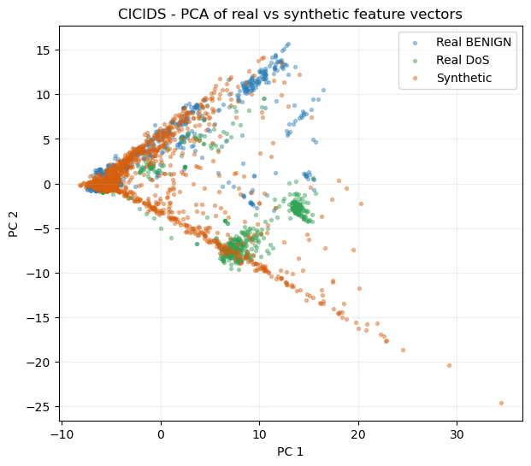
Figure 9. PCA of real (BENIGN and DoS) versus synthetic flow vectors.
3.4 Creative sketches with QuickDraw
The last case study learns a DCGAN using the QuickDraw dataset, the category of birthday cake (Ha and Eck, 2017), 144,982 bitmaps. To show a second standard construction, this generator uses transposed convolutions with a 64-dimensional latent vector and its critic uses dropout in place of batch normalisation. Figure 10 follows the visual output per epoch: the initial grids are blurry blobs, which begin to turn into recognisable cake outlines with candle-like features, indicating that the generator is creating the shape of the cake and training does not change drastically at the end of the final epoch.
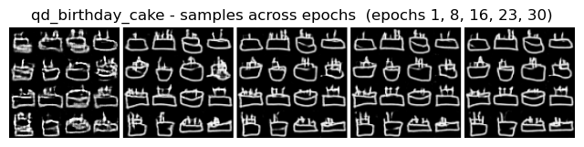
Figure 10. Birthday-cake samples captured at successive training epochs.
Most of the generated sketches are recognisable cakes with some strokes which stick together, as evidenced by a cake FID of 25.56, the best sketch score, with few artefacting stroke artefacts as shown in Figure 11. When Figure 12, showing the second and more counter-intuitive result of the report, is trained on two additional categories, it yields cake 25.56, cat 28.51 and house 41.98 FIDs, and ink density of 0.198, 0.1985 and 0.173. The least abundant type, but with the poorest FID, is house, which is a reverse of the mere busier-is-harder hypothesis. The percentage of ink coverage is thus not a good measure of difficulty: a house consists of a few straight lines (long) crossing at right angles, and recreating that construction is more of a challenge than the free-flowing, forgiving lines of a cat or a cake. This is more of an inductive bias point, since convolutional generators are cheap atlocal texture but high-level geometric constraints, thereby, a drawing that is simple to a human being is not always easy to the model.
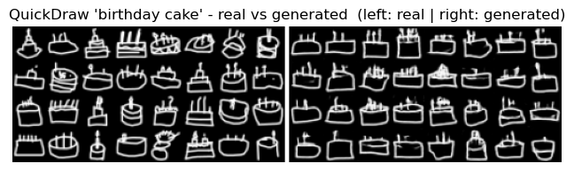
Figure 11. QuickDraw 'birthday cake': real (left) versus generated (right) sketches.
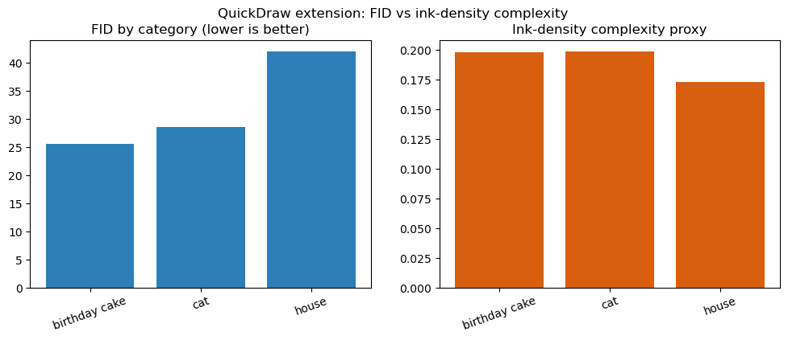
Figure 12. QuickDraw extension: FID and ink density by category.
4. Responsible use and the 'duck' problem
The repetitive duck prompt in the brief, in which a picture that appears and quacks like a duck is referred to as such the duck, is actually a query, what a low metric measure ensures, and it is valuable to bring together in the two delicate domains. Any GAN is never sufficiently trained to successfully complete a surface test of reality: the critic never knows what is medically correct or what a real attack would actually look like, just whether a sample is similar to the training set. Here the OCT model implies that a convincing scan may still have structure not produced by any actual patient, and a low FID only says that the population statistics are consistent, not that any one image is real; synthetic scans are acceptable to augment or teach but not diagnose. In the case of the traffic model that gap is sharper due to the impossibility of eyeballing a row of 78 numbers as wrong as is possible with an image and the possibility of a synthetic flow being statistically plausible and yet operationally impossible. Rare, extreme feature values are used by intrusion detectors: these values are precisely what this generator is compressing, so it should never be assumed that its output is a substitute of actual attack data. The moment separation in both of these cases, and more largely the standard-deviation gap, is the candlmap of a good-looking sample, that it is doing what it is being required to do.
5. Reflection and future work
In the four case studies the models trained in a stable manner and achieved a performance close to the actual data on the metrics used: the Part 1 GANs at least cover all modes, the OCT DCGAN at least achieves an FID of 17.89 with a working conditional extension, cicids generator CICID trains to place synthetic flows in the real distribution with moderate moment gaps, and the QuickDraw DCGAN achieved a FID of 25.56 on cakes. Clear limits also emerged in the analysis, and the two counter-intuitive results are the most educative: saturated losses may conceal the actual quality differences (Task 3), and drawing difficulty is motivated by geometric regularity to a greater extent than ink volume (Part 2.3). In addition to these, conditional GANs were very sensitive to the manner in which the label is injected (Part 2.1), and unconditional generators are less favorable towards rare classes on imbalanced data (Part 2.2). A Wasserstein GAN with a gradient penalty would be used in future work to close the CICIDS gaps, a class-conditional oversampling would serve up-to-rare attack families, a train-on-synthetic, test-on-real check would measure the downstream utility of the synthetic data beyond its distributional similarity. In the medical task a domain-specific perceptual metric would be more reliable than the ImageNet-derived FID in this case, and a small classifier-based comparison of the generated image to the target class would ensure that a network trained on real OCT scans correctly sorts generated images to the desired class prior to any downstream use.
References
Arjovsky, M. and Bottou, L. (2017) 'Towards principled methods for training generative adversarial networks', International Conference on Learning Representations (ICLR).
Ba, J.L., Kiros, J.R. and Hinton, G.E. (2016) 'Layer normalization', arXiv preprint arXiv:1607.06450.
Goodfellow, I., Pouget-Abadie, J., Mirza, M., Xu, B., Warde-Farley, D., Ozair, S., Courville, A. and Bengio, Y. (2014) 'Generative adversarial nets', Advances in Neural Information Processing Systems, 27, pp. 2672-2680.
Ha, D. and Eck, D. (2017) 'A neural representation of sketch drawings', arXiv preprint arXiv:1704.03477.
Heusel, M., Ramsauer, H., Unterthiner, T., Nessler, B. and Hochreiter, S. (2017) 'GANs trained by a two time-scale update rule converge to a local Nash equilibrium', Advances in Neural Information Processing Systems, 30, pp. 6626-6637.
Mirza, M. and Osindero, S. (2014) 'Conditional generative adversarial nets', arXiv preprint arXiv:1411.1784.
Miyato, T., Kataoka, T., Koyama, M. and Yoshida, Y. (2018) 'Spectral normalization for generative adversarial networks', International Conference on Learning Representations (ICLR).
Odena, A., Dumoulin, V. and Olah, C. (2016) 'Deconvolution and checkerboard artifacts', Distill, 1(10), e3.
Radford, A., Metz, L. and Chintala, S. (2015) 'Unsupervised representation learning with deep convolutional generative adversarial networks', arXiv preprint arXiv:1511.06434.
Salimans, T., Goodfellow, I., Zaremba, W., Cheung, V., Radford, A. and Chen, X. (2016) 'Improved techniques for training GANs', Advances in Neural Information Processing Systems, 29, pp. 2234-2242.
Sharafaldin, I., Lashkari, A.H. and Ghorbani, A.A. (2018) 'Toward generating a new intrusion detection dataset and intrusion traffic characterization', Proceedings of the 4th International Conference on Information Systems Security and Privacy (ICISSP), pp. 108-116.
van der Maaten, L. and Hinton, G. (2008) 'Visualizing data using t-SNE', Journal of Machine Learning Research, 9, pp. 2579-2605.
Yang, J., Shi, R., Wei, D., Liu, Z., Zhao, L., Ke, B., Pfister, H. and Ni, B. (2023) 'MedMNIST v2 - a large-scale lightweight benchmark for 2D and 3D biomedical image classification', Scientific Data, 10(1), 41.

