

**Maru Dry Fruits**

|  |  |  |
| --- | --- | --- |
| **Supervisor:** | *LÊ THANH NHÂN* | |
| **Semester:** | *01* | |
| **Batch No:** | *T5.2309.E0* | |
| **Group No:** | *03* | |
| **Order:** | **Full name** | **Roll No.** |
| *1.* | *Nguyễn Nhật Minh* | *Student1513384* |
| *2.* | *Trịnh Đình Trường* | *Student1513448* |
| *3.* | *Võ Minh Khôi* | *Student1513450* |

***Month****: 12* ***Year****: 2023*



This is to certify that

|  |  |
| --- | --- |
| **Mr.** | **NGUYEN NHAT MINH** |
| **Mr.** | **TRINH DINH TRUONG** |
| **Ms.** | **VO MINH KHOI** |

Have successfully Designed & Developed

|  |  |  |
| --- | --- | --- |
|  |  |  |
| **MARU DRY FRUITS** | | |

Submitted by:

|  |
| --- |
| **Mr. LE THANH NHAN** |

Date Of Issue:

|  |  |
| --- | --- |
|  |  |

Authorized Signature:

|  |  |
| --- | --- |
|  |  |

|  |
| --- |
| **Content** |

Content

Acknowledge

Synopsis

Review1 (điền số trang theo thực tế)

Review2 (điền số trang theo thực tế)

Review3 (điền số trang theo thực tế)

Testing Document (điền số trang theo thực tế)

Final Checklist (điền số trang theo thực tế)

Tasksheet (điền số trang theo thực tế)

|  |
| --- |
| **Acknowledge** |

As we understand that the e-Project is a step-by- step learning environment that closely simulates the classroom and Lab based learning environment into actual implementation. It is a project implementation at your fingertips!! An electronic, live juncture on the machine that allows you to.

* Practice step by step i.e. laddered approach.
* Build a larger more robust application.
* Usage of certain utilities in applications designed by user.
* Single program to unified code leading to a complete application.
* Learn implementation of concepts in a phased manner.
* Enhance skills and add value.
* Work on real life projects.
* Give a real-life scenario and help to create applications more complicated and useful.
* Mentoring through email support.

We would like to send a great thank to our professor and others student for the adorable supports during the time in project.

Beside several mistakes we had made in the project, we hope to have more opportunities to widen our knowledge in web developing world.

We also thank you so much for your information and the “demo” project from India Aptech to help us get more reality experience in this project. Since we have gained more experience from this project, we will not stop learning anything as much as we can to be more successful in the future.

Best,

Group 03.

|  |
| --- |
| **Synopsis** |

The Objective of this program we aim is to give a sample project to work on real life projects. These applications help us build a larger more robust application.

The objective is not to teach us HTML/JavaScript but to provide us with a real life scenario and help us create basic applications using the tools.

Hence, we can revise the chapters before we start with the project.

This project is meant for students like us who have completed the module of HTML5. These programs should be done in the Lab sessions with assistance of the faculty if required.

|  |
| --- |
| The website (in this project) is a tool that help a traditional store adapt into the digitalization world with a new method of sale via Internet to keep and bring more customers. |

It is very essential for us that will have a clear understanding of the subject. We think we should go through the project and solve the assignments as per requirements given.

And get back ***eprojects@aptech.ac.in*** as the assigned schedule.

|  |
| --- |
| **Problem Definition** |

The dry fruits are rich in vitamins and proteins; they also boost immunity and prevent lifestyle diseases such as cholesterol and diabetes. Most dry fruits are rich in minerals, proteins, fibre and vitamins add to that they are tasty and delicious too. Dry fruits are excellent and healthy substitute for daily snacks.

Maru dry fruits - a local shop in the market is quite old and needs website for advertising the products, providing information about them so as to attract more and more customers.

**Requirement Specification:**

1. The Web site is to be created based on the following requirements.
2. The home page must be designed with beautiful color combination with all the required links defined properly. Also, all the section of the webpage must be in used to avoid the blank space.
3. It should include all the variety dry fruits, its rate as per quality.
4. Site should also provide nutrition information about each dry fruit.
5. Customer should be able to buy online, quantity as specified by them.
6. The site should display various offers / discounts announced time to time.
7. It should also include the festival gift packs.
8. About us, Contact Us, Disclaimer must be included.
9. Contact us page: contact us details with location should be displayed using GeoLocation API (eg. GoogleMaps).
10. Creating an account facility can also be added.
11. Dummy procedure for buying to be added.
12. Sitemap must be added.
13. Navigation of the project must be made smooth.

|  |  |  |  |  |  |  |  |  |  |  |  |  |  |  |  |  |
| --- | --- | --- | --- | --- | --- | --- | --- | --- | --- | --- | --- | --- | --- | --- | --- | --- |
| |  |  | | --- | --- | | **Customer Requirements Specifications** | | | **User:** | | |  | **Input:** | |  | * User’s data for registration * Name of a dry fruit * Quality level * Click to sort dry fruits * Click to add a dry fruit to cart * Apply offer/discount * Festival pack * Checkout cart | |  | **Process:** | |  | * Check whether user is registered * Add new user to the database * Search for information about the dry fruit * Find all dry fruits which qualified (equal or greater) * Sort dry fruits based on provided criteria * Put the dry fruit to user’s cart * Find the best offer/discount available * Search for festival packs currently available * Calculate the payment | |  | **Output:** | |  | * Success/Failure notification about the registration * Information about the dry fruit * List of dry fruits * Display dry fruits in sorted order * Notification about offers/discounts successfully applied or none available * Success/Failure notification about adding a dry fruit to cart * List of festival packs * Success/Failure notification about the order * Display payment | |

|  |  |
| --- | --- |
| **Webmaster:** | |
|  | **Input:** |
|  | * Data of a dry fruit * Data of a festival pack * Data of the shop |
|  | **Process:** |
|  | * Add new dry fruit to the database * Update data of an existing dry fruit * Add new festival pack to the database * Update data of an existing dry fruit * Update data of the shop |
|  | **Output:** |
|  | * Success/Failure notification about the addition * Success/Failure notification about the update |

|  |  |
| --- | --- |
| **Hardware / software requirement:** | |
|  | **Software:** |
|  | * Notepad/HTML editor/CoffeeCup * Angular / Angular JS / React / BootStrap * Dreamweaver / Figma * MS IE / Chrome / FireFox / Netscape /MS Edge |
|  | **Hardware:** |
|  | * A minimum computer system that will help you access all the tools in the courses is a Pentium 166 or better * 64 Megabytes of RAM or better |

|  |
| --- |
| **Architecture and design of the project** |

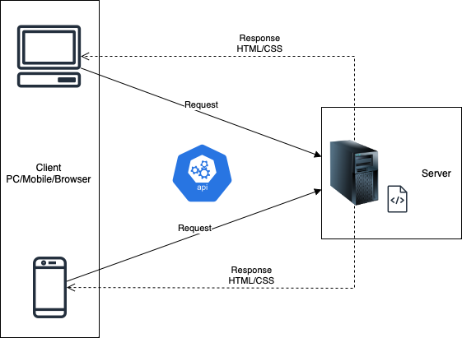

|  |
| --- |
| **SiteMap** |

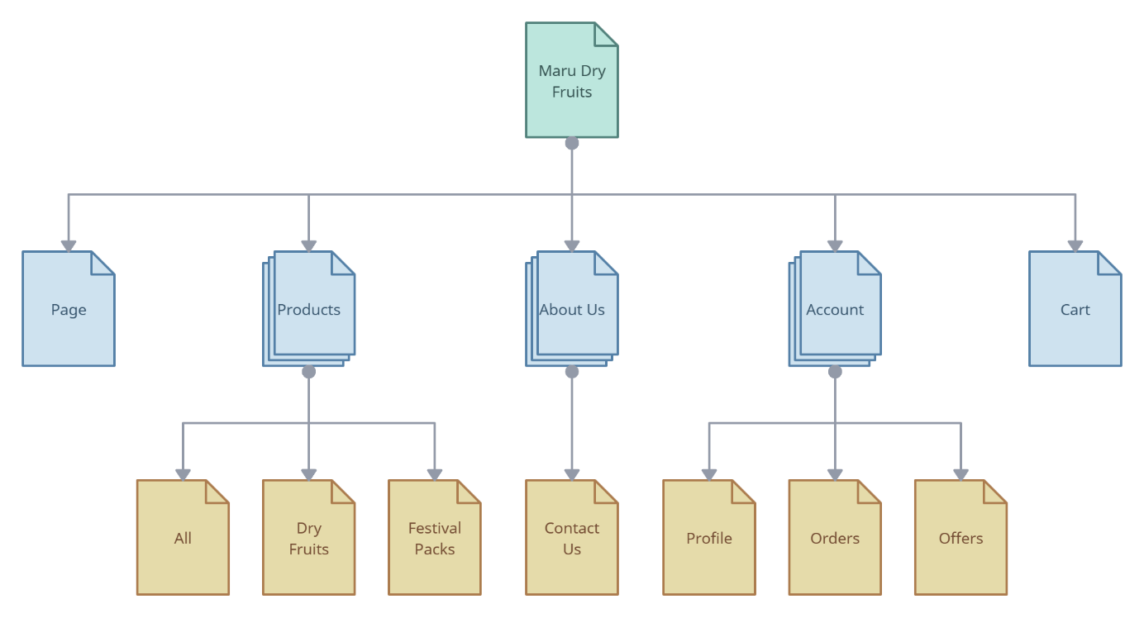

|  |
| --- |
| **Screen shots** |

1. **Homepage:**

|  |  |  |  |  |  |
| --- | --- | --- | --- | --- | --- |
| Logo and Banner | | | | | |
| Home | Products | About Us | Search bar | Sign In / Sign Up | Cart |
| Product carousel | | | | | |
| Footer | | | | | |

**Description** : This is the homepage of the website, to show up a quick preview of top-selling products in a carousel.

**From** : Can be accessed from the Home button in the navigation bar.

**To** : Can go to Products, About Us, Sign In, Sign Up, and Cart via buttons in the navigation bar.

1. **Products:**

|  |  |  |  |  |  |  |
| --- | --- | --- | --- | --- | --- | --- |
| Logo and Banner | | | | | | |
| Home | Products | | About Us | Search bar | Sign In / Sign Up | Cart |
| Search criteria | | Sort option  Products showed as grid or vertical list | | | | |
| Footer | | | | | | |

**Description** : This is the Products page, show all the available products in the store. The products can be filtered via the left panel and can be sorted via the button above the list or grid of products.

**From** : Can be accessed from the Products button in the navigation bar.

**To** : Can go to Home, Product Detail, About Us, Sign In/Sign Up, and Cart via buttons in the navigation bar.

1. **Product Detail:**

|  |  |  |  |  |  |
| --- | --- | --- | --- | --- | --- |
| Logo and Banner | | | | | |
| Home | Products | About Us | Search bar | Sign In / Sign Up | Cart |
| Quick information about the product  Product images  Detail information | | | | | |
| Footer | | | | | |

**Description** : This is the Product Detail page, show the detail information of the particular product.

**From** : Can be accessed after click into a certain product in the Products page or from the carousel in Homepage.

**To** : Can go to Home, Products, About Us, Sign In/Sign Up, and Cart via buttons in the navigation bar.

1. **Products:**

|  |  |  |  |  |  |
| --- | --- | --- | --- | --- | --- |
| Logo and Banner | | | | | |
| Home | Products | About Us | Search bar | Sign In / Sign Up | Cart |
| Information about the store  GeoLocation Map points to the location of the store | | | | | |
| Footer | | | | | |

**Description** : This is the Products page, show all the available products in the store. The products can be filtered via the left panel and can be sorted via the button above the list or grid of products.

**From** : Can be accessed from the About Us button in the navigation bar.

**To** : Can go to Home, Products, Sign In/Sign Up, and Cart via buttons in the navigation bar.

1. **Sign In / Sign Up:**

|  |  |  |  |  |  |
| --- | --- | --- | --- | --- | --- |
| Logo and Banner | | | | | |
| Home | Products | About Us | Search bar | Sign In / Sign Up | Cart |
| Sign In / Sign Up Form | | | | | |
| Footer | | | | | |

**Description** : This is the Products page, show all the available products in the store. The products can be filtered via the left panel and can be sorted via the button above the list or grid of products.

**From** : Can be accessed from the Sign In/Sign Up button in the navigation bar.

**To** : Can go to Home, Products, About Us, and Cart via buttons in the navigation bar.

1. **Cart:**

|  |  |  |  |  |  |
| --- | --- | --- | --- | --- | --- |
| Logo and Banner | | | | | |
| Home | Products | About Us | Search bar | Sign In / Sign Up | Cart |
| Checkout  Apply discount  Preview add products | | | | | |
| Footer | | | | | |

**Description** : This is the Products page, show all the available products in the store. The products can be filtered via the left panel and can be sorted via the button above the list or grid of products.

**From** : Can be accessed from the Cart button in the navigation bar or from the Quick Buy button in the Product Detail page.

**To** : Can go to Home, Products, About Us, and Sign In/Sign Up via buttons in the navigation bar.

|  |
| --- |
| **Testing document** |

|  |  |  |
| --- | --- | --- |
| **No** | **Features Tested** | **Remarks** |
| 1 | Navigation bar |  |
| 2 | Carousel |  |
| 3 | Search bar |  |
| 4 | Search panel |  |
| 5 | Sort button |  |
| 6 | Product Detail button |  |
| 7 | Add to Cart button |  |
| 8 | Quick Buy button |  |
| 9 | Sign In form |  |
| 10 | Sign Up form |  |
| 11 | Account Profile |  |
| 12 | Update Profile button |  |
| 13 | Apply Discount button |  |
| 14 | Checkout button |  |
| 15 | Geo Map |  |

|  |
| --- |
| **Final checklist** |

|  |  |  |
| --- | --- | --- |
| **No** | **Expected Tested** | **Suggestion/**  **Remarks** |
| 1 | Are all the users able to view the images and links? |  |
| 2 | Have all the views, modules and controllers been properly integrated and is the site function as a single page application? |  |
| 3 | Are the GUI content devoid of spelling mistakes? |  |
| 4 | Is the application user-friendly? |  |
| 5 | Is the Website launching correctly in all popular browsers? |  |
| 6 | Are all the forms validated with proper criteria? |  |
| 7 | Do all text links lead to the appropriate website? |  |
| 8 | Do all image links lead to the appropriate website? |  |
| 9 | Are all the images and links clearly visible on the page? |  |
| 10 | Does the Web page work properly in all the tested browsers? |  |
| 11 | Does the Web page take too long to be loaded fully? |  |
| 12 | Is the navigation sequences correct through all the Web pages on the site? |  |
| 13 | Is the JavaScript code working as expected in all click events? |  |
| 14 | Are all the features tested properly and work without any impactful issues? |  |

|  |  |  |  |  |  |  |  |
| --- | --- | --- | --- | --- | --- | --- | --- |
| **No** | **Member** | **Contents** | **Page Name** | **Activity Plan** | **Date of Preparation of Activity Plan** | | |
| **Planed Start Date** | **Actual Start Date** | **Actual Days** | **Status** |
| 1 | Nguyễn Nhật Minh | NavBar | NavBar.jsx | 08-12-2023 | 08-12-2023 | 1 | OK |
| 2 | Carousel | Carousel.jsx | 09-12-2023 | 09-12-2023 | 1 | OK |
| 3 | Homepage | Homepage.jsx | 10-12-2023 | 10-12-2023 | 1 | OK |
| 4 | SearchPanel | SearchPanel.jsx | 11-12-2023 | 11-12-2023 | 2 | OK |
| 5 | Products | Products.jsx | 13-12-2023 | 13-12-2023 | 5 | OK |
| 6 | ProductDetail | ProductDetail.jsx | 18-12-2023 | 18-12-2023 | 5 | OK |
| 7 | Registration Form | Form.jsx | 23-12-2023 | 27-12-2023 | 1 | OK |
| 8 | Sign In | SignIn.jsx | 24-12-2023 | 28-12-2023 | 1 |  |
| 9 | Sign Up | SignUp.jsx | 25-12-2023 |  | 1 |  |
| 10 | Cart | Cart.jsx | 26-12-2023 |  | 5 |  |
| 11 | Account Profile | Profile.jsx | 31-12-2023 |  | 3 |  |
|  | | | | | | | |
| 1 | Trịnh Đình Trường | About Us | AboutUs.jsx | 08-12-2023 |  | 3 | N/A |
| 2 | Contact Us | ContactUs.jsx | 11-12-2023 |  | 3 | N/A |
|  | | | | | | | |
| 1 | Võ Minh Khôi | Search | SearchBar.jsx | 08-12-2023 |  | 8 | N/A |
| 2 | Geolocation | GeolocationMap.jsx | 11-12-2023 |  | 5 | N/A |