|  |
| --- |
| VIETNAM NATIONAL UNIVERSITY, HANOI  **INTERNATIONAL SCHOOL**    **CLASS NAME:** PROGRAMMING TECHNOLOGY  **CLASS CODE:** INS310701  **FINAL PROJECT REPORT**  PROJECT TOPIC:  **LAB RESERVATION SYSTEM**  **Group members:**  **Cao Sỹ Minh-19071616**  **Đỗ Công Tuấn-19071639**  **Đỗ Trần Tùng Lâm**  *Hanoi - Year 2023 - 2024* |

Table of Contents

I. Abstract: 2

II. Objective: 3

III. System specification: 3

1. DATABASE - SQL SERVER: 3

2. NAMESPACES USED C#: 4

1. In C#, a namespace 4

2. System.Data.SqlClient 5

3. DGVPrinterHelper 6

4. System.Windows.Forms 7

IV. System Design: 7

1. Input Design: 7

2. Main dash board 12

3. Data base design: 13

V. ER Diagram: 15

VI. Conclusion & Scope for Enhancement for the future: 16

1. Automation and Integration: 16

2. Enhanced Usability and Accessibility: 17

3. Advanced Security and Data Privacy: 17

4. Virtual and Remote Labs: 17

5. Sustainability and Resource Optimization: 17

# Abstract:

There have been several occasions when someone had to walk to the labs to see if they are in use before using the facilities at the school or organization. The entire trek from a class or a staff room may be both tiresome and irritating. So, we devised and implemented a system that allows us to determine if the laboratories are in use or not with a single click, and if not, whether they can be booked so that the other person is not disappointed if they arrive to check for unoccupied labs.

The lab reservation system in our database-driven project was built with ASP.NET and a SQL server database. It is quite simple to use and can be accessed from a standard desktop. This technology allows customers to schedule or cancel lab sessions while sitting in one spot with only one cell phone in their hand. This idea may be adapted for a variety of reservations. The one who books can see who has booked and how many students are present in the lab at any one time.

# Objective:

Here are the objectives of this project:

* Increased scheduling: Makes it easier for potential researchers to find and setup their lab, potentially leading to higher occupancy rates.
* Reduced administrative workload: Automates reservation management tasks, saving staff time and effort for the administrator.
* Direct organizing: Can help admin reduce dependence on third-party booking platforms and save on commission fees.
* Data insights: Provides valuable data on client’s preferences and setting up patterns, allowing administrator to organize the labs correctly and more compatible list

Overall, a lab reservation system is a valuable tool for both travelers and hoteliers, offering convenience, efficiency, and a more seamless booking experience.

# System specification:

This project is made using C# programming language on .NET platform in Microsoft Visual Studio IDE. For storing and exporting data we use Microsoft SQL Server for our best performance. And below is our detail specification of our project.

## DATABASE - SQL SERVER:

SQL Server is a relational database management system (RDBMS) developed by Microsoft. It is designed to store and retrieve data as requested by other applications. SQL Server supports ANSI SQL, which is the standard SQL (Structured Query Language) language. However, SQL Server comes with its own implementation of the SQL language, T-SQL (Transact-SQL). T-SQL is a Microsoft proprietary language that provides further capabilities of declaring variables, exception handling, stored procedures, etc. SQL Server Management Studio (SSMS) is the main interface tool for SQL Server, and it supports both 32-bit and 64-bit environments.

SQL Server is used in a client-server architecture, where a client application sends requests to the SQL Server installed on a given machine. The server processes input data as requested and responds with processed output data as a result.

IN THIS PROJECT, we use SQL Server Express

SQL Server Express is a free edition of SQL Server that is ideal for development and production for desktop, web, and small server applications. It provides a scalable, secure, and manageable data platform for building data-driven applications. SQL Server Express supports T-SQL (Transact-SQL), which is a Microsoft proprietary language that provides further capabilities of declaring variables, exception handling, stored procedures, etc…

## NAMESPACES USED C#:

1. In C#, a namespace is a way to organize classes, interfaces, and other types into a logical group. It helps to control the scope of methods and classes in larger .NET programming projects and provides a way to keep one set of names (like class names) different from other sets of names.

The biggest advantage of using a namespace is that the class names which are declared in one namespace will not clash with the same class names declared in another namespace.

System.Data is a namespace in C# that provides access to classes that represent the ADO.NET architecture. ADO.NET lets you build components that efficiently manage data from multiple data sources. Here are some of the classes provided by this namespace:

* + **DataSet:** Represents an in-memory cache of data.
  + **DataTable:** Represents one table of in-memory data.
  + **DataColumn:** Represents the schema of a column in a DataTable.
  + **DataRow:** Represents a row of data in a DataTable.
  + **DataRelation:** Represents a parent/child relationship between two DataTable objects.
  + **DataView:** Represents a databindable, customized view of a DataTable for sorting, filtering, searching, editing, and navigation.
  + **DataAdapter:** Represents a set of data commands and a database connection that are used to fill the DataSet and update a data source.
  + **DbCommand:** Represents a SQL statement or stored procedure to execute against a data source.
  + **DbConnection:** Represents a connection to a data source.
  + **DbDataAdapter:** Represents a set of data commands and a database connection that are used to fill the DataSet and update a data source.

**Note:** Show data on Data Grid View using System.Data

2. System.Data.SqlClient is a namespace in C# that provides a collection of classes, interfaces, and other types that can be used in your code. It is the .NET Data Provider for SQL Server. It provides classes and enums for various SQL Server-related operations, such as authentication, encryption, bulk loading, and notifications.

* + **SqlConnection:** Represents a connection to a SQL Server database. You can use the SqlConnection class to open a connection to a SQL Server database and execute SQL commands.
  + **SqlCommand:** Represents a Transact-SQL statement or stored procedure to execute against a SQL Server database. You can use the SqlCommand class to execute SQL commands and retrieve data from a SQL Server database.
  + **SqlDataReader:** Provides a way of reading a forward-only stream of rows from a SQL Server database. You can use the SqlDataReader class to retrieve data from a SQL Server database.
  + **SqlDataAdapter:** Represents a set of data commands and a database connection that are used to fill the DataSet and update a data source. You can use the SqlDataAdapter class to retrieve data from a SQL Server database and fill a DataSet with the retrieved data.
  + **ExecuteNonQuery():** Executes a Transact-SQL statement against the connection and returns the number of rows affected.
  + **ExecuteScalar():** Executes the query and returns the first column of the first row in the result set returned by the query. Additional columns or rows are ignored.
  + **ExecuteReader():** Sends the CommandText to the Connection and builds a SqlDataReader.

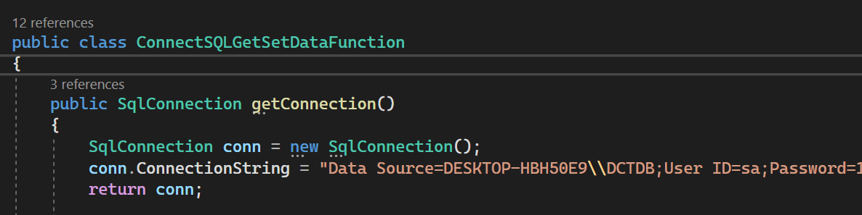

Figure 1: Connect machine to SQL Server using SqlConnection

Figure 2: Get data from SQL Server using SqlCommand and SqlDataAdapter

Figure 3: Set new data in database with ExecuteNonQuery():

Figure 4: Get data for combo box (lists of items for user to choose)

3. DGVPrinterHelper is a class that provides an easy way to print a DataGridView control in C# Windows Forms applications.

4. System.Windows.Forms is a namespace in C# that provides classes for creating Windows-based applications that take full advantage of the rich user interface features available in the Microsoft Windows operating system 1. Most classes within the System.Windows.Forms namespace derive from the Control class 1. The Control class provides the base functionality for all controls that are displayed on a Form 1. The Form class represents a window within an application, including dialog boxes, modeless windows, and Multiple Document Interface (MDI) child windows.

* + **Button:** Represents a Windows button control.
  + **CheckBox:** Represents a Windows check box control.
  + **ComboBox:** Represents a Windows combo box control.
  + **DataGridView:** Represents a Windows grid control for displaying and editing tabular data.
  + **DateTimePicker:** Represents a Windows control that allows users to select a date and time.
  + **Label:** Represents a Windows label control.
  + **ListBox:** Represents a Windows list box control.
  + **ListView:** Represents a Windows control that displays a collection of items that can be displayed using one of four different views.
  + **PictureBox:** Represents a Windows picture box control.
  + **RadioButton:** Represents a Windows radio button control.
  + **RichTextBox:** Represents a Windows control that enables the user to enter and edit text.
  + **TabControl:** Represents a Windows tab control.
  + **TextBox:** Represents a Windows text box control.

# System Design:

The initial phase in the user interface design activity is to prepare input and design output reports in a user-friendly format.

Input design and output design are the two processes in user interface design.

## Input Design:

Input design is an essential part of any system design. In data processing, the most prevalent cause of mistakes is inaccurate input data. Input design can be used to regulate data entry. The design step is known as input design; the extended data flow diagram identifies logical data flows, data storage, sources, and destinations. The purpose of input data design is to make data entering as simple as possible.

This phase has received a lot of attention in the instance of "Lab Reservation System." To eliminate input mistakes, either options are shown to users or incorrect inputs are limited. The odds of inputting inaccurate data are slim here.

When entering data, operators must be aware of the following: the assigned space for each field; field sequences that must match those in the source document; and the format in which the data field is entered.

The input panels were created and built with the user's needs in mind, to allow for easy and error-free data entering. All input panels have been built in real mode (GUI) based on the various sorts of inputs to be supplied to the computer while utilizing the proposed system.

The details of all input screens are shown as follows:

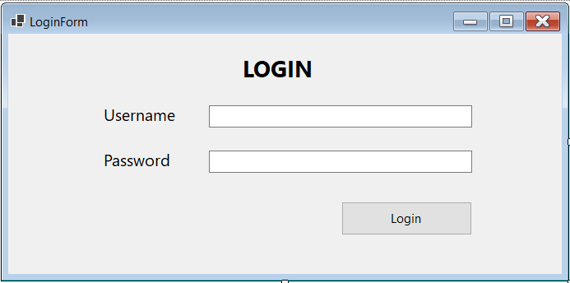

Figure 5: Login Screen

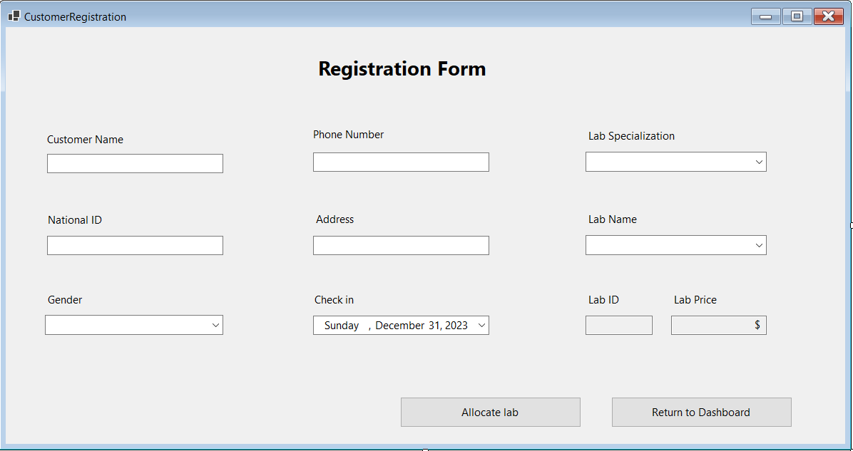

Figure 6: Registration Form

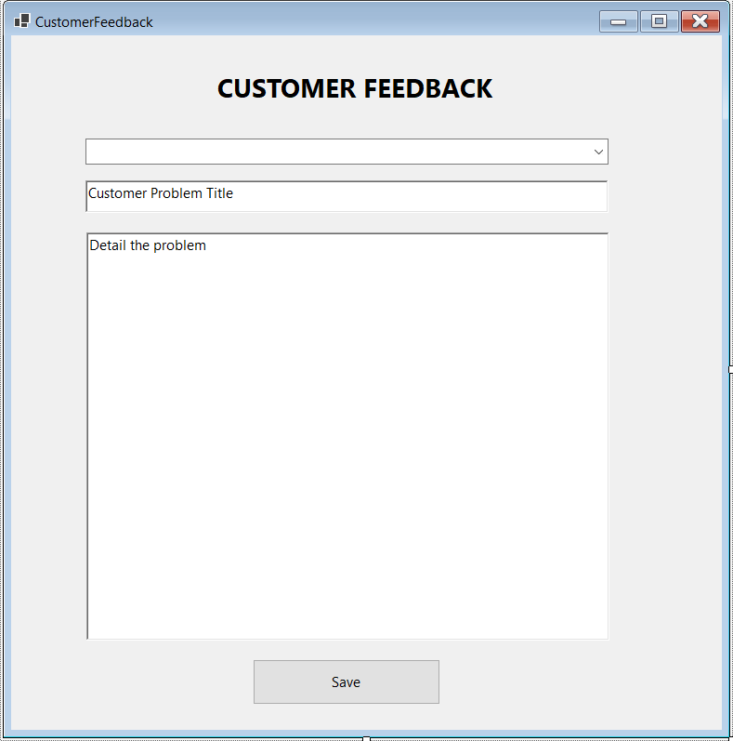

Figure 7: Customer feedback

Besides of input forms, we also implement it to our list so that admin can easily track down all the details:

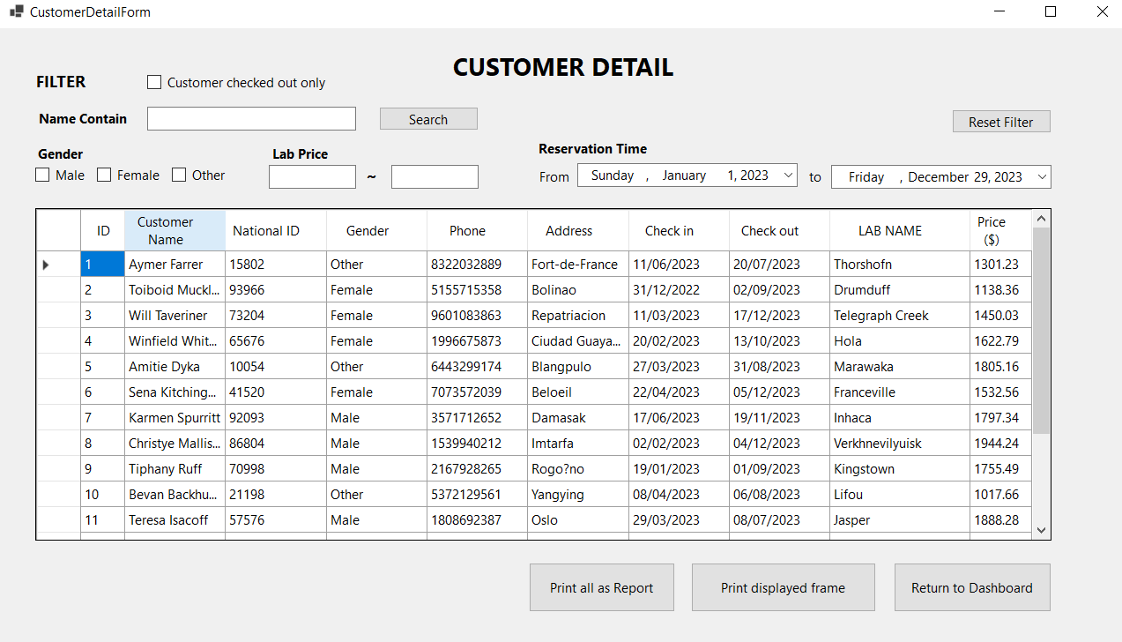

Figure 8: Customer Details and list of Customers

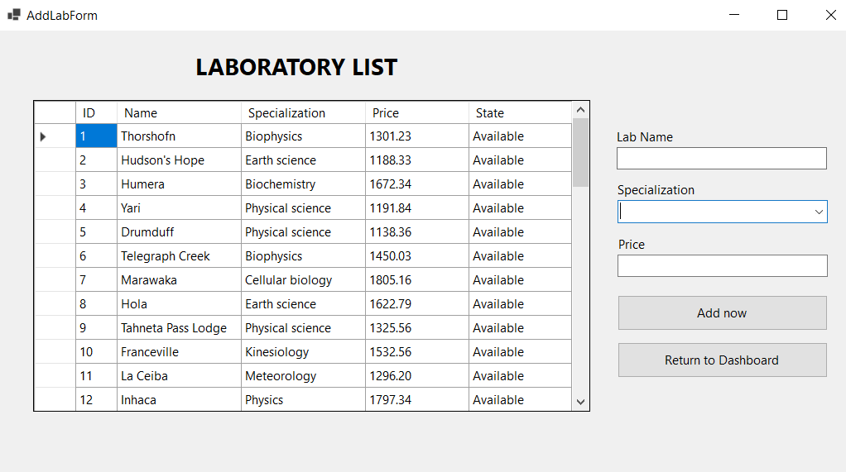

Figure 9: List of laboratory

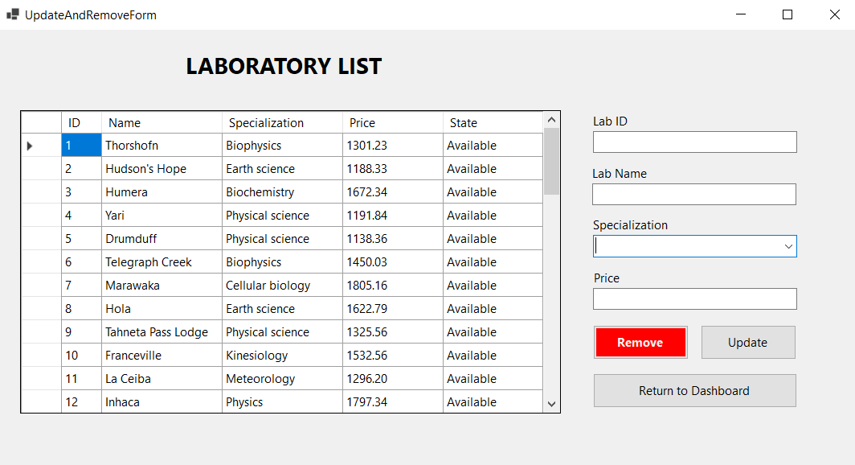

Figure 10: Update and remove form list

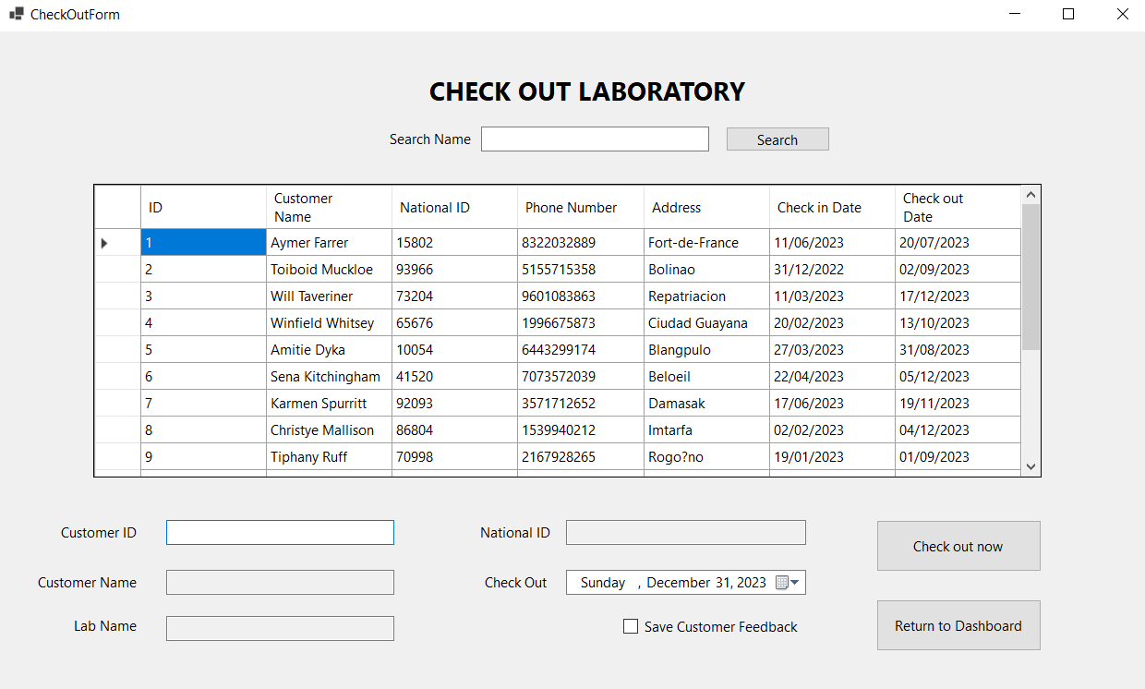

Figure 11: Check out list

## Main dash board

Users also greet with a main dashboard that shows all the options and tools.

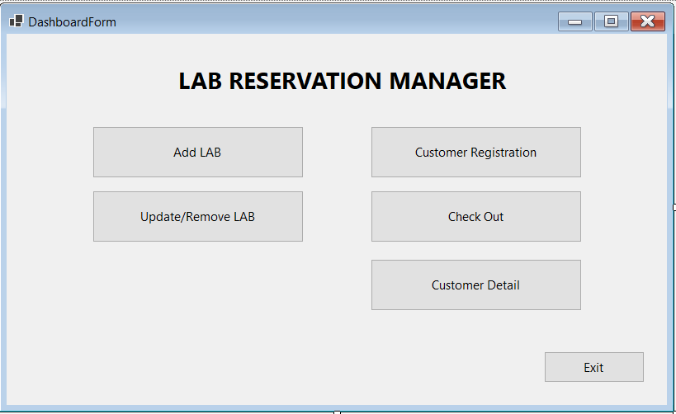

Figure 12: Main dash board

## Data base design:

Database design is the process of defining the structure and organization of a database to store, manage, and retrieve data efficiently and effectively. It involves determining the data entities, their attributes, relationships.

Here are our SQL relationship graph and designs:

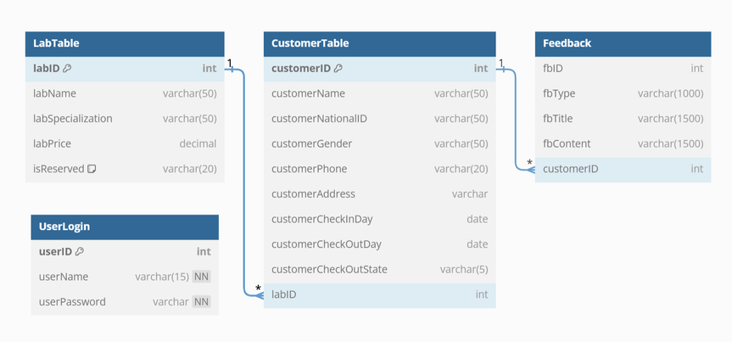

Figure 13: DataBase realionship graph

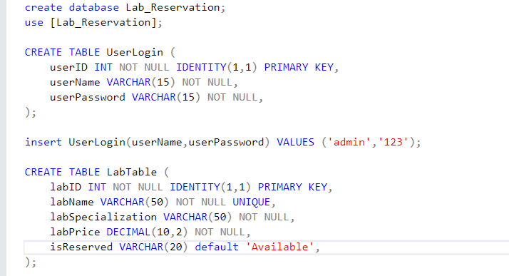

Figure 14: Lab Reservation Database design

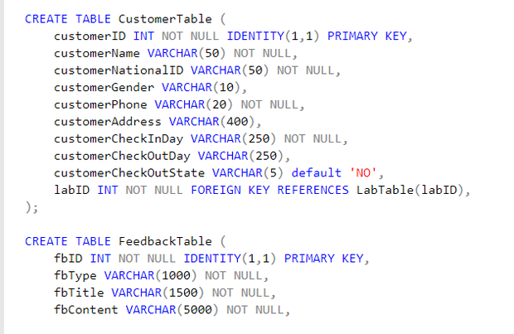

Figure 15: Customer Table DataBase design

# ER Diagram:

An entity-relationship model depicts the relationships between objects of interest in a certain domain of knowledge. A simple ER model is made up of entity types and defines the relationships that can exist between them.

Our Diagram will serve these purpose below:

* Visualizing Data Structure: ER diagrams provide a clear visual representation of the entities (things), attributes (properties), and relationships within a reservation system's database. This helps developers, designers, and users understand the overall structure and how data elements interact with each other.
* Planning and Design: They serve as a blueprint for database design, ensuring that all necessary data elements are captured and relationships are appropriately defined. This helps prevent errors and inconsistencies in the database implementation.
* Communication Tool: ER diagrams facilitate communication among stakeholders, promoting a shared understanding of the system's data requirements and ensuring alignment between business needs and technical implementation.
* Data Integrity: They enforce data integrity rules, such as cardinality (one-to-one, one-to-many, many-to-many) and participation constraints (optional or mandatory relationships). This helps maintain data consistency and prevent anomalies.
* Maintenance and Evolution: ER diagrams serve as a reference point for future modifications and updates to the reservation system. They help developers understand the existing structure and make informed changes without disrupting the system's functionality.

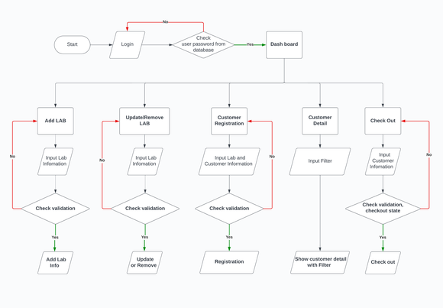

Figure 16: ER Diagram of Lab Reservation System

# Conclusion & Scope for Enhancement for the future:

These are some of the growing themes that will influence lab reservation systems in the future. These technologies will continue to adapt and improve the lab experience for researchers, instructors, and students as technology develops and user demands grow.

### 1. Automation and Integration:

Advanced booking algorithms: AI-powered systems will optimize scheduling, predict lab utilization, and automatically suggest booking slots while accounting for user preferences and equipment availability.

Integrated access control: Reservation systems will connect with lab door locks and equipment, granting access only to authorized users during their booked times.

Automated data collection and analysis: Sensors and lab instruments will automatically collect data on equipment usage, resource consumption, and experiment conditions, providing valuable insights for lab optimization.

### 2. Enhanced Usability and Accessibility:

Mobile-first design: User-friendly and intuitive mobile apps will enable on-the-go booking, tracking, and communication about lab usage.

Universal accessibility: Interfaces will cater to users with disabilities through features like voice commands, text-to-speech, and adjustable font sizes.

Personalized dashboards: Users will have personalized dashboards displaying their upcoming reservations, past activities, and relevant lab information.

### 3. Advanced Security and Data Privacy:

Blockchain technology: Secure and transparent data sharing between users, researchers, and lab managers can be facilitated through blockchain platforms.

Biometric authentication: Fingerprint or facial recognition can be used for secure lab access control and equipment use.

Data anonymization and encryption: User data and sensitive information will be anonymized and encrypted to ensure privacy and compliance with regulations.

### 4. Virtual and Remote Labs:

Virtualized lab environments: Simulations and remote access to equipment will allow users to conduct experiments remotely, improving accessibility and resource utilization.

Interactive virtual tours: 3D models and virtual reality experiences will allow users to explore lab facilities and equipment virtually before booking physical access.

Collaboration tools: Integrated messaging and video conferencing features will facilitate collaboration between researchers in different locations, even when using virtual labs.

### 5. Sustainability and Resource Optimization:

Smart energy management: Systems will dynamically adjust equipment power consumption based on usage patterns and lab occupancy, reducing energy waste.

Resource sharing and reuse: Reservation systems will facilitate shared access to equipment and lab resources, promoting sustainability and efficient utilization.

Real-time monitoring and alerts: Sensors will monitor equipment performance and environmental conditions, sending alerts for potential issues and enabling preventive maintenance.