Action List

Icon Forge

# Action 1

Generate a new theme to add to the backlog.

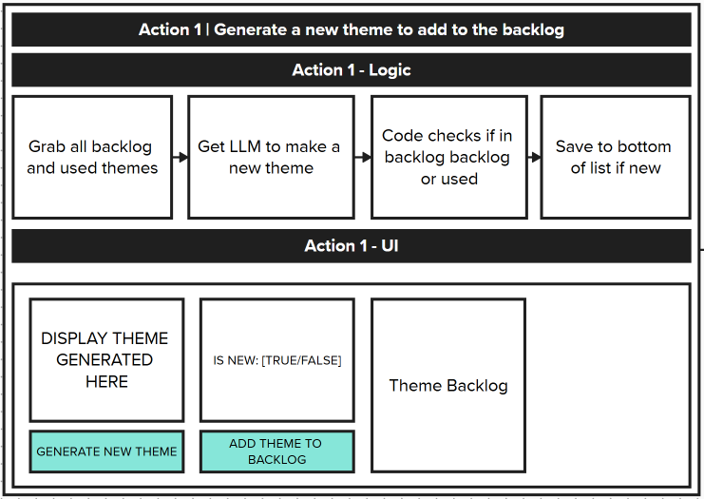

**Action 1 - Logic**

1. Grab all backlog and used themes →
2. Get LLM to make a new theme →
3. Code checks if in backlog backlog or used →
4. Save to bottom of list if new

**Action 1 - UI**

* DISPLAY THEME GENERATED HERE
* IS NEW: [TRUE/FALSE]
* Theme Backlog
* [GENERATE NEW THEME] button
* [ADD THEME TO BACKLOG] button

# Action 2

Generate icon idea based on a selected theme from the backlog.

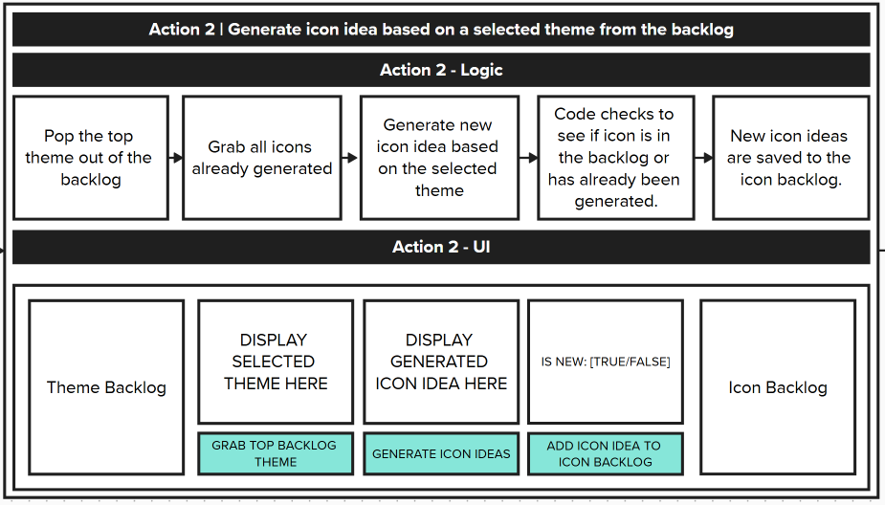

**Action 2 - Logic**

1. Pop the top theme out of the backlog →
2. Grab all icons already generated →
3. Generate new icon idea based on the selected theme →
4. Code checks to see if icon is in the backlog or has already been generated. →
5. New icon ideas are saved to the icon backlog.

**Action 2 - UI**

* Theme Backlog
* DISPLAY SELECTED THEME HERE
* DISPLAY GENERATED ICON IDEA HERE
* IS NEW: [TRUE/FALSE]
* Icon Backlog
* [GRAB TOP BACKLOG THEME] button
* [GENERATE ICON IDEAS] button
* [ADD ICON IDEA TO ICON BACKLOG] button

# Action 3

Generate icon based on selected icon idea.

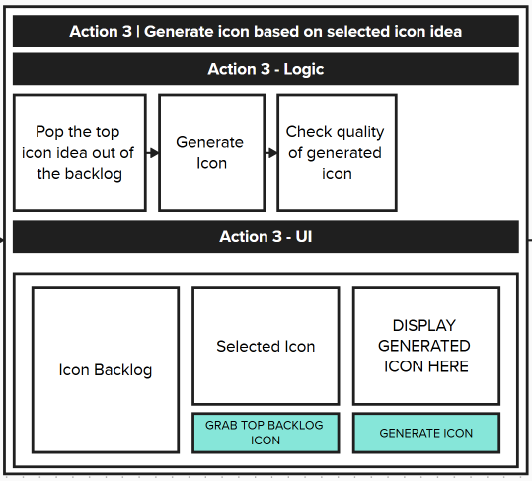

**Action 3 - Logic**

1. Pop the top icon idea out of the backlog →
2. Generate Icon →
3. Check quality of generated icon

**Action 3 - UI**

* Icon Backlog
* Selected Icon
* DISPLAY GENERATED ICON HERE
* [GRAB TOP BACKLOG ICON] button
* [GENERATE ICON] button

# Action 4

Vectorize PNG to SVG.

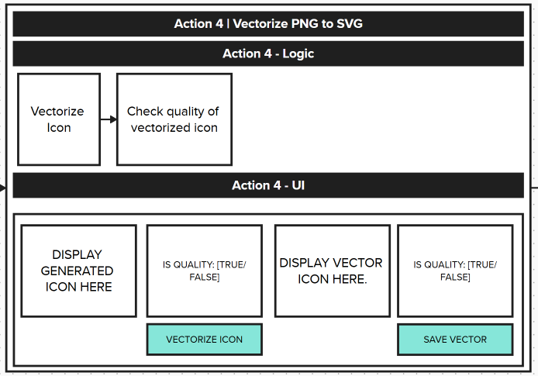

**Action 4 - Logic**

1. Vectorize Icon →
2. Check quality of vectorized icon

**Action 4 - UI**

* DISPLAY GENERATED ICON HERE
* IS QUALITY: [TRUE/FALSE]
* DISPLAY VECTOR ICON HERE
* IS QUALITY: [TRUE/FALSE]
* [VECTORIZE ICON] button
* [SAVE VECTOR] button

# Action 5

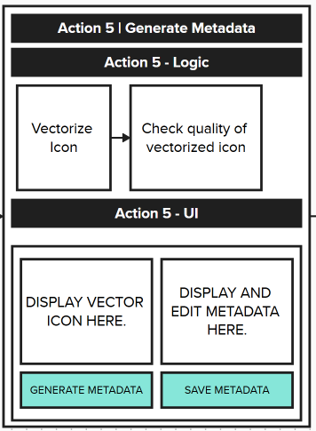

**Action 5 - Logic**

1. Vectorize Icon →
2. Check quality of vectorized icon

**Action 5 - UI**

* DISPLAY VECTOR ICON HERE
* DISPLAY AND EDIT METADATA HERE
* [GENERATE METADATA] button
* [SAVE METADATA] button