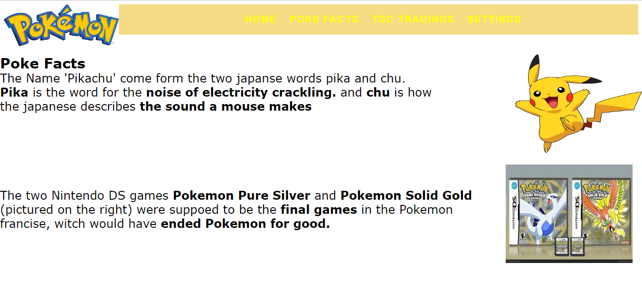

<!DOCTYPE html>

<html lang="en">

<head>

<title> Pokemon Central </title>

<meta charset="utf-8">

<link href="css/Pokemonstyle.css" rel="stylesheet">

<style>

<style>

\*{margin: 0;}

nav{

width:100%;

background-color:#EEBA0B80;

height:100%;

px;

}

nav ul{

text-align:center;

}

nav ul li{

list-style:none;

display: inline-block;

}

nav ul li a{

display:block;

text-decoration:none;

text-transform: uppercase;

color:yellow;

font-size: 20px;

font-family: Sans-Serif;

letter-spacing:2px;

font-weight:600;

padding:1px;

}

nav ul li a:hover{

background-color: gold;

transition:all ease 1.5s;

}

.Box1{

position: absolute;

top:125px;

left: 0px;

right: 0px;

font-size:25px;

text-decoration: line;

color: Black ;

font-family: verdana;

font-weight: ;

}

.Box2{

position: absolute;

top:115px;

left: 0px;

right: 0px;

font-size:30px;

text-decoration: line;

color: Black;

font-family: verdana;

font-weight: ;

}

.Box3{

position: absolute;

top:115px;

right: 0px;

font-size:30px;

text-decoration: line;

color: Black;

font-family: verdana;

font-weight: ;

}

.Box4{

position: absolute;

top:350px;

right: 20px;

font-size:30px;

text-decoration: line;

color: Black;

font-family: verdana;

font-weight: ;

}

.Box5{

position: absolute;

top:375px;

left: 0px;

right: 0px;

font-size:25px;

text-decoration: line;

color: Black;

font-family: verdana;

font-weight: ;

}

</style>

</style>

</head>

<body>

<header>

<div class="container2">

<img src="images/Pokemonlogo.png"alt="Pokemon Logo" height="90" width="250"> <br>

<nav height="3500">

<ul>

<li><a href="index.html">Home</a></li> &nbsp; &nbsp;

<li><a href="about.html">Poke Facts</a></li> &nbsp; &nbsp;

<li><a href="classes.html">TGC TradingS</a></li> &nbsp; &nbsp;

<li><a href="nutrition.html">Settings</a></li> &nbsp; &nbsp;

</ul>

</nav>

</div>

</header>

<nav>

</nav>

<main>

<div class="Box2">

<div class="text">

<b>Poke Facts</b>

</div>

</div>

<div class="Box1">

<div class="text">

<p> The Name 'Pikachu' come form the two japanse words pika and chu.<br> <b> Pika</b> is the word for the <b> noise of electricity crackling.</b> and <b>chu</b> is how <br> the japanese describes <b> the sound a mouse makes </b> </p>

</div>

</div>

<div class="Box3">

<img src="images/pikachu.webp"alt="Pokemon Logo" height="210" width="270">

</div>

<div class="Box4">

<img src="images/Pure A Silver.jfif"alt="Pokemon Logo" height="210" width="270">

</div>

<div class="Box5">

<div class="text">

<p>The two Nintendo DS games <b>Pokemon Pure Silver</b> and <b>Pokemon Solid Gold</b><br> (pictured on the right) were suppoed to be the <b>final games</b> in the Pokemon<br> francise, witch would have <b>ended Pokemon for good.</b></p>

</div>

</div>

</main>

<footer>

</footer>

</body>

</html>