

**CA1: DSA Report**

Prepared and submitted by

| Name: | Challa Surya Kaanth | **2100874** |
| --- | --- | --- |

## **Starting the application**

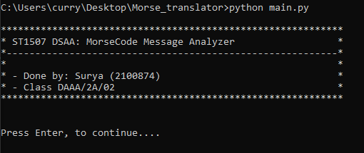

1. Convert Text to Morse Code

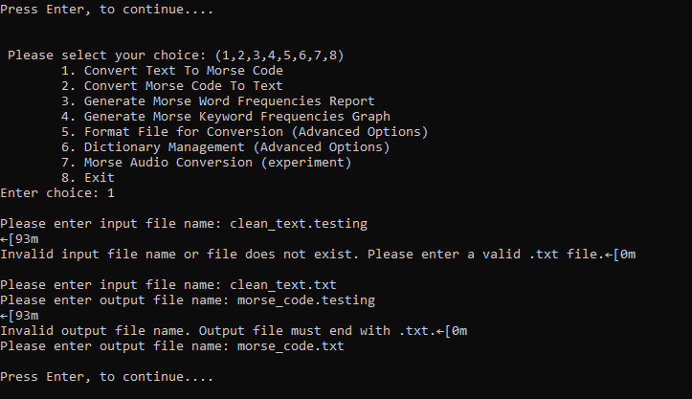

The inputs all have user validation and only accept text files.

| Input: clean_text.txt | Output: morse_code.txt |
| --- | --- |
| HELLO THIS IS A TRANSLATED TEXT FILE THIS IS THE TRANSLATED MORSE CODE TEXT FILE TRANSLATED TRANSLATED | ....,.,.-..,.-..,---, ,-,....,..,..., ,..,..., ,.-, ,-,.-.,.-,-.,...,.-..,.-,-,.,-.., ,-,.,-..-,-, ,..-.,..,.-..,., ,-,....,..,..., ,..,..., ,-,....,., ,-,.-.,.-,-.,...,.-..,.-,-,.,-.., ,--,---,.-.,...,., ,-.-.,---,-..,., ,-,.,-..-,-, ,..-.,..,.-..,., ,-,.-.,.-,-.,...,.-..,.-,-,.,-.., ,-,.-.,.-,-.,...,.-..,.-,-,.,-.. |

1. Convert Morse Code to Text

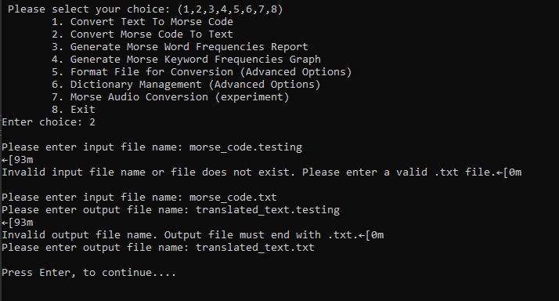

| Input: morse_code.txt | Output: translated.txt |
| --- | --- |
| ....,.,.-..,.-..,---, ,-,....,..,..., ,..,..., ,.-, ,-,.-.,.-,-.,...,.-..,.-,-,.,-.., ,-,.,-..-,-, ,..-.,..,.-..,., ,-,....,..,..., ,..,..., ,-,....,., ,-,.-.,.-,-.,...,.-..,.-,-,.,-.., ,--,---,.-.,...,., ,-.-.,---,-..,., ,-,.,-..-,-, ,..-.,..,.-..,., ,-,.-.,.-,-.,...,.-..,.-,-,.,-.., ,-,.-.,.-,-.,...,.-..,.-,-,.,-.. | HELLO THIS IS A TRANSLATED TEXT FILE THIS IS THE TRANSLATED MORSE CODE TEXT FILE TRANSLATED TRANSLATED |

1. Generate Morse Word Frequencies Report

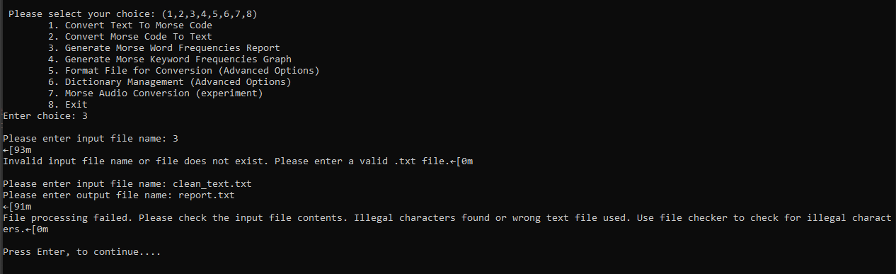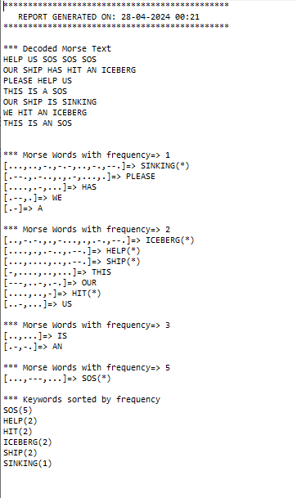

In case a Morse code file is not used, it will return such an error

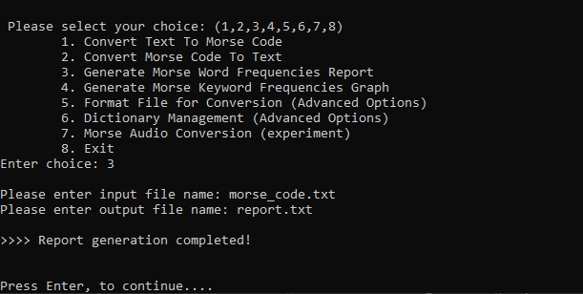

1. Generate Keyword Frequencies Graph

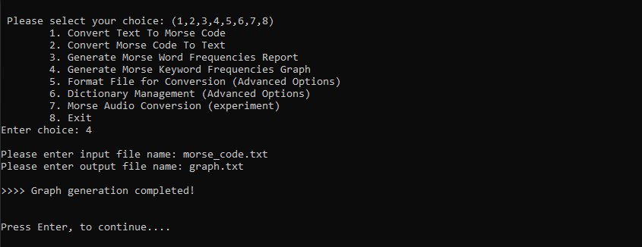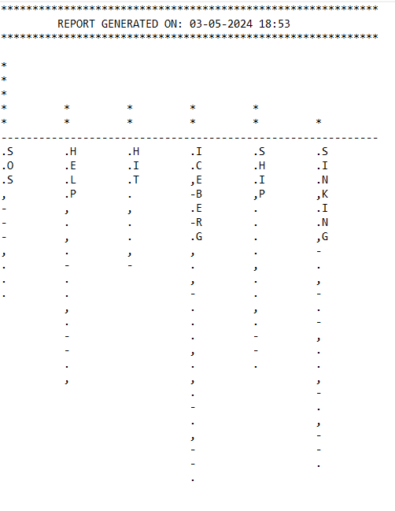

1. Format file for Conversion( adv 1)

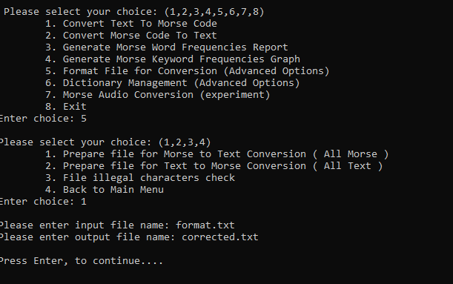

| hello this is a testing file ,-,....,..,..., this is morse code ,...,---,..., for THIS IS AN SOS ,-,....,..,..., ,..,..., ,.-,-., ,...,---,... | ....,.,.-..,.-..,---, -,....,..,..., ..,..., .-, -,.,...,-,..,-.,--., ..-.,..,.-..,., ,-,....,..,..., -,....,..,..., ..,..., --,---,.-.,...,., -.-.,---,-..,., ,...,---,..., ..-.,---,.-., -,....,..,..., ..,..., .-,-., ...,---,..., ,-,....,..,..., ,..,..., ,.-,-., ,...,---,... |
| --- | --- |

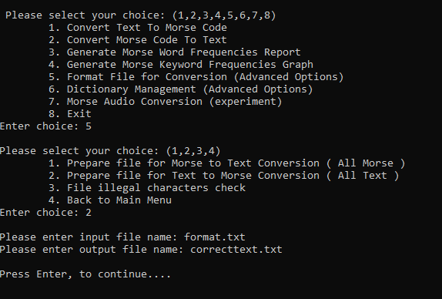

| hello this is a testing file ,-,....,..,..., this is morse code ,...,---,..., for THIS IS AN SOS ,-,....,..,..., ,..,..., ,.-,-., ,...,---,... | hello this is a testing file THIS this is morse code SOS for THIS IS AN SOS THIS IS AN SOS |
| --- | --- |

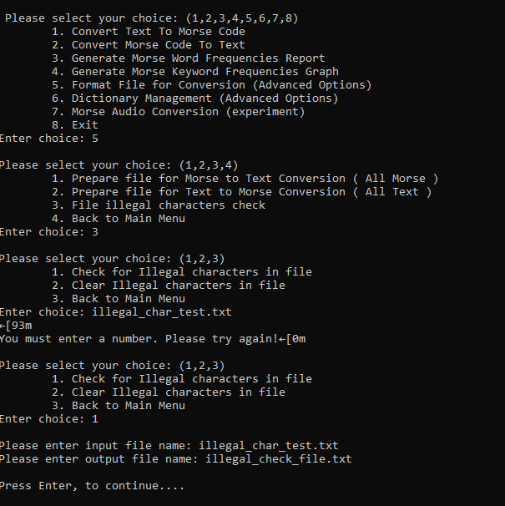

| HELLO THIS IS A^ TESTING FILE THIS THIS^ IS MORSE CODE SOS FOR THIS IS AN SOS THIS I~S AN SOS | Illegal characters denoted by ():  HELLO THIS IS A(^) TESTING FILE THIS THIS(^) IS MORSE CODE SOS FOR THIS IS AN SOS THIS I(~)S AN SOS |
| --- | --- |

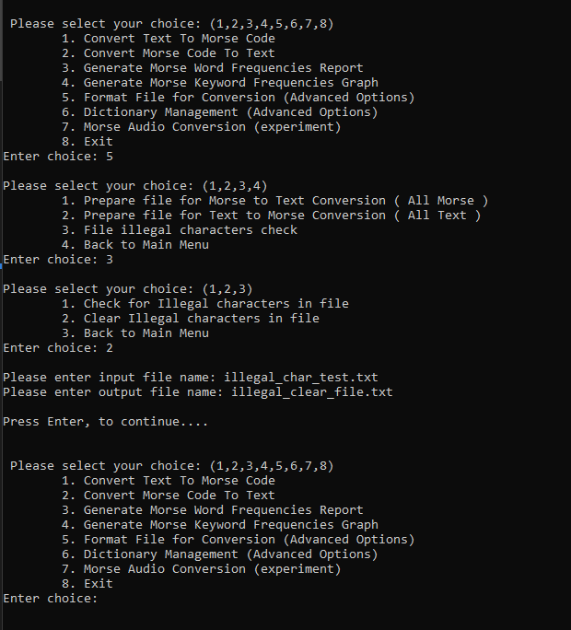

| HELLO THIS IS A^ TESTING FILE THIS THIS^ IS MORSE CODE SOS FOR THIS IS AN SOS THIS I~S AN SOS | HELLO THIS IS A TESTING FILE THIS THIS IS MORSE CODE SOS FOR THIS IS AN SOS THIS IS AN SOS |
| --- | --- |

1. Dictionary Management (adv 2)

|  |  |
| --- | --- |
|  |  |
|  |  |
|  |  |

1. Morse Audio Conversion

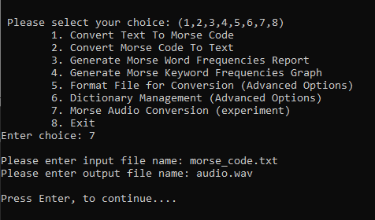

| **Data Structure** | **Developed/Built-in** | **Performance (Big O)** | **Use Case** | **Reason for Suitability** |
| --- | --- | --- | --- | --- |
| Sorted Linked List | Developed | Insert:  𝑂(𝑛)  *O*(*n*), Search:  𝑂(𝑛)  *O*(*n*) | Dynamic sorted data | Space efficiency, maintains order |
| Hash Table | Built-in | Insert:  𝑂(1)  *O*(1), Search:  𝑂(1)  *O*(1) | Fast lookups, insertions, deletions | Average-case constant time complexity |
| Hash Map | Built-in | Insert:  𝑂(1)  *O*(1), Search:  𝑂(1)  *O*(1) | Fast key-value operations | Optimized, convenient for rapid development |
| Bubble Sort | Developed | Worst:  𝑂(𝑛^2)  *O*(𝑛^2), Best:  𝑂(𝑛)  *O*(*n*) | Small or nearly sorted datasets | Easy to implement, suitable for small data |
| Trie/Prefix Tree | Developed | Insert:  𝑂(n)  *O*(*n*), Search:  𝑂(𝑚)  *O*(*m*) | String retrieval, autocomplete systems | Perfect for mapping strings to trees for string lookup |
| Oop methods used |  |  |  |  |
| Operator Overloading | Developed |  | Enhances readability/usability of classes | Intuitive usage of custom data structures |

I didn't face any challenges. It went smoothly. 8 pages is not enough for the content I have in my project but the table above should do the trick in giving an idea.

Class Diagram (i know its small, please zoom in)

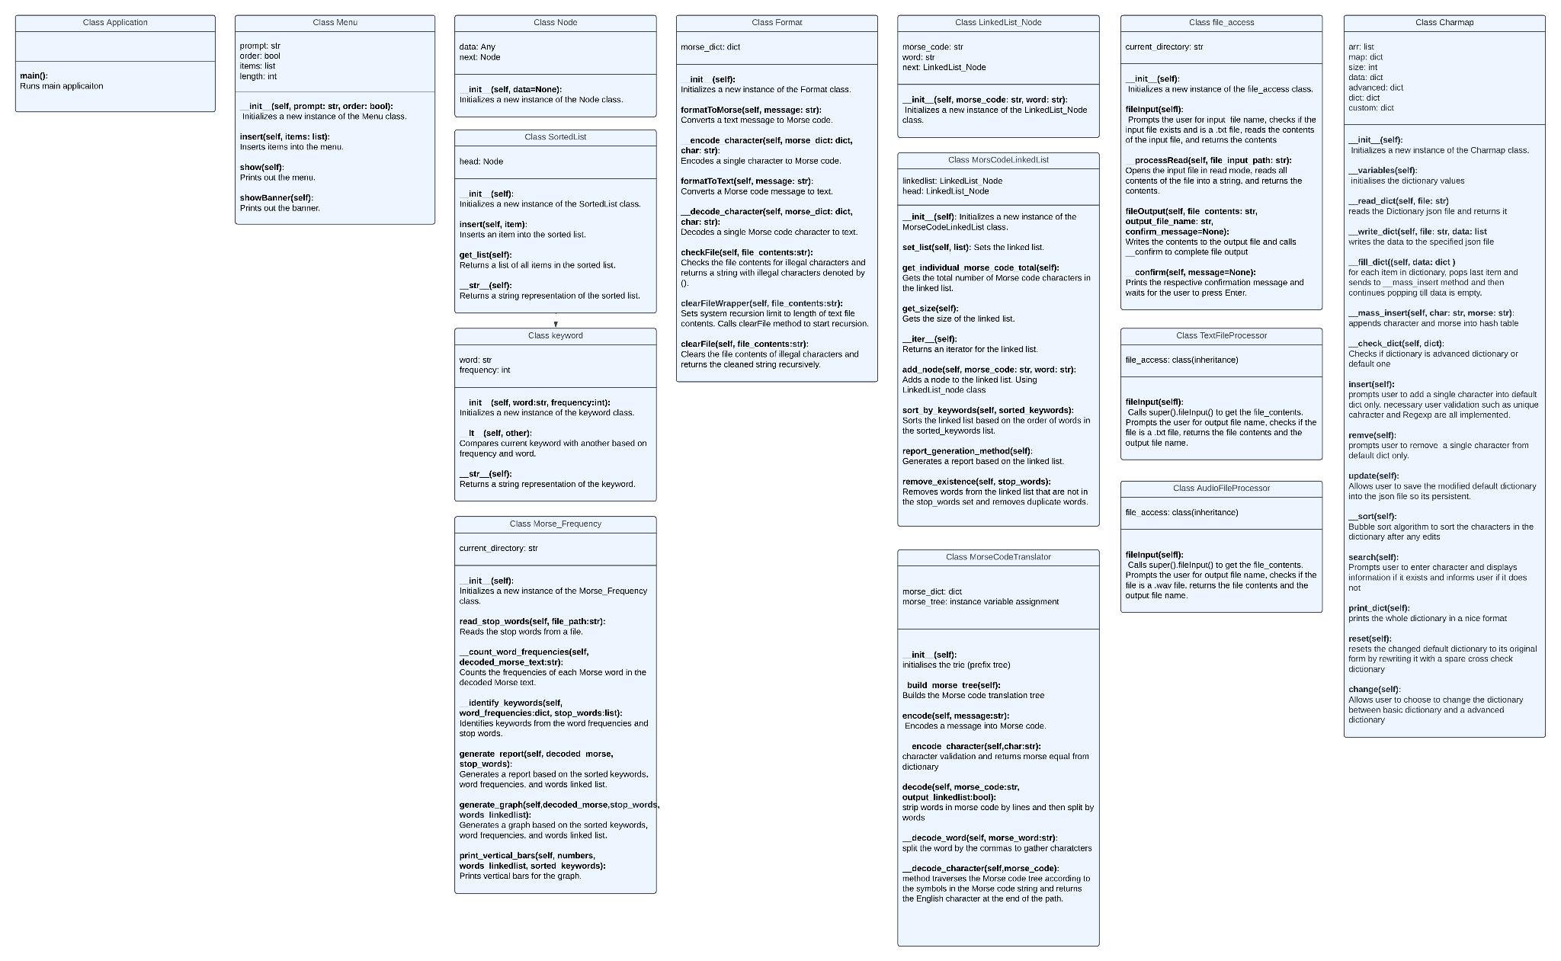

References  
<https://wangyy395.medium.com/implement-a-trie-in-python-e8dd5c5fde3a>

<https://stackoverflow.com/questions/40782159/writing-wav-file-using-python-numpy-array-and-wave-module>

<https://realpython.com/python-wav-files/>