%% to edit a Word-template, do not double-click in Explorer (this opens a derived new document), but use the Open-dialog from word

\documentclass{article}

\usepackage{amsmath}

\usepackage{graphicx}

\title{MS Word as Latex editor}

\author{Doktorierer}

\date{\today}

\begin{document}

\maketitle

# \section{Example Code for itemize}

This is just a text.

\begin{itemize}

\item Test1

\item Test2

\item Test3

\end{itemize}

This is just a text.

\begin{enumerate}

\item Test1

\item Test2

\end{enumerate}

# \section{Example Code for Preview Snippets}

Lorem ipsum dolor sit amet, consectetuer adipiscing elit. Maecenas porttitor congue massa. Fusce posuere, magna sed pulvinar ultricies, purus lectus malesuada libero, sit amet commodo magna eros quis urna. See~\eqref{eq:1}

\begin{equation}

a + b = c

\label{eq:1}

\end{equation}

# \section{ Lorem ipsum dolor}

Lorem ipsum dolor sit amet, consectetuer adipiscing elit. Maecenas porttitor congue massa. Fusce posuere, magna sed pulvinar ultricies, purus lectus malesuada libero, sit amet commodo magna eros quis urna. See~\eqref{eq:2}

\begin{equation}

\int_a^b f(x)\, dx

\label{eq:2}

\end{equation}

## \subsection{Lorem ipsum dolor sub}

Lorem ipsum dolor sit amet, consectetuer adipiscing elit. Maecenas porttitor congue massa. Fusce posuere, magna sed pulvinar ultricies, purus lectus malesuada libero, sit amet commodo magna eros quis urna. See Tab.~\ref{tab:1}

\begin{table}

\centering

\caption{my table}

\begin{tabular}{|c|c|}

\hline

a & b \\

\hline

\end{tabular}

\label{tab:1}

\end{table}

### \subsubsection{Lorem ipsum dolor sub sub}

Lorem ipsum dolor sit amet, consectetuer adipiscing elit. Maecenas porttitor congue massa. Fusce posuere, magna sed pulvinar ultricies, purus lectus malesuada libero, sit amet commodo magna eros quis urna. See Fig.~\ref{fig:1}

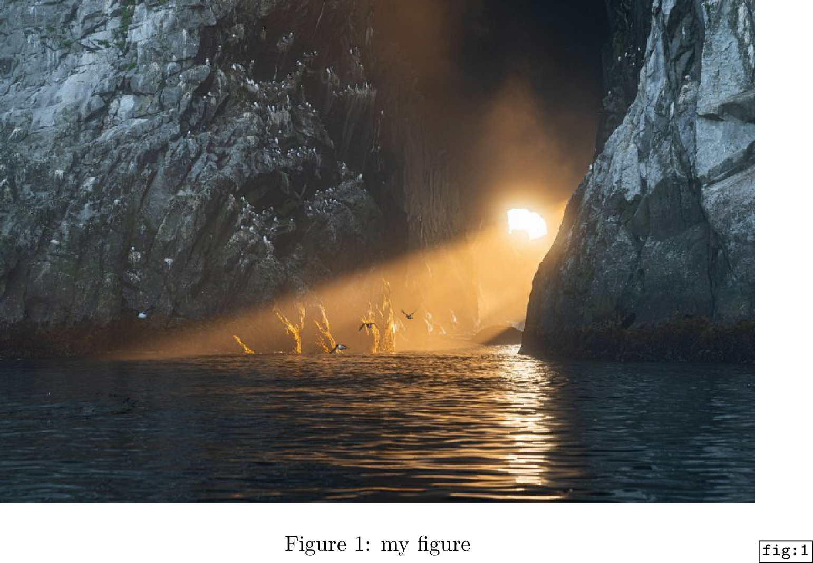\begin{figure}

\centering

\includegraphics[width=\textwidth]{test.jpg}

\caption{my figure}

\label{fig:1}

\end{figure}

\end{document}