PrFm “Prüfungsspick” - Raphael Zimmermann – HS2016
Imperative = How it operates. Program = sequence of commands computation = change of state (Assignment, Conditional execution (if...then...else) ,Repetition).
Declarative = Group - contains logical and functional programming paradigms. Describes "what" should be done - how is left to the languages implementation. Programs = Theories of a formal logic Computation = Deductions.
- Functional
  - Functions are First-Class Citizens
  - No mutable State (Problem: Every statement can potentially change the underlying state of the program)
  - Simple concept & short & Easier to reason about → Easier to get right
  - (almost) only Expressions (“execute & evaluate expressions”)
In OO, data & logic is both in Objects whereas in Functional Programming, data and logic are separate.

Sequent Calculus
Sequent: a generic name for a statement
proof rule: Used to construct proofs of sequents. Consists of a list of an antecedent (vorhergehend) and a consequent (nachfolgend) sequent. Read: "To proof, that [Nenner], it is sufficient to proof that [Zähler]"
Axiom: Is a Proof rule: (Rule ohne antecedents) - leaf node. → Needed for a complete proof. "Grundelemente, die immer gelten"
Theories: a theory is a set of proof rules Usually infinite - specified using a finite set of proof rule schams
Proof: A finite tree with the following properties
- Node consists of 1 sequent and 0/1 proof rule of the theory
- root node = sequent to proof
- node without proof rule has no child nodes
Pending Sub-goals of a Proof: The sequents of a proof that have non Axium leaf nodes are called prnding sub-goals.
Complete / Incomplete: The proof is complete if it has no prnding Sub-goals. Otherwise, it's incomplete.
Statement: Was im Nener steht

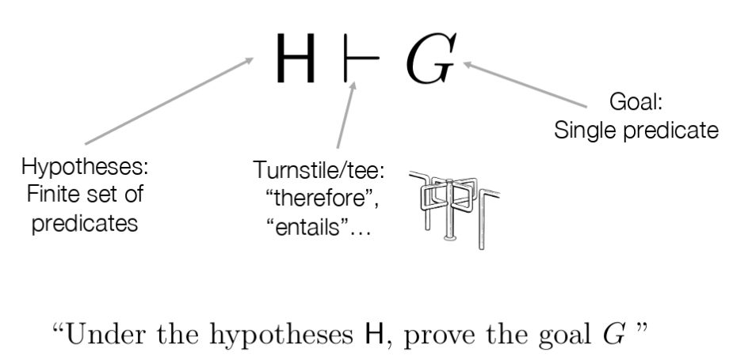
Propositional Calculus
Proposition: A proposition is a blackbox with no input and either true or false (Eg. B)
Predicate The outcome of a Predicate depends on the input and can therefore be both, true or false. (Eg. B(x) or A ∧ B => B ∧ A)
Binding Strength for PC: ¬, ∧, ∨, ⇒, ⇔
KEINE QUANTIFIZIERUNG! ( Sokrates geht nicht!)

First-order Predicate Calculus (FoPC)
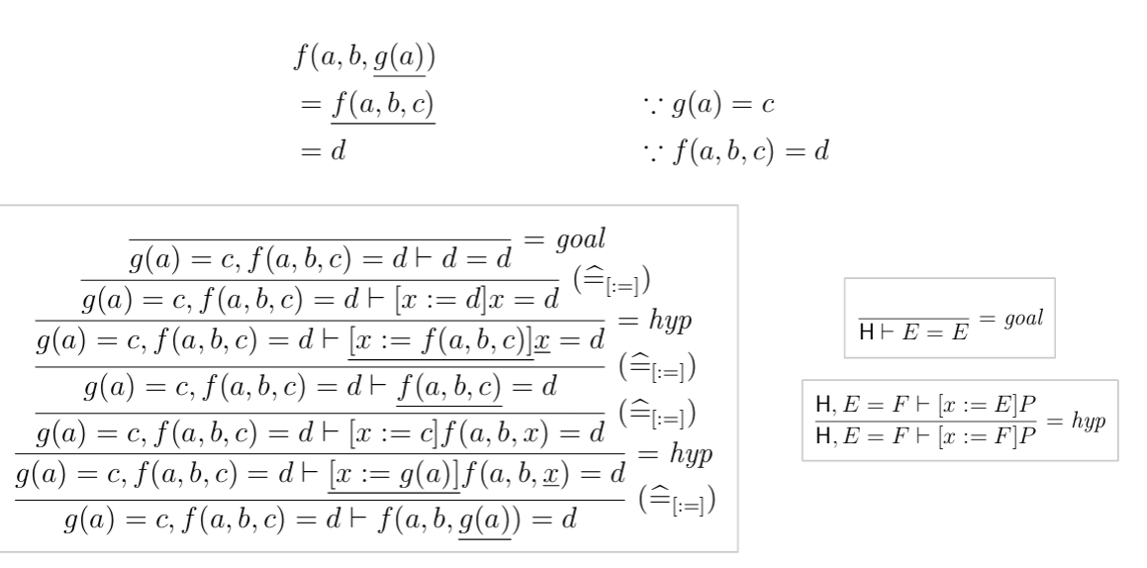
Equational Resoning (Syntactic Sugar)
Expression syntactic construct denoting a math. object such as number, set, function ...
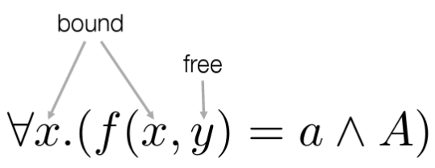
expressions can't be proofed - they depend on the input!
Only a predicate can be proven ( = expression with input)
Variable: Identifier / Placeholder: subject to subtstitution
bound variable: place holder. It's name has no significance and can be changed. Is bound in a certain context
→ It's useful to draw an abstract syntax tree!

Approach “Is it a well-formated predicate?”
- Expression or Predicate (eg. Equality is only defined for expressions)
P ::= ... | ∀x.P | E = E | R(E')
E ::= x | f(E')
- Relation or function symbol
- Operators OK? (not Operator is is unary!)
- Is it ambiguous? operator precedence OK? (binding strength: ¬, ∧, ∨, ⇒, ⇔)
  - Can I draw a parse tree

Lambda Calculus
Application binds tighter than abstraction→=
Left associative =
Confluence: Execution strategy does not matter (The computation would not be deterministic without this property!)
Beta normal form = no further beta reductions possible. Term can have 0 or 1 beta normal forms.
Delta-Reduction = substitution.
Higher-Order Functions are functions that accept a function as input and/or return a function as output.
Redex = reducable expression.
Innermost-first: Use innermost or leftmost innermost first. “applicative order”. →pass by value - terms are fully evaluated before passed as parameters to another function. Therefore, arguments are reduced exactly once. Usually, innermost-first results in a shorter derivation. “Calculate” all substitution
Outermost-first: Use outermost or leftmost outermost first. “normal order”. → pass by name – terms are substituted into the function body without being reduced. Therefore, arguments are reduced as often as needed → Which can also be never! Will always find the normal form if it exists. “Calculate” required substitution
Encoding: Pure lambda calculus does neither have primitive data types, boolean algebra nor arithmetic operations but all of it can be encoded in lambda calculus.
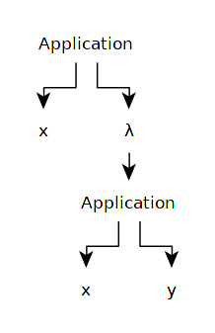
x λ. x y als parse tree
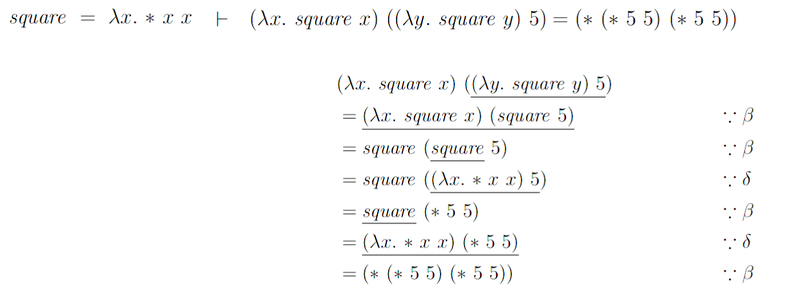

Prolog (Don’t forget the dots!)
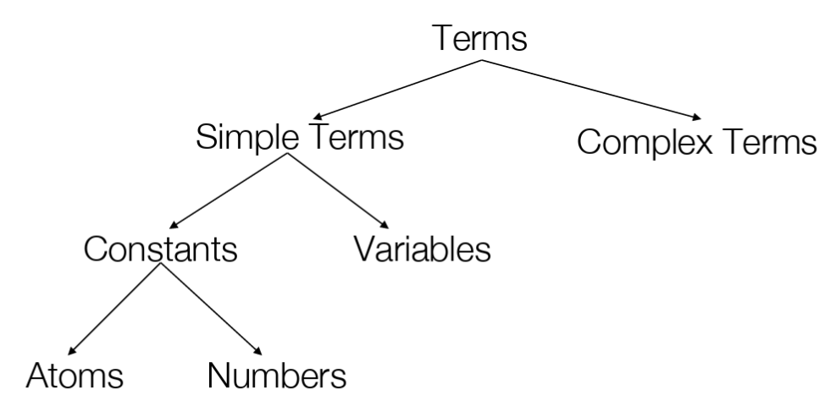
Program = Predicate calculus, Computation = Proof of a sequent. It’s declarative, based on recursion (no for/while), relations (no functions) e.g. woman(mia) and unifications. Prolog anserws with: `yes`, `no` or `no`/`error` (depending on the interpreter)
- Atoms: Begins with lowercase – contains upper-case letters, lower-case letters, digits, and the underscore character or anything in Singlequotes. eg. xx, burger_king, '@$%' (; and :- are Atoms as well but with a predefined meaning. (Warning: mia=’mia’ is true – but ’2’ = 2. isnt – because atom != number!)
- Numbers: Just plain integers or floats (eg. 1, 3.141 etc.)
- Variables: Beginning with an uppercase letter or an underscore – contains upper-case letters, lower-case letters, digits and underscore characters.
- Complex Terms: A (nested) construct of Atoms, numbers and variables (loves(peter, maria), loves(me, Q)” .Functor: Name, eg. love. Arity: If Arity of 2 predicates with different names are different, prolog treats them as different predicates: eg: love(a, b) / 2
- Relations = relational Predicates etg. woman(mia) or party.
- Rule head :- body (:- means implication). Fact: eg. listens2Music(mia). (Rule with empty body)
- clauses: facts and rules contained in a knowledge base

% And - with a comma
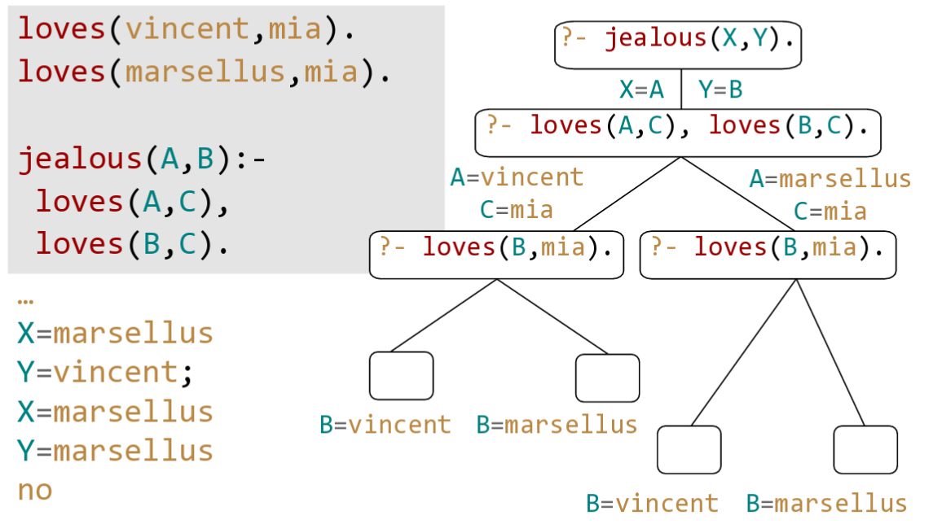
Proof Search: From top to bottom and From left to right → establish Priority (not possible in “logic”)
playsAirGuitar(butch):-
happy(butch),
listens2music(butch).
% OR - with a semicolon
playsAirGuitar(butch):-
happy(butch);
listens2music(butch).
% OR - with two rules
playsAirGuitar(butch):-
happy(butch).
playsAirGuitar(butch):-
listens2music(butch).

A Recipe for Recursion + example
- Write down the signature of the predicate you want to define
len(_, _) % First argument List, second argument the length
- Choose the parameter(s) over which recursion shall be performed → Here the list (first param)
- Identify the case distinctions for the recursion parameter(s) on the left hand side of the rules.
len([], ) % Base Case
len([H|T], ) % Recursive Case
- On the right hand side of the Rule, write down the predicate applied to the input parameter(s) made “smaller”.
len([], ) % Base Case
len([H|T], ):- ??? len(T, ) % Recursive Case
- Complete Rules
len([], 0). % Base Case
len([H|T], L ):- len(T, LT), % Recursive Case
L is LT+1.
- Check it

Unification aka bind/instantiates
42 and 42, `mia` and mia, woman(mia) and woman(mia), mia and X if mia is substituted with X, woman(Z) and woman(mia) if mia is substituted with Z. … loves(mia, X) and loves(X, vincent) can not be unified

Occurs Check: father(X) = X. calculates to father(X) = X. (First check if the term to unify with a variable contains the same variable. If so → abort (impossible)
Lists: [Head, Tail] – not possible for empty list!
?- [X1,X2,_,X4|_] = [mia,vincent,marsellus, jody,yolanda]. % X1=mia X2=vincent X4=jody

member(X,[X|_]).
member(X,[_|T]):- member(X,T).

len([],0).
len([_|L],N):- len(L,X), N is X + 1.

append([], L, L). % Base Case
append([H|T], L, [H|R]) :- append(T, L, R). % Recursive call
suffix(S,L):-append(_,S,L).
prefix(P,L) :- append(P,_,L).
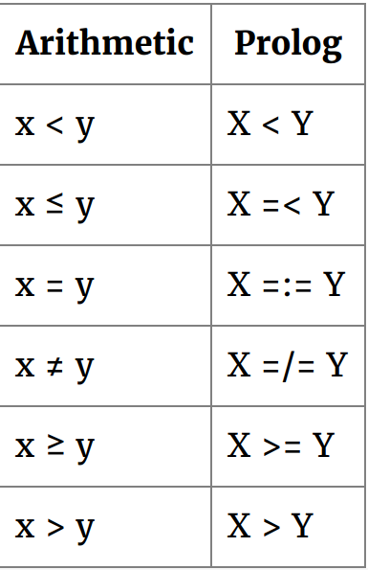
Arithmetic
`8 is 6+2. ` → `is(8, +(6, 2))`. Operators don’t carry out any arithmetic – are just functors.
`is` forces Prolog to evaluate arithmetic expression → Everything on the right hand side must be instantiated – passed like this to the CPU.
Accumulators = variables, that hold intermediate results.
acclen([], Acc, Len):- Len = Acc.
acclen([_|L, OldAcc, Len):- NewAcc is OldAcc + 1,
acclen(L, NewAcc, Len).
accReverse([],L,L).
accReverse([H|T],Acc,Rev) :- accReverse(T,[H|Acc],Rev).
% Wrapper
reverse(L1,L2) :- accReverse(L1,[],L2).

accMax([H|T], A, Max):- H > A, accMax(T, H, Max).
accMax([H|T], A, Max):- H =< A, accMax(T, A, Max).
accMax([], A, A).
Horn Clauses
have better computational properties than normal clauses, because: Resolution of two Horn clauses always results in a Horn clause and Resolution of a goal clause and a definit clause is always a goal clause.
Horn Clause: a clause with at most one un-negated (positive) literal: 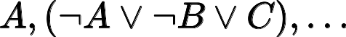
Horn formula: a conjunctive normal form (CNF) formula whose clauses are all Horn clauses.
Goal clause: i.e. Horn clause with no positive literal (Prolog query) |---->
definite clause: i.e Horn clause with exactly one positive literal (Prolog rule)

Haskell
Lots of list functions like head, tail, take n xs, drop n xs, enght, sum, product, reverse.
Appending two lists xs ++ ys. Selecting the nth element of a list: [1,2,3] !! 2.
function application is denoted using space and is left associative. multi x y z = ((multi x)y)z
function application binds stronger than all other operators.
Arrows (->) are right associative. Int->Int->Int->Int = Int->(Int->(Int->Int))
f a b + c * d ↔ f(a b) + c d
f a + b ↔ (f a) + b
div 4 2 ↔ 4 `div` 2
4 / 2 ↔ (/) 4 2 ↔ (4 /) 2 ↔ (/ 2) 4
Functions and arguments lowercase – list suffix (xs, nss (list of lists)).
Layout Rule: Everything in the same column – allows implicit grouping
Types: Bool, Char, String, Int, Integer, Float, Double. Can be set manually using ::. Haskell is typesafe –(automatic type inference at compile time).
(in)finite lists – of exactly one type: [False, True] :: [Bool] or [“Foo”, “Baa”] :: [[Char]]. Nothing else than syntactic sugar for the cons operator: [1,2,3] = 1 : (2 : (3:[]))
tuples are finite – of possibly different types eg. ('a', True, "Haha") :: (Char, Bool, [Char])
Function Types mapping from of some type to a result of a possibly other type. eg. even :: Int → Bool. (Type definition of a function prior to it’s definition is good practice). eg. :type (+) is (+) :: Num a => a -> a -> a (two arguments (one at a time) of type a – returns a result of type a)
Currying: add x y =x + y means add = \ x -> (\ y -> x + y)
Polymorphic Functions: If function contains one or more type variables eg. length::[a]-> Int.
Overloaded: if its type contains one or more class constraints ((+)::Num a => a -> a -> a)
Conditional Expressions: Exactly ONE if and ONE else.can be nested.
signum n = if n < 0 then -1 else
if n == 0 then 0
else 1
Guarded Equations: Mathematical intuition, otherwise is synonym for True. Order is important, | reads as such that, other is not required but readable.
signum n | n < 0 = -1
| n == 0 = 0
| otheriwse = 1
Pattern Matching: order should NOT matter, Can only bind a variable ONCE. Works also for lists.
not :: Bool -> Bool
not False = True
not True = False
(&&) :: Bool -> Bool -> Bool
True && True = True
_ && _ = False -- Wildcard pattern
tail :: [a] → [a]
tail(_ : xs) = xs
Lambdas: (\x -> x + x) 2
List Comprehensions. Can have multiple Generators (ie. x <- [1..5]) their order is important (nested loops).
[(x,y) | x <- [1..3], y <- [x..3]]
-- Result: [(1,1),(1,2),(1,3),(2,2),(2,3),(3,3)]
concat xss = [x | xs <- xss, x <- xs]
factors n = [x | x <- [1..n], n `mod` x == 0] -- using guards
positions x xs = [i | (k, i) <- zip xs [0 ..], k == x] -- all position of x using zip
Recursive Functions
reverse :: [a] -> [a] -- Reverse - analog zu Prolog
reverse []= []
reverse (x:xs) = reverse xs ++ [x] -- Append operator
Recipe for Recusion
- Define the type (ie. product :: [Int] -> Int)
- Enumerate the cases (ie. product [] = and product(n:ns) = )
- Define the simple cases (product [] = 1)
- Define the other cases (ie. product (n:ns) = n * product ns)
- Generalize and simplify
Higher-Order Functions: takes a function as an argument or returns a function as a
map :: ( a -> b) -> [a] -> [b]
map f [] = []
map f (x:xs) = f x : map f xs
-- foldr/foldl “reduce” -- simple pattern of recursion on lists - can be optimized
Type Declarations: Must start with uppercase letter.
type String = [Char] -- synonym, can be TRANSITIVE but NOT RECURSIVE
data Shape = Circle Float | Rect Float Float
-- > :type Circle results in Circle :: Float -> Shape
-- > :type Rect results in Circle :: Float -> Float -> Shape
square :: Float -> Shape -- example usage
square n = Rect n n
-- Example recursive definition: "Natural numbers"
data Nat = Zero | Suc Nat
data Tree a = Leaf a | Node (Tree a) a (Tree a)
-- Exaple
-- 5
-- / \
-- 3 7
-- / \ / \
-- 1 4 6 9
t :: Tree Int
t = Node (Node (Leaf 1) 3 (Leaf 4)) 5 (Node (Leaf 6) 7 (Leaf 9))

Polymorphism
- Ad-hoc Polymorphism → Haskell uses type classes (Eq, Num, etc) - is similar to interfaces in Java.
- Parametric Polymorphim
- Subtype Polymorphim (not supported in most functional languages)
instance Eq Bool where
Fals == False = True
True == True = True
_ == _ = False
-- or simpler
data Bool = False | True
deriving (Eq, Ord, Show, Read)

Scala (has NO primitives)
lazy val max = if (a >= b) a else b
var iHaveVariableContent = 1
val stringInterpolation = "my ${foo(10)}" // Multi line Strings with """
implicit class Duration(i: Int) {
def secondsa = java.time.Duration.ofSeconds(i)
def minutes = java.time.Duration.ofMinutes(i)
}
10.minutes // int hat keine Methode / Property minutes
// Compiler sicht nach Klasse, die `minutes`-Methode hat.
// Compiler sucht nach implizitem Converter - und fügt diesen ein
class X(){
def ***(other : X){ print("My funky operator") }
}
new X() *** new X() // Outputs My funky operator

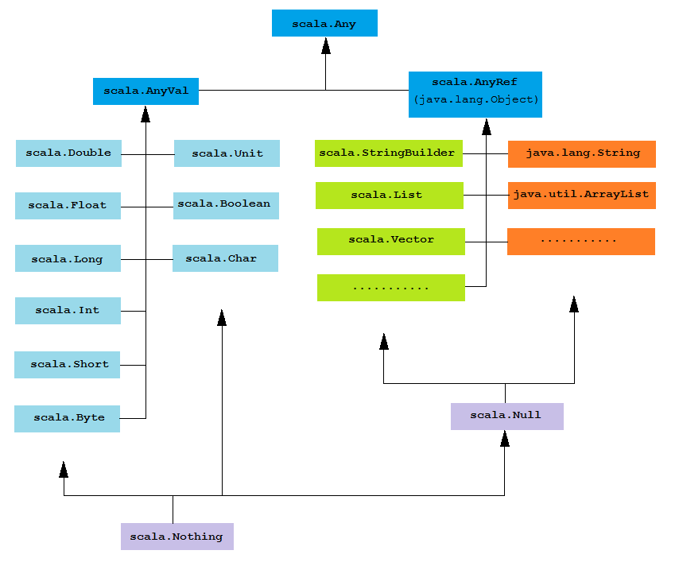
Lists
val list1 = "Willkommen" :: "zu" :: "Scala" :: Nil
val list2 = List("Willkommen", "zu", "Scala")
list1.head; list1.tail; list(2);
val triple = ("key", "value", "?")
val pair = "key" -> "value"

Funktionen & Methoden
- Alles Pass-By-Value!
- Implizites Return
- Funktionen = Values = Objektinstantzen
- Funktionen sind Objekte - leiten von FunctionN ab.
def b(x : Int = 144){print(x)}

// Lambdas
val istVolljährig: Function1[Person, Boolean] = (p: Person) => p.age >= 18
people.filter((p: Person) => p.age >= 18)
people.filter(p => p.age >= 18)

// Pass function as parameter
def unless(condition: Boolean, then: () => Any) = {
if (!condition) { then()}
}
unless(1 + 2 == 3, () => throw new RuntimeException("…"))

// Methoden mit mehreren Parameterlisten
def add(m: Int)(n: Int) = m + n
val addToTen = add(10) _
addToTen(5)

Generics
- Werden auch zur Laufzeit vergessen (case class Node[T <: Comparable[T]] (...))
- Enschränkungen (Type-Bounds) mit <: (extends in Java) und >: (super)
- Ivariant: Nur der angegebene Typ ist erlaubt (Keine Sub-/Super-Klassen)
- Covariant: Es sind auch Subtypen erlaubt (Gleiche Richtung wie Spezialisierung)
- Contravariant: Es sind auch Supertypen erlaubt (Selbe Richtung wie UML-Vererbungspfeil)
- Rückgabetypen sind Covariant
- Parameter sind Contravariant
- -> Parameter/Rückgabetypen können in Subklassen nicht spezialisert bzw. generalisiert werden.
- Gererics sind by default in Scala invariant. Mit einem + können diese Covariant und mit - Contravariant gemacht werden.

Pattern Matching & Case Klassen
- Case Klassen haben automagisch toString, equals, hashCode und copy anhand der Parameter
- haben Companion-Object
// With Types & Conditions
def patternMatching(any: Any) = {
any match {
case i: Int => "Int: " + i
case f: Float if f > 10.0 => "Float: " + f
case "s" => "String: s"
case (s: String, _) => "String: " + s
case head :: tail => "Non-empty list"
case any => any.toString
}
}

// with case classes
case class Person(name: String, alter: Int)
// Compiler generiert:
//object Person {
// def apply(name: String, age: Int) = new Person(name, age)
//}
def matchAPerson(person: Person) = {
person match {
case Person("Mirko", 32) => "Found Mirko!"
case Person(name, age) if age < 18 => s"Minor: $name"
case Person(name, _) => s"Adult: $name"
}
}

// Regex
val Chf = new Regex("""([0-9]+)\.([0-9][05])""") // Mit """ kein doppeltes escaping
"1.50" match {
case Chf(franken, rappen) => // Regex Gruppen extrahieren
println(s"$franken Franken und $rappen Rappen")
case _ =>
println("Ungültiger Betrag")
}

Klassen, Objekte, Traits
- Überschreiben benötigt explizites override-Keyword – abstract keyword optional.
- Primärkonstruktor wird immer aufgerufen.
- Alle Member können auch abstract sein.
- static gibts nicht.
- Objekte = Singletons
class Person(no_member:String, val name: String, var age : Int) {
// Weiterer Konstruktor
def this(name: String) = this(name, 0)
val readOnlyAttr = 0;
private val privateVal : String = ...
protected val protectedVal2 : String = ...
type MyMap = Map[Int, String] // Andere Notation für Generics!
def methode() = ..
}
object Main { def main(args: Array[String]) = {}}
trait Equal[T] {
def isEqual(t: T): Boolean
def isNotEqual(t: T) = !isEqual(t)
}
case class User(name: String) extends Named with Equal[User]{ ... }

