3.1 Analysis

*Problem Identification

Currently there is no application or website that allows you to develop a unique football team for: Friendly Matches; Sunday League Matches and School Football Teams. The only application or website based Football Management Systems are based around real players that play weekly games on a schedule. However, football is not just a sport played by those we watch on the TV, there is also a drive to win by us whole play the Sunday league matches; the school football team matches and the matches with friends. As this Football Management System would be used by the informal coaches and managers to pick the best fitted teams and not by the coaches and managers that get paid thousands of pounds a week to make the best possible team to win week in and week out. This Football Management System is used to bridge the gap between the informal and formal coaches and managers, hence why the hardware to use this application or website would be basic hardware found on the average PC and no extra hardware is needed as this Football Management System is a software based program to improve the efficiency and accuracy of the informal football matches to increase the competitiveness.

Stakeholders

The clients that would want access to my application/website would be people who are interested in creating the most efficient and achievable teams out of a set of players. Specifically, I will focus on Football Coaches/Manager for Local Sunday League teams; Football Coaches/Managers of School Football Teams. The end user for the Football Manager System would be my Sunday League Football Manager (Dean).Problems that may be occurring for these Football Managers before engaging with the website/application Football Management System, could be that the Football Manager cannot create the most achievable team of 11 Players and 7 Subs, hence why they would be losing matches so the Football Management System would assist by creating the most achievable line up of 11 players and 7 subs to win games which is the desire for the Coaches/Managers. So, the solution of this Football Management System would be quick, efficient and easy to use for Coaches/Managers as it would be accessible via phone due to it being application based and website based.

Moreover, the Football Manager System could be used my Football Players themselves to see their relevant statistics of the year or all-time playing, this could allow the players to maximise their actual and potential career by scoring more goals; assisting more goals; defending more attacks; and saving more shots. Problems that may occur to the Football Player prior to the creation of this Football Management System (which they can check their statistics on), could be that the players can’t check their current season statistics so this could mean that if they’re working on a below par level that they wouldn’t be aware so they carrying on playing below par; which is undesirable for the player, managers and coaches. So, the solution of this Football Management System would be quick, efficient and easy to use for Players as they could check stats before training or before matches so they would know what to work on.

Why it is suited to a computational solution?

This problem can be implemented through computational methods due to the importance of computers in the world and how computers can now be accessed quickly on your phone, so I am going to implement my Football Manager System into an application to allow it to be accessed through mobile phone devices.This solution will be mainly software based in many different ways such as grafted statistics and gameplay simulations.

Moreover, the software would process the data and statistics to graph the statistics to make it easier for the user to compare players and teams as depending on the users wants.

Problem Decomposition

The problem: ”Currently there is no application or website that allows you to develop a unique football team for: Friendly Matches; Sunday League Matches and School Football Teams.” This problem can be further split into numerous more easily understandable steps:

1. Allow the user to input players into their unique team and input statistics of these players
2. Graphing the statistics
3. Creating the best statistical team
4. Extension: Simulate game play between teams

These are the steps to the Football Manager System and these steps would allow for users to create the best statistical team.

Thinking abstractly

Since the Football Manager System is made up of 4 complex steps I would have to implement the thinking abstractly chapter of the OCR Computer Science Textbook (Chapter 47), this can be defined as removing the unnecessary details of the problem to ‘simplify’ the complex nature of the Football Manager System.

Thinking ahead

In Chapter 48, the textbook discusses how a software developer should identify the inputs and outputs for a program in the case of my football management system the inputs I have thought of include Football Players and their assigned statistics in a given season; the accompanied output for my solutions would be the advised training and the match simulations.

Thinking Procedurally

In Chapter 49, the textbook discusses thinking procedurally there is a similarity in this chapter to Chapter 47 which includes thinking abstractly which separates the physical reality of a program from the logical view, but in this case procedural abstraction means using a procedure to carry out a sequence of steps achieving some task for example in my Football Management System we will implement this went following a set of steps to go through the numerous display screens.

Thinking Logically

In Chapter 50, the textbook discusses thinking logically which is having a structure programming approach which may consist of if, elif, else statements to show selection within the software structures like this aim to improve the clarity and maintainability of programs I will use this when selecting through whether the user has selected Player or Manager which are two options within the program.

*Interview

Interview Questions

This interview will be directed at the Stakeholders I have mentioned previously e.g: Football Coaches and Football Players. The question I will ask are to see if a Football Manager System for ametuer Football Coaches and Players would be beneficial and if they would like to use it.Hence, the questions will vary depending on who is being questioned.

Football Manager

Questions for Dean and Les (Ametuer Football Managers):

1. Does your current managerial system fulfil all yours need?
2. Would a Team-Creator based on statistics catered to that position take away the need for managers/coaches?
3. Would a simulation of future matches be beneficial and why?
4. Do you have anything else to add?

Question 1 - The current managerial systems in use is put to question this is to show the user that a better type of managerial system if any could be used to help the Manager or Coach.

Question 2 - Provokes thought on how the progressions of technology takes away the human aspect of football.

Question 3 - Provokes the interviewee (Football Manager/Coach) to try and think about what my Football Managerial System has to other and how it could help them adapt their play and team creating.

Question 4 - Ask for anything else to be added.

Football Player

Questions for Daniel (Amatuer Football Player):

1. Is the current way you check statistics good?
2. Do you think graphed statistics would be a good aspect?
3. Would advised training on your weak points from the graph be beneficial?
4. Would advised training take away the need for coaches?
5. Do you have anything to add?

Question 1 - Questioning and provoking thought on statistical checks.

Question 2 - Provokes thought on the Football Management Systems that i am offering and developing.

Question 3 - Shows the benefits of my Football Management System and how it could assist the player.

Question 4 - Provokes thought on how the progressions of technology takes away the human aspect of football.

Question 5 - Ask for anything else to be added.

Interview

Football Manager

Dean

1. **Does your current managerial system fulfil all yours need?**

“Yes, My current managerial system fulfils all of my needs. It assists me by picking and creating a team based on statistics which makes my job as a Football Manager for my local amateur football team much more easier and straight forward.”

1. **Would a Team-Creator based on statistics catered to that position take away the need for managers/coaches?**

“Well no. Since my time of using my own managerial system started to implement a team-creator based on statistics it only made my job as a manager way more easier and didn’t make me unnecessary.”

1. **Would a simulation of future matches be beneficial and why?**

“That is not part of my current managerial system but I can see how a simulation of future matches with the best statistical team could be beneficial as it would allow for us managers to see how the team would perform. However, the only thing is that it would be difficult to implement the opposistions team let alone their playing style as they wouldn’t willing share that with the opposition.”

1. **Do you have anything else to add?**

“No I have nothing to add.”

Les

1. **Does your current managerial system fulfil all yours need?**

“No, we currently use an old managerial system that consists of paper and pen methods and due to this I think this is why our team is not getting the number of wins that we would like compared to other teams in our amateur league so we are not as competitive as other teams ”

1. **Would a Team-Creator based on statistics catered to that position take away the need for managers/coaches?**

“I am a manager who likes the old-school method of the manager job where you pick a team based on your instincts and the best in-form player. A generation of football that takes away that aspect of managers picking and choosing their teams is just football base on computers and doesn’t show the actual enjoyment of football managing. ”

1. **Would a simulation of future matches be beneficial and why?**

“Again, it would be a brilliant idea but this just takes away the aspect of football that we enjoy the most the unpredictableness of the game.”

1. **Do you have anything else to add?**

“Yes, please don’t spoil the art of football by trying to modernise it. ”

Analysis:

The football managers that we have interviewed had two different views one computerised software based football manager systems that allow for game simulations, Dean (one of the managers) supported the development of the game simulations as he saw the way it could develop football as a sport. However, Les also doesn’t have access to game simulations but doesn’t want it as he believes that it takes away the natural aspect of the game. However, I believe that as the world is moving into a more computerized based environment we should be open to these developments of software and hardware.

Moreover, we can see how Les could benefit from my Football Manager System that I am offering because he is clearing losing matches and this software based project could assist him to win games instead of losing them. However, this may not be down to his Pen & paper method of managing but it can still be an aspect that could be adapter to win games.

Football Player

Daniel

1. **Is the current way you check statistics good?**

“Yeah, it’s just a simple way. But it doesn’t matter as I don’t focus on my statistics I just like to play football and win matches ”

1. **Do you think graphed statistics would be a good aspect?**

“As I said before I am not too fussed on such things but it does sound nice and futuristic so it good to see football getting more modern not just on the pitch with VAR (Video Assisted Referee) and Goal-line technology but also with things like this graphed statistics.”

1. **Would advised training on your weak points from the graph be beneficial?**

“I like to win matches like any football player would so advised training determined by graphed statistics would improve my game and also allow me to win more games so yeah i guess i would find that beneficial.”

1. **Would advised training take away the need for coaches?**

“Well no, because the software would only tell you what to do and it wouldn’t see if you’re doing it wrong and if the training needs an interaction then the coach would provide that as the software cannot. Advised training just makes the coaches job more easier than it originally was.”

1. **Do you have anything to add?**

“No that would be all.”

Analysis:

The interview with Daniel showed me that some players don’t focus on statistics at all and just enjoy playing football and winning but it also showed me that as they like to win my football manager system that can give them advised training could beneficial to them as it would allow them focus on key parts of their game so they can win more so my software would even be beneficial for those players.

*Research

Existing similar solutions

FIFA Ultimate Team (FUT)

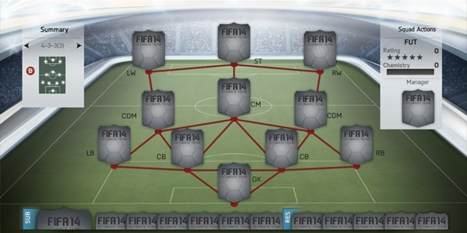

Overview:

FIFA Ultimate Team is virtual football management system that allows a user/player to manage a team of 23 players (including reserves) and play against your friends online or computerised competition. FUT is compatible on Game Consoles, PC and Mobile Phones. This solution is helpful for a professional football manager as it allows them to draft teams and compare stats between players in numerous sections for the player’s position. However, this solution doesn’t solve the problem at hand which is a Football Management System for amateur football managers because the only players that are on the database for FUT are professional players and non-professional players that would be in the amateur manager’s teams cannot be integrated into the FUT database as it only consists of professional players.

Parts that I can apply to my solution:

Even though, FIFA Ultimate Team(FUT) doesn’t solve the problem that I am trying to solve but there are still aspects of that solutions that I could apply to my solutions for example, the user friendly layout of the ‘Player Cards’ showing their statistics and ratings would be a good way to compare between players as a shows a quick & easy way to compare which it was I’m aiming for in my Football Management System.

Football Manager

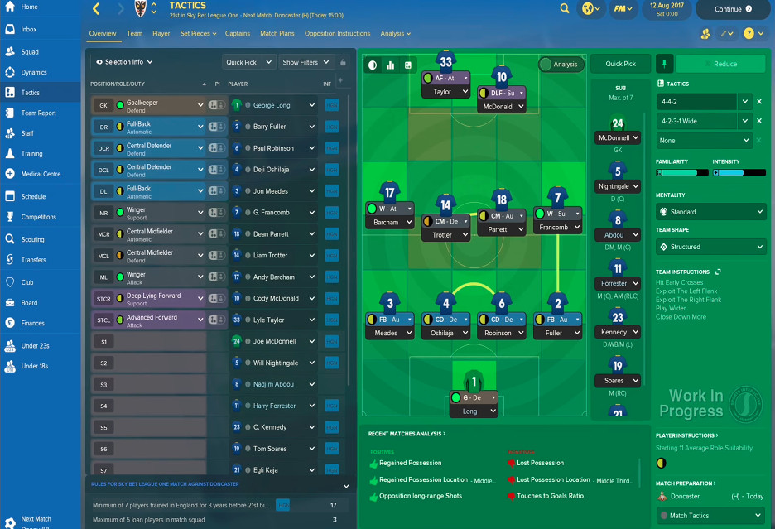

Overview:

‘Football Manager’ is a more complicated version of a football management system than allows you to create your own team but instead of being able to move the players around on the screen using hardware (Game Controller) like FIFA Ultimate Team. ‘Football Manager’ is a simulated game where you make your own teams to play against a computerised competition and has less online access than FIFA Ultimate Team, the simulated version of play means that computers use players statistics instead of someone skill at playing the actual game so it is more balanced than a FIFA Ultimate Team version as it uses simulation. Moreover, ‘Football Manager’ is more in depth than FIFA Ultimate Team as it deals with more aspects of football rather than just buying and selling players; in football manager players can request a transfer from the team. However, this solution doesn’t solve the problem at hand which is a Football Management System for amateur Football Managers/Coaches even though ‘Football Manager’ doesn’t solve the problem at the centre of this project it still does what is does better than FIFA Ultimate Team as it allows for a more in-depth approach to an Management System for professional players/managers.

Parts I can apply to my solution:

Even though this similar solution doesn’t solve my problem I could still apply certain aspects from ‘Football Manager’ to my own Football Management System for example the complicated that ‘Football Manager’ allows for the games to be simulated instead of played by the user, I could apply that to my solution so that it could show unbiased play of a football selected by the user.

Premier League Statistics

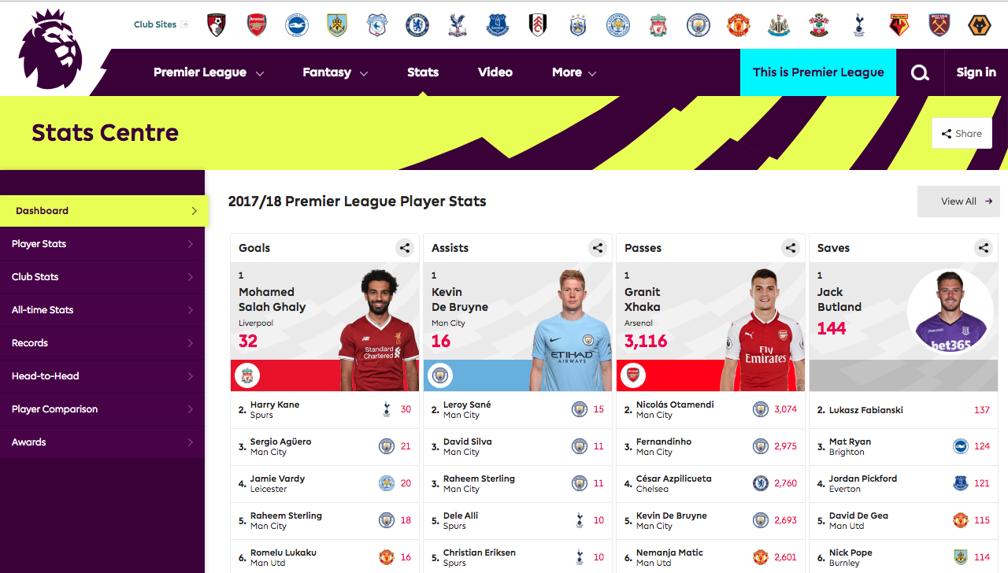

Overview:

Premier League Statistics is a real-time statistics counter that changes after every game a team has played. This allows for players, supporters, managers and coaches to check the statistics of their favourable player or team; this is good for a team or a player as they can see where they need to improve and what they have been doing good on throughout the season/campaign. However, this solution doesn’t solve the problem at hand which is a Football Management System for amateur Football Managers/Coaches as it doesn’t allow for automatic comparisons of players moreover it doesn’t let the user pick a team after viewing the statistics and the Premier League Statistics is only good for analyzing statistics.

Parts that I can apply to my solution:

Even though this similar solution doesn’t solve my problem I could still apply certain aspects from ‘Premier League Statistics’ to my own Football Management System for example the thoroughness of the statistics and how it varies for different player positions is a good aspects as it allows for a focus point for different players and positions.

Features of the proposed solutions

After the interviews and conversations with the stakeholders (e.g. Football Coaches/ Management) from multiple teams and leagues of varying levels of professionalism, I now have a set of key features that I would like to implement that fall into what the favoured and a set of my own features, following these features and also the features that are defaulty required by a Football Management System.

* **Graphed Statistics/Ratings based on statistics**

This feature would allow for players, managers and coaches to allow be able to check a visualization of a certain players statistics, a certain position on the field(e.g. Defense, Midfield and Attack) and also to visualize see the statistics as the team as a whole.

* **Team-Creator**

This feature would allow, for the manager or coach to get a computer automated team based on a number of filters and options to match the users wants out of the team this being defensive play or attacking play as the default and basic options that can be picked.

* **Advised training**

This feature would allow, for player to check based on their statistics the computer will check their ‘Weak Points’ and establish what aspects of their game that they need to train and give them advised training drills based on this option. Moreover, another aspect of this would be advised training on the team as a whole based on the teams weak points and to allow for the teams end targets of the season to be reached.

* **Comparisons**

This feature would be based on the statistics and would allow the players to get comparison between other players so this could increase competitiveness hence improving their game. Moreover, the coaches could use these statistics based comparisons to choose between a number of players that play the same or similar positions.

* **Simulation of game play**

This feature would be an extension as it is very difficult and challenging in the time allocated, but if it was to be done it would enable access to simulations of future games of teams and these simulations would also be based on a ‘Win/Lose Formula’ which is composed on a number of aspects (e.g. Attacking Play; Defensive Play; Win/Loss of previous games; Goals For/Goals Against; Injuries) all of these aspects would have different proportion of whether the team lose or win.

Limitations

The limitations which I could encounter when creating the solution would be the reliability of the game simulation as this depends on the weighting I put on each aspect of my ‘Win/Loss Formula’ as many aspects can change in a game and the football match can get some different and random aspects of it.

*Requirements

Software & Hardware requirements

Hardware

* **Monitor**

The monitor is a output device that is a basic requirement that needs to be met to access the visualization of the ‘Football Management System’. Without the monitor the user/ stakeholder will not be able to access the graphed statistics, game play simulation and to see the team that has been created for the user / stakeholder.

* **Keyboard/Mouse**

The Keyboard/Mouse are input devices that are also basic requirements that need to be met by the creator (me) to enable that the user / stakeholder can actually access the ‘Football Management System’. The Keyboard / Mouse would be used to access the different option that would be displayed in my Graphical User Interface.

* **Good processor**

A Processor is ‘ a logical circuit that responds to and processes the basic instructions that drive a computer.’ The user / stakeholder would need a good processor so that the software can run smoothly as there would be many background procedures going on and the game play simulation may be very tasking on a low level processor hence the need for a good processor.

Software

* **Python Interpreter**

The codes will be written in Python, so an interpreter would be needed to allow for the program to actually be run by the user/stakeholder

* **Operating System**

This program needs to be ran on a compatible Operating System the recommended operating system would be Windows, macOS or Linux

Stakeholders Requirements

Design

|  |  |
| --- | --- |
| **Requirement** | **Explanation** |
| Quick and Easy | The design of the program needs to a smooth flow form page to page. for example the login process should take a maximum amount of time. |
| Secure and Safe Design | The stakeholders login in details need to be kept secure through hashing in SHA1 as it is Newer function and produces a longer and harder to decrypt hash. Moreover, the stakeholder should only be allowed up to 3 attempts to login after that they should be expelled from the Football Management System. |

Hardware and Software

|  |  |
| --- | --- |
| **Requirement** | **Explanation** |
| Easily Accessible by anyone | This can be used by anyone with a basic PC that is fully working: Processor:dual core 2.4 GHz+ ; RAM: 16gb; Hard Drive: 256gb+; Graphics Card recommended for efficient graphing but not necessary |
| Easily Accessible anywhere | Application Based for IOS, macOS, Windows etc |

*Success Criteria

Overall:

|  |  |
| --- | --- |
| **Requirement** | **Explanation** |
| Simple main menu with 2 options on display | 1. The main menu should be the first thing the user / stakeholder encounters when accessing the 2. ‘Football Management System’ which displays 2 buttons:’ Manager’ or ‘Player’ 3. A simple main menu means that a decision can be made in the first 20 seconds of the user / stakeholder opening the software. |
| Only 1 option can be selected at a time | 1. This is logical as a user cannot be a Player and Manager at the same time so they should only be allowed to access one pathway. 2. This is to keep the integrity of the software as we don’t want duplicates in our database. |
| After an option is selected allow the user / stakeholder to login | 1. This requirement keeps the flow of the Football Management System so that the user / stakeholder who wants to access to a manager or player account can do so if they have the correct login details. 2. This allows for the data of our user / stakeholders to keep protected from hackers and/ or other teams in the league that are competition. |
| Check if the login details are correct | 1. To keep the security of our software we can use a complex hashing algorithm to make it difficult for any hackers to access the data of our users / stakeholders. |

Players:

|  |  |
| --- | --- |
| **Requirements** | **Explantation** |
| Display that certain player statistics | 1. The player should only be allowed to access their own statistics and not another players as one player doesn’t have the same credentials as a manager would. |
| Targets for the season  Match averages | 1. Targets for the seasons for the team as a whole can be viewed on this GUI. 2. Unique targets that is set for each player at the beginning of the season can be viewed here and the progress for these targets can be checked. 3. Average performance per match can be checked here so the player knows how they normally perform statistically. |
| Advised training | 1. Based on the players statistics they can be given advised training drills that would allow the player to improve on those weak parts of their statistics. As this whole Football Management System is based on statistics. |

Managers:

|  |  |
| --- | --- |
| **Requirements** | **Explanation** |
| Sub-Menu Display | 1. When the Manager access the Football Management System they can choose options between: 2. Current Line-Up -> Statistics + Graphed Stats 3. Team-Creator -> Simulation |
| Current Line-up/Roster | 1. When the manager chooses the option of ‘Current Line-Up’ they are displayed with a list of player that played in the most recent match. 2. The display consists of the players: Name,Position and picture. 3. This is also where the manager can add/edit players as the come and go. |
| Click the players picture or name to get statistics | 1. When a certain players picture or name is pressed the Graphical User Interface will move to another page displaying the statistics. 2. Only allows one player to be clicked at once to stop confusion of the data. |
| Statistics + Graphed Statistics | 1. After the player is selected their statistics are displayed in 2 formats: Basic Numerical and Graphed to show progress & decline more visualizally as it gets a message across. 2. This is also where the statistics can be edited by the Manager to keep an up to date Football Management System. |
| Team-Creator | 1. Allow for a certain amount of filters and options to be picked to allow for the team most desired by the manager. 2. If a manager has previously asked for a team similar or identical to the filters and options selected use cache memory to save and access these at will as it makes the program run much faster than redoing the team creating everytime certain filters/options are enabled. |
| **Requirements** | **Explantation** |
| Simulation of game play | 1. A Simulation of game play that displays the first and second half scores then displays the final scores at the end of the game. 2. Based on statistics previously inputted by the manager for players and the team as a whole. 3. Allows the manager to get an idea about how the game might pan out. So that they can train certain aspects of the game. |
| Win/Lose Formula | 1. Make sure the proportion/weighting of each of aspect is correct. 2. Make sure the Win/Loss Formula is accurate as we dont want 100% wins and 100% losses. 3. Aspect of randomality as a football game can go either way. |