BTS IS BACK
BTS IS BACK BTS IS BACK BTS IS BACK BTS IS BACK BTS IS BACK BTS IS BACK BTS IS BACK BTS IS BACK BTS IS BACK BTS IS BACK BTS IS BACK BTS IS BACK BTS IS BACK BTS IS BACK BTS IS BACK BTS IS BACK BTS IS BACK BTS IS BACK BTS IS BACK BTS IS BACK BTS IS BACK BTS IS BACK BTS IS BACK BTS IS BACK BTS IS BACK BTS IS BACK BTS IS BACK BTS IS BACK BTS IS BACK BTS IS BACK BTS IS BACK BTS IS BACK
BTS IS BACK BTS IS BACK BTS IS BACK BTS IS BACK BTS IS BACK BTS IS BACK BTS IS BACK BTS IS BACK BTS IS BACK BTS IS BACK
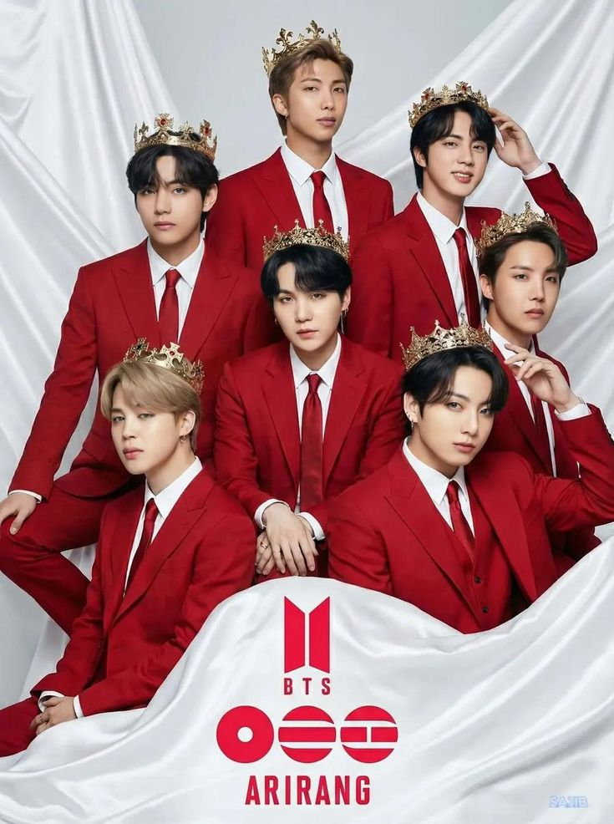
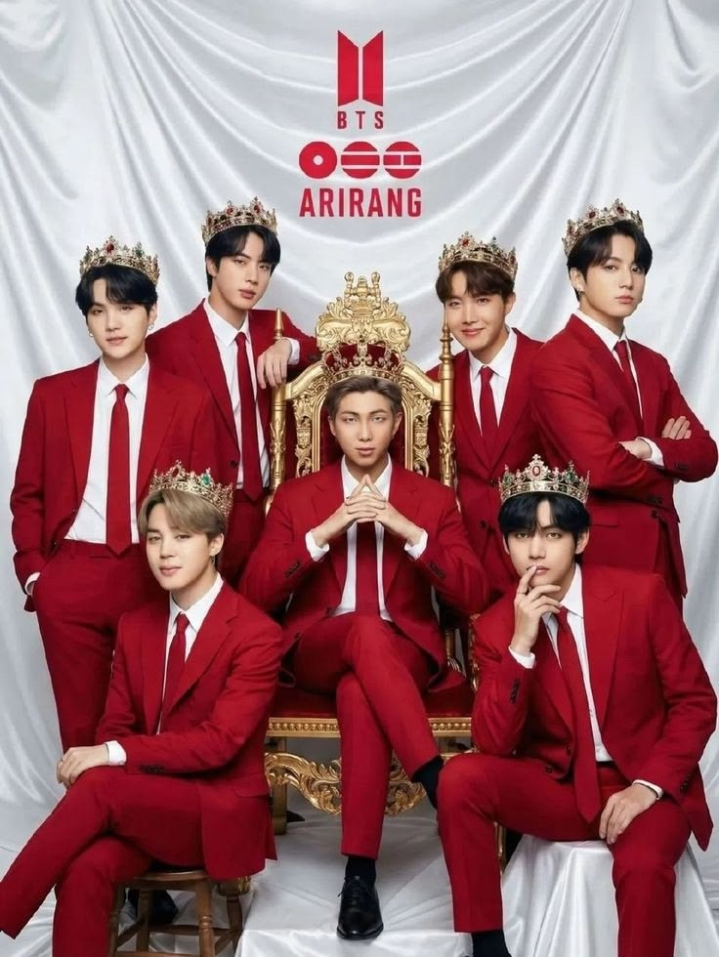

1 | Ким Намджун
2 | Ким Сокджин
3 | Мин Юнги
4 | Чён Хосок
5 | Пак Чимин
6 | Ким Техён
7 | Чён Чонгук

