### A REPORT ON FOOD SERVICE COMPANY

### 

**Name: Dolly Khatun**

**Batch:22**

**Roll: 01-022-18**

|  |  |  |
| --- | --- | --- |
| Serial no | topic | page |
| 01 | Executive summary | 03 |
| 02 | Products and services | 03 |
| 03 | Business plan | 05 |
| 04 | Sales and cost statistics | 06 |
| 05 | Formating | 08 |

### Executive Summary

My food service company prepares and delivers food to customers. They can operate in many different ways, such as:

* Supplying restaurants with ingredients [Food service company serving institutions]
* Running cafeterias in businesses or schools [Contract Food Service Companies]
* Offering vending services with snacks and drinks [Corporate Food Services]
* Providing catering for events [Corporate catering and event management]

### Products and Services

Food service companies can be broken down into two main categories: those that supply food and those that provide food service.

Suppliers to [foodservice](https://en.wikipedia.org/wiki/Foodservice) operators are [foodservice distributors,](https://en.wikipedia.org/wiki/Foodservice) who provide small wares (kitchen utensils) and foods. Some companies manufacture [products](https://en.wikipedia.org/wiki/Foodservice) in both consumer and food service versions. The consumer version usually comes in individual-sized packages with elaborate label design for retail sale. The [foodservice](https://en.wikipedia.org/wiki/Foodservice) version is packaged in a much larger industrial size and often lacks the colorful label designs of the consumer version.

**Food Service Distributors**

Food service [distributors](https://gemini.google.com/app/eae4ccf563a469bf) supply restaurants, hotels, schools, hospitals and other [businesses](https://gemini.google.com/app/eae4ccf563a469bf) with the food and supplies they need to prepare and serve meals. They offer a wide variety of products, including:

* [Fresh produce](https://gemini.google.com/app/eae4ccf563a469bf)
* Meat, poultry, and seafood
* Dairy products
* Dry goods, such as flour, sugar, and spices
* Beverages
* Disposable tableware, napkins, and cleaning supplies

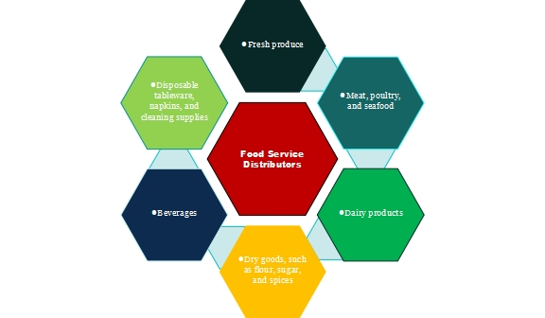

**Food service distributor products**

**Foodservice Management Companies**

Foodservice management [companies](https://gemini.google.com/app/eae4ccf563a469bf) contract with businesses and institutions to provide food service for their employees, patients, or guests. They handle everything from menu planning and food preparation to staffing and dining room operations.

Here are some of the services that foodservice management companies may provide:

* **Meal preparation:** These companies have large kitchens where they prepare meals for their clients. They may also cook meals on-site at a client's facility.
* **Menu planning:** Foodservice management companies can help clients create menus that meet their needs and budget. They can also accommodate dietary restrictions.
* **Staffing:** Foodservice management companies provide the staff needed to prepare and serve meals, including cooks, servers, and dishwashers.
* **Dining room operations:** Foodservice management companies can handle all aspects of dining room operations, including setting up and cleaning tables, taking orders, and serving food.

**Examples of food service companies**

There are many different [food service](https://gemini.google.com/app/eae4ccf563a469bf) companies, both large and small. Some of the largest food service companies in the world include:

* Aramark
* Compass Group
* Sodexo
* Sysco
* US Foods

### Business plan

Building a successful food service company requires a well-defined plan. Here's a roadmap to get you started:

**1. Concept and Target Market**

* **Concept:** Identify your niche. Will you be a casual eatery, a fine dining establishment, or a food truck? What kind of cuisine will you offer?
* **Target Market:** Research your local demographics and identify your ideal customer. Are you targeting busy professionals, families, or health-conscious individuals?

**2. Competitive Analysis**

* Research your competitors. What are their strengths and weaknesses? How can you differentiate your service?

**3. Menu and Pricing Strategy**

* Craft a menu that aligns with your concept and target market. Consider portion sizes, pricing strategy, and any dietary restrictions you want to cater to.

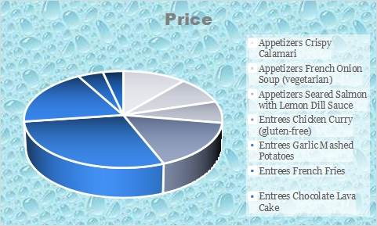

**4. Operations Plan**

* **Logistics:** Determine your service style (dine-in, takeout, delivery). Plan your kitchen layout, equipment needs, and inventory management.
* **Staffing:** Identify the staff you'll need, including chefs, servers, and kitchen assistants.

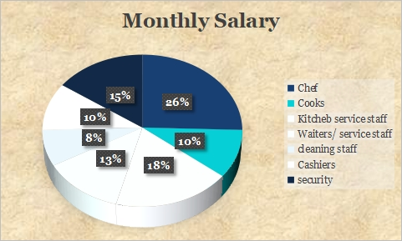

**5. Marketing and Branding**

* Develop a strong brand identity that reflects your concept.
* Create a marketing strategy to reach your target audience. This could include social media, local advertising, or partnerships with other businesses.

**6. Financial Projections**

* Create a financial forecast that includes startup costs, ongoing expenses, and projected revenue. This will help you secure funding if needed.

**7. Legal and Regulatory Compliance**

* Ensure you have all the necessary licenses and permits to operate a food service business.
* Stay up-to-date on health and safety regulations.

### Sales and cost statistics

The food service industry is a complex and dynamic sector, but here's a breakdown of some key sales and cost statistics you might find interesting:

**Sales**

* **Average Annual Revenue:** For all sole proprietorship restaurants in the US, the average annual revenue sits around $129,637 [ProjectionHub]. It's important to consider this includes part-time operations and smaller establishments that bring down the overall average.
* **Sales Growth:** Despite inflationary pressures, some major fast-food chains like McDonald's have shown continued sales growth [GlobalData].

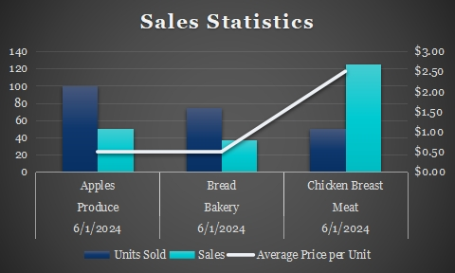

**Costs**

* **Cost of Goods Sold (COGS):** This metric reflects the cost of ingredients used in preparing food and beverages. It's a significant expense, often accounting for a large portion of a restaurant's total expenses. Ideally, COGS should be efficiently controlled to maximize profits. A typical COGS percentage for restaurants can vary, but it's a crucial metric to monitor [FoodNotify Hospitality Blog].
* **Labor Costs:** Another major expense for restaurants is labor costs, which include salaries, wages, and benefits for employees.

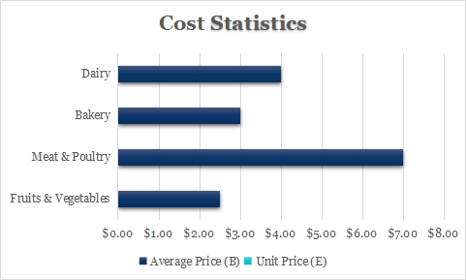

### Formatting

The formatting for a food service company can vary depending on the specific document you're creating. Here are some common formats used:

**Food Billing:**

* **Company Information:** Include the name, address, and contact information for both the food service provider and the client.
* **Date:** Include the date of the transaction.
* **Description of Services:** Provide a detailed breakdown of the food items or services provided, including the quantity and unit price.
* **Taxes & Fees:** List any applicable taxes or service charges.
* **Payment Details:** Clearly outline the total amount due, accepted payment methods, and any payment terms.

**Food Catering Order Form:**

* **Company Branding:** Include the company logo and contact information.
* **Order Details:** Provide sections for customer information, event details (date, time, location), and menu selections (including quantities).
* **Pricing & Terms:** List pricing information and any additional terms or conditions (e.g., cancellation policy, minimum order requirements).

A restaurant is a business that prepares and serves food and drinks to customers. Meals are generally served and eaten on the premises, but many restaurants also offer take-out and food delivery services. Restaurants vary greatly in appearance and offerings, including a wide variety of cuisines and service models ranging from inexpensive fast-food restaurants and cafeterias to mid-priced family restaurants, to high-priced luxury establishments. The word derives from the early 19th century, taken from the French word restaurer 'provide meat for', literally 'restore to a former state' and, being the present participle of the verb, the term restaurant may have been used in 1507 as a "restorative beverage", and in correspondence in 1521 to mean 'that which restores the strength, a fortifying food or remedy'.