Assignment-1

Question-1: Draw your Home Network Topology and explain how you are accessing the RPS lab environment?

Answer:

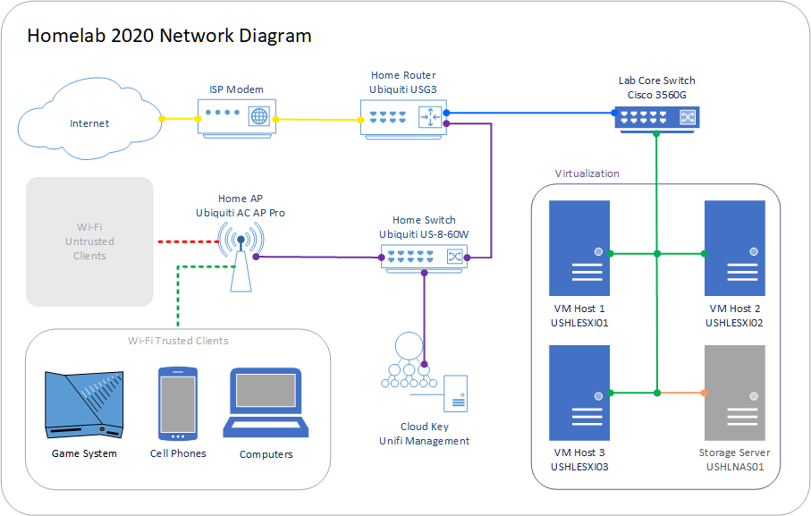

Assignment-2

Question-2 Identify a real-world application for both parallel computing and networked systems. Explain how these technologies are used and why they are important in that context?

Answer: Parallel Computing:

Real-world application: Weather Forecasting and Climate Modeling

Explanation: Weather forecasting and climate modeling require massive computational power to process vast amounts of data and simulate complex atmospheric phenomena. Parallel computing enables these tasks to be distribute

across multiple processors or computing nodes, allowing for faster and more efficient simulations. In this context, parallel computing techniques such as parallel algorithms, parallel processing frameworks (like MPI or OpenMP), and parallel architectures (such as clusters or supercomputers) are used to divide the workload and execute computations simultaneously.

Importance: Parallel computing is crucial for improving the accuracy and timeliness of weather forecasts, which have significant implications for various sectors including agriculture, transportation, energy, and disaster management. By leveraging parallel computing, meteorologists and climatologists can perform more detailed and comprehensive simulations, leading to better predictions of weather patterns, extreme events, and long-term climate trends.

Networked Systems:

Real-world application: Online Shopping and E-commerce Platforms

Explanation: Online shopping and e-commerce platforms rely on networked systems to connect buyers and sellers, process transactions, and deliver products or services over the internet. These systems consist of multiple interconnected components, including web servers, databases, payment gateways, content delivery networks (CDNs), and customer relationship management (CRM) systems. Networked systems enable seamless communication and data exchange between these components, allowing users to browse products, place orders, make payments, and track shipments from anywhere with internet access.

Importance: Networked systems play a central role in modern commerce by providing a convenient and accessible platform for buying and selling goods and services. They enable businesses to reach a global audience, automate various aspects of the sales process, and provide personalized experiences to customers. Additionally, networked systems facilitate data analytics and customer insights, which businesses can use to optimize their marketing strategies, inventory management, and product offerings, ultimately driving revenue growth and customer satisfaction.