Assignment-1

Question-1 SDLC Overview Create a one-page infographic that outlines the SDLC phases (Requirements, Design, Implementation, Testing,Deployment), highlighting the importance of each phase and how they interconnect.

Answer: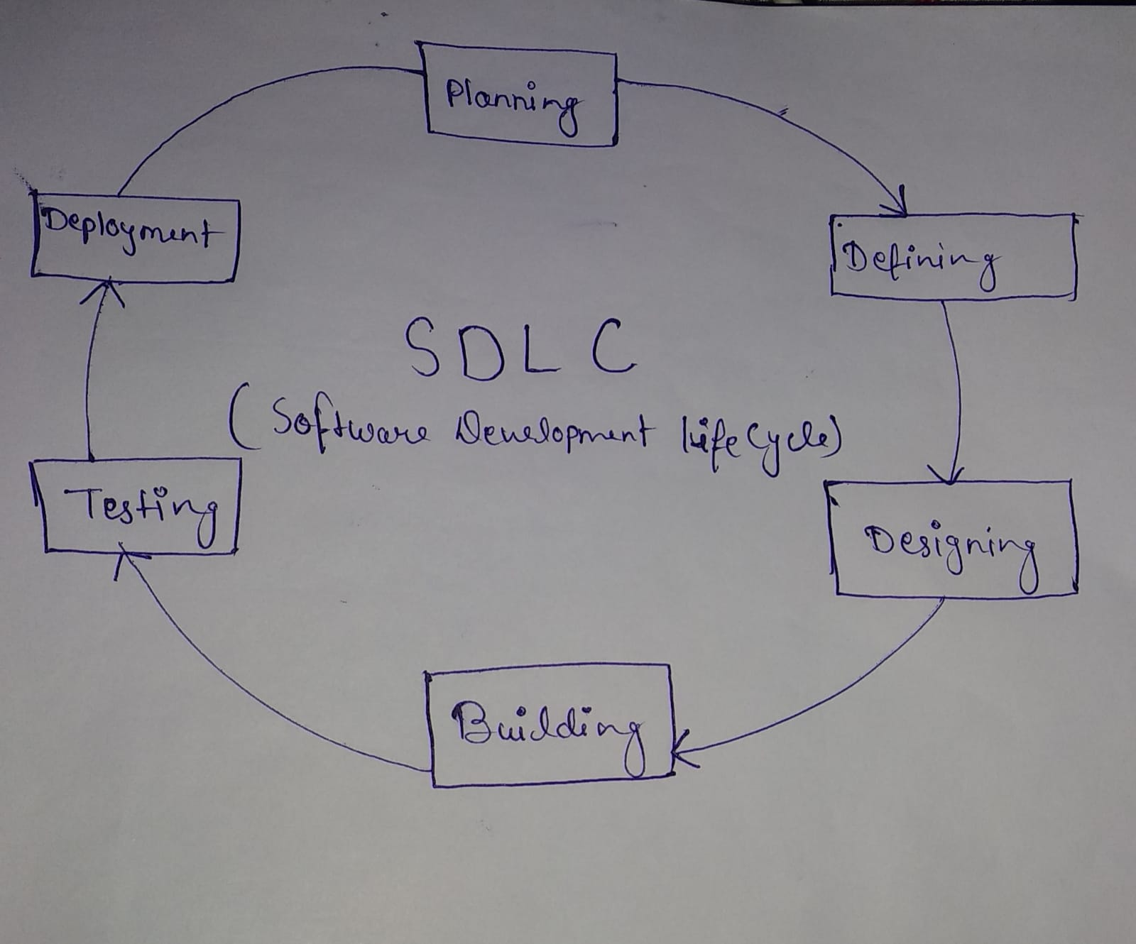

Planning-> The planning phase typically includes tasks like cost-benefit analysis, scheduling, resource estimation, and allocation. The development team collects requirements .

Designing->In the design phase, software engineers analyze requirements and identify the best solutions to create the software. For example, they may consider integrating pre-existing modules, make technology choices, and identify development tools. They will look at how to best integrate the new software into any existing IT infrastructure the organization may have.

Building->In this stage of SDLC the actual development starts and the product is built. The programming code is generated as per DDS during this stage.

Testing-> This stage is usually a subset of all the stages as in the modern SDLC models, the testing activities are mostly involved in all the stages of SDLC. However, this stage refers to the testing only stage of the product where product defects are reported, tracked, fixed and retested, until the product reaches the quality standards defined in the SRS.

Deploying->Once the product is tested and ready to be deployed it is released formally in the appropriate market. Sometimes product deployment happens in stages as per the business strategy of that organization.

Assignment-2

Question-2 Develop a case study analyzing the implementation of SDLC phase in a real-world engineering project.Evauate how Requirement Gathering, Design,Implementation,Testing,Deployment, and Maintanance contribute to project outcomes.?

Answer: Case Study-> E-Commerce Platform:

Requirement Gathering:

->Understand business needs, user requirements, and system functionalities.

-> Conduct meeting with stakeholders, analyze competitor platforms, and gather feedback from potential user.

->Identified key features such as user authentification, product catalog,shopping cart, payment gateway integration, and order management.

Design:

->Architect a scalable and user-friendly platform.

-> Utilize wireframing, mockups, and architectural diagrams to visualize system components and interactions. Choose appropriate technologies and frameworks.

-> Designed a modular system architecture leveraging microservices for scalability. Created intuitive UI/UX designs for seamless user navigation.

Implementation:

->Translate design into functional software components.

->Agile development methodology with sprints and daily stand-ups. Assign tasks to development team based on expertise.

-> Implementation backend. Developed frontend interfaces using HTMl/CSS/JavaScript frameworks.Integrated third-party APIs for payment processing and shipping.

Testing:

->Ensure quality, functionality, and performance meet requirements.

->Conduct unit testing, integration testing, regression testing , and performance testing at various stages of development.Utilize automated testing tools.

-> identified and fixed bugs related to security vulnerabilities, usability issues, and performance bottlenecks.Ensured compatibility across different devices and browser.

Deployment:

->Deploy the system to production environment seamlessly.

->Follow DevOps practices for continuous integration and deployment (CI/CD).Utilize containerization and orchestration for scalability and reliability.

->Successfully deployed the e-commerce platform to cloud infrastructure with zero downtime.

Maintenance:

->Ensure the system operates smoothly and evolves with changing requirements.

->Establish a maintenance schedule for regular updates, patches, and enhancements. Monitor user feedback and system performance metrics.

->Addressed user-reported issues promptly. Implemented new features such as personalized recommendations and customer support chatbot to enhance user experience. Conducted periodic security audits to mitigate emerging threats.

Assignment-3

Question-3 Reseach and compare SDLC model suitable for engineering projects. Present finding on waterfall,Agile, Spiral, and V-Model approaches, emphasizing their advantages, disadvantages, and applicability in different engineering context?

Answer: Waterfall Model:

Advantages:

* Sequential Approach: It follows a linear and sequential approach, making it easy to understand and manage.
* : Extensive documentation is produced at each stage, which can be beneficial for compliance and regulatory requirements.
* Clear Milestones: Well-defined milestones and deliverables make it easier to measure progress.

Disadvantages:

* Inflexibility: Lack of flexibility makes it difficult to accommodate changes late in the development process.
* High Risk: If requirements are not gathered correctly at the beginning, it can lead to costly changes later.
* Limited Customer Interaction: Minimal customer involvement until the end, which can result in misalignment with customer needs.
* Applicability: Best suited for projects where requirements are well-understood and unlikely to change significantly.

Agile Model:

Advantages:

* Flexibility: Emphasizes adaptability to changing requirements through iterative development cycles.
* Customer Collaboration: Continuous customer involvement ensures alignment with customer needs.
* Early Delivery of Value: Incremental releases allow for early delivery of usable product features.

Disadvantages:

* Complexity in Large Projects: Agile may become challenging to manage in large, complex projects.
* Dependency on Team Collaboration: Requires strong collaboration and communication within the development team.
* Documentation Challenges : Agile tends to prioritize working software over comprehensive documentation, which can be problematic for certain regulatory environments.
* Applicability: Suitable for projects with evolving requirements, where rapid delivery of usable features is critical.

Spiral Model:

Advantages:

* Risk Management: Incorporates risk management at every stage, allowing for early identification and mitigation of risks.
* Flexibility: Iterative nature allows for incorporating changes as the project progresses.
* Customer Feedback: Regular prototypes allow for continuous customer feedback and validation.

Disadvantages:

* Complexity: More complex than other models, requiring experienced project management.
* Costly: Can be more costly and time-consuming due to the iterative nature and risk analysis.
* Documentation Challenges: Similar to Agile, documentation can be less emphasized, which might be problematic for certain projects.
* Applicability: Well-suited for large-scale projects with high levels of uncertainty and evolving requirements.

V-Model:

Advantages:

* Early Test Planning: Testing activities are planned early in the development cycle, ensuring thorough testing of each stage.
* Traceability: Provides clear traceability between requirements and corresponding test cases.
* Emphasis on Verification and Validation: Ensures that requirements are correctly implemented and that the final product meets customer expectations.

Disadvantages:

* Rigidity: Similar to Waterfall, it can be rigid and less adaptable to changes late in the development process.
* Limited Customer Interaction: Customer involvement tends to be less frequent compared to Agile.
* Complexity in Managing Changes: Changes to requirements can be challenging to accommodate once the development process has progressed.
* Applicability: Suitable for projects with well-defined requirements and where thorough testing and verification are critical.

Assignment-4

Question-4 Create an infographic illustrating the Test-Driven Development (TDD) process. Highlight steps like writing tests befor code,benefits such as bug reduction, and how it fosters software reliability.?

Answer

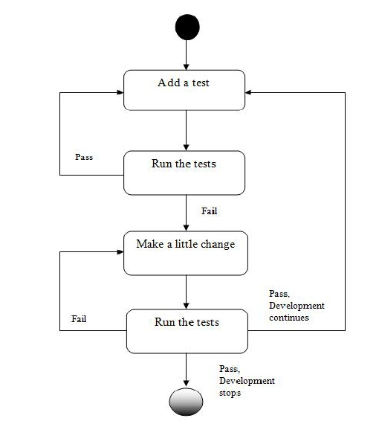

Write Test Cases (Red Phase):

* Developers start by writing automated test cases that define the desired behavior of a specific feature or functionality.
* These tests are typically written to fail initially, as they are written based on the expected behavior that has not yet been implemented.

Write the Minimum Code to Pass the Test (Green Phase):

* Developers then write the minimum amount of code necessary to make the failing test cases pass.
* The focus is on writing code that satisfies the requirements of the test cases without introducing unnecessary complexity.

Refactor Code (Refactor Phase):

* Once the tests are passing, developers refactor the code to improve its design, readability, and performance while keeping the behavior unchanged.
* Refactoring ensures that the code remains clean, maintainable, and extensible over time.

Repeat the Cycle:

* Developers continue to iterate through the Red-Green-Refactor cycle for each new feature or piece of functionality.
* This iterative process helps ensure that the codebase remains stable and reliable as new features are added or existing ones are modified.

Benefits:-

Bug Reduction:

* By writing tests before writing code, TDD helps identify and address bugs early in the development process.
* Writing comprehensive test cases ensures that edge cases and potential failure scenarios are considered upfront, reducing the likelihood of bugs slipping into the codebase.
* Since developers focus on writing code to pass the tests, they are less likely to introduce unnecessary or untested code that could lead to bugs later on.

Improved Software Reliability:

* TDD encourages developers to write small, focused units of code that are easier to test and verify for correctness.
* The automated test suite serves as a safety net, allowing developers to refactor and make changes to the codebase with confidence, knowing that they can quickly detect regressions or unintended side effects.
* Since tests are continuously run throughout the development process, any regressions or defects introduced by new code changes are caught early, preventing them from impacting the overall reliability of the software.

Assignment-5

Question-5 Produce a comparative infographic of TDD, BDD, and FDD methodologies.IIIustrate their unique approaches,benefits, and suitability for different software development contexts. Use visuals to enhance understanding?

Answer: TDD(Test-Driven-Development)



Unique Approaches of TDD:

* Red-Green-Refactor Cycle:-
* Red Phase: Write a failing test.
* Green Phase: Write the minimum code to make the test pass.
* Refactor Phase: Refactor code while keeping the tests passing.

Benefits of TDD:

Bug Reduction:

* Early detection of bugs through comprehensive test coverage.
* Reduced likelihood of introducing new bugs due to small, focused code changes.

Improved Software Reliability:

* Increased confidence in code changes through continuous testing.
* Greater resistance to regressions and unintended side effects.

Suitability for Different Software Development Contexts:

Small to Medium Projects:

* Well-suited for projects with manageable scope and clear requirements.
* Helps maintain code quality and stability as the codebase grows.

Large and Complex Projects:

* Provides a structured approach to manage complexity and mitigate risks.
* Enables incremental development and early validation of key functionalities.

Agile and Iterative Development:

* Aligns with Agile principles by promoting iterative development and continuous feedback.
* Facilitates frequent releases and rapid response to changing requirements.

BDD(Behavior-Driven- Development)

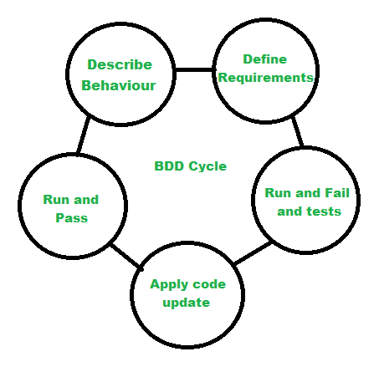

Unique Approaches of BDD:

Given-When-Then Structure:

* Given: Describes the initial context or preconditions.
* When: Describes the action or event that triggers the behavior.
* Then: Describes the expected outcome or behavior.

Benefits of BDD:

Enhanced Collaboration:

* Promotes collaboration between developers, testers, and business stakeholders.
* Encourages shared understanding of requirements and acceptance criteria.

Focus on Business Value:

* Aligns development efforts with business goals and user needs.
* Prioritizes features and functionalities based on their value to stakeholders.

Suitability for Different Software Development Contexts:

Agile Development:

* Fits well within Agile methodologies by promoting collaboration and delivering value incrementally.
* Facilitates the creation of executable specifications that drive development iterations.

User-Centric Design:

* Puts a strong emphasis on understanding and meeting user needs and expectations.
* Ensures that development efforts are focused on delivering features that provide value to users.

Complex Systems:

* Helps manage complexity by breaking down requirements into manageable scenarios.
* Facilitates clear communication and validation of system behavior in complex environments.

FDD(Feature-Driven-Development)

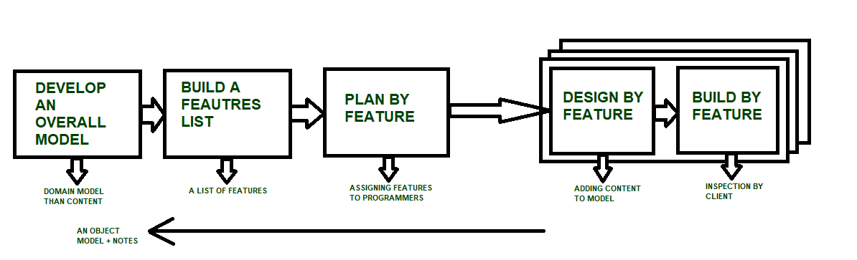

Unique Approaches of FDD:

Feature List:

->Features are identified and prioritized based on business value.

->Each feature is broken down into smaller, manageable tasks for development.

Development by Feature:

->Development progresses through a series of feature sets.

->Each feature set comprises a group of related features that can be implemented together.

Benefits of FDD:

Incremental Delivery:

->Enables early and frequent delivery of working software increments.

->Provides stakeholders with tangible results and feedback throughout the development process.

Clear Accountability:

->Assigns clear responsibilities to developers based on their expertise and the features they are working on.

->Promotes accountability and ownership of feature development and delivery.

Suitability for Different Software Development Contexts:

Large-Scale Projects:

* Well-suited for large-scale projects with multiple teams and complex requirements.
* Enables effective coordination and management of feature development across teams.

Maintenance and Enhancement Projects:

* Facilitates the prioritization and implementation of new features, enhancements, and bug fixes based on business priorities.
* Helps maintain and evolve existing systems while minimizing disruption to ongoing operations.

Client-Focused Projects:

* Aligns development efforts with client needs and priorities.
* Allows for iterative refinement and validation of features based on client feedback and requirements.