Assignment-1

Question-1 Explain kanban and Lean principle?

Answer: Kanban principles:-

Visualization: Kanban emphasizes visualizing the workflow. This is often done using a Kanban board, which typically consists of columns representing different stages of the workflow and cards representing tasks or work items. By having a visual representation of the work, teams can easily see what needs to be done, what is currently being worked on, and what has been completed.

Limiting Work in Progress (WIP): One of the key principles of Kanban is to limit the amount of work that is in progress at any given time. This helps prevent bottlenecks and overburdening of resources. By setting WIP limits for each stage of the workflow, teams can focus on completing tasks rather than starting new ones, which ultimately leads to faster delivery and better flow.

Managing Flow: Kanban focuses on optimizing the flow of work through the system. This involves identifying and removing impediments that may be slowing down the process, as well as continuously improving the workflow to make it more efficient. By paying attention to how work moves through the system and making adjustments as needed, teams can achieve a smoother and more predictable flow of work.

Continuous Improvement: Kanban promotes a culture of continuous improvement. Teams are encouraged to regularly review their processes and look for opportunities to make them better. This can involve things like refining WIP limits, streamlining workflows, or implementing new practices to improve efficiency and quality.

Lean principle:-

Value: Focus on understanding and delivering what the customer truly values. Value is anything for which a customer is willing to pay. By identifying and prioritizing value from the customer's perspective, organizations can align their efforts with customer needs.

Value Stream: Map out the entire value stream, which is the series of steps and activities required to deliver a product or service to the customer. This includes both value-adding and non-value-adding activities. By visualizing the value stream, organizations can identify inefficiencies and opportunities for improvement.

Flow: Strive to create a smooth and continuous flow of work through the value stream. This involves eliminating bottlenecks, reducing cycle times, and minimizing delays. By improving flow, organizations can increase productivity and responsiveness to customer needs.

Pull: Implement pull-based systems where work is pulled through the value stream based on customer demand, rather than pushed based on forecasts or schedules. This helps prevent overproduction and reduces excess inventory, leading to shorter lead times and improved flexibility.

Perfection: Continuously pursue perfection by relentlessly eliminating waste and improving processes. Lean thinking is not a one-time initiative but a journey of continuous improvement. Organizations should strive for perfection by constantly seeking better ways to deliver value to customers.

Respect for People: Recognize and empower the people involved in the value stream. This includes both employees and customers. Lean organizations value their employees' expertise, encourage collaboration, and foster a culture of trust and respect. Additionally, they actively engage with customers to understand their needs and preferences

Question-2 In kanban dashboard,create TODO ,DOING and DONE tasks.  
      list 10 tasks each.?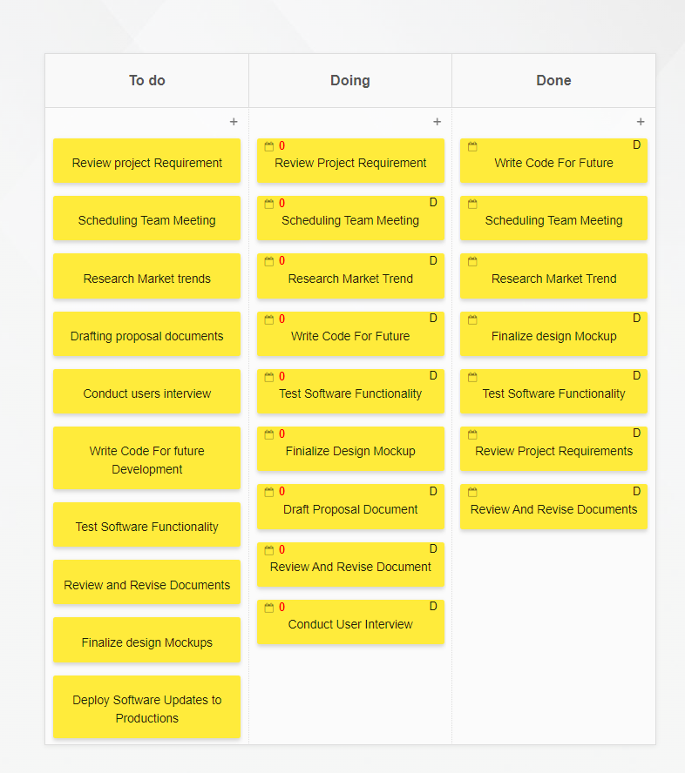

Question-3 Implement waste management by following Lean Culture?

Answer:

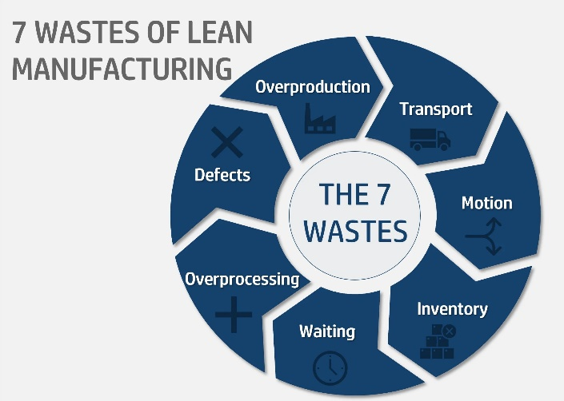

Identify Types of Waste (Muda):

* Transportation: Unnecessary movement of materials or information.
* Inventory: Excess raw materials, work in progress, or finished goods.
* Motion: Unnecessary movement or actions by people.
* Waiting: Idle time spent waiting for materials, information, or resources.
* Overproduction: Producing more than what is needed or before it is needed.
* Over-processing: Performing unnecessary or excessive work on a product or service.
* Defects: Errors or defects that require rework or correction.
* Underutilized Talent: Not fully utilizing the skills and abilities of employees.

Create a Culture of Continuous Improvement:

* Encourage employees at all levels to identify and address waste in their work processes.
* Implement regular improvement initiatives such as Kaizen events to tackle specific areas of waste.
* Foster a mindset of experimentation and learning from failures to drive continuous improvement.

Implement Lean Tools and Techniques:

* Value Stream Mapping: Map out the end-to-end processes to identify areas of waste and opportunities for improvement.
* 5S (Sort, Set in order, Shine, Standardize, Sustain): Organize the workplace to eliminate waste and improve efficiency.
* Single-Minute Exchange of Die (SMED): Reduce setup times to minimize downtime and increase flexibility.
* Pull Systems: Implement pull-based systems to reduce inventory and overproduction.
* Visual Management: Use visual controls such as Kanban boards to make waste visible and facilitate decision-making.

Empower Employees:

* Provide training and resources to enable employees to identify and eliminate waste in their own work areas.
* Encourage frontline employees to suggest and implement improvements based on their expertise and experience.
* Recognize and reward employees for their contributions to waste reduction and process improvement.
* Measure and Monitor Progress:
* Establish key performance indicators (KPIs) to track waste reduction efforts and overall process improvement.
* Regularly review and analyze data to identify trends, patterns, and areas for further improvement.
* Share progress and results with employees to maintain engagement and motivation.