Assignment

Question-1 Access vm successfully and open a terminal.?

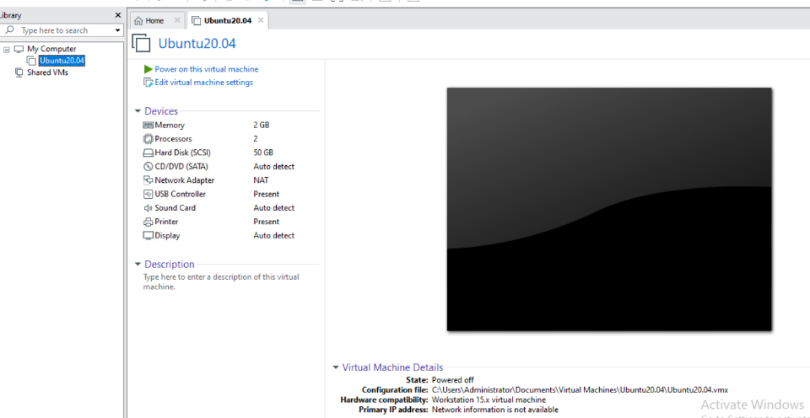

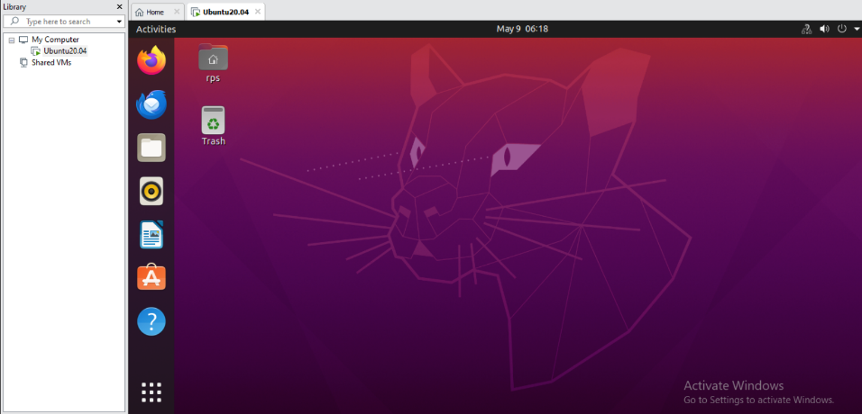

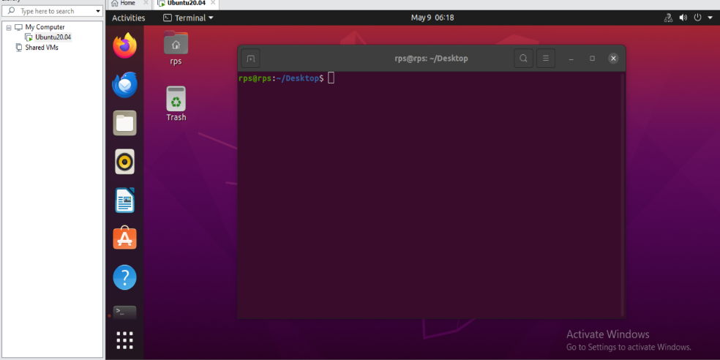

Question -2 find the current user.?

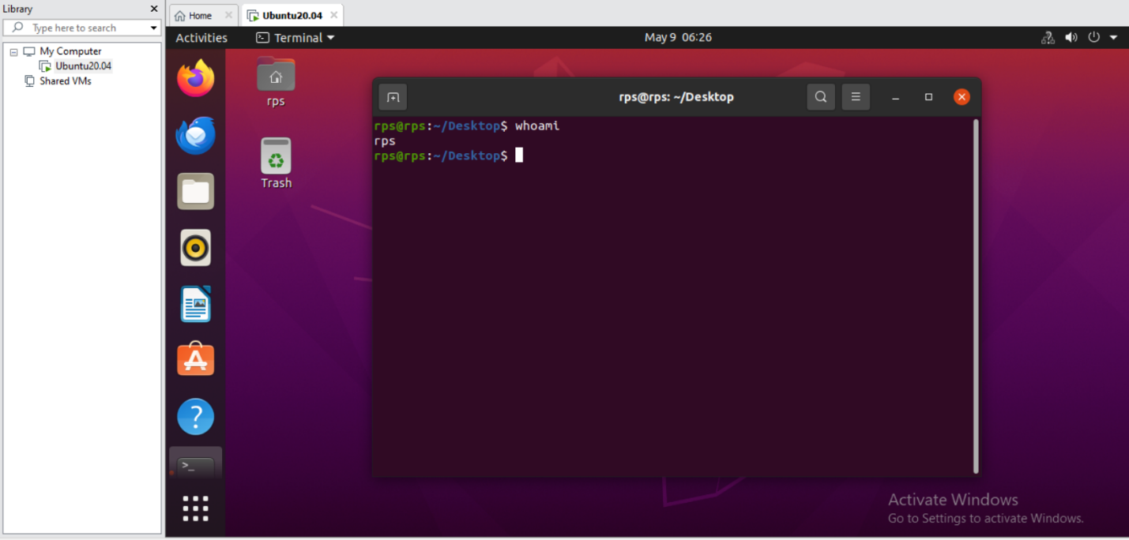

Question-3 navigate to root directory from home directory using terminal.?

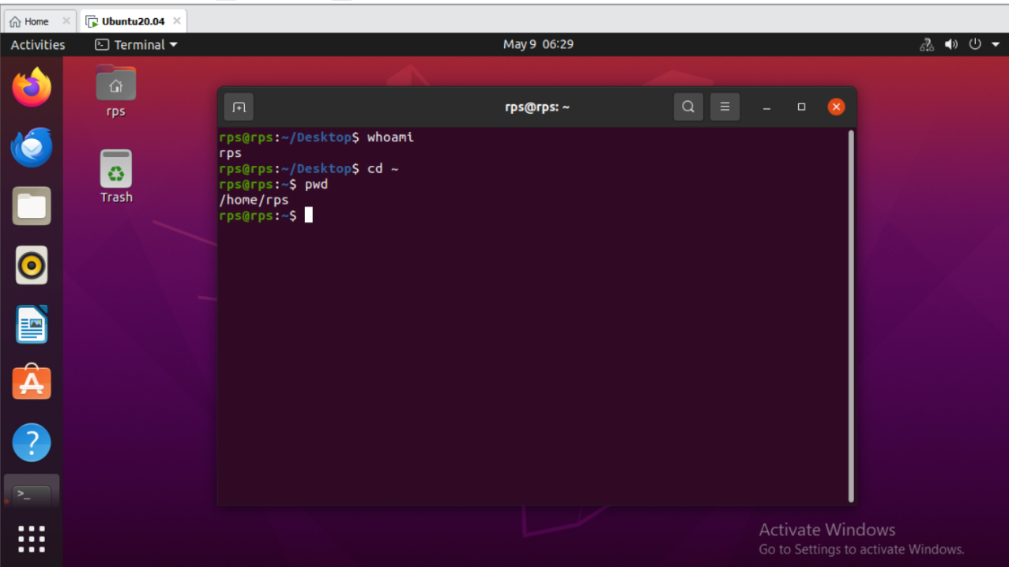

Question-4 Explain File system heirarchy in Linux OS.?

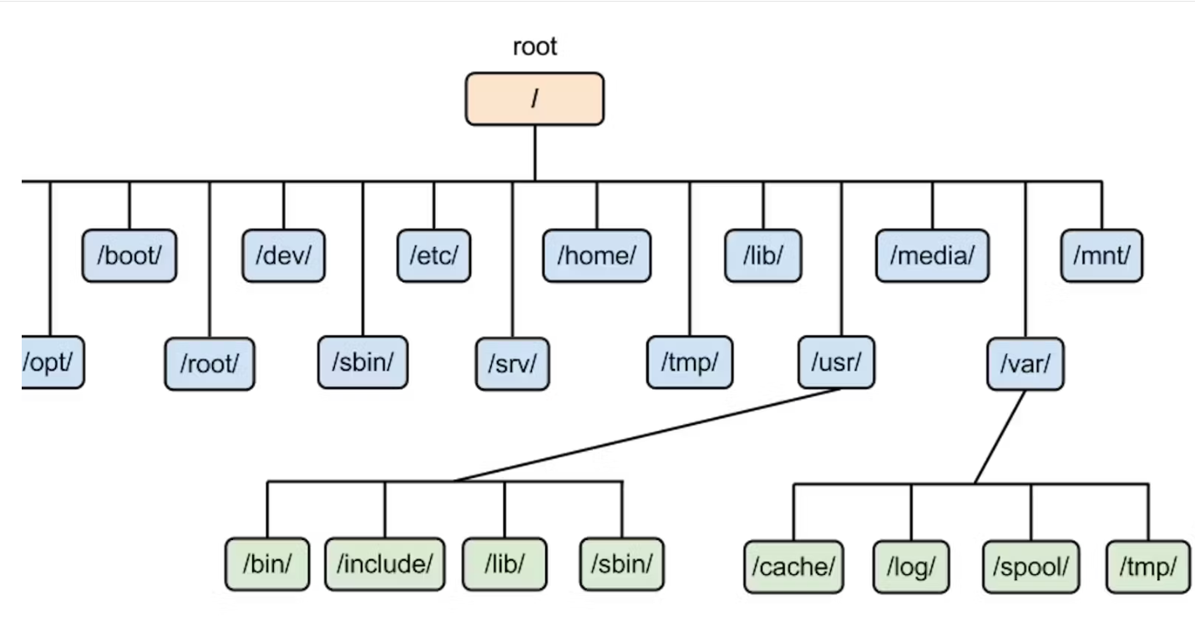

/ (Root directory):

The top-level directory in the hierarchy.

Contains all other directories and files.

Only root user has write permission to this directory.

/bin (Binary):

Contains essential binary executables (programs) that are required for system operation.

Common commands like ls, cp, mv, mkdir, etc., are located here.

/boot:

Contains boot loader files, kernel images, and boot configuration files.

The system boots from here.

/dev (Device):

Contains device files representing hardware devices in the system.

These files allow interaction with hardware devices like hard drives, USB devices, etc.

/etc (Editable Text Configuration):

Contains system-wide configuration files.

Configuration files for various services, such as network configuration, user authentication, etc., reside here.

/home:

Home directories for individual users.

Each user has their own subdirectory here to store personal files and configuration settings.

/lib (Library):

Contains shared libraries needed by the essential binaries in /bin and /sbin.

These libraries are used by programs at run-time.

/media:

Mount point for removable media devices such as USB drives, CDs, etc.

/mnt (Mount):

Temporary mount point for mounting filesystems.

Used for mounting filesystems temporarily.

/opt (Optional):

Directory for installing optional software packages.

Some third-party software may be installed here.

/proc (Process):

Virtual filesystem that provides information about processes and system resources.

Information about currently running processes and kernel parameters can be found here.

/root:

Home directory for the root user (superuser).

Root user's personal files and configuration settings are stored here.

/sbin (System Binary):

Contains system binaries (executable programs) used for system administration tasks.

Commands like fdisk, ifconfig, shutdown, etc., are located here.

/srv (Service):

Contains data for services provided by the system.

Data for services such as HTTP, FTP, etc., may be stored here.

/sys (System):

Virtual filesystem that exposes information about devices, drivers, and some kernel features.

It is used to interact with the kernel at runtime.

/tmp (Temporary):

Directory for temporary files.

Files stored here are typically deleted when the system reboots.

/usr (User):

Contains user-related programs, libraries, documentation, etc.

Subdirectories include /usr/bin, /usr/lib, /usr/share, etc.

/var (Variable):

Contains variable data files such as log files, mail, spool files, temporary files, etc.

Data that changes frequently during system operation is stored here.

Question-5 list all the contents of a directory.?

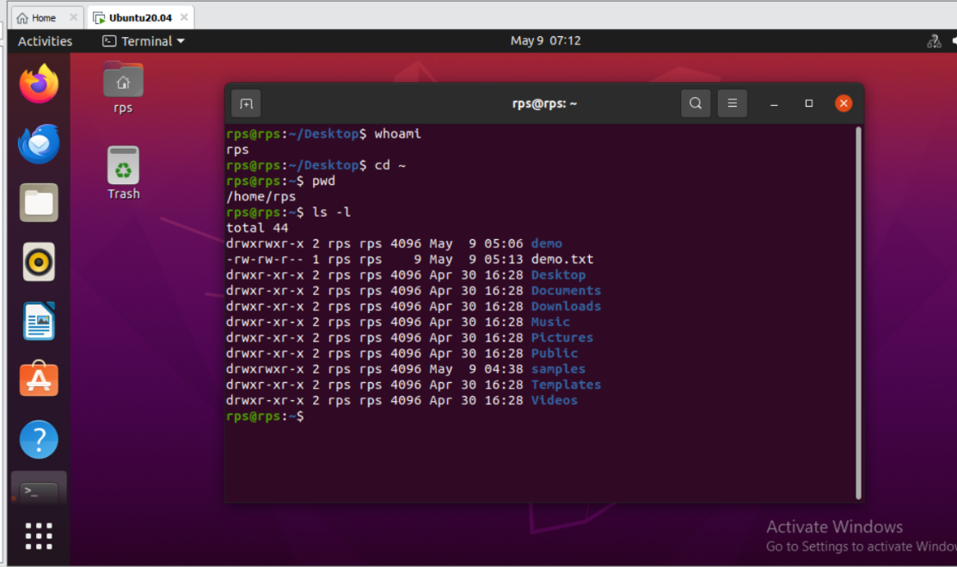

Question-6 perform a directory count.?

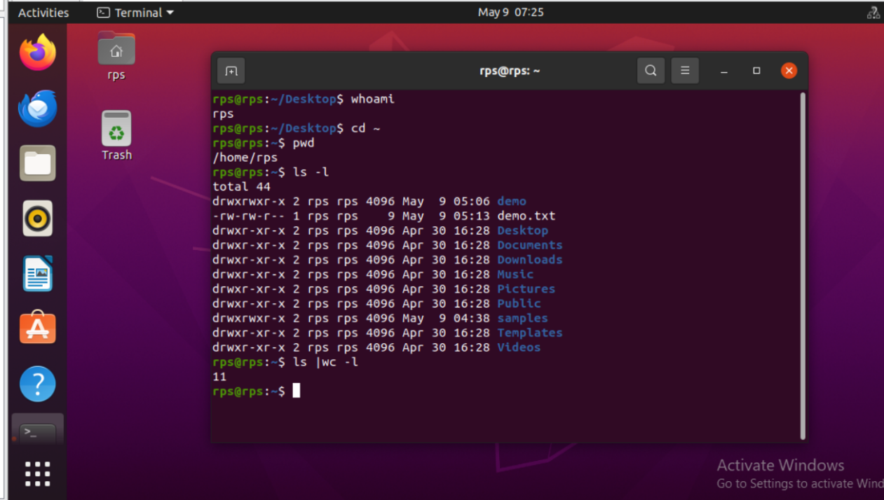

Question-7explain the output of ls -l command.?

File Permissions (1st column):

The first character indicates the file type: - for regular file, d for directory, l for symbolic link, etc.

The next three characters represent permissions for the file owner: r for read, w for write, x for execute.

The following three characters represent permissions for the group: r, w, x.

The last three characters represent permissions for others (everyone else): r, w, x.

If a permission is granted, the corresponding letter appears; if not, a hyphen (-) appears.

Number of Links (2nd column):

Indicates the number of hard links to the file or directory.

Owner (3rd column):

Indicates the user who owns the file or directory.

Group (4th column):

Indicates the group that owns the file or directory.

File Size (5th column):

Indicates the size of the file in bytes.

Last Modified (6th, 7th, and 8th columns):

Indicates the date and time when the file was last modified.

File/Directory Name (Last column):

The name of the file or directory.

Question-8 Difference between ls -l and ls -la command.?

ls -l command:

Lists files and directories in the current directory in a long format.

Does not include hidden files (those whose names start with a dot .).

Provides detailed information about each file and directory, including permissions, owner, group, size, and modification date.

ls -la command:

Lists files and directories in the current directory, including hidden files, in a long format.

Includes all files and directories, including those whose names start with a dot . (hidden files).

Provides detailed information about each file and directory, similar to ls -l, but also includes hidden files.

Question-9 create a directory products in home directory,navigate using using cd command and create a file products.txt.?

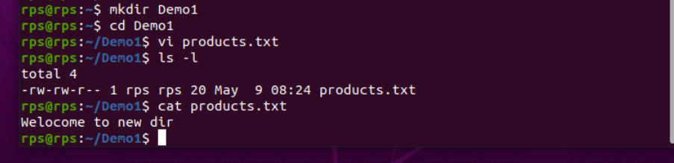

Question-10 create a directory orders in home directory,navigate using using cd command and create a file orders.txt.?

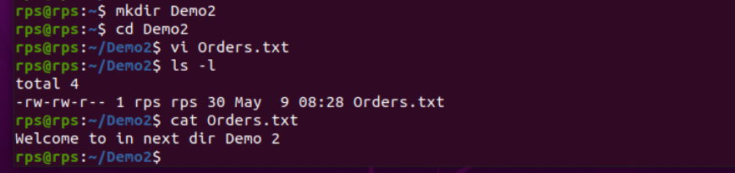

Question-11 What is Path? Define Absolute Path and Relative Path.?

A path in computing refers to the location of a file or directory within a file system. It's like the address that specifies the location of a file or directory within the directory structure of a filesystem.

Absolute Path:

An absolute path specifies the exact location of a file or directory from the root directory (/) of the filesystem.

It starts with a leading forward slash (/).

It provides the full hierarchy from the root directory to the target file or directory.

For example: /home/user/documents/file.txt is an absolute path, where / is the root directory, home is a directory within /, user is a directory within home, and so on until file.txt is reached.

Relative Path:

A relative path specifies the location of a file or directory relative to the current working directory.

It does not start with a leading forward slash (/).

It provides a path relative to the current directory.

Question-12 List the differences between Absolute Path and Relative Path.?

ABSOLUTE PATH:

**Definition:**

Absolute Path: Specifies the precise location of a file or directory from the root directory (/) of the filesystem.

**Starting Point:**

Absolute Path: Begins from the root directory (/).

**Format:**

Absolute Path: Begins with a leading forward slash (/).

**Use Cases:**

Absolute Path: Useful when referencing a file or directory regardless of the current working directory. Provides the full hierarchy from the root directory to the target.

**Portability:**

Absolute Path: Less portable as it depends on the specific filesystem structure.

**Length:**

Absolute Path: Typically longer, including the full hierarchy from the root directory.

**Ease of Use:**

Absolute Path: Can be cumbersome to type, especially for deeply nested directories.

RELATIVE PATH:

**Definition:**

Relative Path: Specifies the location of a file or directory relative to the current working directory.

**Starting Point:**

Relative Path: Begins from the current working directory.

**Format:**

Relative Path: Does not start with a leading forward slash (/).

**Use Cases:**

Relative Path: Useful when referencing a file or directory relative to the current working directory. Provides a path relative to the current directory.

**Portability:**

Relative Path: More portable, adapting to the current working directory, making it easier to move or share files across systems.

**Length:**

Relative Path: Often shorter and more concise, especially when referencing files or directories within the same directory or its subdirectories.

**Ease of Use:**

Relative Path: Often easier and quicker to type, especially for files or directories within the current directory or its immediate subdirectories.

Question-13 Navigate between products and orders with cd command using relative path reference.?

