Assignment -1

Question-1Ensure the script checks if a specific file (e.g., myfile.txt) exists in the current directory. If it exists, print "File exists", otherwise print "File not found".?

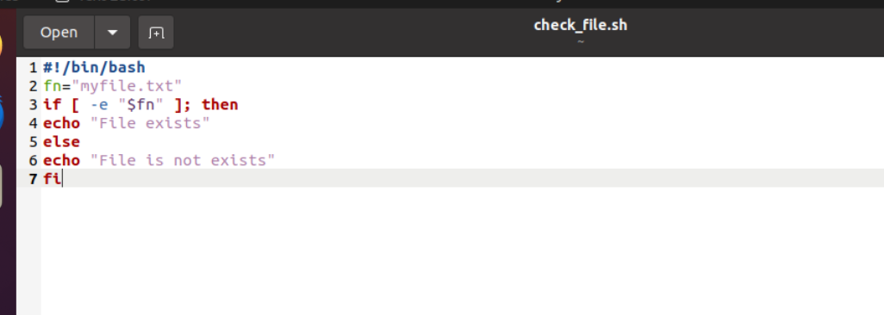

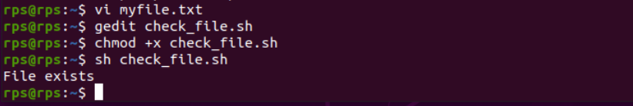

Assignment-2

Question-2 Write a script that reads numbers from the user until they enter '0'. The script should also print whether each number is odd or even.?

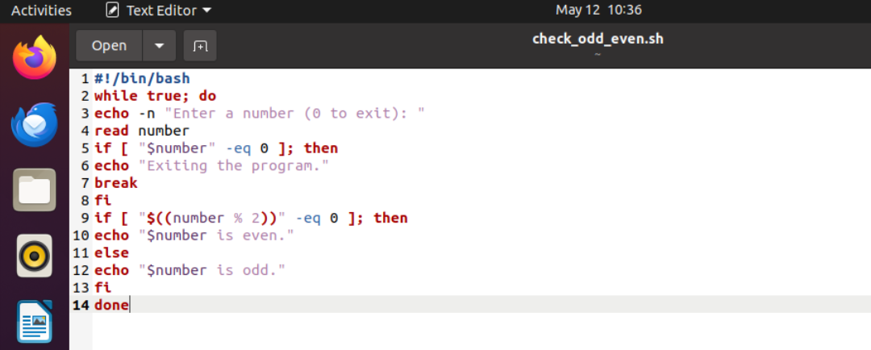

Output:

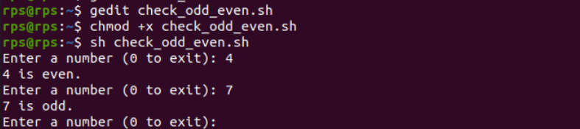

Assignment-3

Question-3 Create a function that takes a filename as an argument and prints the number of lines in the file. Call this function from your script with different filenames.

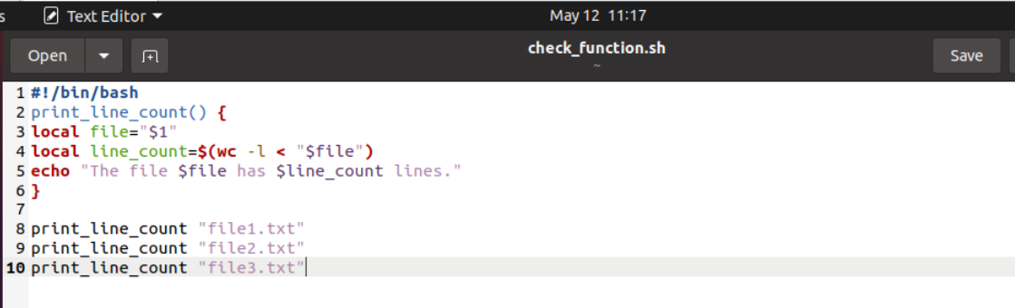

Output:

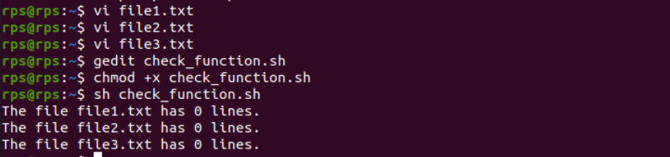

Assignment-4

Question-4 Write a script that creates a directory named TestDir and inside it, creates ten files named File1.txt, File2.txt, ... File10.txt. Each file should contain its filename as its content (e.g., File1.txt contains "File1.txt").

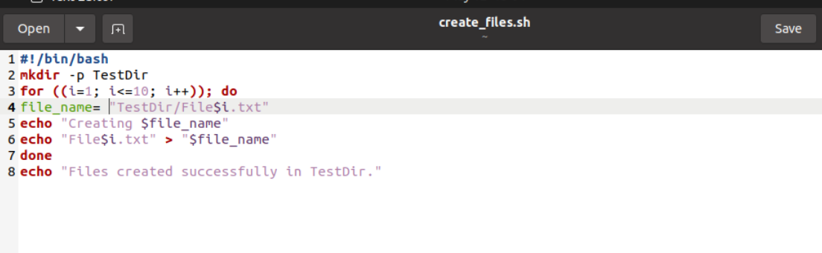

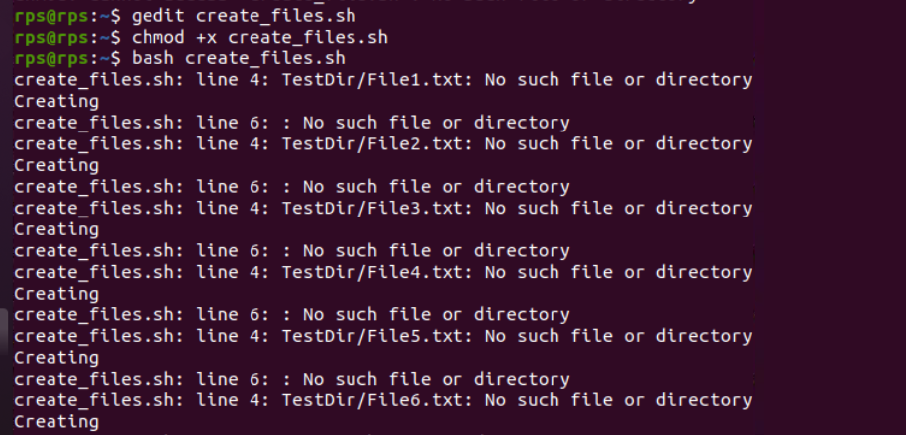

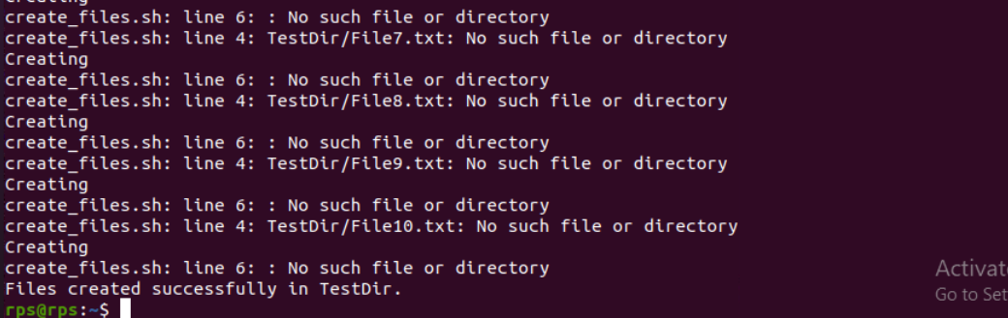

Assignment-5

Question-5 Modify the script to handle errors, such as the directory already existing or lacking permissions to create files.Add a debugging mode that prints additional information when enabled.

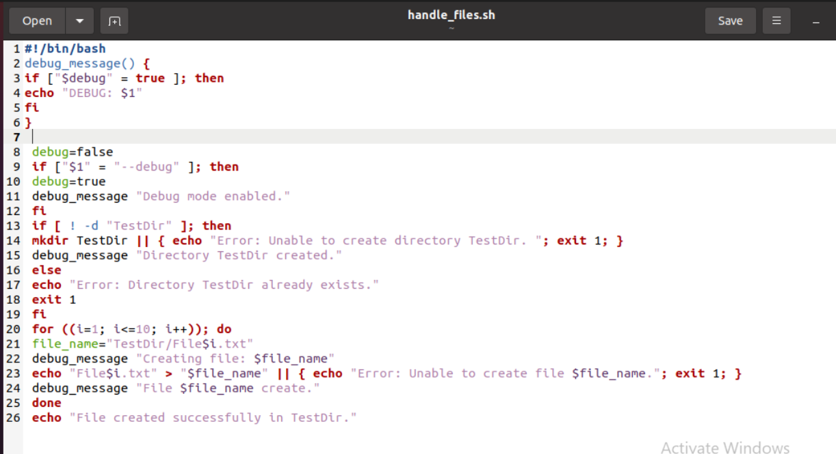



Assignment-6

Question-1 Given a sample log file, write a script using grep to extract all lines containing "ERROR". Use awk to print the date, time, and error message of each extracted line.Data Processing with sed?

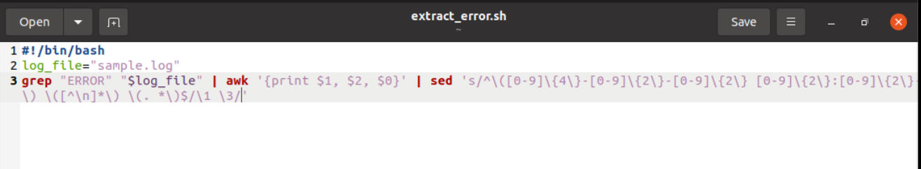

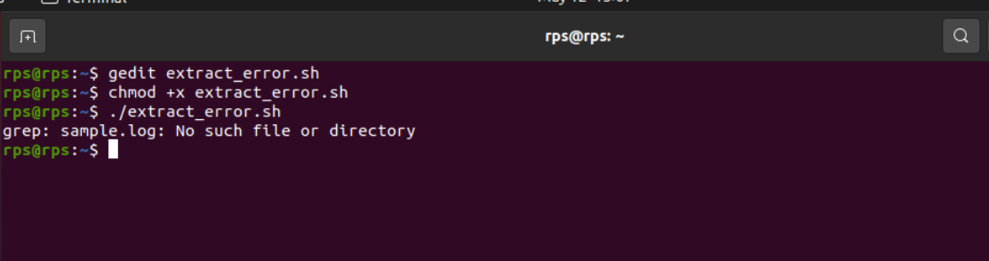

Assignment-7

Question-7 Create a script that takes a text file and replaces all occurrences of "old_text" with "new_text". Use sed to perform this operation and output the result to a new file.has context menu?

