Assignment-1

Question-1 Analyze a given business scenario and create an ER diagram that includes entities, relationships, attributes, and cardinality. Ensure that the diagram reflects proper normalization up to the third normal form.

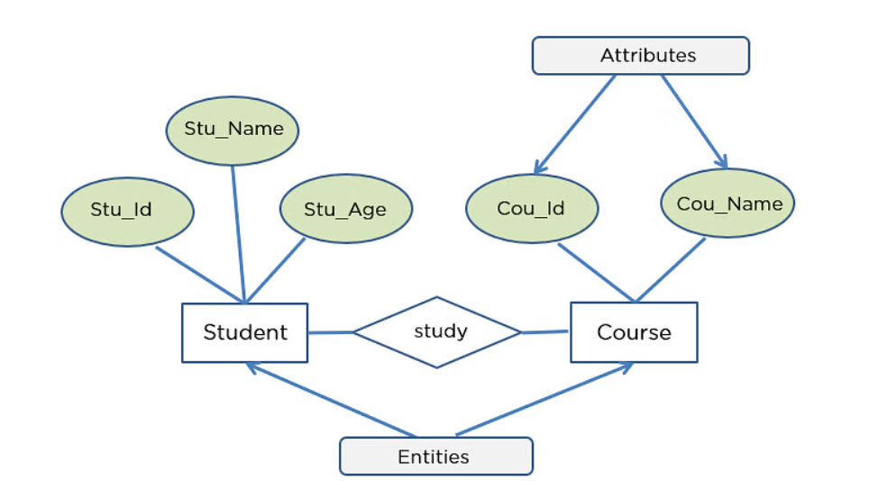

Assignment-2

Question-2Design a database schema for a library system, including tables, fields, and constraints like NOT NULL, UNIQUE, and CHECK. Include primary and foreign keys to establish relationships between tables.

**Tables:**

Books

book_id (Primary Key)

title

author

publication_year

genre

ISBN (Unique)

Authors:

author_id (Primary Key)

author_name

Members:

member_id (Primary Key)

name

email

address

Borrowings:

borrowing_id (Primary Key)

book_id (Foreign Key referencing Books)

member_id (Foreign Key referencing Members)

borrow_date

return_date

status (e.g., 'borrowed', 'returned')

**Constraints:**

NOT NULL Constraints:

All primary key fields (book_id, author_id, member_id, borrowing_id) cannot be NULL.

Fields such as title, author, publication_year, genre, ISBN, author_name, name, email, address, borrow_date, status cannot be NULL where applicable.

UNIQUE Constraints:

The ISBN field in the Books table should be unique to ensure each book has a unique identifier.

email field in the Members table should be unique to ensure each member has a unique email address.

CHECK Constraints:

The status field in the Borrowings table should only allow values 'borrowed' or 'returned'.

**Primary and Foreign Keys:**

book_id in the Books table is the primary key.

author_id in the Authors table is the primary key.

member_id in the Members table is the primary key.

borrowing_id in the Borrowings table is the primary key.

book_id in the Borrowings table is a foreign key referencing book_id in the Books table.

member_id in the Borrowings table is a foreign key referencing member_id in the Members table.

**Database Schema:**

Books:

|  |  |  |  |  |  |
| --- | --- | --- | --- | --- | --- |
| **Books:** |  |  |  |  |  |
| book_id | title | author | publication_year | genre | ISBN |
| **Authors:** |  |  |  |  |  |
| author_id | author_name |  |  |  |  |
| **Members:** |  |  |  |  |  |
| member_id | name | email | address |  |  |
| **Borrowings:** |  |  |  |  |  |
| borrowing_id | book_id | member_id | borrow_date | return_date | status |