LAB SHEET


K.R. MANGALAM UNIVERSITY
SOET
(School of Engineering & Technology)
B.TECH CSE (CORE)
Database & Management System Lab (ENCS254)

Submitted by- Submitted to-
Dolly Mansi Kajal
Roll no - 2401010196

LAB SEET – 2

Objective: To understand and implement SQL transactions using COMMIT, SAVEPOINT, and ROLLBACK, retrieve records using SELECT queries, and perform INSERT, UPDATE, and ALTER operations on tables.

• DDL Questions (Data Definition Language)
- Create table CLASS
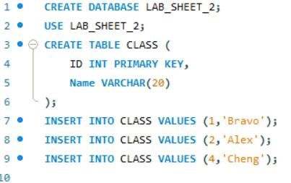

- Create table EMPLOYEES
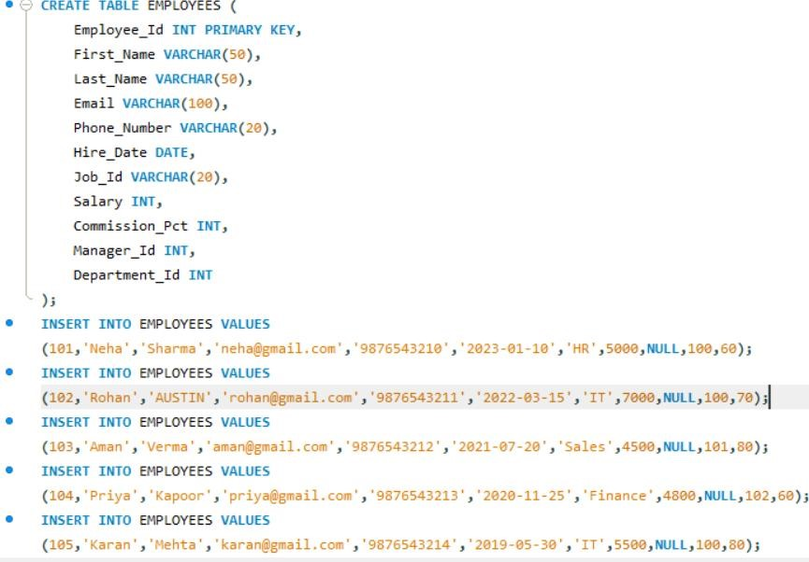
- Create table Client_master
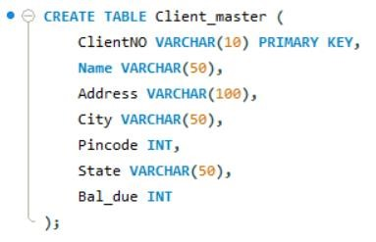
- Rename table Client_master to Client12

- Display bal_due column heading as “BALANCE”
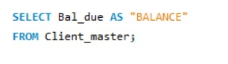

• DML Questions (Data Manipulation Language) ➢ Part A: Transactions and Savepoints (CLASS Table)

- COMMIT
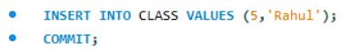
- SAVEPOINT A
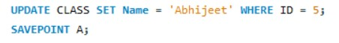
- SAVEPOINT B
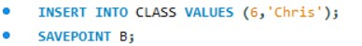
- SAVEPOINT C
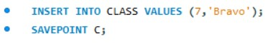
- SELECT ALL FROM CLASS

Output:
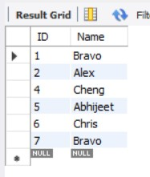

6.ROLLBACK TO B AND SELECT ALL FROM CLASS
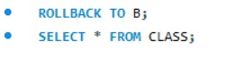
Output:
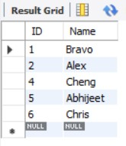
8.ROLLBACK TO A AND SELECT ALL FROM CLASS

Output:
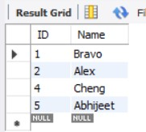

➢ Part B: Retrieving Records (EMPLOYEES Table)

- Employee id, names and salaries

OUTPUT:
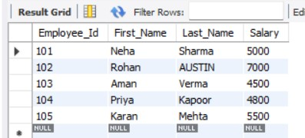

- Employees under manager 100
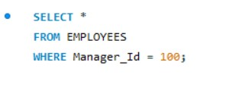
Output:
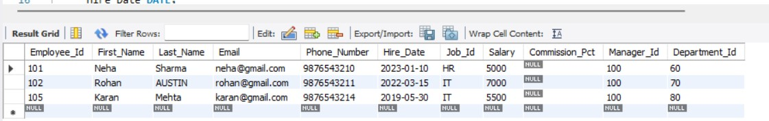

- Salary ≥ 4800
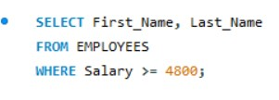

Output:
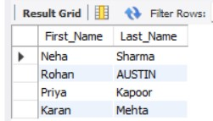

- Last name = 'AUSTIN'
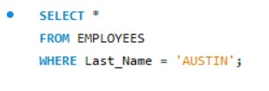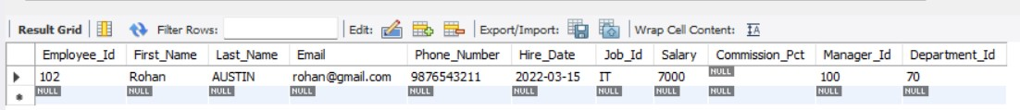

- Department 60, 70, 80
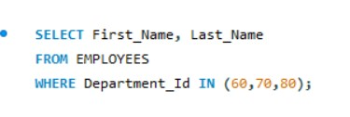
Output:
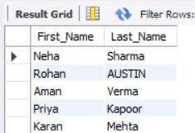

- Display unique Manager_Id
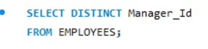
Output:
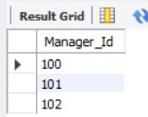

➢ Part C: Updating Records (Client_master Table)
1. Insert 5 records
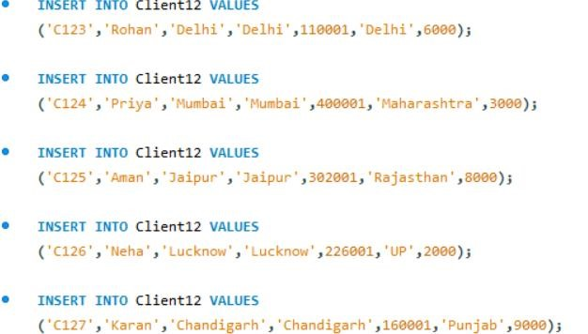
2.Clients with bal_due > 5000
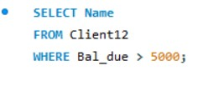
Output:
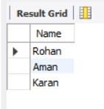
3.Change bal_due of ClientNO "C123" to 5100
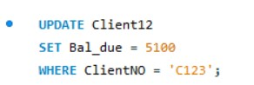
Output:
