LAB SHEET


K.R. MANGALAM UNIVERSITY
SOET
(School of Engineering & Technology)
B.TECH CSE (CORE)
Database & Management System Lab (ENCS254)

Submitted by- Submitted to-
Dolly Mansi Kajal
Roll no - 2401010196

LAB SHEET - 3
Objectives
- To understand the use of COMMIT and ROLLBACK commands in transaction control.
- To use ORDER BY and GROUP BY clauses in SQL queries.
- To understand DCL commands (GRANT, REVOKE) and the use of SAVEPOINT.
- To understand and implement JOIN operations in SQL.
➢ Commands:
- • TCL commands: COMMIT, ROLLBACK, SAVEPOINT are used to control transactions.
- • DCL commands: GRANT and REVOKE are used to give or remove user privileges.
- • GROUP BY is used for aggregation.
- • ORDER BY is used for sorting.
- • JOIN is used to combine data from multiple tables.

• DDL Commands
- Create TEACHER Table
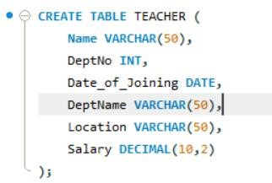
- Create SALES Table
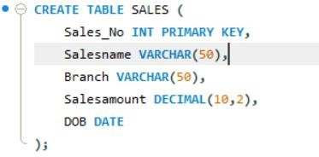

- Create DEPARTMENTS Table
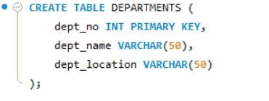
- Create DEPARTMENTS Table
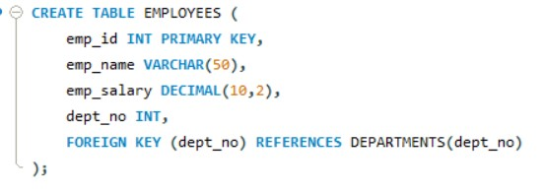
• DML Operations
- Insert 5 Records
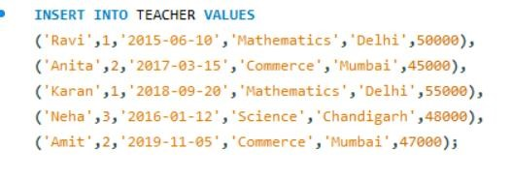
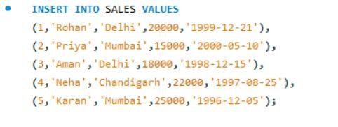
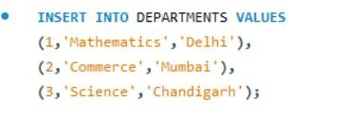
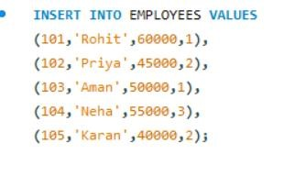
- 25% Increment for Mathematics Department
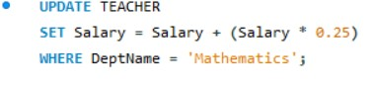
- 15% Increment for Commerce Department
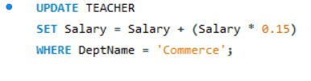

• From SALES Table
1. Total Sales in Each Branch
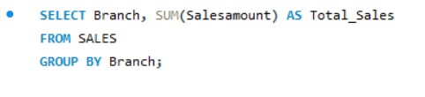
Output:
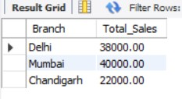

2. Average Sales in Each Branch

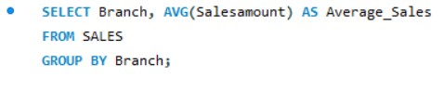

Output:
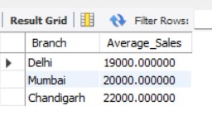
- Salesname and DOB (Born in December)
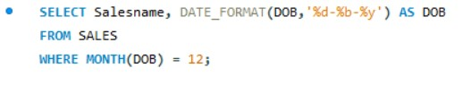
Output:
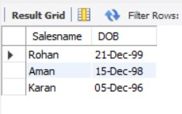
- Salesname and DOB in Alphabetical Order of Month
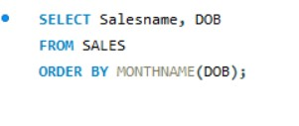
Output:
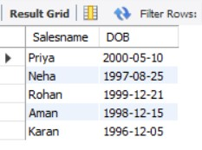

• JOIN Operations
- Employee and Department Details (INNER JOIN)
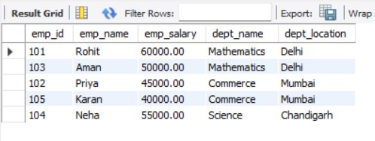
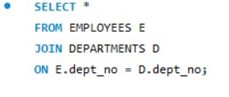
Output:
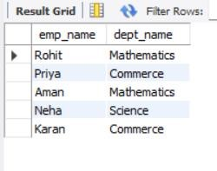
- LEFT OUTER JOIN
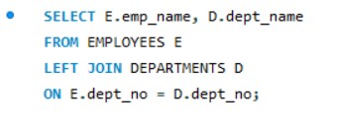
Output:
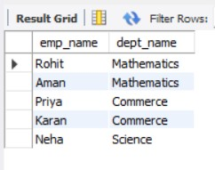
- RIGHT OUTER JOIN
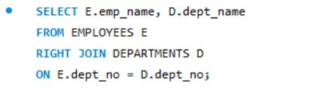
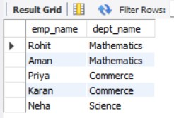
- Employees with Salary Greater than Average
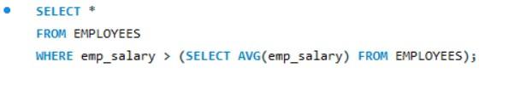
Output:
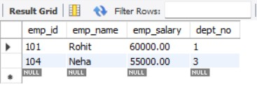

• TCL Commands
- ROLLBACK
- COMMIT
- SAVEPOINT
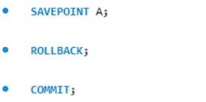

• DCL Commands
- Grant All Privileges
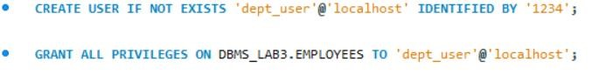
- Grant Selected Privileges
- Revoke All Privileges
- Revoke Selected Privileges

