**JAYA MULTIPLE CAMPUS**

**Tribhuvan University**

**Faculties of Humanities and social Science**



**A Report on : Online-Quiz System**

**Bachelors in Computer Application (BCA)**

**Course: Web Technology**

**Year/ semester : 2/III**

**Submitted by :**

Dolma Lama

ROll No.10

**Submitted to:**

Mr. Prakash Gautam

Faculty of Humanities and social Science

**Contents**

**Contents**

Introduction………………………………………………………..3

Project Requirements……………………………….………….3

Front-end…………………………………………………….………3-9

1.HTML……………………………………………………….……….3-7

2.CSS………………………………………………………….………..8-9

Back-end……………………………………………..………………10-12

* PHP…………………………………………………………………10-12

Database Connection…………………………………..………13

CRUD Operation………………………………………………….14-15

Results…………………………………………………………..……15-17

Conclusion…………………………………………………….……18

Reference…………………………………………………..………19

**Introduction**

Online-Quiz System is a web-based application. It is software that is helpful for students and another learners. This project is basically developed to show the working principal of CRUD operations in database (create, read, update and delete). The main function of this system is for playing quiz game to learn new knowledge and it is about PHP. Here multiple choice questions are given through which it will be easier for user to identify answer. The information about user and score will be set in database.

Project Requirements:

Project Name: - Online-Quiz System

Languages used: - PHP

Database: - MySql

User Interface:-HTML, CSS

Web Browser: - Mozilla, Chrome.

Software:- Xammp

**Front-End**

**HTML**

HTML stands for Hyper Text Markup Language. It is the standard markup language for creating Web page. It describes the structure of a Web page. It consists of a series of elements. It elements tell the browser how to display the content. Its elements label pieces of content such as "this is a heading", "this is a paragraph", "this is a link", etc.

Example:

<!DOCTYPE html>  
<html>  
<head>  
<title>Page Title</title>  
</head>  
<body>  
<h1>My First Heading</h1>  
<p>My First Paragraph</p>  
</body>  
</html>

**HTML Elements**

The HTML **element** is everything from the start tag to the end tag:

<h1>My First Heading</h1>

<p>My first paragraph.</p>



**HTML Attributes**

Attributes are always specified in **the start tag.** They usually come in name/value pairs like: **name="value”**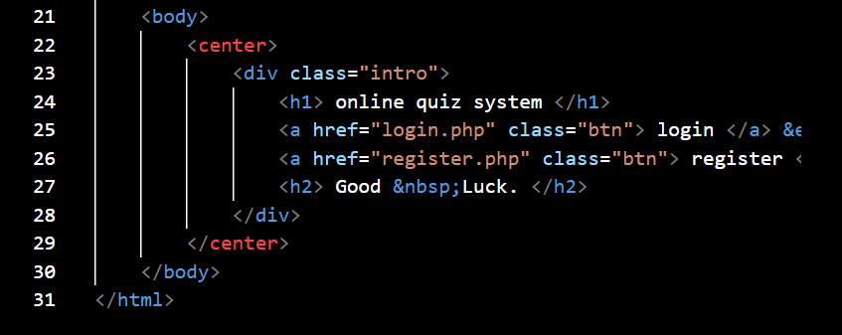

**HTML Headings**

HTML headings are defined with the <h1> to <h6> tags.

<h1> defines the most important heading. <h6> defines the least important heading.

<h1>Heading 1</h1>  
<h2>Heading 2</h2>  
<h3>Heading 3</h3>  
<h4>Heading 4</h4>  
<h5>Heading 5</h5>  
<h6>Heading 6</h6>



**HTML Styles**

The HTML style attribute is used to add styles to an element, such as color, font, size, and more.

Example:

**1.This is red**

**2.This is green**

3. <body style="background-color:powderblue;">

## Block-level Elements

The <p> element is a block-level element.

The <div> element is a block-level element.

## Inline Elements

## <span>Hello World</span>

**HTML Classes**

<div class="city">  
  <h2>London</h2>  
  <p>London is the capital of England.</p> </div>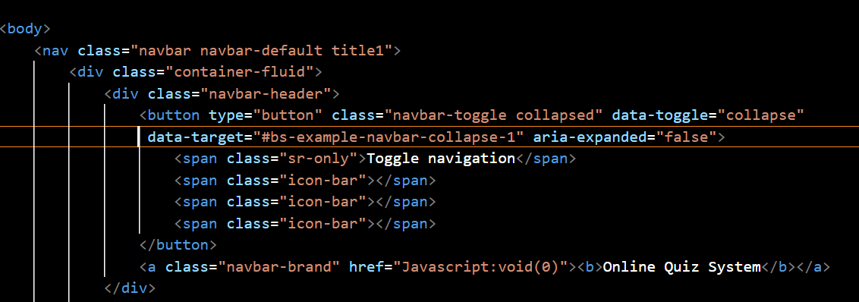

**HTML Links**

Links are found in nearly all web pages. Links allow users to click their way from page to page.

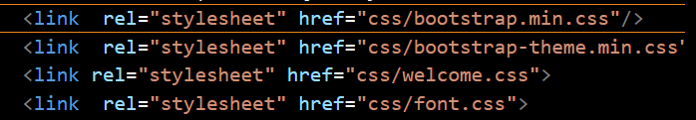

**CSS**

CSS stands for Cascading Style Sheets. CSS describes how HTML elements are to be displayed on screen, paper, or in other media. CSS saves a lot of work. It can control the layout of multiple web pages all at once. External stylesheets are stored in CSS files.

P {

color: red;

font-size: 8px;

text-align: center;

margin: 0;

padding: 0;

}

**CSS Selectors**

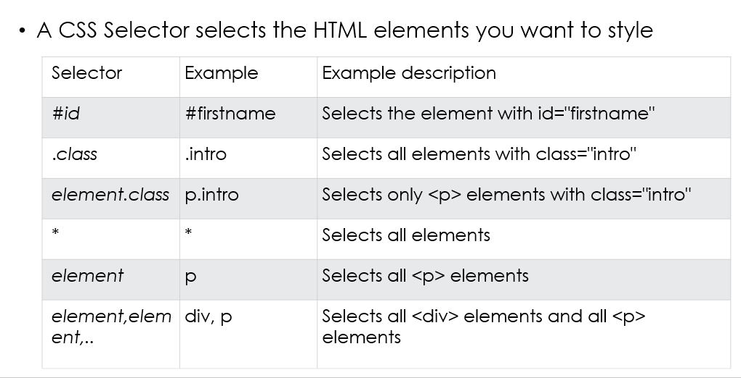

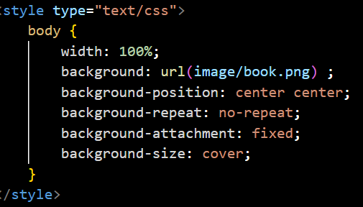

**Back-end**

**PHP**

PHP is an acronym for "PHP: Hypertext Preprocessor". PHP is a widely-used, open source scripting language. PHP scripts are executed on the server.

Syntax:

<?php  
// PHP code goes here  
?>

## The PHP if else Statement

## 

**While Loop**

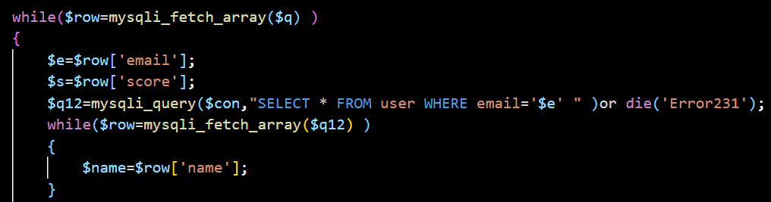

**PHP Superglobals**

* $GLOBALS
* $_SERVER
* $_REQUEST
* $_POST
* $_GET
* $_FILES
* $_ENV
* $_COOKIE
* $_SESSION

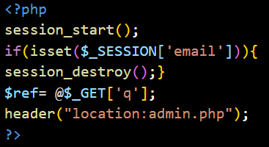

**PHP Cookies**

A cookie is often used to identify a user. A cookie is a small file that the server embeds on the user's computer. Each time the same computer requests a page with a browser, it will send the cookie too. With PHP, you can both create and retrieve cookie values.

setcookie(name, value, expire, path, domain, secure, httponly);

PHP Sessions

When you work with an application, you open it, do some changes, and then you close it. This is much like a Session. The computer knows who you are. It knows when you start the application and when you end. But on the internet there is one problem: the web server does not know who you are or what you do, because the HTTP address doesn't maintain state. Session variables solve this problem by storing user information to be used across multiple pages (e.g. username, favorite color, etc). By default, session variables last until the user closes the browser.

So; Session variables hold information about one single user, and are available to all pages in one application.

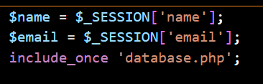

**Database Connection**

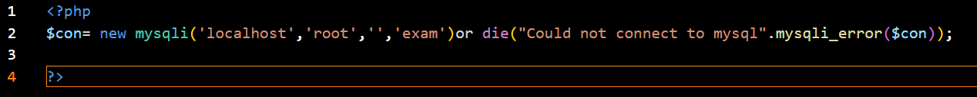

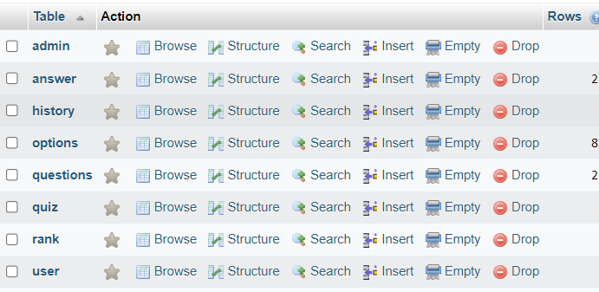

**Users**

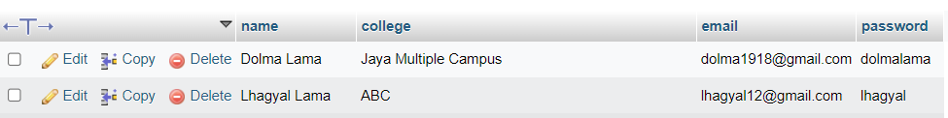





**CRUD Operation**

**1.Create**

To insert new records into a MySQL table, use the INSERT INTO statement.



Here I have added User’s name, college, email, password. Like this we can add new information about user.

**2.Read**

To retrieve data from a MySQL table, you can use the SELECT statement. 

**3.Update**

To record data in a MySQL table, you can use the UPDATE statement.



**4. Delete**

To delete data from table, you can use the DELETE FROM statement.

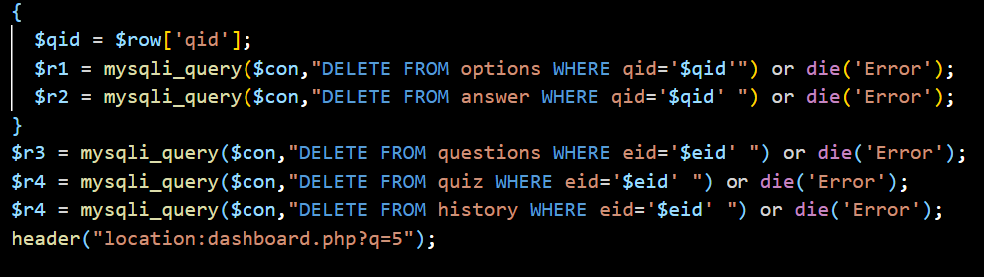



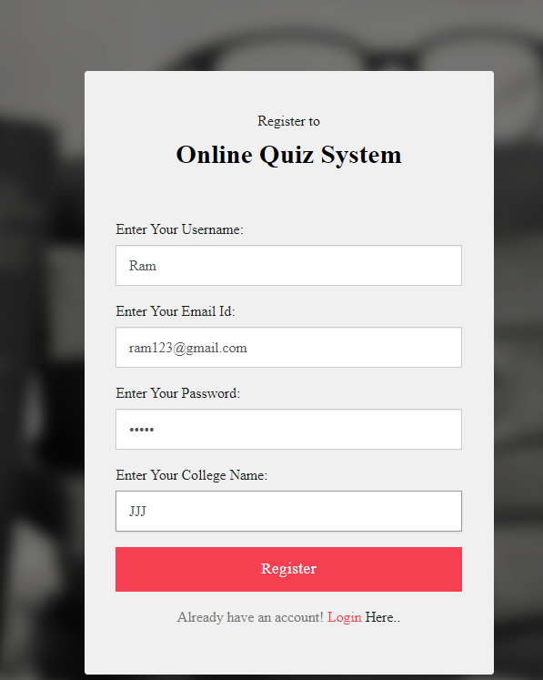



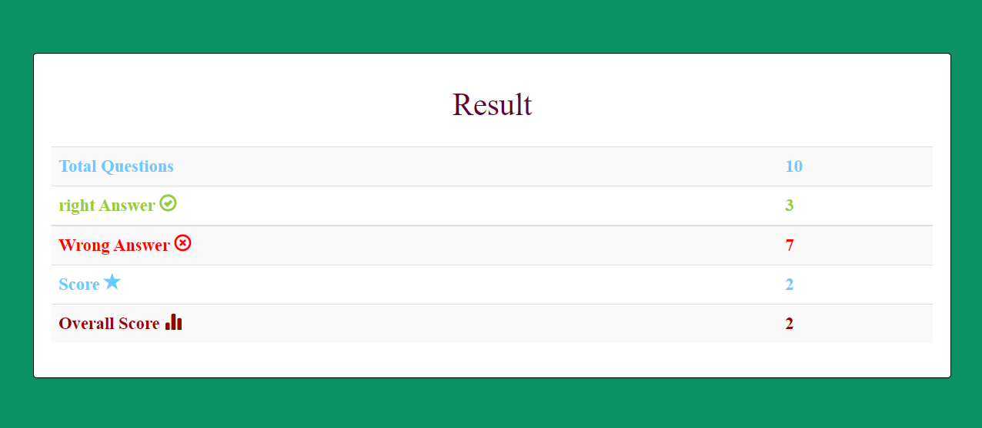



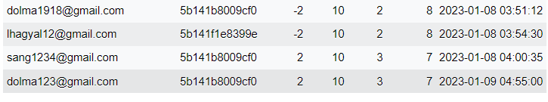

**Conclusion**

Online Quiz System has become a fast growing examination method because of its speed and accuracy. It is also needed less manpower to execute the examination. Almost all organizations now-a-days, are conducting their objective exams by online examination or quiz system, it saves students time in examinations. Organizations can also easily check the performance of the student that they give in an examination. As a result of this, organizations are releasing results in less time. It also helps the environment by saving paper. According to today’s requirement, online examination project in PHP is very useful to learn it.

**Reference**

1.www.youtube.com/Code projects

2.www.w3schools.com

3. https://chat.openai.com/chatgpt