Date: July 17

To,

The Host Master

Mercantile Communication Pvt. Ltd.

Subject: For .com.np Domain Registration

Dear Sir/Madam

I would like to register lamadolma.com.np domain name. I have already submitted the domain registration online form. I have attached the scan copy of citizenship certificate along with this application.

I will happy if you register my lamadolma.com.np domain name as soon as possible. Thank you for considering my application.

My preferred domain Name: lamadolma.com.np

Thank You!

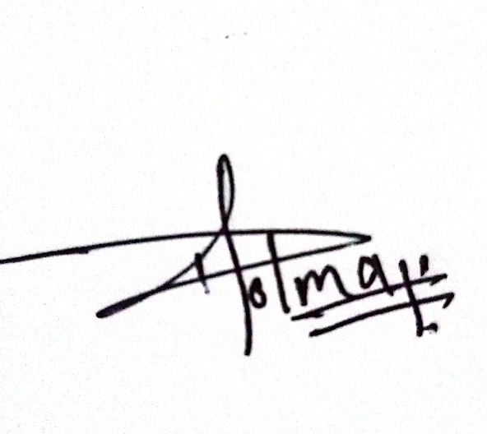

Dolma Lama

