**Introduction and background to the new system**

Exciting news from the team at ThinCats!

As part of the ongoing evolution of the ThinCats Lending Platform we are upgrading our system to a state of the art platform which allows ThinCats to accommodate the next phase of growth. The new platform may look and feel a little different but will have all the same features as today. In the near future we will be introducing improvements to the existing functionality and new features such as a secondary marketplace.

Table of Contents

How to login 2

Reset your password 2

Main Menu 3

Marketplace 4

Dashboard 7

Transaction History 8

Deposit Funds 9

Withdraw Funds 10

Additional Details on Investor Dashboard 11

My Holdings 13

Investor Profile 14

### How to login

Simply go to the ThinCats website and click on investor login as before. The following screen will appear:

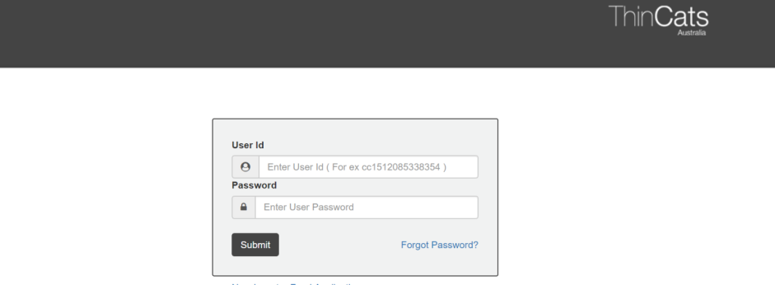

You can use your email address as your User Id

### Reset your password

For security reasons we cannot migrate your password. Click the Forgot Password link to reset your password and you will receive an email instructing you on how to set your new password

### Main Menu

Once you have logged in the system will take you to the home page which is the dashboard view by default.

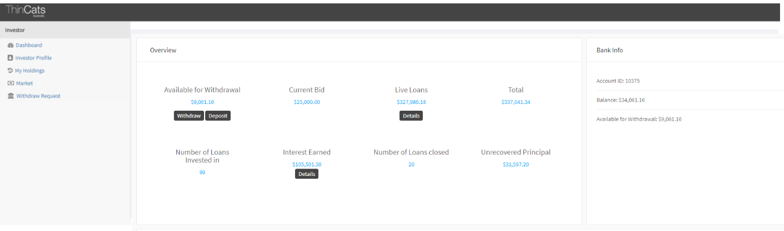

On the left hand side are the menu items. To navigate through your investing platform simply click on the menu item. Each item is explained in more detail below.

### Marketplace

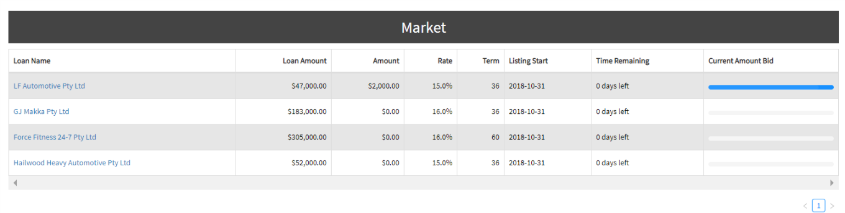

Loans that are currently available to bid on are displayed with summary information.

To select a loan to get more details or to make a bid click on the Loan name highlighted in blue.

The Bid Now screen consisting of three tabs will be displayed:

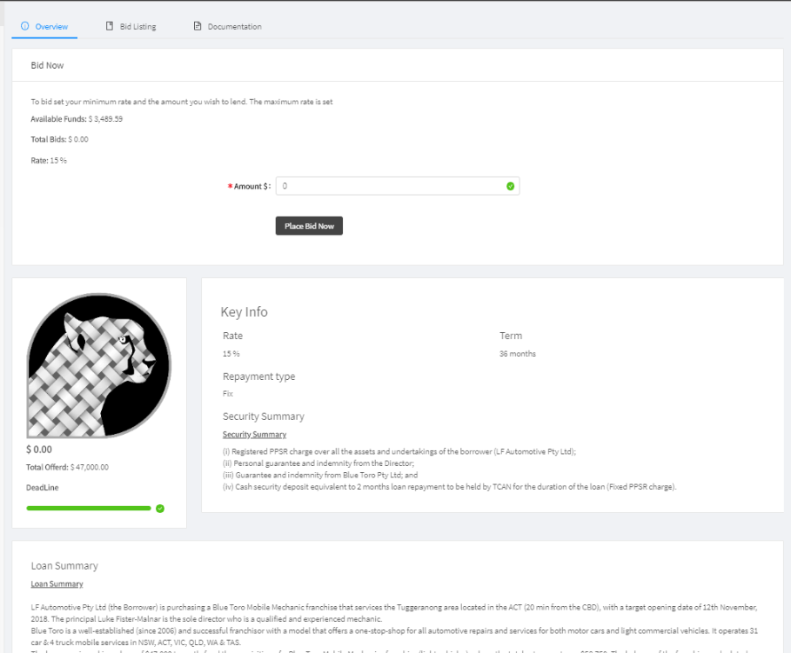

The overview the displays the following:

1. Your available funds
2. Amount of any previous bids on the loan
3. The loan rate
4. A summary of the loan attributes
5. A summary of the security from the borrower

The overview is where you bid on a loan enter the amount you wish to invest in multiples of 1000 and click on Place Bid Now Box. **It is important to remember that once a bid is placed it cannot be withdrawn.**

An investor can increase the amount they wish to invest at a later date by entering a new bid. The new bid must be higher than the old one. For example, to raise an existing bid of $5,000 to $7,000, you would enter $7,000 as the new bid amount.

To view what other investors have bid on this loan click on the Bid Listing Tab (screen below)

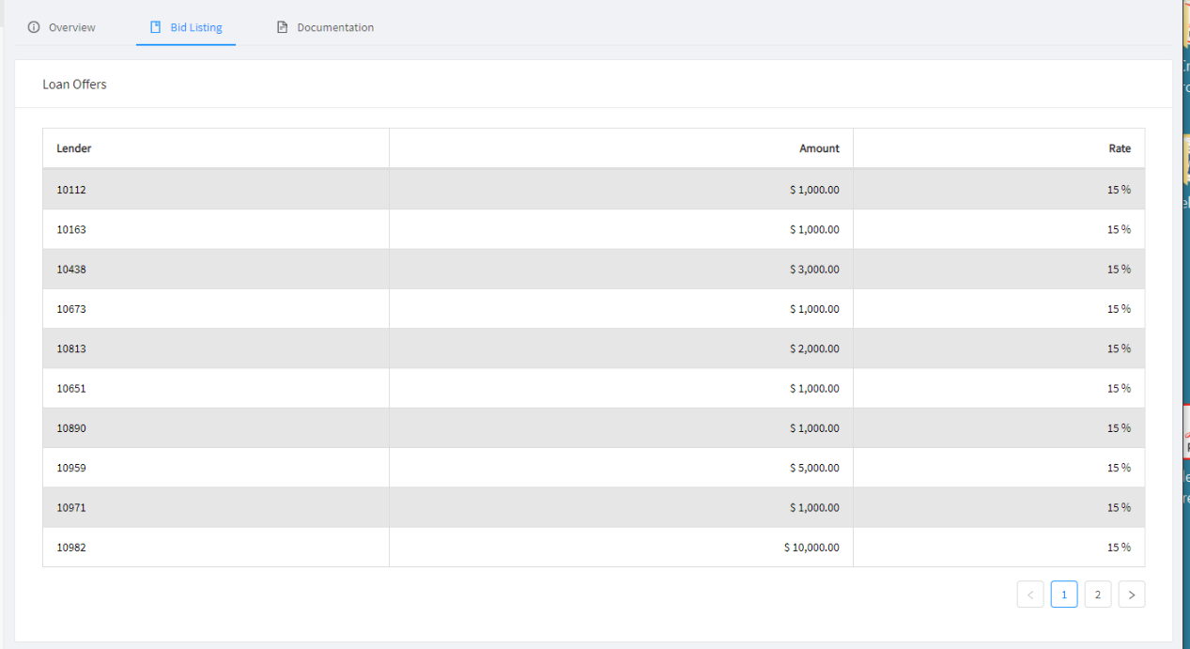

To download & review the supporting documents for the Loan Offer click on the Documentation Tab (screen below)

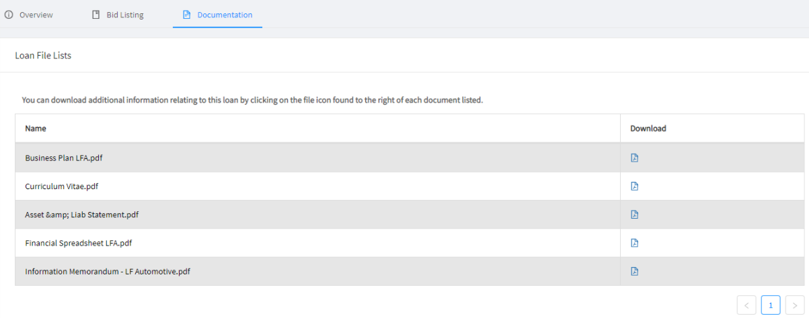

### Dashboard

The Investor dashboard is where investors Manage and review there platform account

Click on Dashboard from the User Menu for the screen below

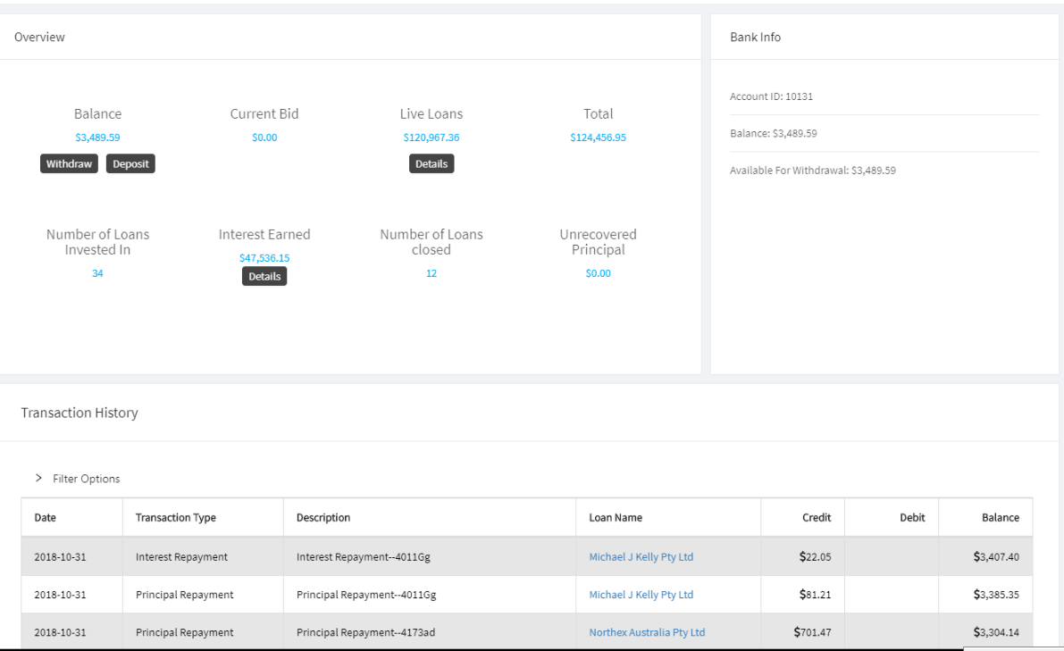

Moving from left to right main window:

1. Balance is the amount of Cash which is available in your ThinCats account
2. Current Bids is the total amount of loans that you have committed to which have not yet settled.
3. Live Loans is the sum of the outstanding capital balance of all your loans
4. Total is the sum of 1-3 above
5. Number of Loans Invested In is the number of loans you invested in since joining the platform
6. Interest Earned is the Sum of all interest earned since joining the platform
7. Closed Loans is the sum of all loans that have been paid out
8. Unrecovered principle is the principal amount from loans that has not and may not be paid back

**Bank Info**

1. Account ID is your unique platform account number
2. Balance is your actual cash balance
3. Available for withdrawal is actual cash balance less future bid commitments

### Transaction History

An itemised description of every transaction that occurs on your account the following is displayed for each item:

1. What type (deposit, withdrawal, Loan Purchase, interest payment, principal payment)
2. The amount
3. Details of the associated Loan.

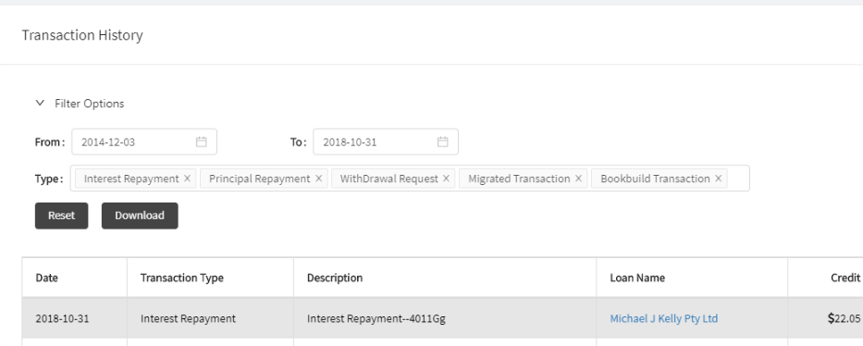

This information can be downloaded or filtered by clicking on “Filter Option”. The window above will appear you can now select date range and which transactions types you wish displayed.

Once you have set the transactions you wish to review you can print or download by clicking on the download button.

### Deposit Funds

To deposit funds into your platform trading account click on the Deposit button on the Dashboard screen.

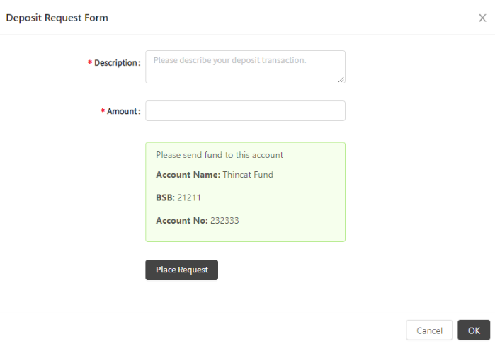

1. Go to your online bank account and transfer funds into the bank account in the screen above.
2. Enter the reference information your account details you entered in your bank transfer in the description
3. Enter the amount you transferred
4. Click place request and then OK

ThinCats staff will apply the money to your trading account as soon as it clears the bank account.

### Withdraw Funds

To withdraw funds into your platform trading account click on the withdraw button on the Dashboard screen or from the Main Menu item.

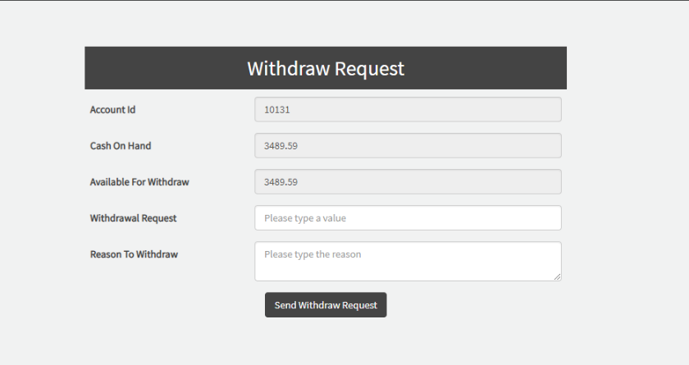

1. Enter the amount you wish to receive in the withdraw request field.
2. Enter and notes you wish to appear in your transaction history in the Reason To Withdraw field.

ThinCats staff will process your request into your nominated bank account.

### Additional Details on Investor Dashboard

Click on Details under Live loans

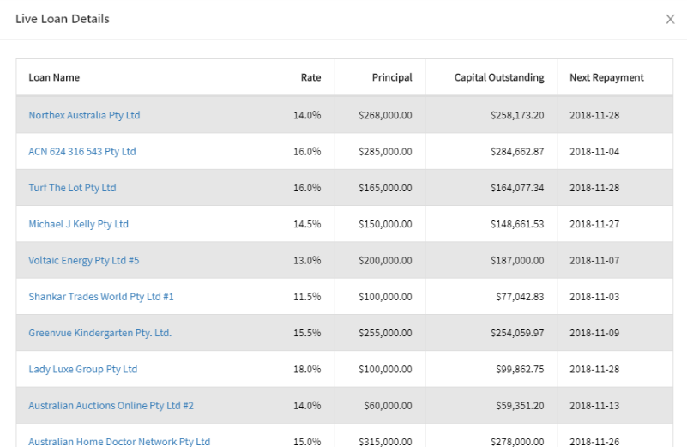

The following details of loans you have invested are displayed

1. Name of borrower
2. Rate
3. Original Loan amount ( at loan level)
4. Current capital outstanding of the Loan ( at loan level)
5. Next Repayment Date

Click on Details under Interest Earned

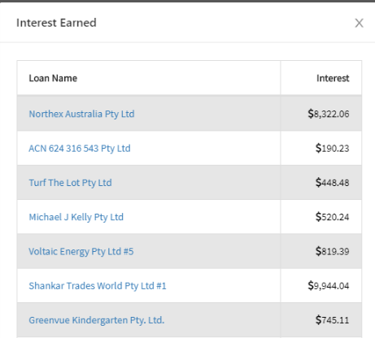

This window displays how much interest you earned for each loan you invested in.

At any place you see the a Borrower name highlighted in blue you can click on it and the following screen will appear

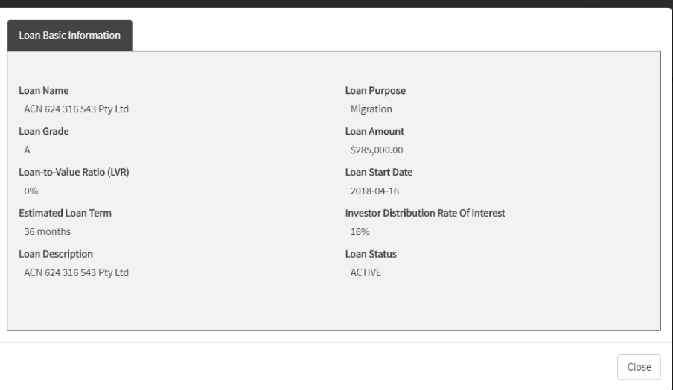

### My Holdings

The My Holdings sections is an itemised list of each of your Loans

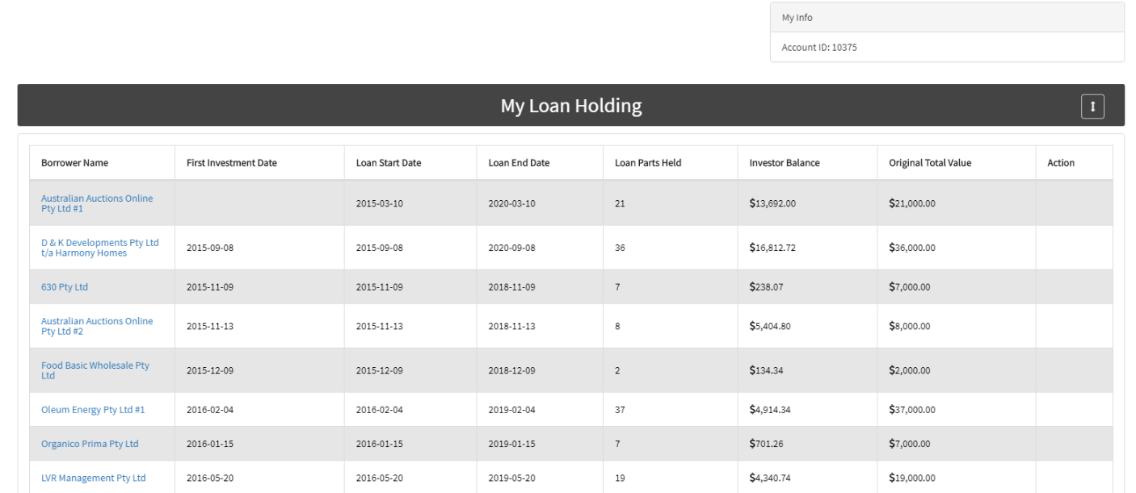

Information displayed is specific your investment

### Investor Profile

From the main Menu click on Investor Profile to update your account details

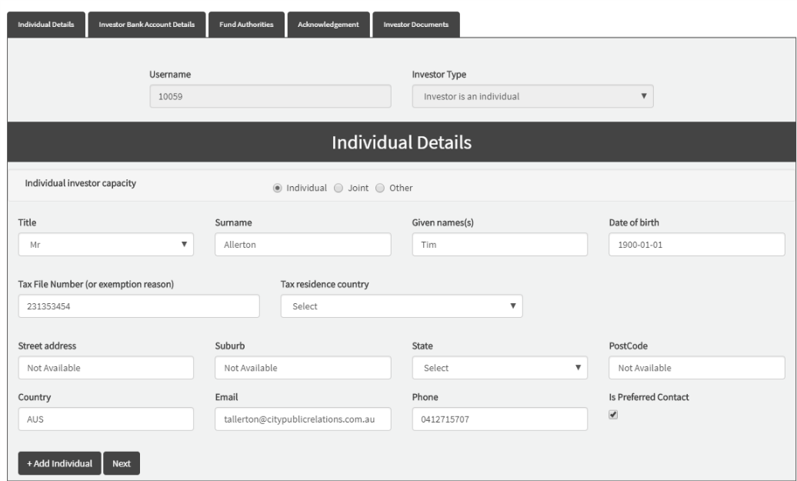

Update Information as required then click on Bank Account Details

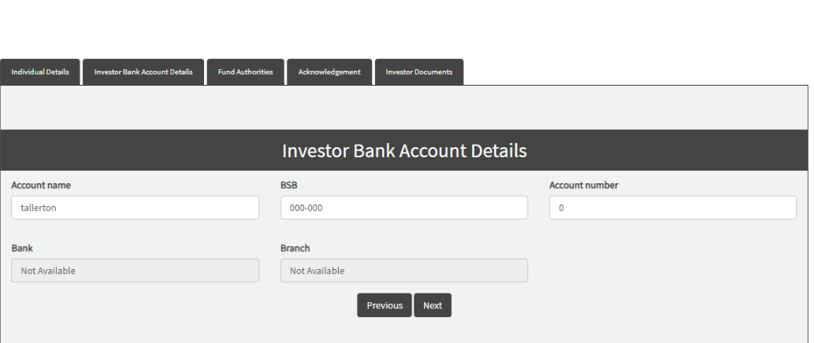

Update your Bank account details as required

To save click on the Acknowledgement Tab and click on Submit at the bottom of the page.