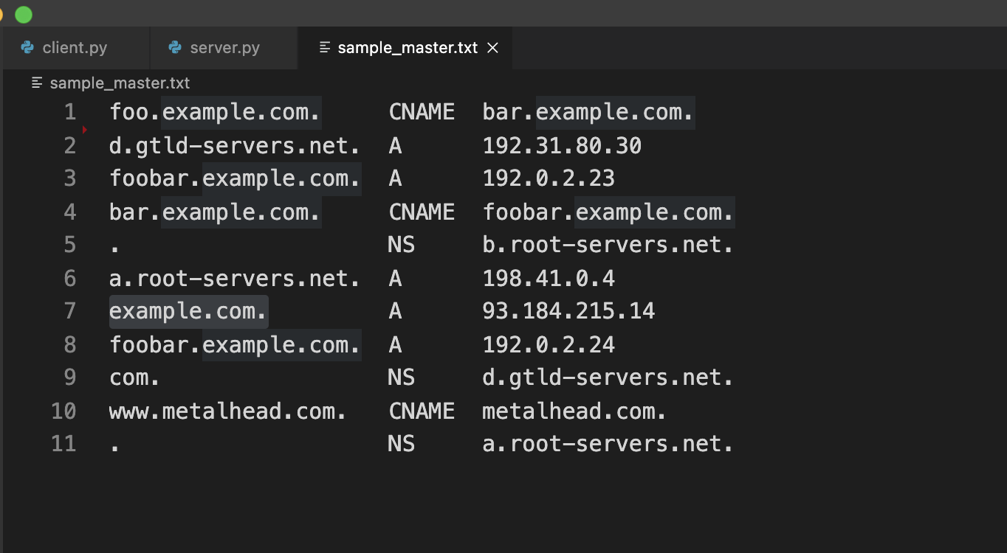

1. **example.com.A**

client output:

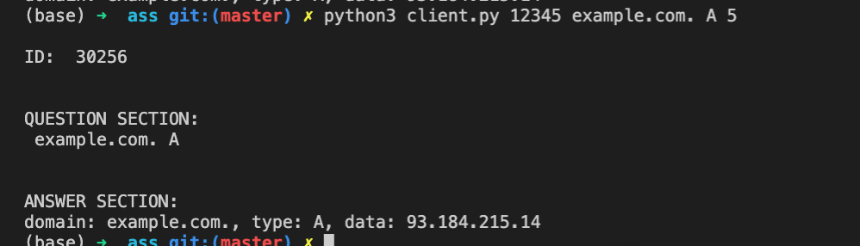

server output:

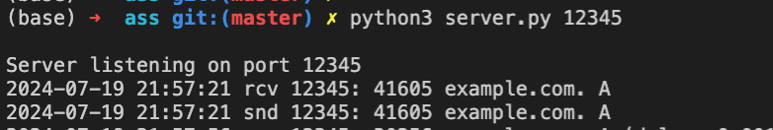

1. **timeout:**

client output:

截屏2024-07-23 13.21.19

server output:

截屏2024-07-23 13.21.49

1. **bar.example.com. CNAME**

client output:

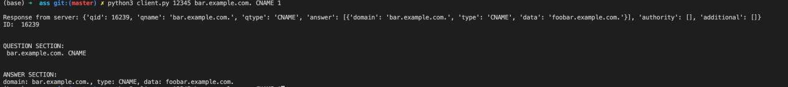

server output:

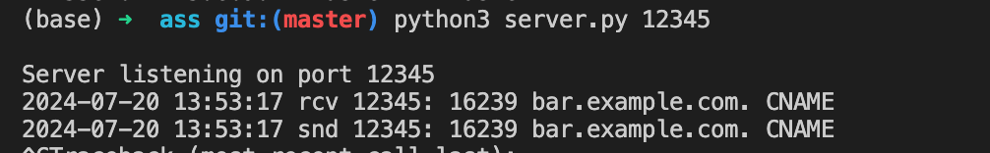

1. **. NS**

client output:

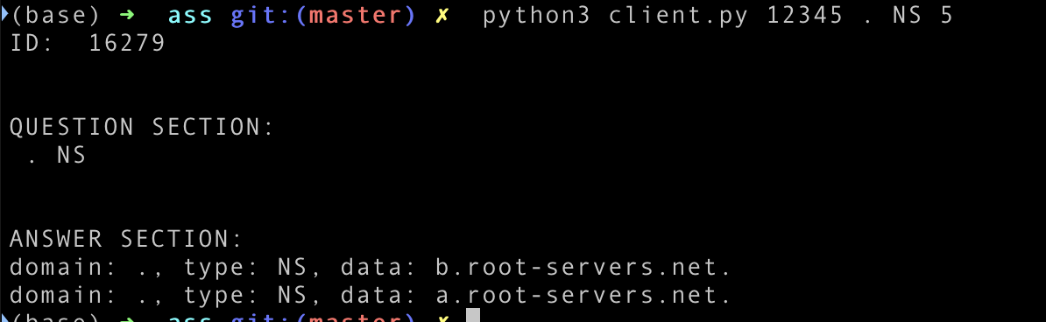

server output:



1. **bar.example.com. A**

client output:

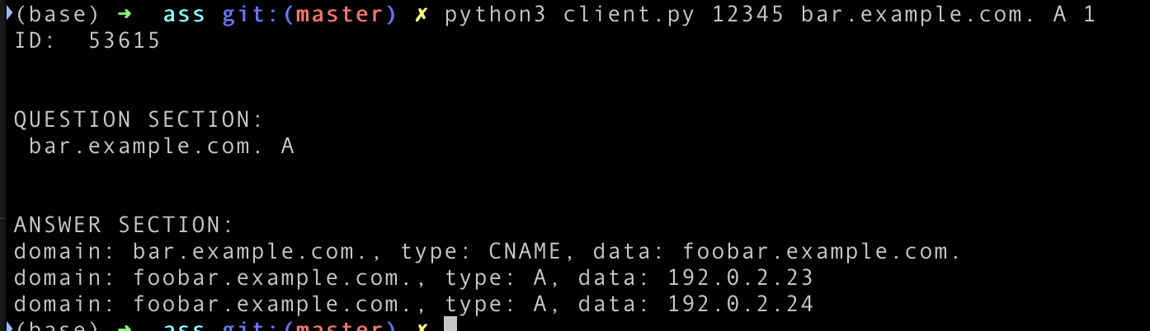

server output:



1. **foo.example.com. A**

client output:

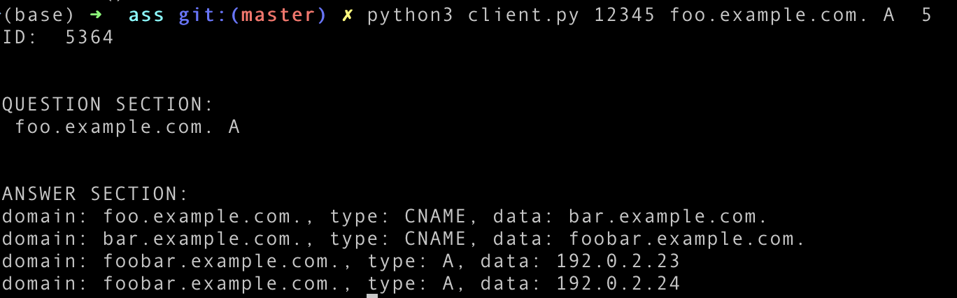

server output:

截屏2024-07-23 21.17.48

1. **example.org. A**

client output:

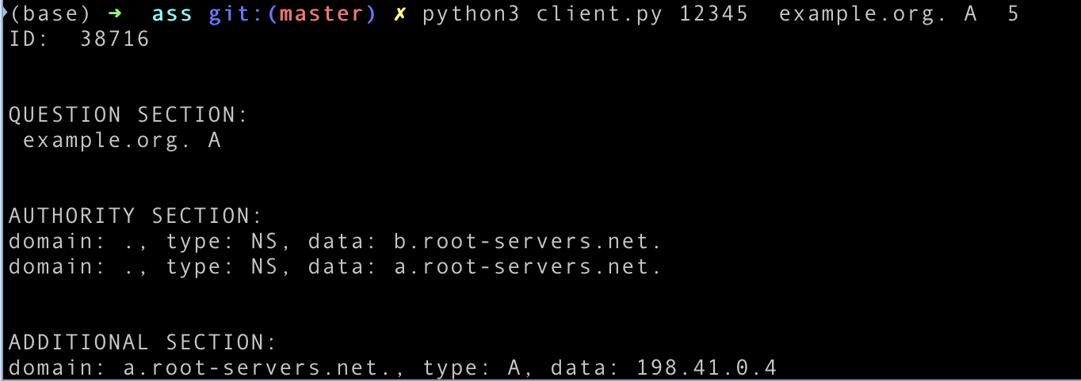

server output:



1. **example.org. CNAME**

client output:

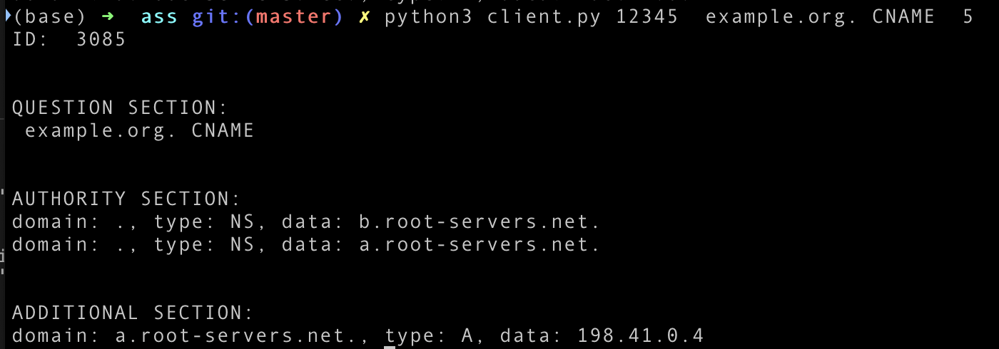

server output:



1. **example.org. NS**

client output:

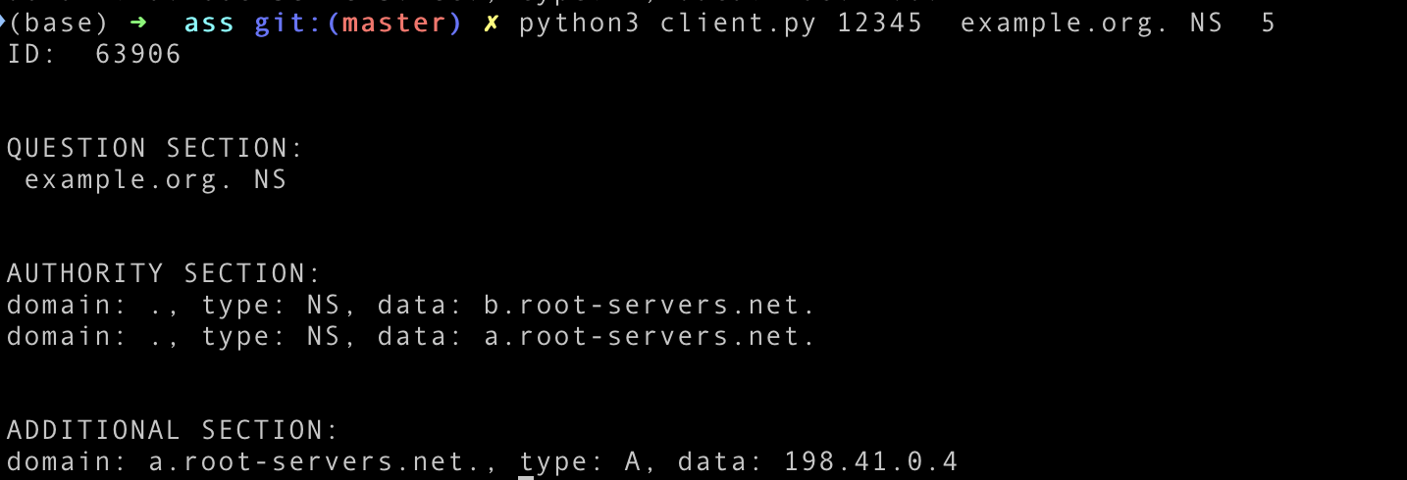

server output:



1. **www.metalhead.com. A**

client output:

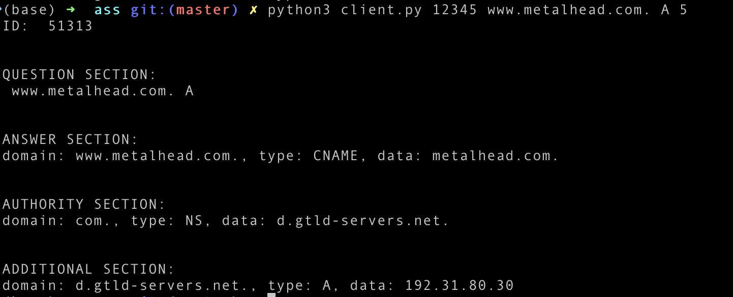

server output:

截屏2024-07-23 22.39.39