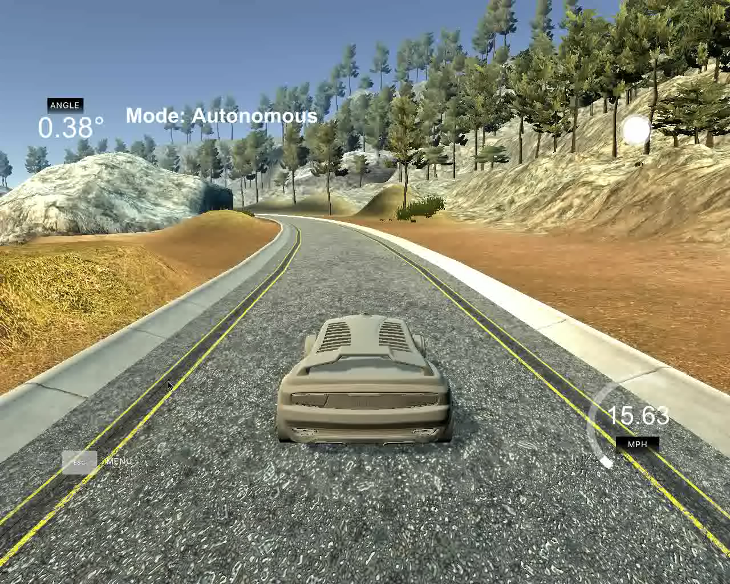**Reflection**

In PID.h, I defined a double array p[3] to represent the P, I, D component. p[0] is for P, p[2] for I, and P[1] for D. **P** is propotionl component, it makes car turn propotional based on CTE to move car closer to the reference trajectory; **D** is to reduce oscillation, so that the car won’t drive in left-right wave; **I** is to adjust system bias. These three components well, see the video below.

To adjust the P, I, D values, in main.cpp, these three values were set to default values given the lesson, 0.2, 3, 0.0004. Then I defined twiddle process in UpdateError method to adjust those values.

The twiddle process is based on a double array dp[3], the initial value set to about 5% - 20% of initial value of coefficients, 0.01, 0.1, and 0.0001. Since we are not creating robot in the project, instead, we are taking car's event, so I created two variables, currIdx, and step. currIdx is for the index to currently adjusting; step is for the three steps, step0 is to adjust p[currIdx] based on dp[currIdx], step1 is to check whether the increasing of p[currIdx] make error smaller, if it is smaller, increase the dp[currIdx], reset step to 0 and move to the next currIdx; if it is not, set step to 2 and minus the 2 * dp[currIdx] from p[currIdx]; In step 2, if the e

rror is smaller, increase dp[currIdx], otherwise, decrease it

. In both cases, reset step and move to the next CurrIdx;