Forensic Investigation Report
Precious Image

Date: 10-12-25
CSA201: Digital Forensics
Case Number: 1
By: Dylan Nelson

Executive Summary:
The purpose of this report is to gather information from the precious.E01 image to determine the user’s preferences. The evidence gathered proves the system to be running on Microsoft Windows XP and is configured to the Mountain Standard Time (MST) zone. The main user of the computer is Frodo Baggins and was actively using the web, communicating via email, listening to music, and creating and deleting files. Precious is said to be a typical computer user and not a hacker or criminal. Some of the files contained on the precious.E01 image challenge the idea they are a typical computer user and may show signs of criminal activity. The tools used to find the information are all open-source or free tools that anyone can use.

Tools Used:
Autopsy - digital forensics platform used to analyze hard drives or images of hard drives.
Registry Explorer – an enhanced Windows registry analysis tool used to examine and interpret registry hives.
Windows Event Viewer - used to view detailed logs of events on a Windows system
PicPick – used to edit photos so it is easier to see important information

Evidence Analysis:
Main User of Computer
Figure 1.1:
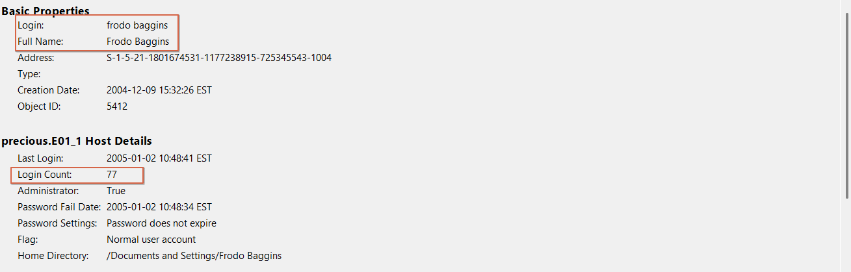
Figure 1.2: 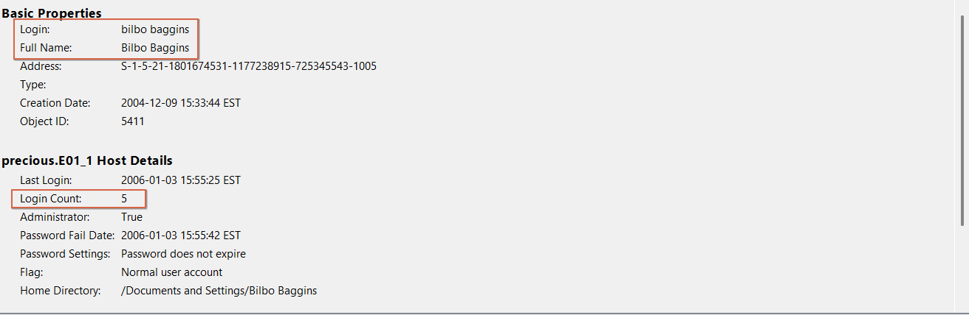
We can conclude that Frodo Baggins is the main user of the computer due to the login count on the computer. Figure 1.1 states that Frodo Baggins logged into the computer a total of 77 times, which suggests that he is the main user. Figure 1.2 shows us Bilbo Baggins logged into the computer 5 times, which is the second highest number of logins. Because Frodo Baggins logged in 77 times, and the next highest number of logins from Bilbo Baggins is 5, we can conclude that Frodo Baggins is indeed the main user of the computer.

System Information & Configuration
Figure 2.1: 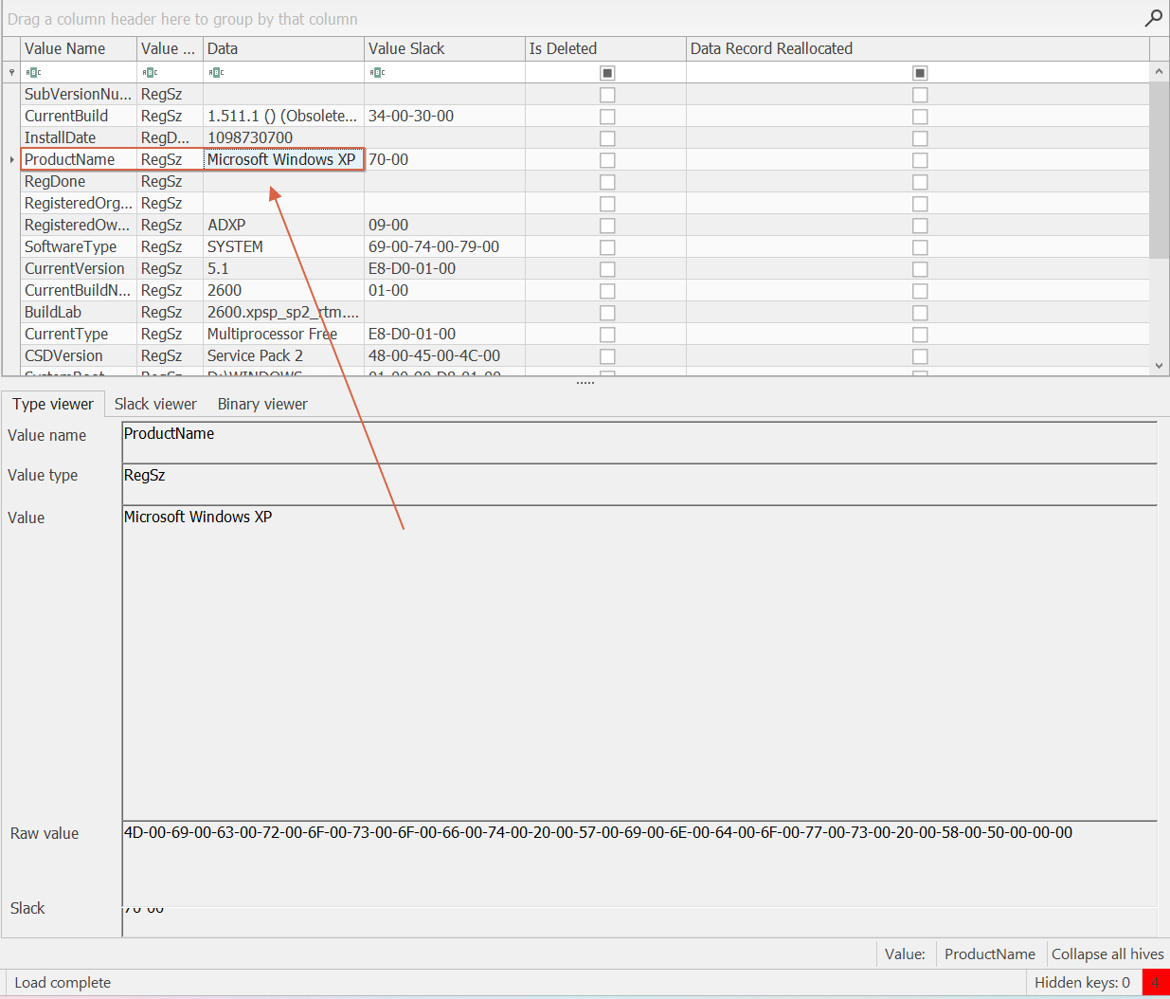
Figure 2.2: 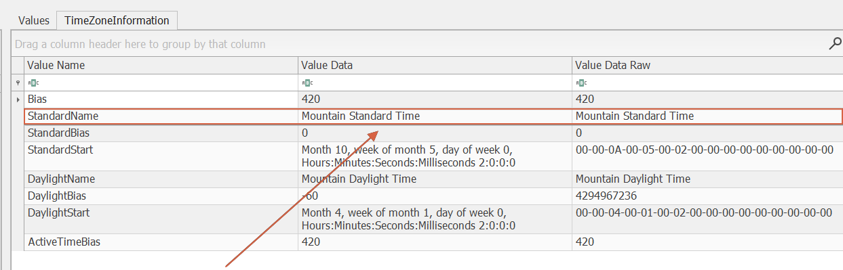
We know the version that the computer is running Microsoft Windows XP and is configured to the Mountain Standard Time (MST) time zone. Figure 2.1 provides us with information that the computer is running on Microsoft Windows XP. Figure 2.2 shows that the time zone the computer is configured to is Mountain Standard time.

USB Device History
Figure 3.1:
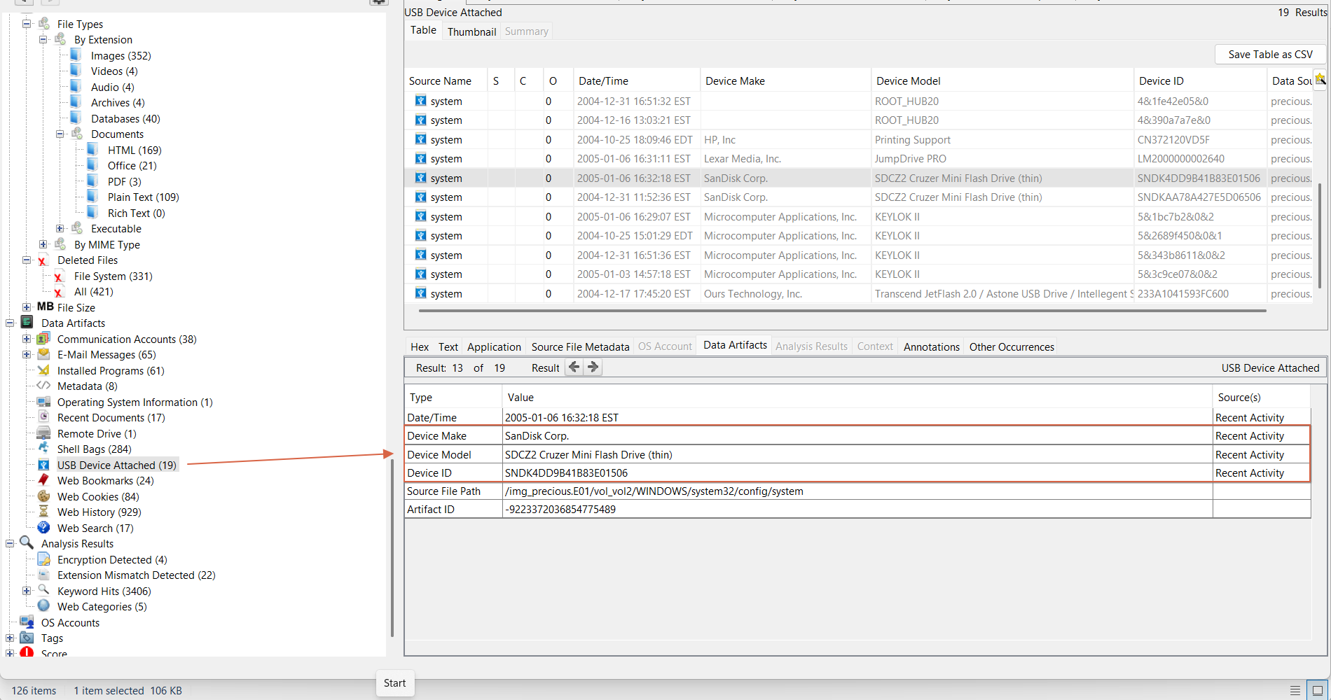
Figure 3.2: 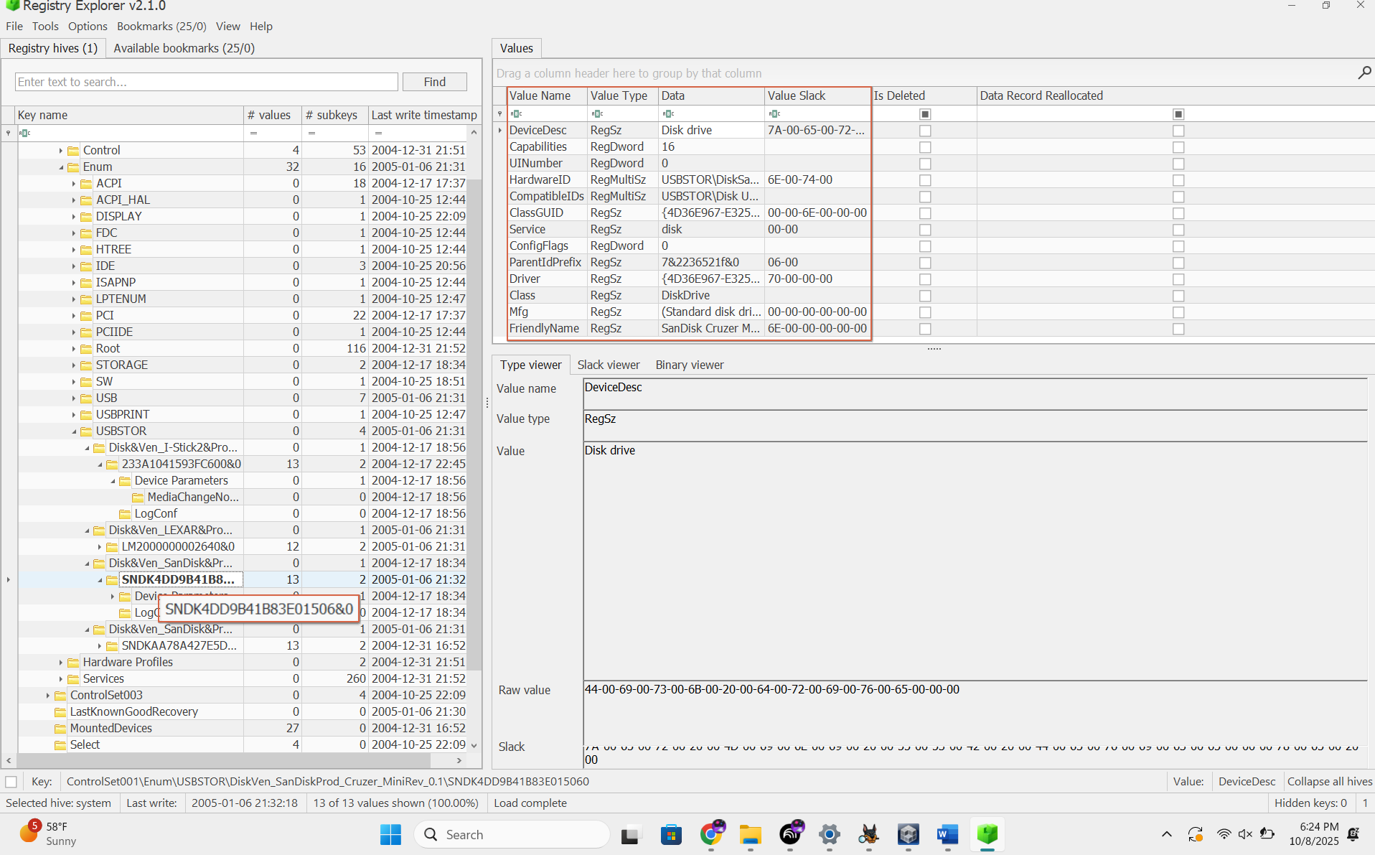
The USB device history proves the computer had at least one device connected to it. Figure 3.1 from Autopsy shows the device that was connected to the computer. Figure 3.2, from Registry Explorer, is located in the system file found in Autopsy, and is used to prove that the USB device Cruzer Mini Flash Drive with the serial number SNDK4DD9B41B83E01506 from the SanDisk Corp. was indeed connected to the computer.

Website Interests and History
Figure 4.1: 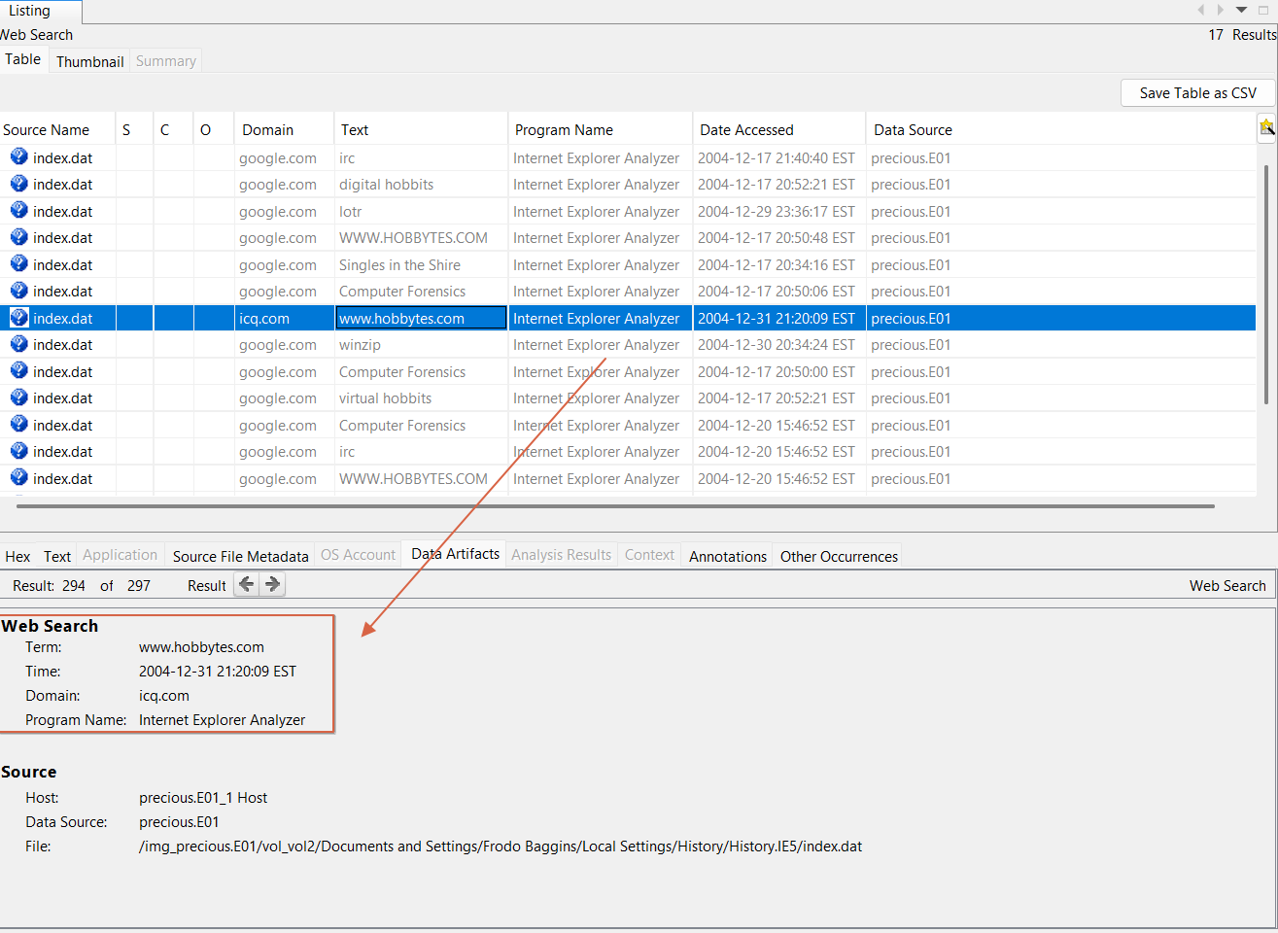
Figure 4.2: 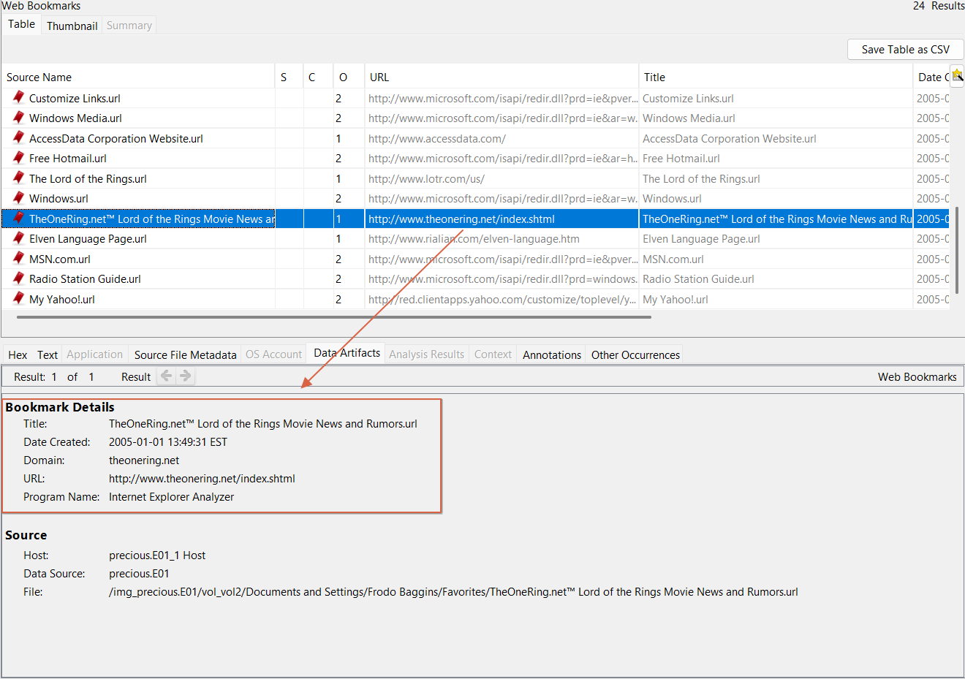
The above images provide information about the web history and websites that interest the user. Figure 4.1 shows the user accessing the website www.hobbytes.com and is found in the user’s web history. Figure 4.2 shows the user’s bookmarks which contains theonering.net and shows the user takes interest in Lord of the Rings.

Computer Email and Communication
Figure 5.1: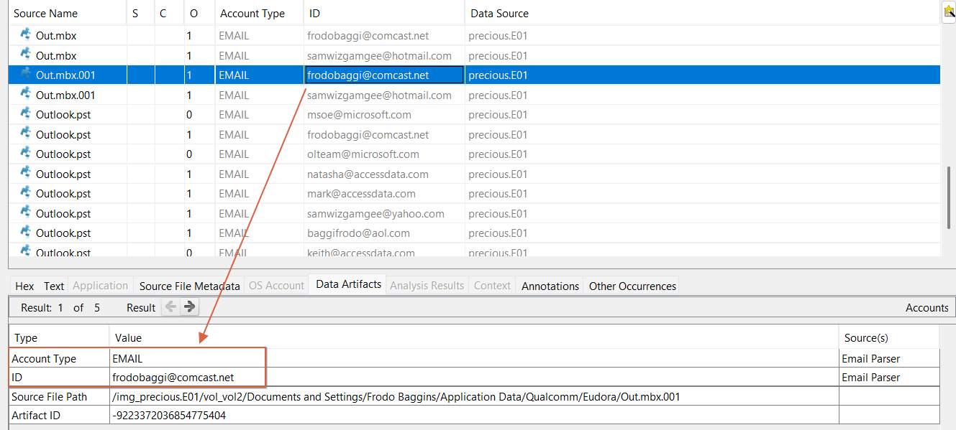
Figure 5.2: 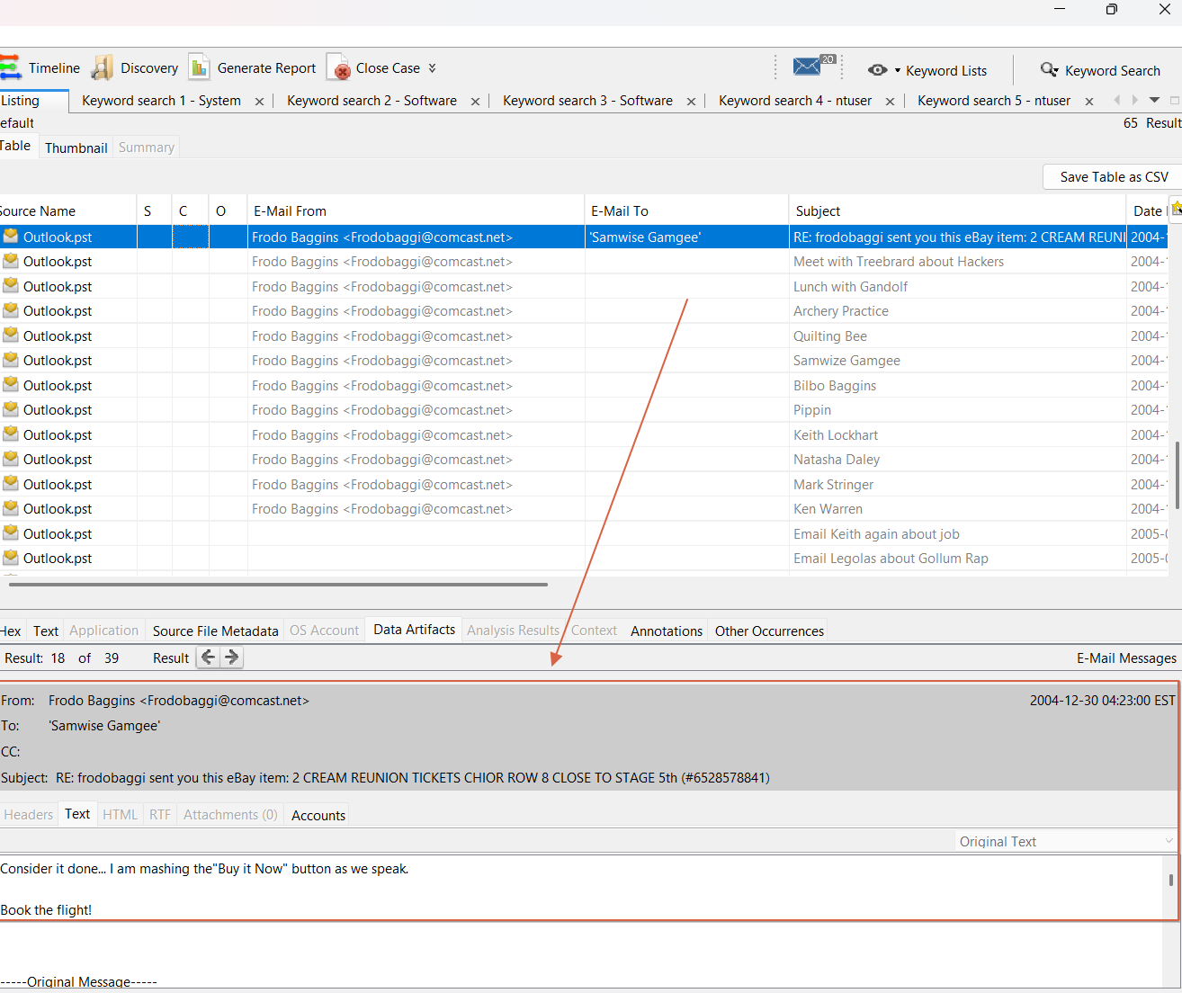
The images above provide an email address used on the computer as frodobaggi@comcast.net. Figure 5.1 provides information of the email address frodobaggi@comcast.net being used on the computer found in Autopsy. Figure 5.2 shows an email sent from the address of frodobaggi@comcast.net. This proves that frodobaggi@comcast.net is an email address within the computer, and was being used to send and receive emails.

Recent Documents Accessed on Computer
Figure 6: 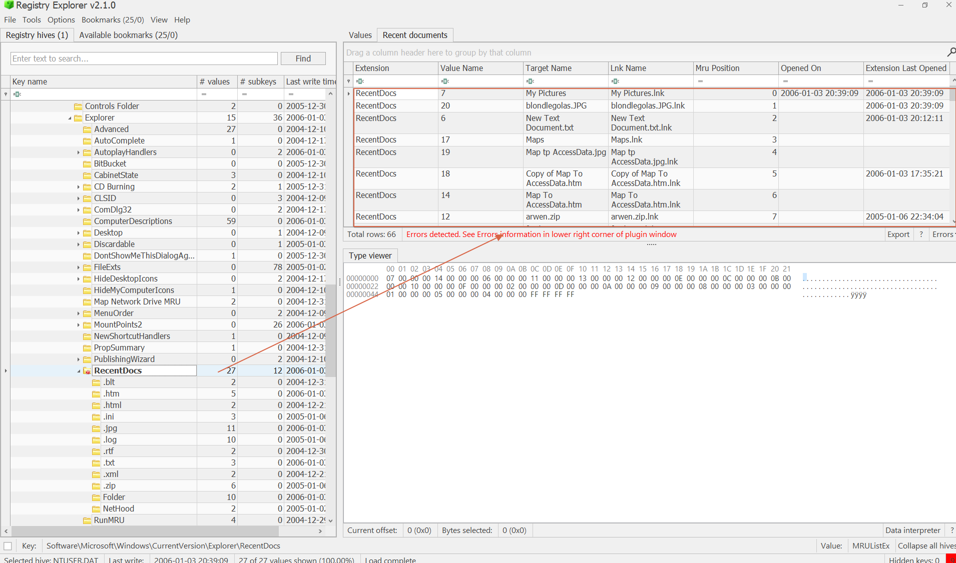
The above image in figure 6 shows documents that were recently accessed on the computer. Some of the documents that were accessed were images, text documents, and .Ink files. The recent files that were accessed were found by following the path NTUSER.DAT\Software\Microsoft\Windows\CurrentVersion\Explorer\RecentDocs on Registry Explorer which shows which documents were accessed, what kind of file it is, and the date and time it was accessed.

Meaningful Images Found on Computer
Figure 7.1: 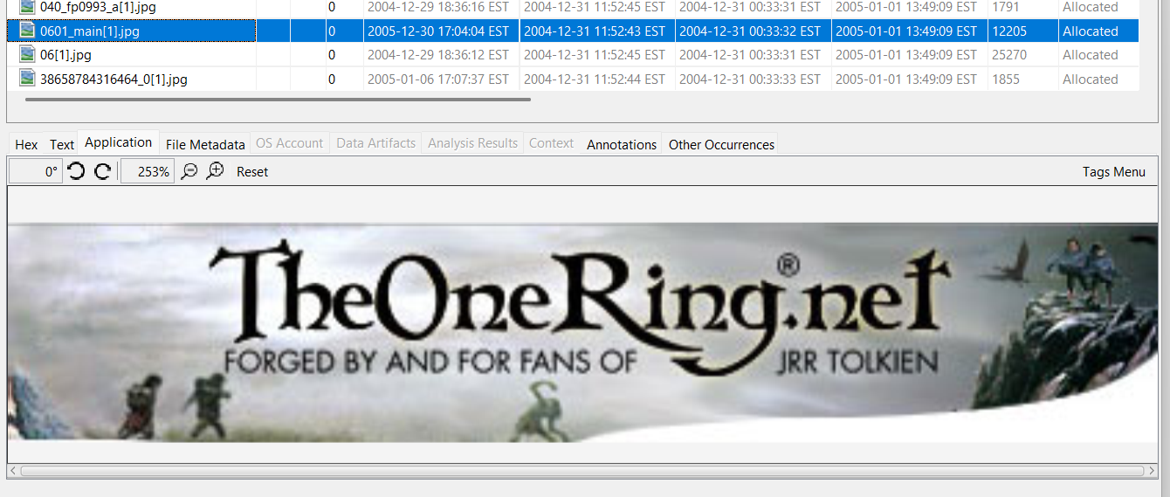
Figure 7.2: 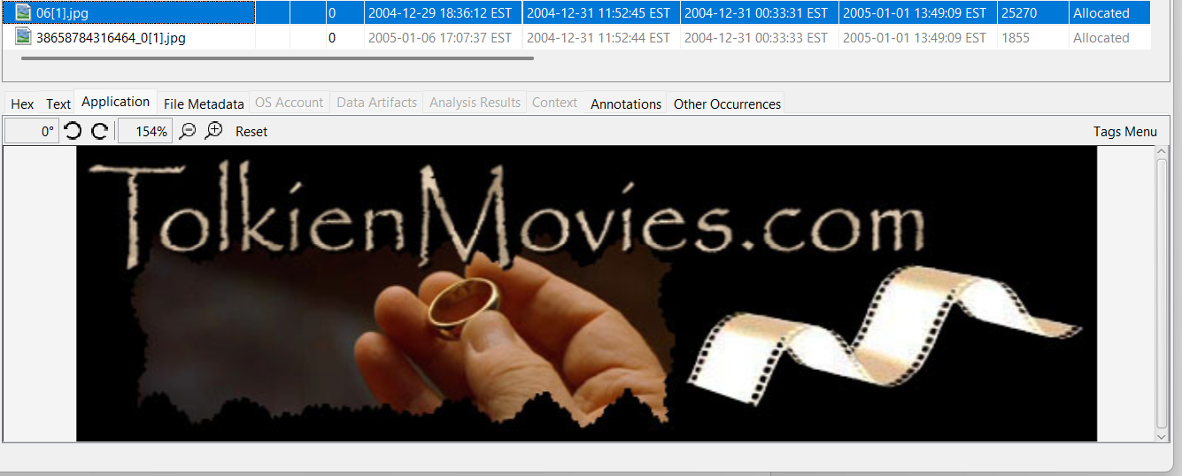
Figure 7.3: 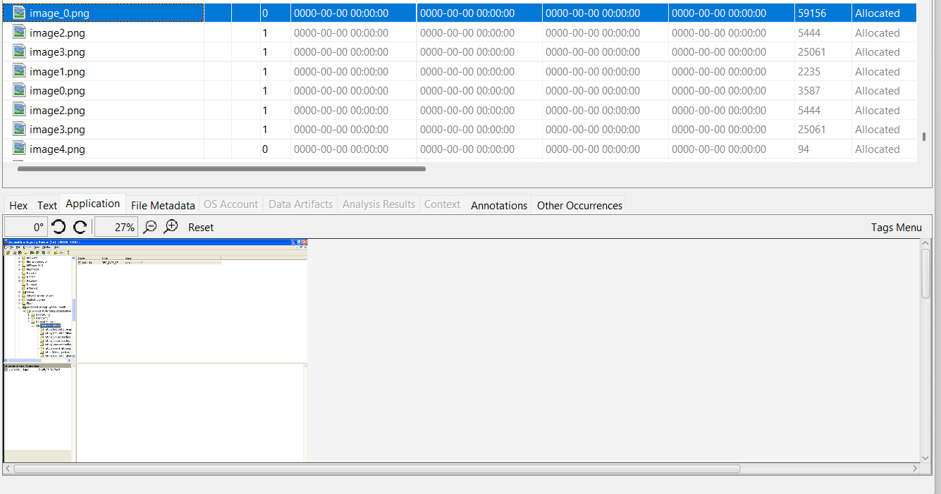
The above images were found on the computer and are extremely important. Figure 7.1 is an image of a link to the website TheOneRing.net which is related to Lord of the Rings and could be a pirating website. Figure 7.2 also shows an image of the link TolkienMovies.com which is related to Lord of the Rings and could also be a sign of pirating movies. Figure 7.3, however, shows an image of the user accessing files in a registry viewer, which could indicate that they know more than the average user about computers. The images prove to be meaningful because they could indicate that the user is pirating movies and that they know more than the average user.

Installed Software on Computer
Figure 8: 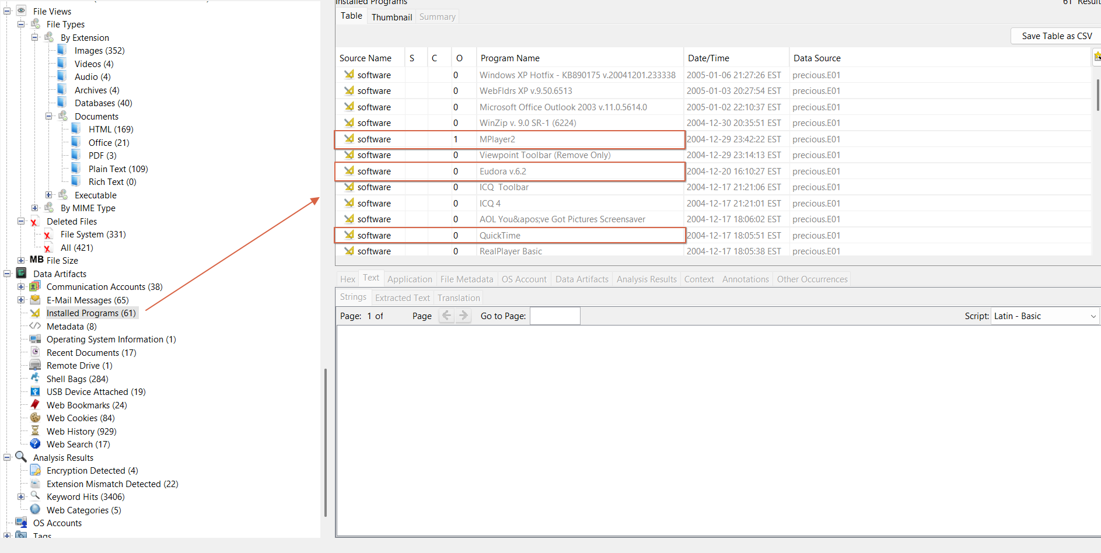
The image in figure 8 shows a list of installed software found on the computer as well as the date and time they were installed. The first highlighted software is MPlayer2, which is used as a media player and suggests that the user listens to music or watches videos. The second highlighted software is Eudora, and it is used as an email communication software, which shows the user was communicating via email. The final highlighted software is QuickTime which is used to play, stream, or edit audio and video, which indicates that the user was more than likely editing video or audio.

Last System Boot Record
Figure 9: 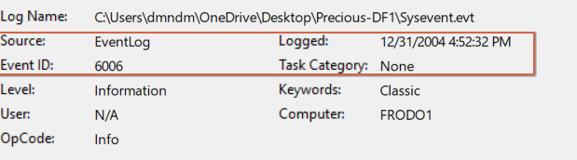
The image in figure 9 shows the last time that the user Frodo Baggins shutdown the system. The date and time that the computer was last shut down was 12-31-2004 at 4:52 PM MST. We know that this is the last time the system was shutdown because of the event ID 6006, the event ID 6006 is a “clean expected shutdown,” and it took place at the given time.

Recovered Deleted File
Figure 10.1:
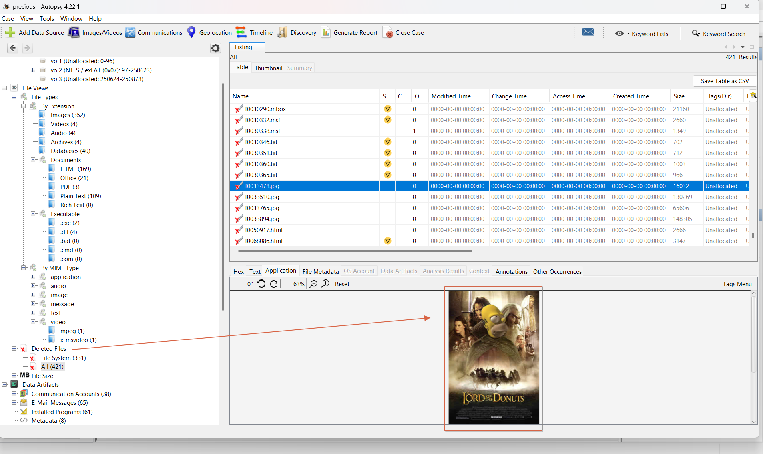

Figure 10.2:

The above images show the deleted file being found on Autopsy and then the image being extracted and pasted straight into the document. Figure 10.1 shows where the image was found and what the image was. Figure 10.2 is the image from Autopsy that was extracted and recovered. The images prove there are files on the computer that were deleted but still recoverable.

Other Interesting Evidence
Figure 11
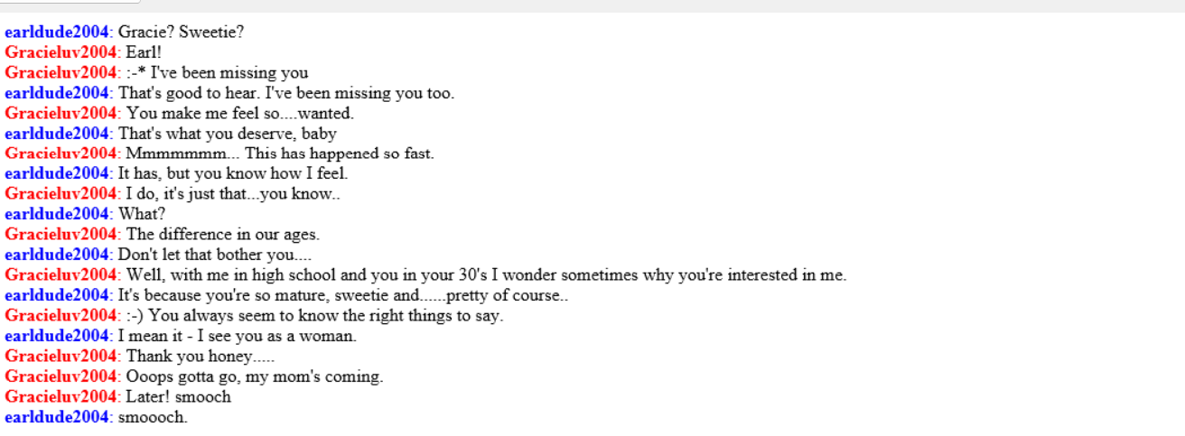
The image in figure 11 was found in the deleted files of the computer. The image indicates that the user is 30 years old and is privately messaging a person in high school. This evidence is interesting because we are led to believe that it is a typical computer user and not a criminal. This suggests that something criminal could have taken place and evidence was left on the computer.

Music Found on Computer
Figure 12.1: 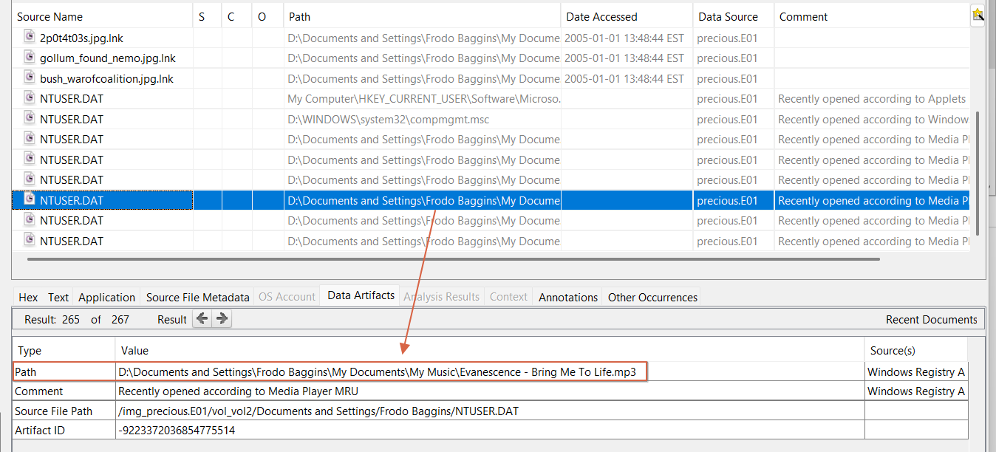
Figure 12.2: 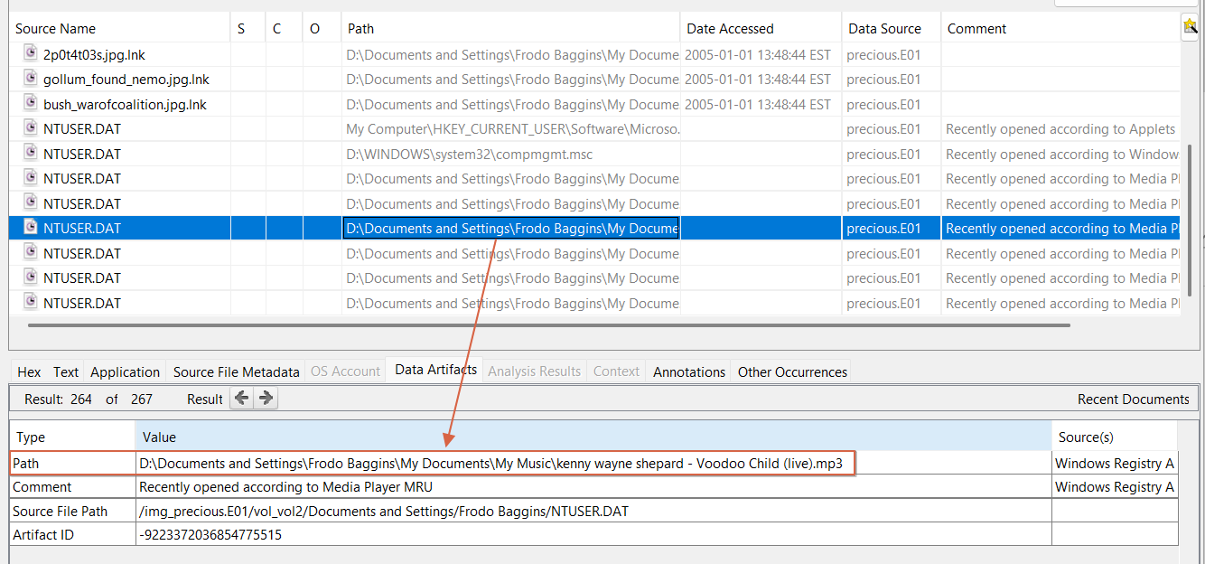
Figure 12.3: 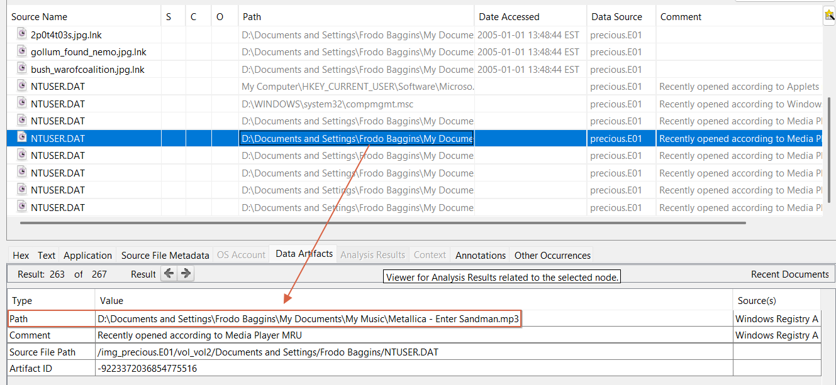
Figure 12.4: 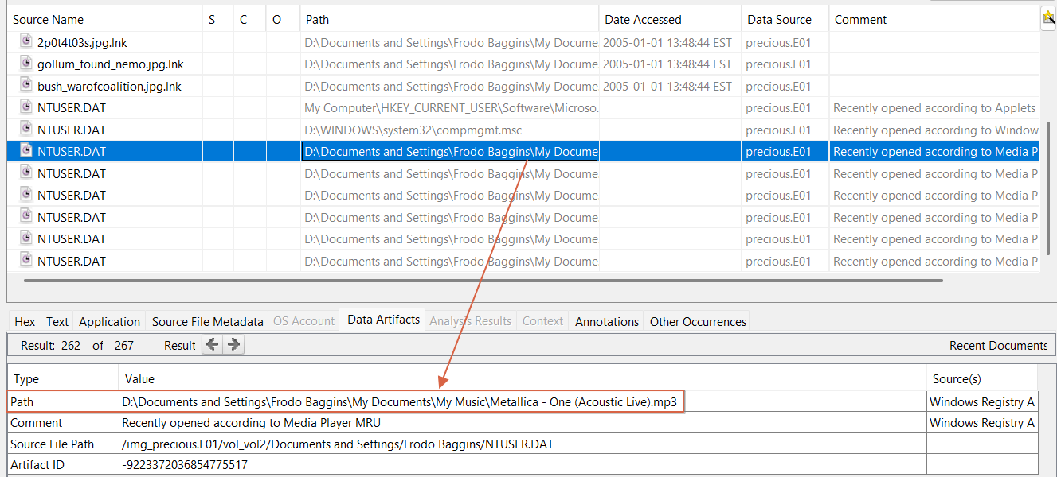
The images provided above suggest the user has an interest in rock or metal style music. Figure 11.1 Found in the NTUSER.DAT contains the .mp3 of the song Bring Me To Life by Evanescence. Figure 11.2 also found in the NTUSER.DAT has the .mp3 file of the song Voodoo Child by Kenny Wayne Shepard. Figures 11.3 and 11.4 show the .mp3 file of the songs One and Enter Sandman by Metallica. Because all the songs found on the computer are rock style, we can conclude that the user has an interest in rock style music.

Timeline of Evidence
Date: | Time: | Activity:
10/2/2025 | 2:49 PM EST | “SYSTEM.DAT” file was found and exported.
10/2/2025 | 2:53 PM EST | “system” file was found and exported.
10/2/2025 | 2:58 PM EST | “software” file was found and exported.
10/2/2025 | 3:12 PM EST | Time zone configured was found and documented.
10/2/2025 | 3:15 PM EST | Email address used was found and documented.
10/2/2025 | 3:19 PM EST | Email sent from same address was found and documented.
10/2/2025 | 3:43 PM EST | Computer OS and version were found and documented.
10/8/2025 | 6:24 PM EST | Evidence of USB device connected was found and documented.
10/8/2025 | 6:27 PM EST | Website being accessed was found and documented.
10/8/2025 | 6:45 PM EST | “NTUSER.DAT” file was found and exported.
10/8/2025 | 6:51 PM EST | First interesting image was found and documented.
10/8/2025 | 6:51 PM EST | Second interesting image was found and documented.
10/8/2025 | 6:54 PM EST | Third interesting image was found and documented.
10/9/2025 | 3:39 PM EST | “Sysevent.evt” file was found and exported.
10/9/2025 | 3:41 PM EST | Last system shutdown event was found and documented.
10/9/2025 | 3:47 PM EST | Deleted photo was found and recovered from the system.
10/9/2025 | 3:52 PM EST | Information about who is the main user was found and documented.
10/10/2025 | 1:50 PM EST | Website that shows personal interest was found and documented.
10/10/2025 | 1:55 PM EST | Deleted chats containing possibly incriminating evidence are found and documented.
10/10/2025 | 1:57 PM EST | Many different programs installed on the computer were located and documented.
10/10/2025 | 2:05 PM EST | Evidence of the user listening to music was found and documented.

Conclusion
In conclusion, this report provides evidence found on the precious.E01 image. The system was running on Microsoft Windows XP and was configured to MST., and the main user on the computer was Frodo Baggins. The user is said to be a typical computer user and not a hacker or criminal. This seems to be true through typical user activity such as web browsing, communication via email, listening to music, and creating and deleting files. The user also seems to have a strong interest in the movie series Lord of The Rings. However, images above show that non-typical user activity appear on the computer, and some potential criminal activity such as accessing files in the Windows registry, possible saved pirating websites, and potentially incriminating chats between a 30-year-old and a high school student.

