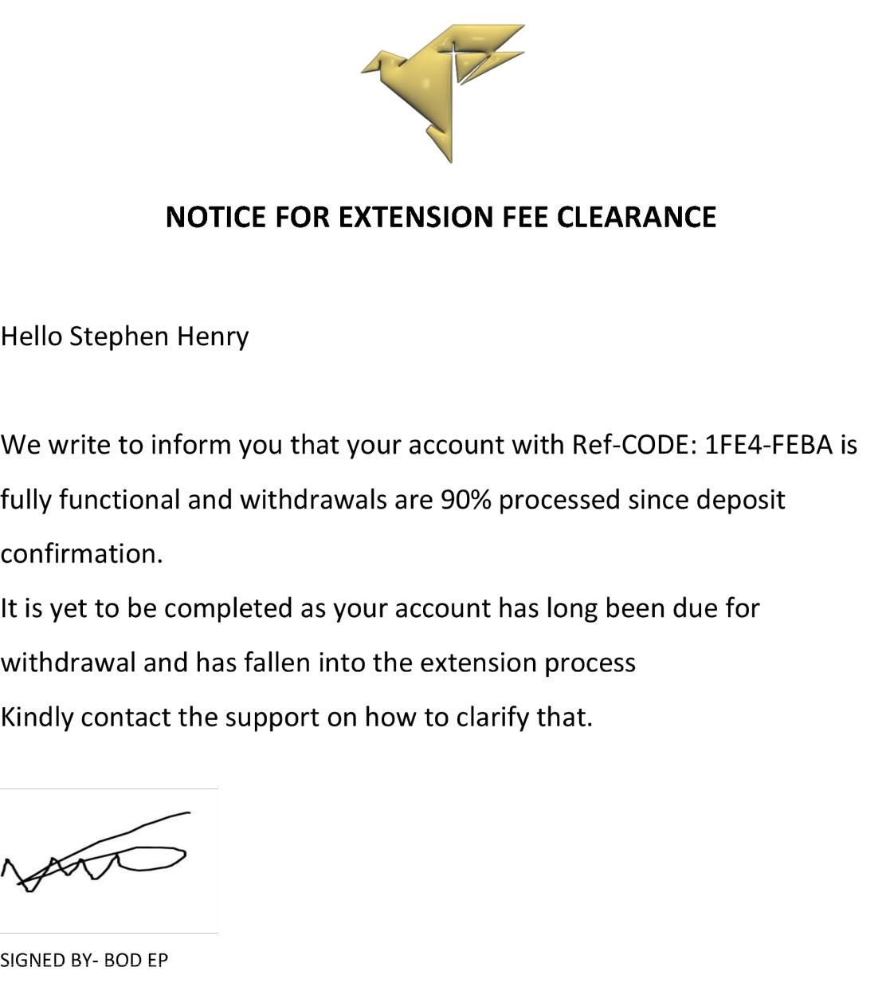

**Urgent: Final Steps for Withdrawal and Tax Fee Clearance**

Hello Investor Stephen,

Your pending withdrawal case has been brought to the attention of the board of directors. Please be aware that your funds, including all profits and refundable deposits, are ready for disbursement pending the provision of your receiving address and the clearance of the pending tax fee. The tax fee is not beneficial to us; as you know, every transaction resulting in earnings is a taxable event. You need to pay tax on your income from the crypto assets trading investment in almost every country in the world.

There is no additional deposit required for the tax fee.

We await your cooperation for the full disbursement of your funds. Thank you for your consideration.

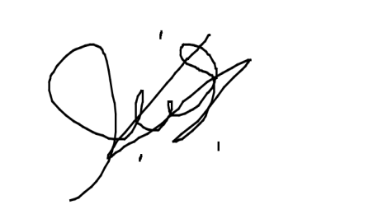

B.O.D ( Borad of Directors)