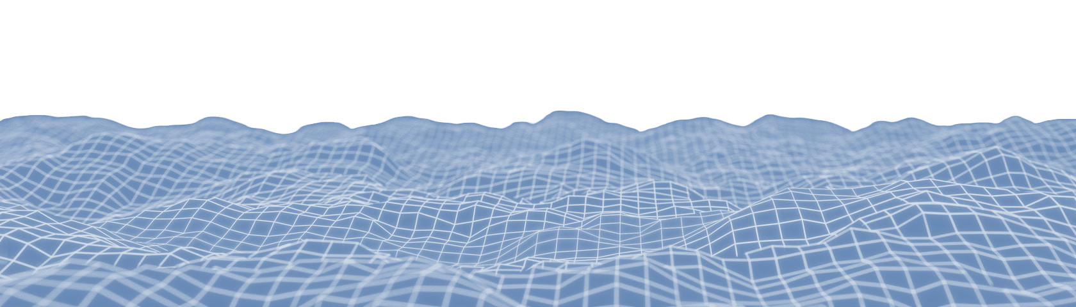
Dominic Barbuto

518-415-8774
dominicabarbuto@gmail.com
Portfolio
Game Developer
OBJECTIVE
As a versatile game developer, I'm driven to blend my programming and artistic knowledge to craft immersive worlds, delivering memorable gaming experiences that resonate with players.

SKILLS
Languages & Software
- C/C++, C#, Java
- HLSL
- Visual Studio, RenderDoc, DirectX 11/12, Vulkan
- Unreal Engine, Unity
- Git, Perforce
- JIRA, Confluence, Trello

Areas of Expertise
- Game engine fundamentals
- 3D math, graphics, and real-time rendering
- Rapid prototyping and optimization
- Gameplay logic and animation systems
- Data-driven asset management
- User interface frontend and backend

PROJECT EXPERIENCE
Lead Programmer | Drenched in Midnight | 1-Bit Game Jam | Horror | 08/2023 (1 Week)
Built with Unity | Team size of 2
Watch out for the vicious scream stalkers that only come out in the rainy darkness in this weird and creepy horror.
Did all level design and most gameplay systems including game loop, player and AI controller, and player interactions.
Wrote custom HLSL post-processing effects utilizing multiple render passes to achieve old-school pixelated visuals.

Lead Animator | Guardian of Root | Global Game Jam | 2.5D Platformer | 01/2023 (1 Week)
Built with Unity | Team size of 2
The natural, organic world has been taken over by robots and it is up to you, a goo-jerm, to restore nature to its roots.
Tasked with texturing, rigging, animating, as well as all UI and most player/AI mechanics.

Systems Programmer | Infinity Field | Full Sail Mid-Capstone | Sci-Fi Shooter | 01/2023 (2 Months)
Built with Unity | Team size of 6
A fun, first-person linear sci-fi shooter filled with a wide variety of enemies, weapons, and level aesthetics.
Tasked with handling core gameplay, visuals, animation, and overall player experience. Very rapid work pace.
Gameplay & AI:
- 3 unique boss fight scenarios and boss behaviors via state machine design pattern.
- Interactable doors, elevators, vending machine shops. Breakable/lootable props and hazardous environments.
- Different actions and behaviors for each weapon and player character type.
- Enemy squad communication, line-of-sight detection, player’s last known location, intricate enemy wave system.
Art & UI:
- Textured 6+ weapons, 6+ enemy types with multiple variations.
- All UI including menus and HUD. Main menu cutscenes, menu navigation, and audio.
Animation:
- Custom rigs and animations for all unique enemy types with foot/hand IK pinning.
- Unique weapon switch, shoot, and reload animations for each weapon type.
- Duplicated/converted third-person humanoid enemy rig and animations for the player’s first-person arm rig.
- Complex animation controllers and smooth transitions between various blend trees and states.

EDUCATION CERTIFICATIONS
Full Sail University | Winter Park, FL | 11/2023
Unity
- Certified Associate: Programmer
- Certified Associate: Game Developer
- Certified User: Programmer
- Bachelor of Science | Game Development
- Course Director Award: Programming II
Hudson Valley Community College | Troy, NY | 12/2021
- Associate of Science | Computer Information Systems
- President’s List Award & Dean’s List Award

