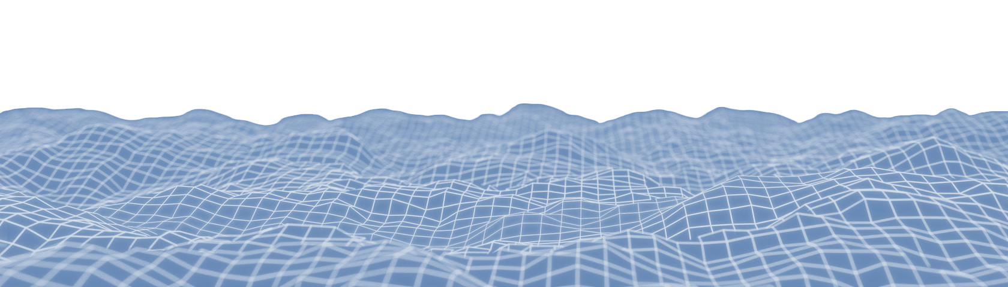
Dominic Barbuto

518-415-8774
dominicabarbuto@gmail.com
www.dominicbarbuto.com
Entry-Level Game Developer
OBJECTIVE
As a versatile game developer and software engineer, I'm driven to blend my programming expertise and artistic knowledge to craft immersive worlds and deliver memorable gaming experiences that resonate with players. I am a soon-to-be graduate who is enthusiastic about finally entering the game industry.
SKILLS
Game Design and Development
- Robust custom game engine systems
- Unreal Engine – C++ and Blueprint
- Unity

API’s
- DirectX 11/12, OpenGL
- FLECS (Fast-Lightweight Entity Component System)
- Dear ImGui
- wxWidgets
Programming
- C/C++, C#, Java
- HLSL, GLSL
- Python
- SQL
- HTML, CSS, XML

Software
- Visual Studio, RenderDoc
- Git, Perforce
- JIRA, Confluence, Trello
- Microsoft Office & Google Docs
- MARS MIPS Assembler
- MATLAB, Jupyter Notebook
- MySQL Workbench
- Adobe Photoshop, 3D Substance Painter
- Blender, Maya
- Audacity
Areas of Expertise
- Graphics and rendering
- 3D mathematics
- Gameplay systems – design and implementation
- Asset pipeline - 3D modeling, texturing, rigging/animation
- User interface frontend and backend

PROJECTS & EXPERIENCE
Drenched in Midnight, 1-Bit Game Jam (Team Size of Two)
- Gameplay and UI programmer. Custom shader work for old-school visuals. Unique theme and fun game loop, heavily inspired by Death Stranding. Made with Unity and relased on itch.io
Guardian of Root, Annual Global Game Jam (Team Size of Two)
- Gameplay, UI, and Audio programmer. 2.5D platformer. Made with Unity.
Infinity Field, Full Sail Mid-Term Project (Team Size of Six)
- Primary Gameplay and UI Programmer, Texturer, Animator, Audio Engineer. Heavy emphasis on custom assets and animations with several fully rigged characters and weapons.
- First-Person Sci-fi action shooter, developed over the course of two months. Made with Unity and released on itch.io

CERTIFICATIONS & AWARDS, Credentials Found on LinkedIn
Course Director Award: Programming II, Full Sail University Issued 05/2023
Unity Certified Associate: Programmer, Unity Technologies Issued 10/2022
Unity Certified Associate: Game Developer, Unity Technologies Issued 09/2022
NSCS Member, The National Society of Collegiate Scholars Issued 08/2022
Unity Certified User: Programmer, Unity Technologies Issued 08/2022
Dean’s List, Hudson Valley Community College Issued 12/2021
President’s List, Hudson Valley Community College Issued 12/2019
EDUCATION
Full Sail University
- Bachelor of Science in Game Development Graduate 11/2023
Hudson Valley Community College
- Associate of Science in Computer Information Systems Graduated 12/2021

