Programming Languages Assignment 1

Dominic Critchlow

1.

(a*) a_string* -> a b*

(b) *b_string* -> a (b|c)*

(c) *a_string* -> “ (*normal_char*\* |ε ) ”

2.

(a)

*S* -> *string* | ε

*string* -> ab| a *string* b

(b)

*s-expr* -> atom| *(string)* | (s-expr)

string -> atom| atom string | ε

3.

(a) *expr* => *expr add_op term*

=> *expr add_op factor*

=> *expr add_op* id

=> *expr* + id

=> *term mult_op factor* + id

=> *term mult_op* id + id

=> *term* * id + id

=> *factor* * id + id

=> id * id + id

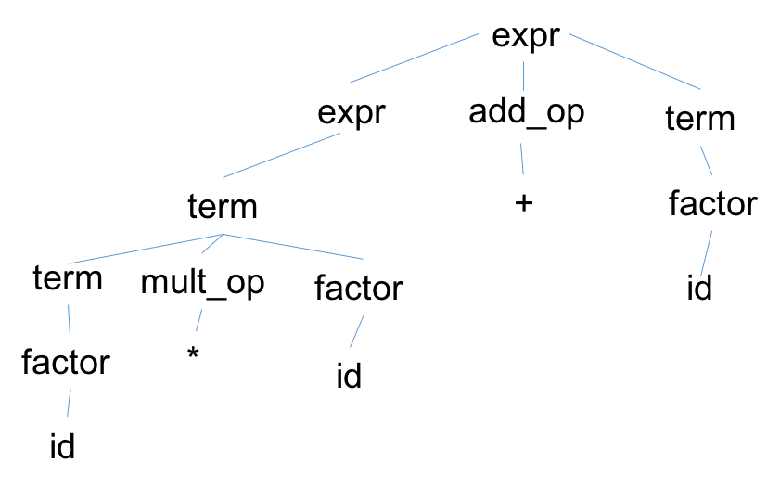

(b)expr => *term*

*=> term mult_op factor*

=> *term mult_op ( expr )*

*=> term mult_op ( expr add_op term)*

=> *term mult_op ( expr add_op factor )*

*=> term mult_op ( expr add_op* id)

=> *term mult_op ( expr* + id)

=> *term mult_op ( term* + id)

=> *term mult_op ( factor* + id)

=> *term mult_op* (id + id)

*=> term* * (id + id)

=> *factor* * (id + id)

=>id * (id + id)

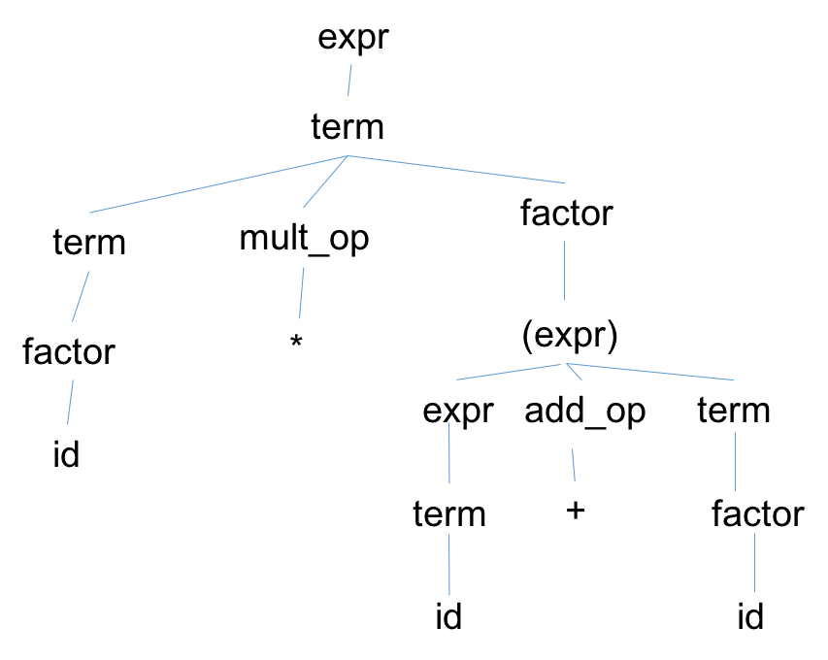

(c) They are different because of the order of operations where the two id’s on either side of the addition sign are kept together because of the parentheses. This makes the tree look right leaning instead of left leaning where the multiplication takes place first.