1. Extract the contains of SQLServerToAzure.zip in a temporary directory (such as C:\temp\SQLServerToAzure).
2. Extract the contains of Example.zip in a temporary directory (such as C:\temp\SQLServerToAzure\scripts).
3. Load the Creation.sql script in SQL Server Management Studio and connect to your instance.
4. Press CTRL+Shift+M (or go to the Query menu and select Specify Values for Template Parameters…):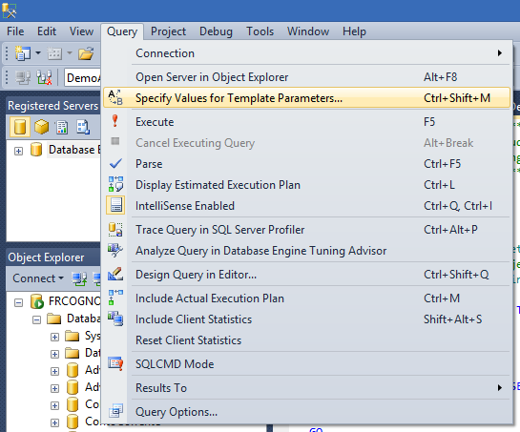
5. Specify the parameters. At very least specify the DLL location (as extracted at step 1) in the full_file_path: 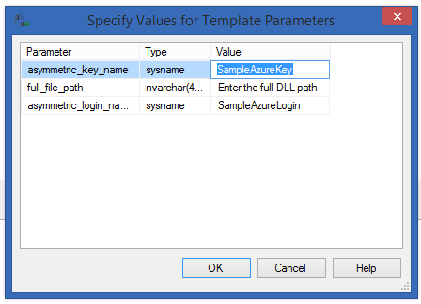
6. Execute the script. It will create a new DB called DemoAzureCLR and load the assembly in it.
7. Close the Creation.sql script
8. Open the SampleExecution.sql script in SSMS and connect to the same instance as before.
9. As before, Press CTRL+Shift+M (or go to the Query menu and select Specify Values for Template Parameters).
10. The parameters to set are: 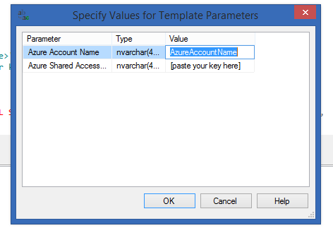

If you need to find the account name, go to your Azure management portal (<https://manage.windowsazure.com>), go to Storage and select an account to work with (you might need to crete one if none is present. To do so click new in the lower left corner). When you have your account selected click Manage Access Keys in the lower bar. A window will pop up with the required credentials: 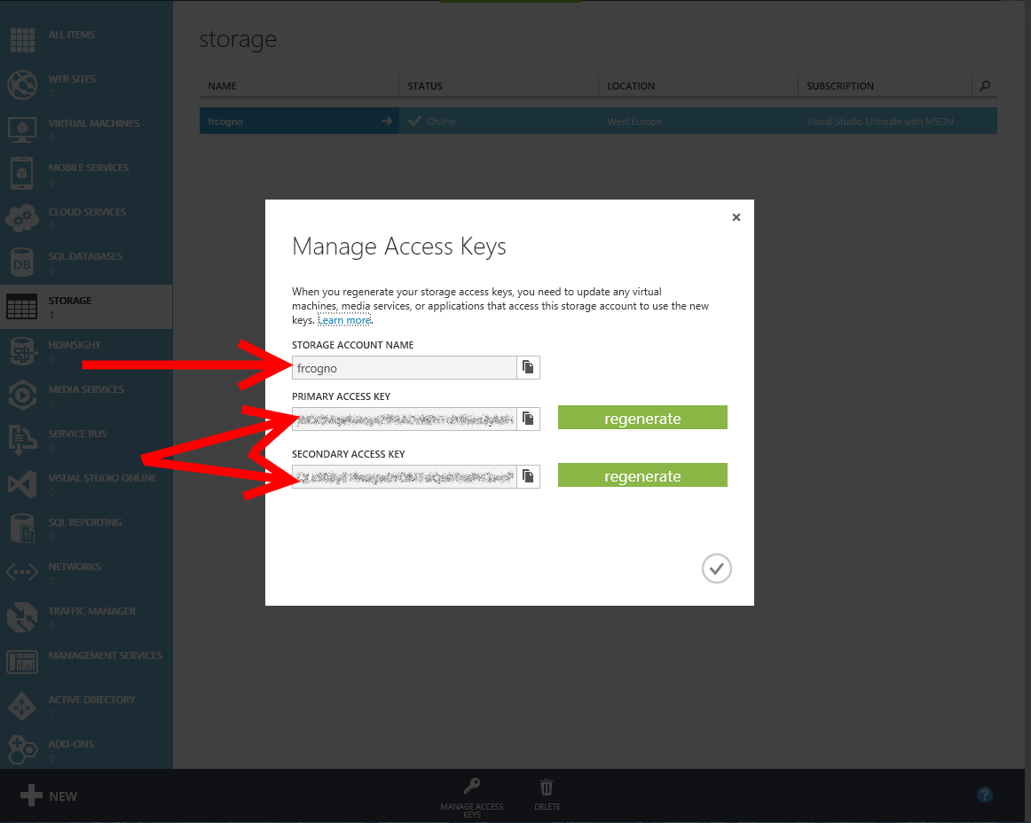

Susbitute those values in the SSMS parameter windowd and click ok.

1. Now execute the sample one statement at the time:
   1. The SELECT * FROM [Azure].ListContainers() will list your containers.
   2. The EXEC [Azure].CreateContainer will create a new public container with public blobs.
   3. The first SELECT [Azure].CreateOrReplaceBlockBlobFunction() will upload a SQL Generated txt file.
   4. The second SELECT [Azure].CreateOrReplaceBlockBlobFunction() will upload an image (make sure the path is correct, in the sample you find c:\temp\paperotto.jpg. correct if different).
   5. Now the last SELECT * FROM [Azure].ListBlobs() will show your blobs. Try as an example to copy-paste the URI in a browser to download the created blobs.

This ends our sample, if you want more please go to <http://blogs.technet.com/b/italian_premier_center_for_sql_server/> or write us.

Cheers,

Francesco