**Variation in behavioural responses of coral reef fish to CO2-induced aquatic acidification**

**Inter-individual differences in the response of a coral reef fish to CO2-induced aquatic acidification**

Dominique G. Roche1,2,*, Ben Speers-Roesch3, Josefin Sundin4,5, Timothy D. Clark6, Sandra A. Binning2,7,

*1 Fish Ecology and Conservation Physiology Laboratory, Department of Biology, Carleton University, 1125 Colonel By Dr., Ottawa, ON, K1S5B6, Canada.*

*2 Institut de Biologie, Éco-Éthologie, Université de Neuchâtel, Rue Emilie-Argand 11, 2000, Neuchâtel, Switzerland.*

*3 Department of Biological Sciences, University of New Brunswick, Saint John, New Brunswick, Canada.*

*4 Department of Neuroscience, Uppsala University, Uppsala, Sweden.*

*5**Department of Aquatic Resources, Swedish University of Agricultural Sciences, Drottningholm, Sweden*

*6 School of Life and Environmental Sciences, Deakin University, Geelong, VIC, Australia 3216.*

*7 Département de sciences biologiques, Université de Montréal, Montréal, Québec, Canada.*

**Keywords**animal personality, damselfish, Great Barrier Reef, ocean acidification, open field test, predation, novel object test, temperament

**Summary**

Ocean acidification (OA) has been shown to negatively impact a wide variety of fish behaviours including activity, exploration and response to predator chemical cues. However, many species naturally show large and consistent inter-individual differences in behaviour (sometimes referred to as animal personality). Whether stressors such as OA differentially impact individuals depending on their individual behaviour has rarely been tested. We recorded the behaviour of the coral reef damselfish, *Pomacentrus amboinensis*, in a novel environment assay before and after treatment with predicted end-of-century OA conditions, and then tested their survivorship in a predation experiment. RESULTS.

**Introduction**

The partial pressure of CO2 in the oceans has increased by ~45% over the past century, driving a process known as ocean acidification (OA) in which the pH of water is decreased (IPCC 2013). This phenomenon shows no signs of stopping: predictions suggest that CO2 levels at the start of the next century will attain those not seen in the last 30 million years (Lüthi et al. 2008). Research into the potential ecological and economic effects of this changing ocean chemistry on marine organisms and ecosystems has grown intensely, and paints a dire picture. Increasing OA will have dramatic effects on the ability of calcifying organisms such as coral and molluscs to build their skeletons, and alter key behaviours (Hofmann et al. 2010, Jellison et al. 2016, Watson et al. 2017, Mollica et al. 2018). Decreased water pH also reportedly has devastating negative effects on a range of fish sensory systems (i.e. olfaction, hearing, vision) and their associated behaviours (i.e. learning, lateralization, activity levels, boldness, anxiety, susceptibility to predation) (Reviewed in Tresguerres and Hamilton 2017, Esbaugh 2018). These findings have led to concern over the potential biodiversity loss and threat to marine ecosystem stability in the next century (Munday et al. 2010, Fabricius et al. 2014, Riebesell and Gattuso 2014).

Despite a large body of literature documenting the detrimental effects of OA on marine organisms, an increasing number of studies fail to find noticeable population-level effects of OA on coral reef fish behaviour (Sundin et al. 2017, Raby et al. 2018, Sundin et al. 2019). Indeed, physiologists have historically considered fishes robust to predicted end-of-century OA levels due to their well-developed acid-base regulatory system allowing them to maintain tissue pH under acidified condition (Ishimatsu et al. 2005). Nevertheless, individual responses to OA treatments vary, with some individuals apparently being more affected by low water pH than others (Tresguerres and Hamilton 2017, Esbaugh 2018, Sundin et al. 2019). Understanding the behavioural traits associated with increased susceptibility and/or resilience to OA is critical for predicting how selection will affect the phenotypic and genetic diversity of future populations.

Resilience of a species to environmental perturbations depends on variation in individual responses (Tuomainen and Candolin 2011). Indeed, phenotypic variation is an inherent biological trait and forms the basis for natural selection. Consistency in the phenotypic differences among individuals across time and contexts enables selection to generate an adaptive response across generations. Individual behavioural traits that are maintained across time and contexts are known as animal “personalities” (Wolf and Weissing 2012, Carter et al. 2013), and interest in understanding the implications of personality differences on trait evolution has grown over the last 20 years. Personality differences influence both the ways in which individuals interact with their environment as well as the outcome of biotic interactions such as predation, competition, parasitism, cooperation and mate-choice (Wolf and Weissing 2012, Roche et al. 2016). Thus, research interested in understanding how a species might respond to environmental stress should explicitly consider variability in individual responses rather than focusing on mean differences among treatment groups.

An increased focus on individual-level variation has major implications for predicting the effects of environmental changes on wild populations. Continuing the current emphasis on mean treatment effects of environmental stressors such as OA while ignoring variation around the mean is a missed opportunity for understanding the traits responsible for conferring resistance or tolerance to stressful conditions (Browman 2016, Killen et al. 2016). As such, behavioural ecologists are increasingly adopting a reaction norm approach to the study of trait variation in order to examine how personality and phenotypic plasticity are correlated and/or under selection in a given environment (Dingemanse et al. 2010, Dingemanse and Dochtermann 2013, Roche et al. 2016)(Fig. 1). Hypothetically, a population-level increase in a behaviour (e.g. activity level) due to OA can occur from all individuals increasing their activity score (Fig. 1Ai). Alternatively, a similar population-level effect might also be detected when only some individuals exhibit a marked increase in activity (Fig. 1Aii, iii): individuals that do not show a change in activity under OA conditions may be considered tolerant. Identifying tolerant individuals and their associated behavioural traits is a critical step in predicting how species will respond to future OA conditions.

Here, we studied inter-individual differences in the behaviour of the coral reef damselfish, *Pomacentrus amboinensis*, and explored how an individual’s behaviour in control conditions affects their response to OA. Importantly, we measured individual behaviour in a novel environment assay twice each before and after exposure to either elevated CO2 or control water. This enabled us to track individual-level changes in behaviour due to OA treatment as well as test for population mean-level effects of OA on the traits measured. We also performed a live predation experiment with the same individuals to explicitly test the effect of OA treatment on fitness while considering the influence of individual behavioural differences to the outcome. This is the first study with the explicit aim to understand how inter-individual behavioural variation affects resilience and susceptibility to OA while incorporating a direct test of the fitness consequences associated with behavioual changes due to CO2-induced acidification. Specifically, we asked the following questions: 1) is there a population level effect of CO2-induced acidification on fish personality? 2) Is there an individual-level effect of CO2-induced acidification on fish personality? 3) Is there a population level effect of CO2-induced acidification on fish survival in a predation trial? 4) Is there an individual-level effect of CO2-induced acidification on fish survival in a predation trial based on personality traits?

**Materials and methods**

***Fish collection***

Animals were collected and cared for under Marine Parks Permit no. G13/35909.1 issued by the Australian Government Great Barrier Reef Marine Park Authority. All experiments were approved by the Animal Experimentation Ethics Committee at James Cook University (permit no.: A1924) according to the Australian Code of Practice for the Care and Use of Animals for Scientific Purposes, 7th edition 2007.

All experiments were conducted in January 2016. Post-settlement juvenile *P. amboinensis* were collected by SCUBA divers on January 12-13 from lagoon reefs at Lizard Island on the northern Great Barrier Reef, Australia (14°40’ S; 145° 28’ E) using hand nets and a barrier net (10 mm stretch monofilament). Fish were transported within 90 minutes of capture to the aquarium facilities at the Lizard Island Research Station (LIRS) in 20L buckets containing seawater aerated with a battery-operated pump. Fish were weighed (Mettler Toledo PL602-S, d = 0.01 g) and measured for standard length in a water-filled plastic bag to the nearest 0.1 mm with calipers. Seventy-four *P. amboinensis* (33.1 ± 2.5 mm; 1.43 ± 0.35 g; mean ± SD) were held individually in 1 l flow-through plastic aquaria (17 × 12 × 7 cm, L × W × H) supplied with seawater pumped directly from the reef. Each aquarium contained a 4 cm long white PVC pipe for shelter. Fish were acclimated for three days prior to the experiments and fed daily with 0.5ml of a commercial fish flake-saltwater slurry per day (TetraMin Tropical Flakes, Tetra, Blacksburg, VA). All animals fed readily by day three post-capture.

***Experiment 1: behavioural trials***

We examined behavioural differences among *P. amboinensis* using a novel environment assay. This assay is a modified version of the open-field test in which an individual is introduced into an unfamiliar environment, where the environment also included a novel object (Carter et al. 2013, Roche et al. 2016). Each assay lasted 25 min and was repeated twice on each fish prior to the experimental treatment (two days between trials) and twice following the treatment (i.e. after 4 and 6 days of CO2 or control water exposure). Trials were conducted between 9:00-16:00 and the time of day was randomized across replicates to control for diurnal patterns in activity. Each trial was filmed (top view) with a digital camera. We presented a note with the fish and trial number at the start of each video to promote transparency and reduce observer bias (Clark et al. 2016, Clark 2017). Fish were transferred from their holding tank to the experimental arena using their water-filled shelter: they either entered their shelter when the experimenter approached their holding tank or were carefully placed into the shelter by the experimenter. This procedure minimized air exposure and reduced handling stress prior to introduction into the experimental arena. However, in instances where a fish was air exposed, we recorded the handling time to account for differences in handling stress prior to the start of the experiment.

The experimental arena (38 × 28 × 30 cm, L × W × H) had white, opaque sides and was devoid of structure other than a novel object fixed in the centre (Fig. 2A). Four novel objects were used (Fig. S1), each measuring approximately 2 cm in diameter and 8 cm in height. The object was changed when the assay was repeated, and the order of objects was randomized between fish and trials such that individual fish were presented with each object only once. The experimenter positioned the shelter and the fish at a fixed, pre-determined location in this arena (Fig. 2A) and exited the room for the duration of the trial. The fish was then free to exit its shelter and explore its surroundings over the 25 minute duration of the trial. Water height was maintained at 7 cm and the arena was emptied and rinsed between each trial. At the end of each trial, the fish was returned to its holding tank with its shelter.

To avoid observer bias (Marsh and Hanlon 2007, Holman et al. 2015), we extracted behavioural data from the videos using the automated tracking software ViewPoint (ZebraLab, Lyon, France). For each trial, we recorded: 1) emergence time (the time at which the fish’s entire body first exited the shelter); 2) activity level (the distance covered per minute after emergence), 3) sheltering (the time spent in the vicinity of the shelter; zone X in Fig. 1); 4) thigmotaxis (the time spent within 3 cm [approximately 1 BL] of the arena walls); 5) latency to approach the novel object (within 5 cm). The behavioural trait assessed by each metric is indicated in Table 1.

***CO2 exposure***

Once all individuals had repeated the behavioural assay twice, half of the fish (n = 37) were maintained in control water at present-day *p*CO2 (458 ± 17.9 μatm (mean ± SD)) and the other half (n = 37) were exposed to end-of-century *p*CO2 levels (1107 ± 170 μatm (mean ± SD)) during four to six days (Fig. S2). Previous studies report that 2 days of exposure is sufficient to detect behavioural impairments and that longer exposure durations (10 or 25 days) do not alter the response any further (Munday et al. 2010, Munday et al. 2013). Control aquaria received seawater at ~ 750 ml min-1 from one of two flow-through 32 L header tanks diffused with ambient air. CO2-treatment aquaria received water at ~ 750 ml min-1 from one of two additional aerated header tanks (32 L, flow-through) in where the *p*CO2 level was gradually increased over 24h using pH stat computers (Aqua Medic GmbH, Bissendorf, Germany) connected to solenoid valves regulating administration of 100% CO2. We monitored *p*CO2 in the header- and holding tanks daily using a handheld CO2 meter (Vaisala GMT 222, Finland) connected to an aspiration pump (Vaisala GM 70, Finland) and a submerged gas-permeable PFTE probe (Qubit Systems, Kingston, Canada; following Hari et al. 2008, Jutfelt and Hedgärde 2013). The Vaisala CO2 meter was factory calibrated prior to experiments (Vaisala, Finland). The experimental design and CO2-dosing system thus followed best practices for ocean acidification research (Reibesell et al. 2011, Cornwall and Hurd 2015). Complete water carbonate chemistry was calculated using the constants of Roy et al. (1993) and Dickson (1990) in CO2calc (Hansen, USGS, USA) (Table X).

Following a period of four days, we repeated the behavioural assay described in *experiment 1* on control and CO2-treated fish (Fig. S2). The assay was conducted in control or high CO2 water corresponding to each fish’s treatment. Each fish was again tested twice, with two days between trials.

***Experiment 2: predation trials***

We collected 22 *Cephalopholis microprion* (family Serranidae) from lagoon reefs nearby LIRS using hook-and-line. *C. microprion* is a common predator of small fishes on the Great Barrier Reef (Vail and McCormick 2011). Fish were transported to the aquarium facility in 20 L aerated buckets within two hours of capture and housed in large (~300 l) flow-through aquaria. We selected 14 individuals that began feeding within 12h of capture and moved them to individual 32 L aquaria (38 × 28 × 30 cm, L × W × H). Each aquarium contained a 12.5 cm long pvc pipe (55 mm diameter) providing shelter for the predator at one end of the tank (Fig. 2B). At the other end, we positioned six pieces of half pvc pipe (55 mm diameter) glued together to create a refuge for *P. amboinensis* (Fig. S3). This allowed us to standardize the refuge across all aquaria. The predator shelter and prey refuge were affixed to the bottom of the tank with silicone. To habituate *C. microprion* in these aquaria, we fed them cut pieces of pilchard during four days prior to the experiments. During this time, seven *C. microprion* were kept in present-day control water (508 ± 48.4 μatm (mean ± SD)) and seven were exposed to end-of-century *p*CO2 levels (1254 ± 300 μatm). CO2 dosing and measurements followed the procedures detailed in the *CO2 Exposure* section above. Two header tanks were used for each of the CO2 and control fish.

Predator trials commenced when experiment 1 had been completed (January 28). Twentyminutes before the onset of a predation trial, we introduced an opaque partition in the middle of the aquarium, restricting *C. microprion* to the area of the tank containing its shelter. One *P. amboinensis* from experiment 1 was introduced to the other half of the tank with its pvc shelter (Fig. 1B) and given a 20 minute exploration period. We then lifted the partition, and allowed the predator and prey to interact for 60 min. We filmed interactions with a GoPro camera mounted above the aquarium. Prey that were not consumed within 60 min were returned to their holding aquarium. Control and CO2-treated *P. amboinensis* were paired with a predator receiving the same experimental treatment using stratified randomization so that each predator received approximately the same number of prey, which spanned a range of behavioural scores. Each predator was tested between 5 and 6 times with different prey individuals. Each predator was tested once per day and fed XXX in between trials.

***Statistical analysis***

* Test for repeatability of behaviours in the controls
* Test for effect of CO2 on 3 most repeatable behaviours (GLM)
* Tests effect of personality and CO2 on probability of survival (survival analysis) – include a random factor to block by predator or a covariate if we quantify predator personality

All analyses were done in R 3.1.2 (R Development Core Team, 2014). The data and code for this study are publicly available in the repository Figshare (ref) following best practices for data archiving (White et al. 2013, Roche et al. 2015).

For the analysis of Experiment 1, we first checked the distributions of the behavioural measurements and determined appropriate transformations to meet the normality assumption of residuals for each behavioural measurement: 1) ‘activity’ level (square-root-transformed), 2) time spent in the ‘shelter’ (identity or no transformation), 3) ‘thigmotaxis’ (time spent close to the wall; square-root -transformed), 4) latency to approach ‘novel’ objects (log-transformed after adding 0.5), and 5) time to ‘emergence’ from the shelter (log-transformed). We used the R package, *lme4* (REF), to fit a linear mixed model (LMM) for each measurement with the following fixed effects: 1) ‘group’ (binary variable: control vs. treatment: CO2 exposure), 2) the sequence of ‘trial’ (ordinal variable from 1 to 4 with trials 3 and 4 being CO2 exposure for the treatment group), 3) the interaction between ‘group’ and ‘trial’, and 4) the ‘standard length’ of fish (continuous variable). The random effects for these LMMs included trial as random slopes and ‘fish identity’ as random intercepts. Then, we used the *brms* package (REF) to fit a double-hierarchical linear mixed model (DHLMM), which consisted of two parts: the mean (location) and standard deviation (scale) part. The location part of the DHLMMs was identical to the LMMs above, while the scale part had the fixed effects of group, trial and their interaction and the random effects of fish identity. The DHLMMs allowed us to investigate the effect of CO2 exposure on both mean and residual variance (or within-individual variance) (Cleasby et al. 2015; cf. O’Dea et al. 2022). In addition, we obtained the coefficient of variation for predictability (CVp), defined in Cleasby et al. (2015). CVp represents standardized variation in within-individual variance among individuals, whereas repeatability represents relative magnitude (0 to 1) of between-individual variance to the sum of between and within-individual variances.

We also used the *rptR* package (Stoffel et al. 2015) to calculate three different intra-class correlations (repeatabilities; Nakagawa & Schielzeth 2010): overall (combined), control and treatment (note that repeatabilities could also be obtained from DHLMMs, yet these models could not provide separate repeatability estimates for the control and treatment groups; see Cleasby et al. 2015). The *rptR* package uses mixed models from the lme4 package to obtain repeatabilities of behavioural measurements; we obtained ‘adjusted’ repeatabilities for fish identities by fitting ‘trial’ as a fixed effect to control for time-related changes of behaviour (cf. Mitchell et al. 2019). We tested whether repeatability estimates between the control and treatment groups were significantly different by calculating contrasts between the two groups; when the contrast’s 95% confidence interval (CI) included zero, we considered their repeatabilities statistically different.

For the analysis of Experiment 2, ……..

**Results**

***The effects of CO2 exposure***

The exposure to the high level of CO2 did not significantly affect any behavioural traits in their means (indicated by DHLMMs; Fig. 3; Table SX) and residual (within-individual) variance (Fig 4; Table SX). ….(WE COULD PUT OTHER TRENDS HERE).

All behaviours in both groups were moderately and significantly repeatable ( ; Table 2), and none of the repeatabilities estimates was different between the control and treatment groups. Also, there was substantial variability in predictability or within-individual variance for all the behaviors (CVp; see Table 1), the CO2 exposure did not influence within-individual variance, as mentioned above.

**Acknowledgements**

We thank the staff of the Lizard Island Research Station for logistic support. This study was supported by grants from Swedish Research Council Formas (Dnr: 2013-947), Magnus Bergvalls stiftelse, Stiftelsen Lars Hiertas minne, IRIS stipendiet, Wallenbergstiftelsen, Inez Johanssons stiftelse and Sederholms resestipendium to JS, the Fonds de Recherche du Québec Nature et Technologies (SAB, DGR), and Discovery Grants from the Natural Sciences and Engineering Research Council of Canada (SAB, BSR).

**References**

Browman, H. I. 2016. Applying organized scepticism to ocean acidification research. ICES Journal of Marine Science **73**:529-536.

Carter, A. J., W. E. Feeney, H. H. Marshall, G. Cowlishaw, and R. Heinsohn. 2013. Animal personality: what are behavioural ecologists measuring? Biological Reviews **88**:465-475.

Clark, T. D. 2017. Science, lies and video-taped experiments. Nature **542**:139.

Clark, T. D., S. A. Binning, G. D. Raby, B. Speers-Roesch, J. Sundin, F. Jutfelt, and D. G. Roche. 2016. Scientific Misconduct: The Elephant in the Lab. A Response to Parker *et al.* Trends in Ecology & Evolution **31**:899-900.

Cornwall, C. E., and C. L. Hurd. 2015. Experimental design in ocean acidification research: problems and solutions. ICES Journal of Marine Science **73**:572-581.

Dingemanse, N. J., and N. A. Dochtermann. 2013. Quantifying individual variation in behaviour: mixed-effect modelling approaches. Journal of Animal Ecology **82**:39-54.

Dingemanse, N. J., A. J. Kazem, D. Réale, and J. Wright. 2010. Behavioural reaction norms: animal personality meets individual plasticity. Trends in Ecology & Evolution **25**:81-89.

Esbaugh, A. J. 2018. Physiological implications of ocean acidification for marine fish: emerging patterns and new insights. Journal of Comparative Physiology B **188**:1-13.

Fabricius, K. E., G. De'ath, S. Noonan, and S. Uthicke. 2014. Ecological effects of ocean acidification and habitat complexity on reef-associated macroinvertebrate communities. Proceedings of the Royal Society B: Biological Sciences **281**:20132479.

Hari, P., J. Pumpanen, J. Huotari, P. Kolari, J. Grace, T. Vesala, and A. Ojala. 2008. High-frequency measurements of productivity of planktonic algae using rugged nondispersive infrared carbon dioxide probes. Limnology and Oceanography: Methods **6**:347-354.

Hofmann, G. E., J. P. Barry, P. J. Edmunds, R. D. Gates, D. A. Hutchins, T. Klinger, and M. A. Sewell. 2010. The Effect of Ocean Acidification on Calcifying Organisms in Marine Ecosystems: An Organism-to-Ecosystem Perspective. Annual Review of Ecology, Evolution, and Systematics **41**:127-147.

Holman, L., M. L. Head, R. Lanfear, and M. D. Jennions. 2015. Evidence of Experimental Bias in the Life Sciences: Why We Need Blind Data Recording. Plos Biology **13**:e1002190.

IPCC. 2013. Climate change 2013: the physical science basis. Page 1535 *in* T. F. Stocker, D. Qin, G.-K. Plattner, M. Tignor, S. K. Allen, J. Boschung, A. Nauels, Y. Xia, V. Bex, and P. M. Midgley, editors. Contribution of Working Group I to the Fifth Assessment Report of the Intergovernmental Panel on Climate Change Cambridge University Press, Cambridge, NY, USA.

Ishimatsu, A., M. Hayashi, K.-S. Lee, T. Kikkawa, and J. Kita. 2005. Physiological effects on fishes in a high-CO2 world. Journal of Geophysical Research: Oceans **110**.

Jellison, B. M., A. T. Ninokawa, T. M. Hill, E. Sanford, and B. Gaylord. 2016. Ocean acidification alters the response of intertidal snails to a key sea star predator. Proceedings of the Royal Society B: Biological Sciences **283**:20160890.

Jutfelt, F., and M. Hedgärde. 2013. Atlantic cod actively avoid CO2 and predator odour, even after long-term CO2 exposure. Frontiers in Zoology **10**:81.

Killen, S. S., B. Adriaenssens, S. Marras, G. Claireaux, and S. J. Cooke. 2016. Context dependency of trait repeatability and its relevance for management and conservation of fish populations. Conservation Physiology **4**.

Lüthi, D., M. Le Floch, B. Bereiter, T. Blunier, J.-M. Barnola, U. Siegenthaler, D. Raynaud, J. Jouzel, H. Fischer, K. Kawamura, and T. F. Stocker. 2008. High-resolution carbon dioxide concentration record 650,000–800,000 years before present. Nature **453**:379.

Marsh, D. M., and T. J. Hanlon. 2007. Seeing What We Want to See: Confirmation Bias in Animal Behavior Research. Ethology **113**:1089-1098.

Mollica, N. R., W. Guo, A. L. Cohen, K.-F. Huang, G. L. Foster, H. K. Donald, and A. R. Solow. 2018. Ocean acidification affects coral growth by reducing skeletal density. Proceedings of the National Academy of Sciences **115**:1754-1759.

Munday, P. L., D. L. Dixson, M. I. McCormick, M. Meekan, M. C. O. Ferrari, and D. P. Chivers. 2010. Replenishment of fish populations is threatened by ocean acidification. Proceedings of the National Academy of Sciences **107**:12930-12934.

Munday, P. L., M. S. Pratchett, D. L. Dixson, J. M. Donelson, G. G. Endo, A. D. Reynolds, and R. Knuckey. 2013. Elevated CO 2 affects the behavior of an ecologically and economically important coral reef fish. Marine Biology **160**:2137-2144.

Raby, G. D., J. Sundin, F. Jutfelt, S. J. Cooke, and T. D. Clark. 2018. Exposure to elevated carbon dioxide does not impair short-term swimming behaviour or shelter-seeking in a predatory coral-reef fish. Journal of Fish Biology **93**:138-142.

Reibesell, U., V. J. Fabry, L. Hansson, and J.-P. Gattuso. 2011. Guide to best practices for ocean acidification research and data reporting. Luxembourg.

Riebesell, U., and J.-P. Gattuso. 2014. Lessons learned from ocean acidification research. Nature Climate Change **5**:12.

Roche, D. G., V. Careau, and S. A. Binning. 2016. Demystifying animal ‘personality’ (or not): why individual variation matters to experimental biologists. The Journal of Experimental Biology **219**:3832-3843.

Roche, D. G., L. E. B. Kruuk, R. Lanfear, and S. A. Binning. 2015. Public data archiving in ecology and evolution: How well are we doing? PLoS Biol:e1002295.

Sundin, J., M. Amcoff, F. Mateos-González, G. D. Raby, and T. D. Clark. 2019. Long-term acclimation to near-future ocean acidification has negligible effects on energetic attributes in a juvenile coral reef fish. Oecologia:1-14.

Sundin, J., M. Amcoff, F. Mateos-González, G. D. Raby, F. Jutfelt, and T. D. Clark. 2017. Long-term exposure to elevated carbon dioxide does not alter activity levels of a coral reef fish in response to predator chemical cues. Behavioral Ecology and Sociobiology **71**:108.

Tresguerres, M., and T. J. Hamilton. 2017. Acid–base physiology, neurobiology and behaviour in relation to CO<sub>2</sub>-induced ocean acidification. The Journal of Experimental Biology **220**:2136-2148.

Tuomainen, U., and U. Candolin. 2011. Behavioural responses to human‐induced environmental change. Biological Reviews **86**:640-657.

Vail, A. L., and M. I. McCormick. 2011. Metamorphosing reef fishes avoid predator scent when choosing a home. Biology Letters **7**:921-924.

Watson, S.-A., B. Fields Jennifer, and L. Munday Philip. 2017. Ocean acidification alters predator behaviour and reduces predation rate. Biology Letters **13**:20160797.

White, E. P., E. Baldridge, Z. T. Brym, K. J. Locey, D. J. McGlinn, and S. R. Supp. 2013. nine simple ways to make it easier to (re)use your data. Ideas in Ecology and Evolution **6**:1-10.

Wolf, M., and F. J. Weissing. 2012. Animal personalities: consequences for ecology and evolution. Trends in Ecology & Evolution **27**:452-461.

**Tables and Figures**

Table 1: Table of behavioural traits measured by each behaviour in the trials

Table 2 …..

Repeatabilities from rptR – based on 10,000 bootstrapping iterations

Predictability.. from brms

|  |  |  |  |  |  |
| --- | --- | --- | --- | --- | --- |
| **Behavior** | **Overall repeatability**  **(95% CI)** | **Control repeatability**  **(95% CI)** | **Treatment repeatability**  **(95% CI)** | **Contrast**  **(95% CI)** | **Variation in predictability, CVp (95% CI)** |
| Activity | 0.278  (0.149, 0.402) | 0.255  (0.068, 0.427) | 0.303  (0.113, 0.472) | 0.046  (-0.211, 0.302) | 0.805  (0.625, 0.997) |
| Shelter | 0.381  (0.247, 0.502) | 0.427  (0.230, 0.588) | 0.340  (0.147, 0.509) | -0.085  (-0.335, 0.174) | 0.545  (0.202, 0.775) |
| Thigmotaxis | 0.245  (0.118, 0.368) | 0.243  (0.066, 0.413) | 0.225  (0.043, 0.398) | -0.020  (-0.271, 0.229) | 0.568  (0.175, 0.805) |
| Novelty | 0.497  (0.363, 0.605) | 0.568  (0.390, 0.703) | 0.405  (0.210, 0.571) | -0.162  (-0.403, 0.082) | 0.636  (0.324, 0.856) |
| Emergence | 0.298  (0.169, 0.424) | 0.317  (0.124, 0.488) | 0.303  (0.118, 0.478) | -0.015  (-0.269, 0.247) | 0.754  (0.533, 0.967) |
|  |  |  |  |  |  |

Figure 1:Examples of hypothetical behavioural reaction norms from exposure to high CO2. On average, individuals might exhibit either (A) an increase (refs) or (B) no change in a given behavioural trait (e.g. activity, anxiety). Different combinations of individual-level responses can underpin population-level patterns, where individuals might or might not respond similarly to high CO2 exposure. A population-level increase in behaviour can result from (A1) all individuals increasing their behaviour or (A2-A3) some individuals exhibiting a sharp increase in behaviour and others, no change in behaviour. A lack of population-level change in behaviour can result from: (B1) the behaviour of all individuals remaining unchanged; (B2) differences in the behaviour of individuals accentuating; or (B3) no consistent changes in behaviour across individuals.

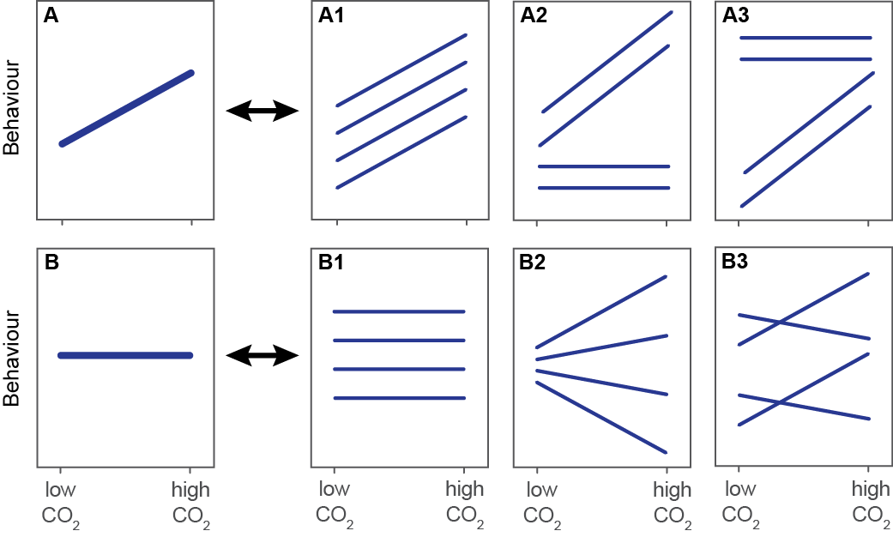

Figure 2: A) diagram of the experimental arena for behavioural assays. B) diagram of experimental arena for predation trials

**Fig 3 – legend to be written**

Please cite the R packages*: ggplot2, tidybayes* and *emmeans* as we used these packages for plotting – the same for the next figure…

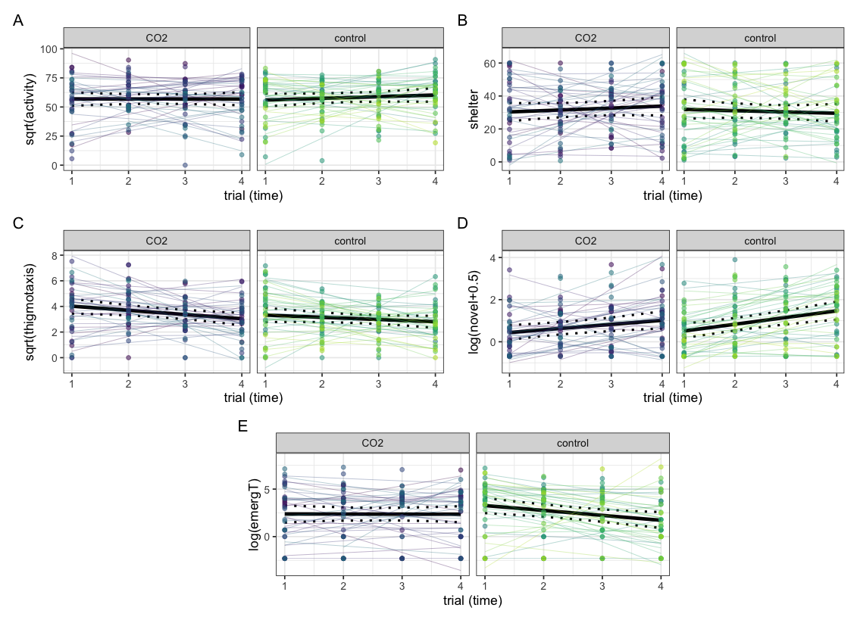

**Fig 4 - legend to be written**

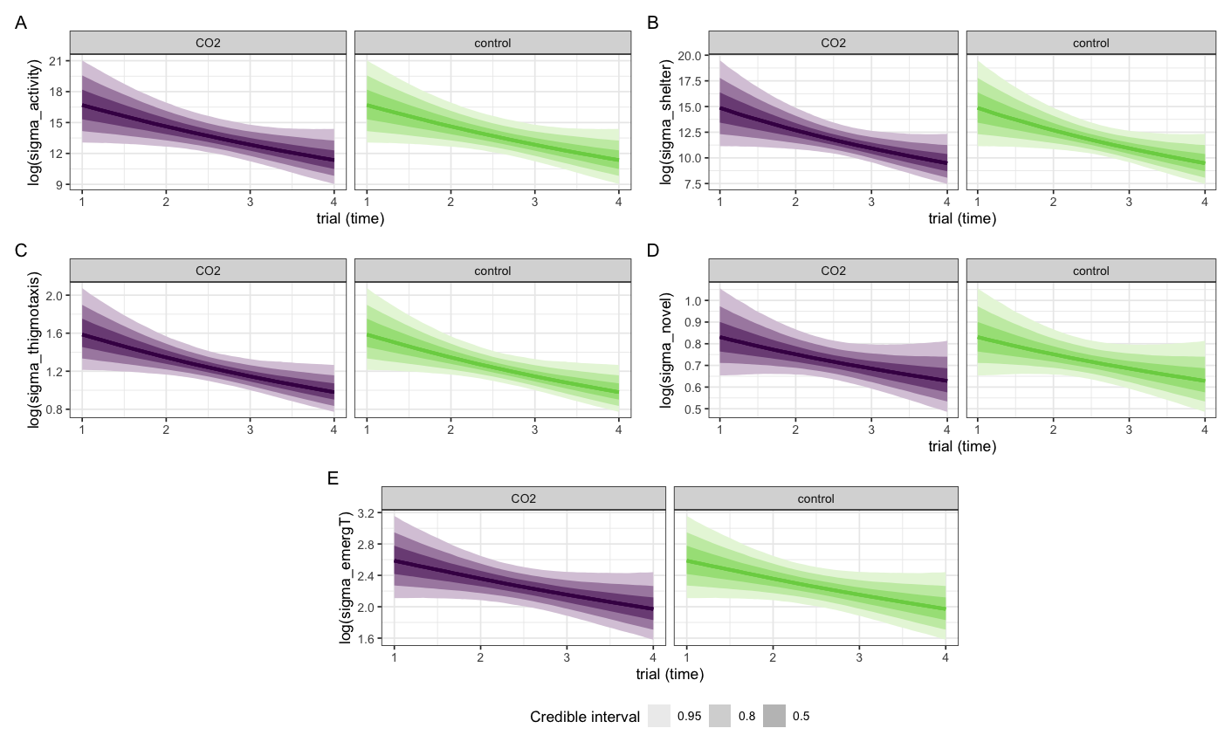

**Supplemental material**

Figure S1: Novel objects used in the behavioural assays

Figure S2: Graphical representation of the experimental timeline used to examine the effect of exposure to end-of-century CO2 levels on personality and susceptibility to predation in *Pomacentrus amboinensis*. Fish personality was assessed by repeatedly measuring behavior in the same fish in a novel environment assay on specific days (orange arrows) during 4 days exposure to present day CO2 (n=74) followed the next day by treatment with either present day CO2 or high CO2 for 6 days (n=37 each). At the end of the CO2 treatments, each fish was exposed to a predator-prey trial (using *Cephalopholis microprion* as predator) under the same CO2 treatment.

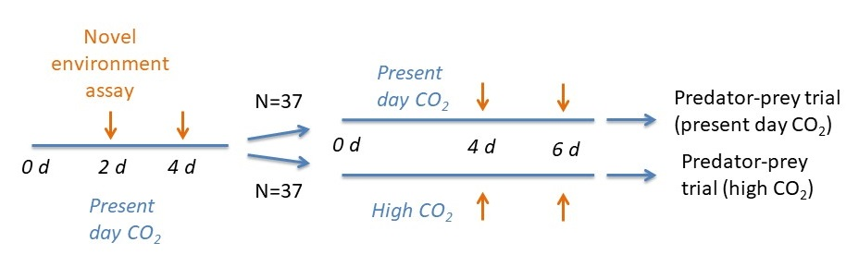

Figure S3: Photo of ambo refuge used in the predation assays