Dominic DiPasquale
CS1567 Introduction to Machine Learning
Professor Milos Hauskrecht

Problem Assignment 10
Problem 1

- 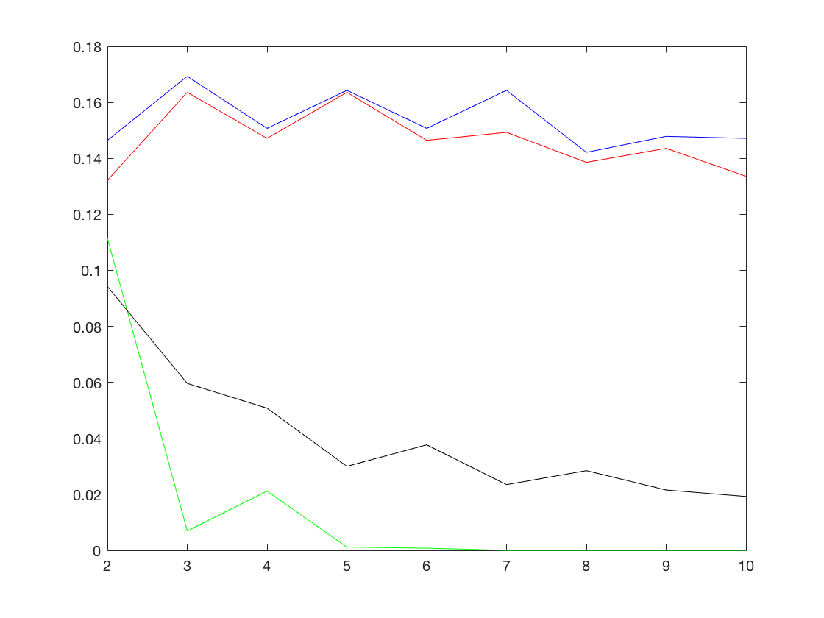
In the above graph the top two lines are the test boosting and bagging errors, the bottom to lines are the boost and bag training. The X axis represents the T value and the Y value represents the error. As expected we see that the training sets have much lower error in both cases. The test sets in general achieve a lower error as you increase the value of T.
- 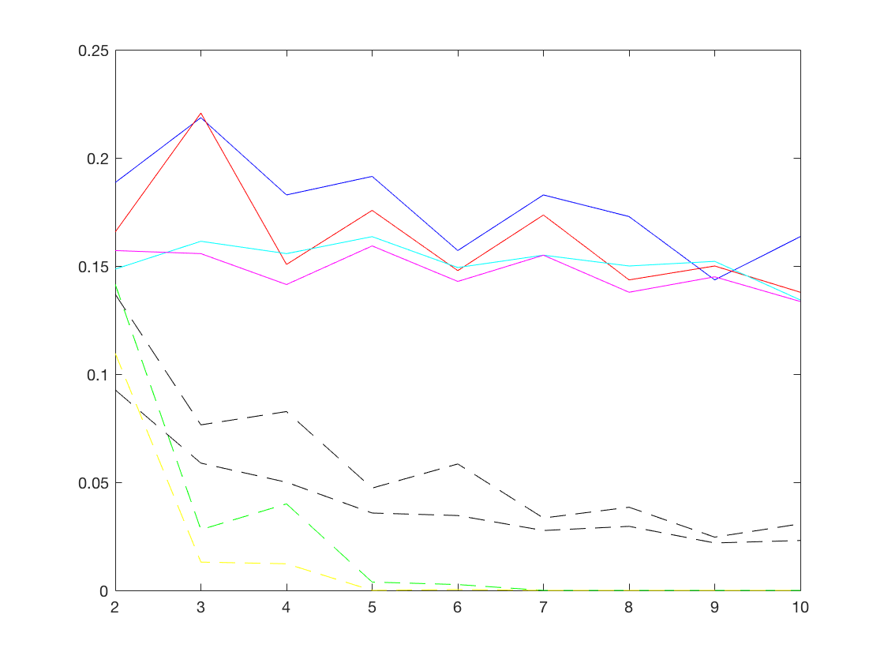
In the above graph all of the training set errors are dotted lines, as we expect they are considerably lower than any of the test sets hinting that perhaps we have done a little bit of overfitting. The blue line is the boost algorithm run with dt_full, while it follows the same pattern as all the others in this specific example it preformed the worst. It should be noted however that the performance difference seems to be negligible. The red line is the bagging algorithm run with the dt_full, it preforms very comparably to the SVM_base bag and boost runs that we saw in part a.
- 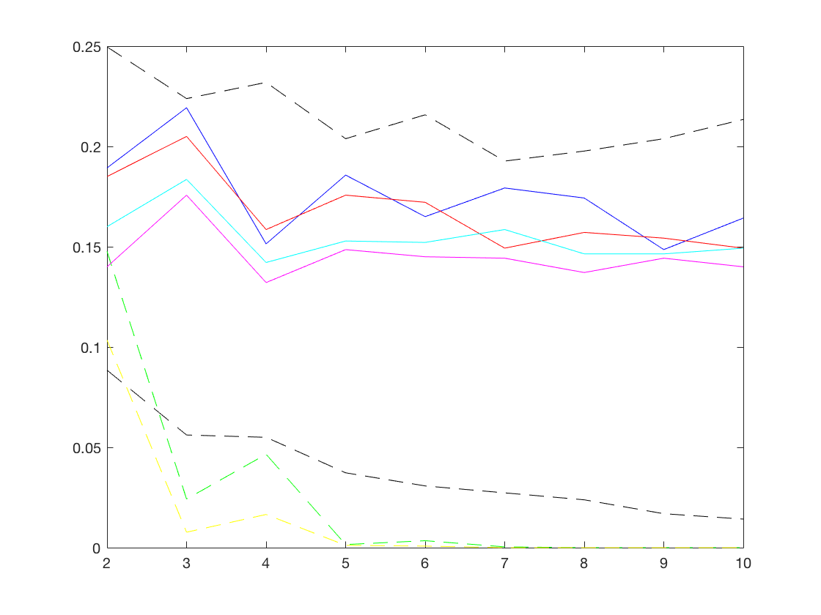
As we can see again with this graph the SVML base is pretty consistent for both the train and testing sets in the same places as before. The difference is obviously the massive difference in the training set for the dt_simple. It has jumped from below all of the testing set runs to above them. This is a considerable change in average error. Surprisingly it does not seem to effect the testing set as much, perhaps implying that the simple dt implementation is as bad as the training set would suggest. It also might be that it is hard to overfit when you are only given 1 split (i.e. you have a simple model), but when using a boosting or bagging a simple model can be comparable to a more complex model without bagging.
Problem 2
- The top 20 fisher scores are:
0.3192 48.0000
0.2140 25.0000
0.1910 21.0000
0.1892 70.0000
0.1693 65.0000
0.1673 40.0000
0.1650 29.0000
0.1402 19.0000
0.1255 57.0000
0.1212 20.0000
0.0995 24.0000
0.0950 30.0000
0.0858 12.0000
0.0846 47.0000
0.0607 61.0000
0.0579 10.0000
0.0527 34.0000
0.0462 27.0000
0.0461 39.0000
0.0422 41.0000
- The top 20 ROC scores are:
0.7340 25.0000
0.6837 29.0000
0.6695 11.0000
0.6661 47.0000
0.6315 19.0000
0.6174 34.0000
0.6021 32.0000
0.6021 30.0000
0.6000 9.0000
0.5971 56.0000
0.5953 27.0000
0.5929 60.0000
0.5881 51.0000
0.5874 26.0000
0.5845 53.0000
0.5797 7.0000
0.5709 10.0000
0.5686 61.0000
0.5567 43.0000
0.5422 44.0000

