Dominic DiPasquale (dfd13@pitt.edu)
CS1675 Introduction to Machine Learning
Professor Milos Hauskrecht

Problem assignment 1
Problem 1.
- N/A
Problem 2.
- (a)
Attr | Pregnancies | Plasma | Blood Pressure | Triceps Thickness | Insulin | BMI | Diabetes | Age
Min | 0 | 0 | 0 | 0 | 0 | 0 | .078 | 21
Max | 17 | 199 | 122 | 99 | 846 | 67 | 2.42 | 81

- (b)
Attr | Pregnancies | Plasma | Blood Pressure | Triceps Thickness | Insulin | BMI | Diabetes | Age
Mean | 3.845 | 120.89 | 69.105 | 20.536 | 79.799 | 32 | .471 | 33
Variance | 11.354 | 1022.2 | 374.647 | 254.47 | 13281.18 | 62.2 | .109 | 138

- (c)
Plasma had the highest correlation to the target at 0.466581. Having the highest correlation would imply that it is the most helpful, but this is not necessarily the case because theoretically something with a lower correlation could perfectly explain the variance.
- (d) BMI and the diabetes pedigree function have the highest correlation coefficient.
- (e) It would not help in predicting a target class because if one attribute fully explains the other you have one less thing that can predict the target.
- (f) The most normal distribution belongs to blood pressure if you remove the 0s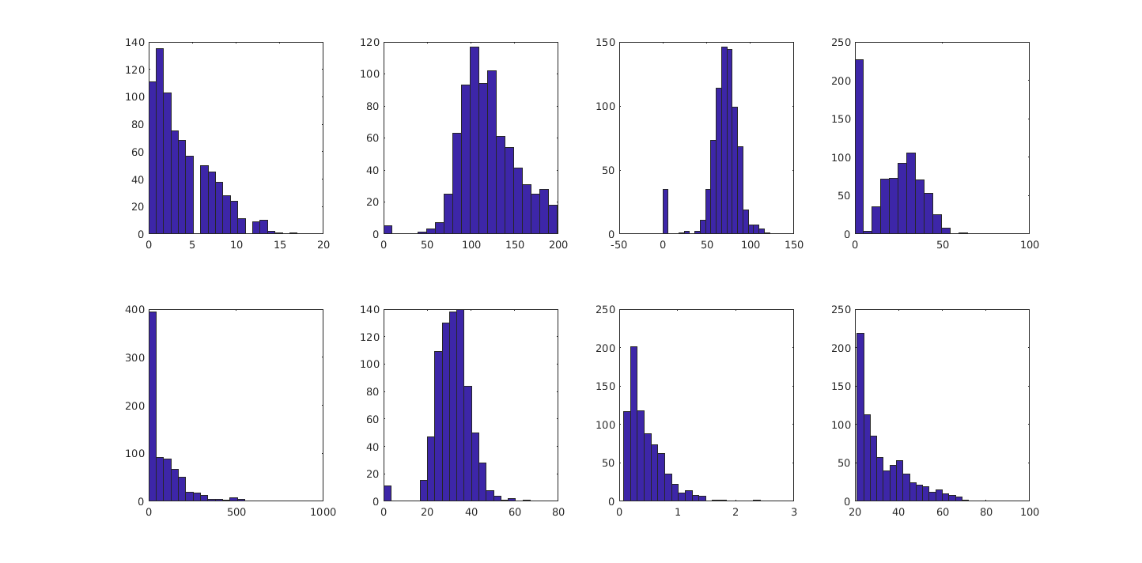

- (g) It seems that there could be a possible inverse linear relationship between insulin and diabetes. Insulin and diabetes are the first graph, age and blood pressure are the second.
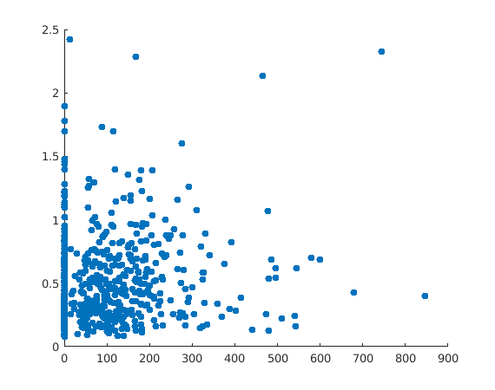
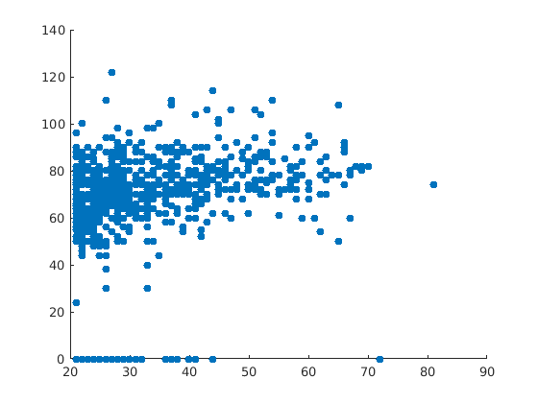

Problem 3.

- (a) The first five values of the normalized dataset for blood pressure are: 0.1495 -0.1604 -0.2638 -0.1604 -1.5037
- (b) The first five values of the discretization for blood pressure are:
6 6 6 6 4

Problem 4.
- (a)

Tested Negative

Attr | Pregnancies | Plasma | Blood Pressure | Triceps Thickness | Insulin | BMI | Diabetes | Age
Mean | 3.298 | 109.98 | 68.184 | 19.66 | 68.79 | 30.30 | .429 | 31.19
Std | 3.01 | 26.141 | 18.063 | 14.889 | 98.86 | 7.689 | .299 | 11.667

Tested Positive
Attr | Pregnancies | Plasma | Blood Pressure | Triceps | Insulin | BMI | Diabetes | Age
Mean | 4.865 | 141.25 | 70.824 | 22.164 | 100.335 | 35.145 | .5505 | 37.067
Std | 3.741 | 31.939 | 21.49 | 17.679 | 138.689 | 7.262 | .3723 | 10.96

- (b) The average was 506.15.
- (c)

