Dominic DiPasquale
CS1567 Introduction to Machine Learning
Professor Milos Hauskrecht

Problem Assignment 2

Problem 1:
- Mean: 15.0415, Standard Deviation: 5.0279
- N/A
- Mean: 15.0402
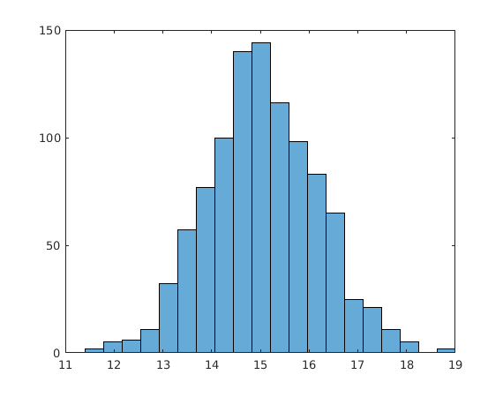
- The mean is approximately the same in both – off by only .001. This means that that the mean subsets of data are approximately equivalent to the mean of the data itself
- Mean: 15.0486
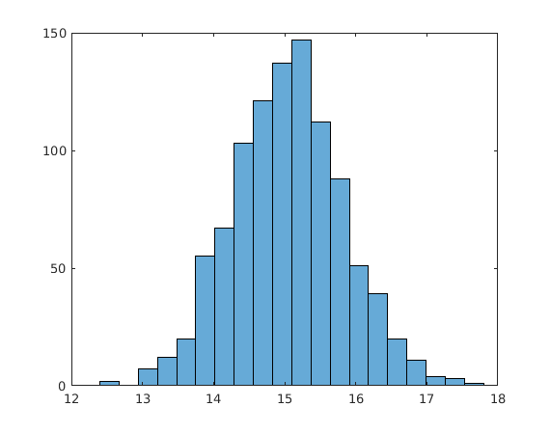
Again the means are all approximately the same, the differences being a slightly larger difference in the 40 subsample plot, but what appears to be a smaller standard deviation. This means that the more subsamples we take the closer we will get to the original dataset.
Problem 2:
(Part 1) N/A
(Part 2) Test data:

Problem 3:
- 2
- 1 + 6x²
- e^{x}
- 2x*cos(x²)
- -1/x²
- -(1+2x)/(x+x²)²
- 5/x
- 0
- n(n+1)/2x
Problem 4:
a)

Sum | 2 | 3 | 4 | 5 | 6 | 7 | 8 | 9 | 10 | 11 | 12
Probability | 1/36 | 2/36 | 3/36 | 4/36 | 5/36 | 6/36 | 5/36 | 4/36 | 3/36 | 2/36 | 1/36
b)

2*(1/36)+3*(2/36)+...+12(1/36) = 7
c)
(11/12)^5 is the probability we never see an outcome of 4
(1/2^5) is the probability we see an even outcome in all 5 trials
d)