Dominic DiPasquale
CS1567 Introduction to Machine Learning
Professor Milos Hauskrecht

Problem Assignment 3

Problem 1:
- An ML estimate of θ is .65
- Blue line = posterior, red line = prior
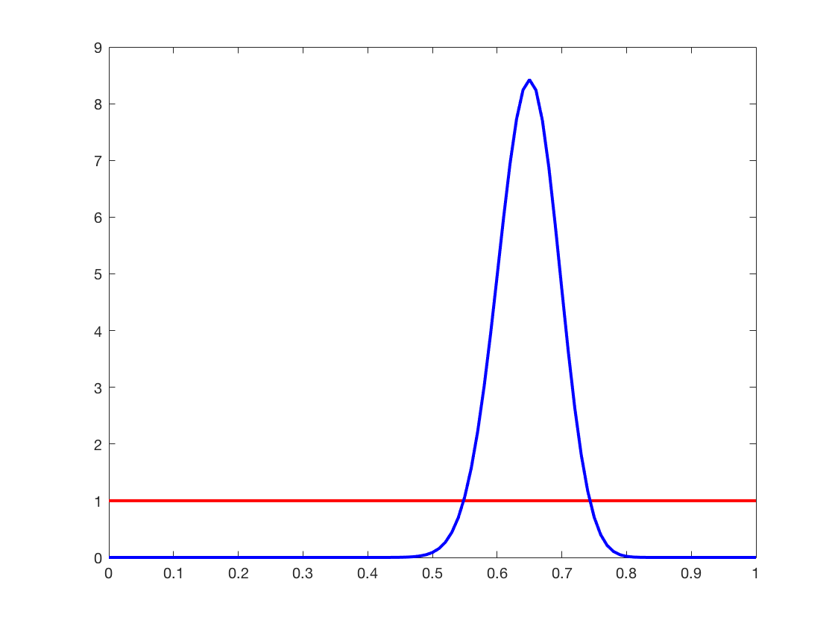
- θmap = (a1 + N1 – 1)/(a1 + a2 + N1 +N2 – 2)
= (1 + 65 – 1)/(1 + 1 + 65 + 35 – 2)
= 65/100
= .65
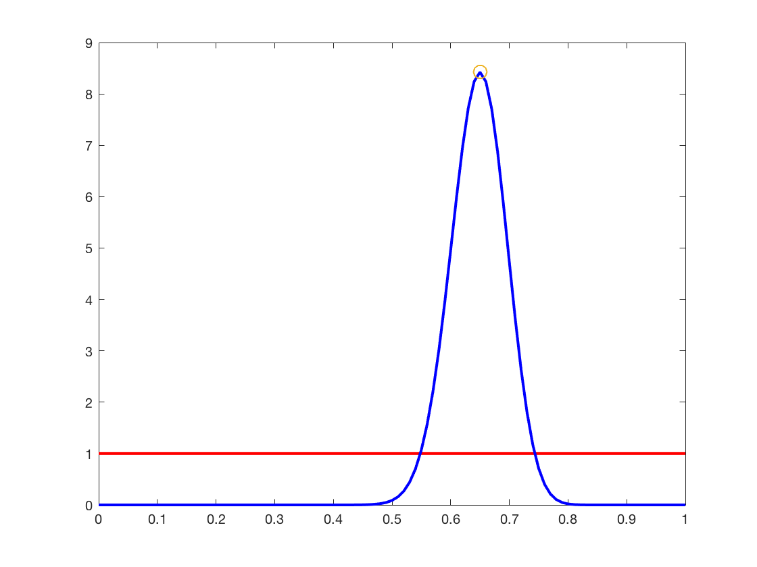

- θmap = (a1 + N1 – 1)/(a1 + a2 + N1 +N2 – 2)
= (4 + 65 – 1)/(4 + 2 + 65 + 35 – 2)
= 68/104
= .653846
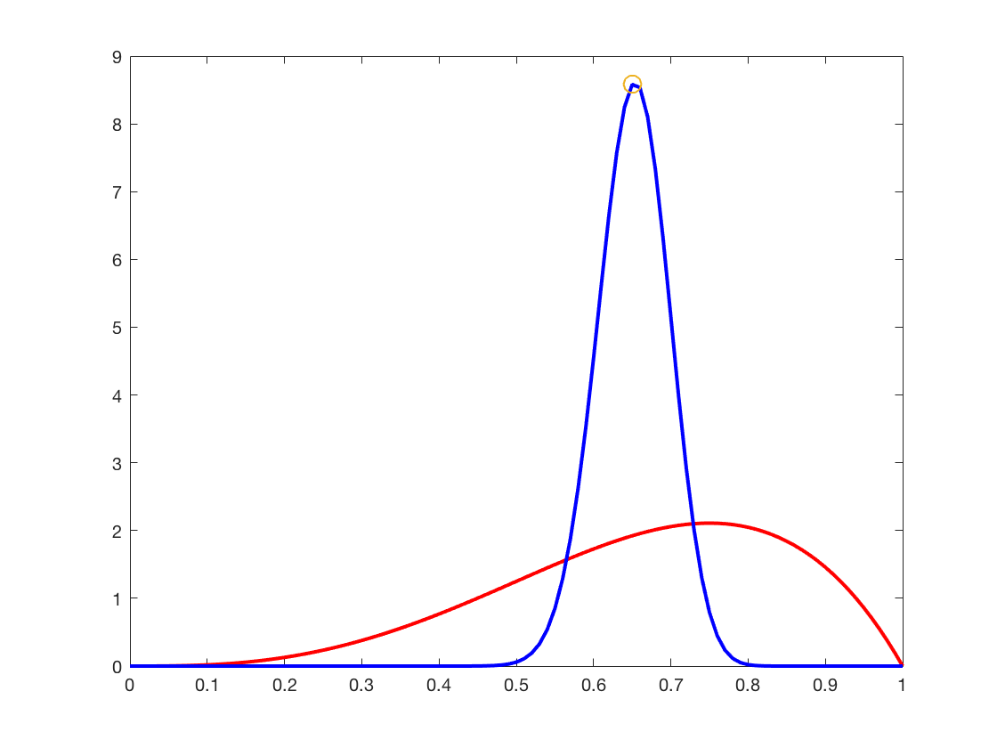
Problem 2:
- 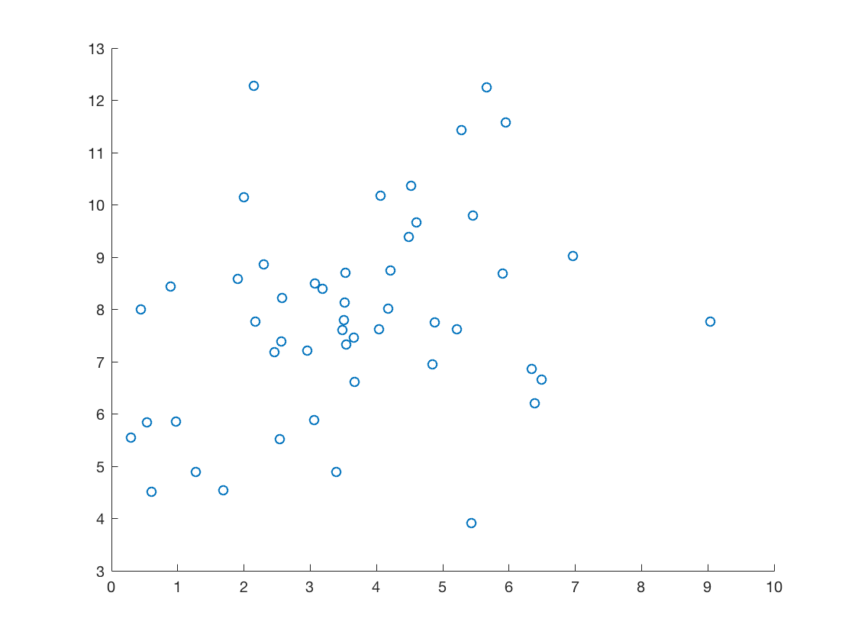
- ML estimate for the mean: 3.6377, 7.8506
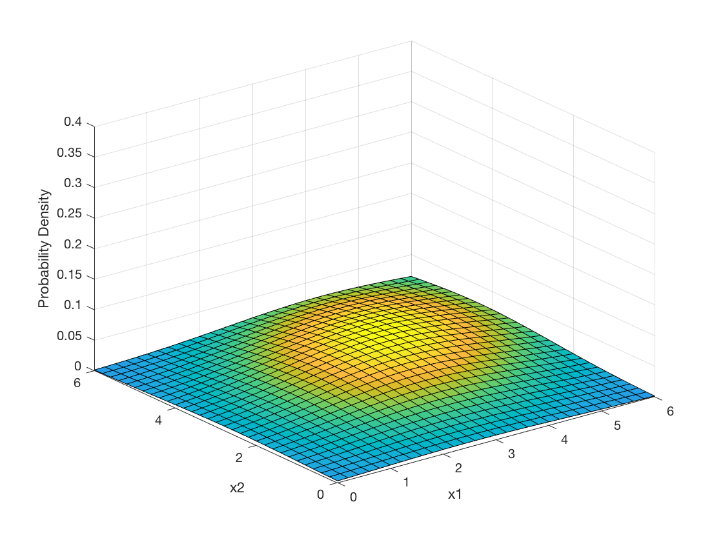

- I believe that the multivariate model is better because it will be easier for us to see dependencies between variables.

Problem 3:
- lambda = 2 lambda = 6
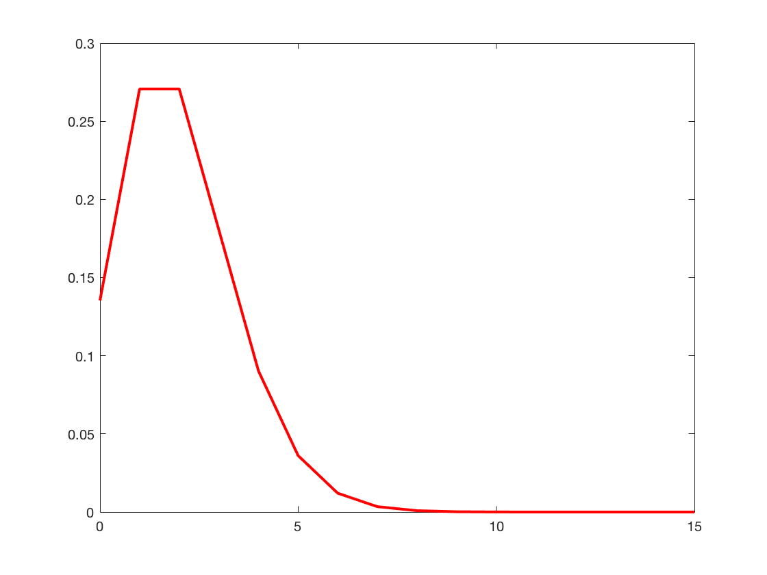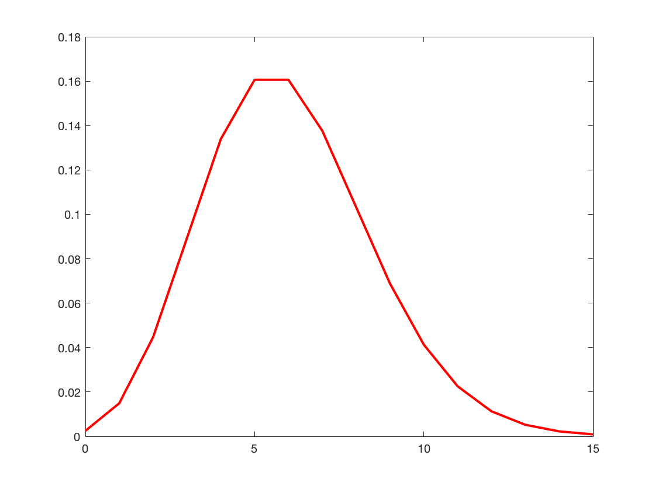
- ML = 5.2400
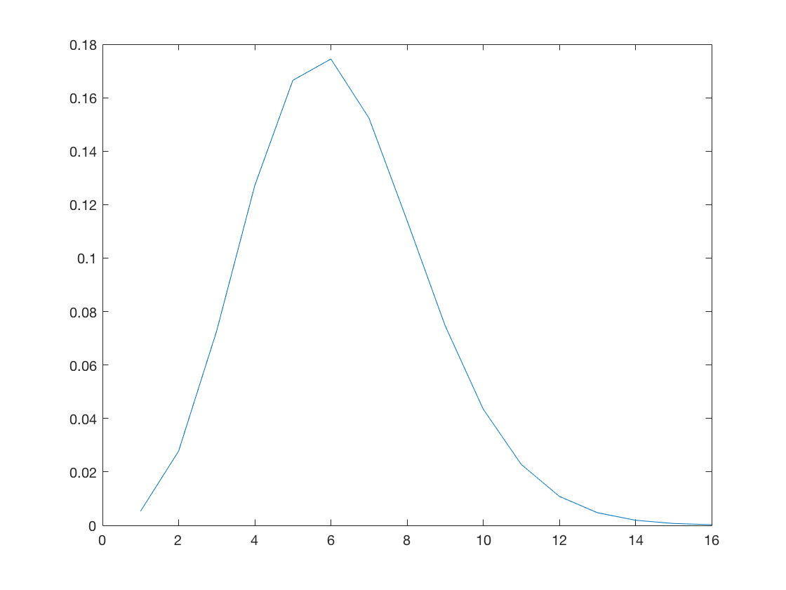
- left side is a = 1, b = 2, right side is a = 3, b = 5
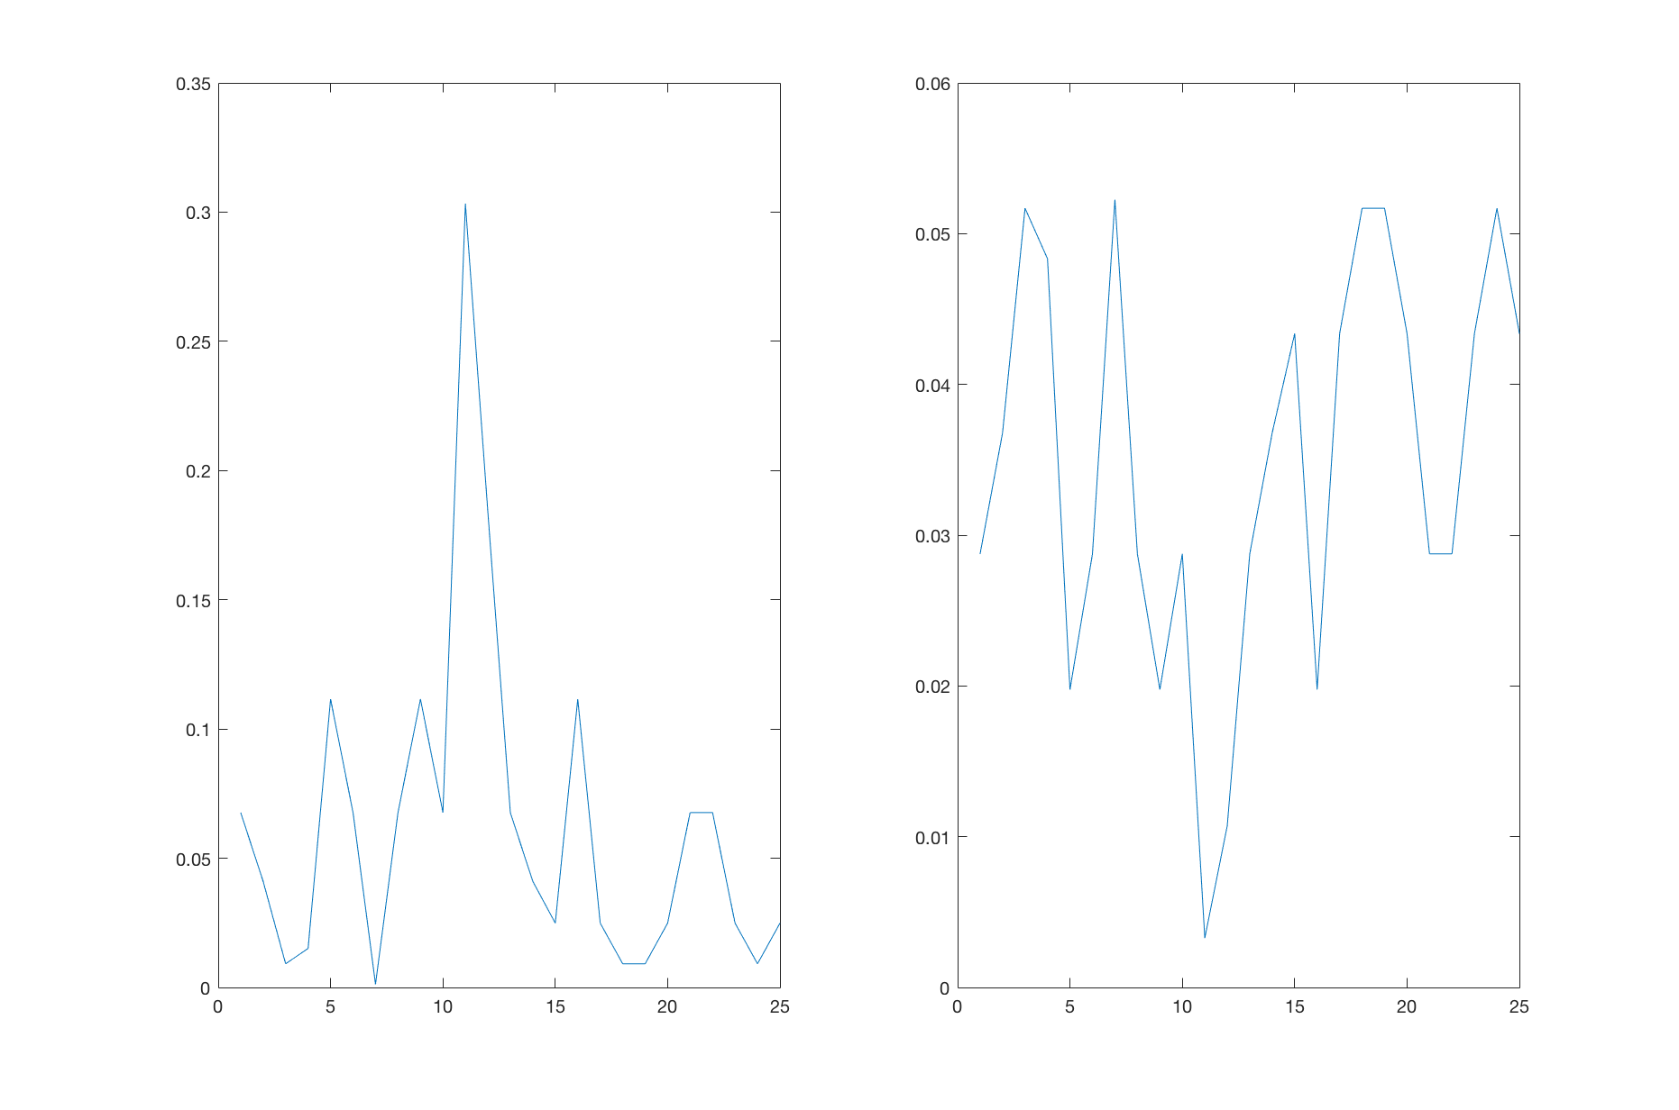
- Gamma(λ|a + sum(data) , b/(nb + 1 ))
a = 1, b = 2
Gamma( λ| 1 + 131, 2/(25*2 + 1))
Gamma( λ|132, .03921)
a = 3, b = 5
Gamma( λ| 3 + 131, 5/(25*5 + 1))
Gamma( λ|132, .0397)
Left is a = 1, b = 2. Right is a = 3, b = 5
