Concepts and Architecture

Backup

Author(s): M.Jerger
Version 0.5 on 13.02.2015
State: valid

Changehistory
Version | Author / Actor | Date | Change / Activity | State
0.1 | M,Jerger | 14.11.14 | initial | draft
0.2 | M.Mörike, M.Caspari,  T.Scherer | 12.12.14 | Reviewed | valid
0.3 | M.Jerger | 22.12.14 | Described Solution Architecture and refactored document structure. | valid
0.4 | M.Jerger | 28.01.15 | Reviewed for consistency, added restore | valid
0.5 | meissa | 30.01.15 | Reviewed and translated. | valid

Legend
New State | Consequence
draft | Content not yet complete according to the authors.
valid | Content is complete and valid according to the authors.
verified (with → responsible) | The content is also valid in the opinion of other people
approved (by → responsible) | The client / responsible declares the content to be valid.

1 Document Scope 4
1.1 Target and Objective 4
1.2 Intended Reader 4
1.3 Additional Documents 4
2 Requirements Analysis 5
2.1 Types of Backup Data 5
2.2 Backup Data De-Duplication 5
2.3 Relevant Questions to answer 5
2.4 Specialties at Log File Backup 5
2.4.1 Further Analysis Options on Log Backups 5
2.4.2 Logdata handling on ubuntu12.04 5
2.5 Specialties at HostEurope 6
3 Backup Decisions 7
3.1 Global Decisions 7
3.1.1 Data Types to Backup 7
3.1.2 Availability 7
3.1.3 Decisions and Analysis per Application 8
3.2 Decision per Application 9
3.2.1 Example Portal Server 9
3.2.2 Example Owncloud Server 10
3.2.3 Example CRM Server 11
3.2.4 Example Ticket System 12
4 Solution Architecture 13
4.1 Backup Process Steps 13
4.1.1 Backup Source 13
4.1.2 Backup Data Transport (2) 13
4.1.3 Backup Log Transport (3) 14
4.1.4 Use HostEurope Backup (4) 14
4.2 Restore Process Steps 14
4.2.1 Restore Data Transport (1) 14
4.2.2 Restore (2) 15
4.3 Backup Source 15
4.3.1 Source System Principles 15
4.3.2 Transport outgoing Folder 15
4.3.3 Local Backup Store Folder 15
4.4 Backup Sink 16
4.4.1 Sink System Principles 16
4.4.2 Transport incoming Folder 16
4.4.3 Backup Store Folder 16
5 Solution Details 17
5.1 Interface between application and backup 17
6 Appendix 18
6.1 Solutions for more Advanced Backup 18
6.1.1 rsnapshot 18
6.1.2 bacula 18

Document Scope

Target and Objective
This document describes backup concepts on an example company.

Intended Reader
Software Operating, Architects, Developer and PO.

Additional Documents
- BSI Datensicherung: https://www.bsi.bund.de/DE/Themen/ITGrundschutz/ITGrundschutzKataloge/Inhalt/_content/baust/b01/b01004.html
- HostEurope Virtual Server Offer: https://www.hosteurope.de/Server/Virtual-Server/
- https://www.bsi.bund.de/DE/Themen/ITGrundschutz/ITGrundschutzKataloge/itgrundschutzkataloge_node.html

Requirements Analysis

Types of Backup Data
- Application Code: Code for all individual application installations.
- Application Data: Data of installed and used applications.
- Configuration: Configuration of components or applications.
- Log Data: Logfiles for all running applications.
- Security Log Data: For secured systems, there are special security log files.

Backup Data De-Duplication
Although there are many types in between we will distinguish between the two major types here:
- full backup or
- incremental backup
Due to the small backup sizes at Example Company, we will use full backup only.

Relevant Questions to answer
Relevant questions with relation to backup are
- Access-Security: Who has access to backups?
- Computer Center Outage: What happens, if the whole computer center fails?
- Protection Requirements: How sensible are backup data?
- Recovery: Recovery describes the context for rescuing applications, their data and configuration in case of disaster. So the question is: What's the duration for recovery?

Specialties at Log File Backup

Further Analysis Options on Log Backups
Backup allows some special analytics, for example, log files can be analyzed for not authorized changes.

Logdata handling on ubuntu12.04
Current Name | Frequency | Compress | Generations | Uncompressed Name
auth.log | 2d | 1+ | 6 | auth.log.0
syslog | 1d | 1+ | 6 | syslog.0
apache* | 1w | 1+ | 52 | access.log.1
catalina.out | 1w | 0+ | 52 | --

Specialties at HostEurope
The Example Company is hosted at HostEurope. According to HostEurope product specification, the Example Company has the following backup (options) available:
- Snapshot: stores the whole server (application, configuration, data) – the recovery takes about 2-5h. The snapshots are stored for three months.
- Permanent Snapshot: Like snapshots, but with unlimited storage duration.
- File system backup: On daily backup basis, stored of the last 14 days.

Backup Decisions

Global Decisions

Data Types to Backup
We backup application data and log data.
Code and configuration needs no backup, because code is saved by Version Management System.

Application Data

Log Data
Logfiles are synchronized daily.
Storage duration is: 1 Year

Security Log Data
Security logs need no backup, because they're synchronized in real time.
Storage duration is: 1 Year

Availability

High
High important data are stored on another computing center.

Normal
Normal important data are stored on another server.

Low
Low important data are stored only on the same server and on the hosting providers backup store.

Decisions and Analysis per Application
ID | Measurement
Application name
Current application data size
Estimated application data growth for upcoming year
Log data growth / year
App data backup on SourceSystem
Generations in daily interval
Generations in weekly interval
Generations in monthly interval
App data backup on SinkSystem
Generations in daily interval
Generations in weekly interval
Generations in monthly interval
Application needs
App data importance / availability
App data confidentiality
Log data confidentiality
Time for disaster recovery

Decision per Application

Example Portal Server
ID | Measurement
Application name | Size
Current application data size | 3,5G
Estimated application data growth for upcoming year | 500M
Log data growth / year | 250M
App data backup on SourceSystem
Generations in daily interval | 1 (14 by HostEurope)
Generations in weekly interval | 0
Generations in monthly interval | 0
App data backup on SinkSystem
Generations in daily interval | 2
Generations in weekly interval
Generations in monthly interval
Application needs
App data importance / availability | high
App data confidentiality | normal
Log data confidentiality | normal
Time for disaster recovery | 1 day

On System Space
13 * 4G = 52G

Remote Space
35 * 4G = 140G

Example Owncloud Server
ID | Measurement
Application name | Size
Current application data size | 15G
Estimated application data growth for upcoming year | 5G
Log data growth / year | 50M
App data backup on SourceSystem
Generations in daily interval | 1 (14 by HostEurope)
Generations in weekly interval | 0
Generations in monthly interval | 0
App data backup on SinkSystem
Generations in daily interval | 1
Generations in weekly interval
Generations in monthly interval
Application needs
App data importance / availability | low
App data confidentiality | high
Log data confidentiality | normal
Time for disaster recovery | 5 days

On System Space
3 * 15G = 45G

Remote Space
12 * 15G = 180G

Example CRM Server
ID | Measurement
Application name | Size
Current application data size | 50M
Estimated application data growth for upcoming year | 10M
Log data growth / year | 5M
App data backup on SourceSystem
Generations in daily interval | 1 (14 by HostEurope)
Generations in weekly interval | 52
Generations in monthly interval | -
App data backup on SinkSystem
Generations in daily interval | 1
Generations in weekly interval | -
Generations in monthly interval | -
Application needs
App data importance / availability | high
App data confidentiality | normal
Log data confidentiality | normal
Time for disaster recovery | 5 days

On System Space
12 * 50M = 1G

Remote Space
23 * 50M = 1G

Example Ticket System
ID | Measurement
Application name | Size
Current application data size | 2M
Estimated application data growth for upcoming year | 100K
Log data growth / year | 100K
App data backup on SourceSystem
Generations in daily interval | 1 (14 by HostEurope)
Generations in weekly interval | 52
Generations in monthly interval | -
App data backup on SinkSystem
Generations in daily interval | 1
Generations in weekly interval | -
Generations in monthly interval | -
Application needs
App data importance | low
App data confidentiality | normal
Log data confidentiality | normal
Time for disaster recovery | 5 days

On System Space
12 * 50M = 1G

Remote Space
23 * 50M = 1G

Solution Architecture

Backup Process Steps
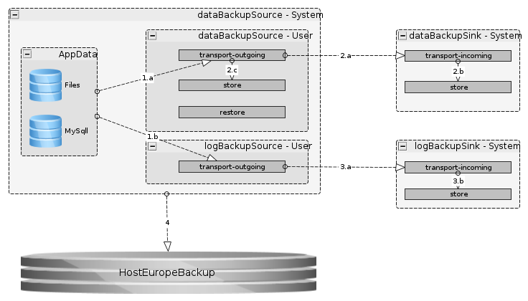

Backup Source

Backing up (1)
In the backup step, a source system cron job will
- collect all application (1.a) and log (1.b) data.
- deliver this data to the “Transport Handover Point”
- handle the “previous transport failed” case (send a mail).

Backup Data Transport (2)

Do the Transport (2.a)
In the transport step a sink system cron job will
- do the transport (2.a): using ssh and rsync. For ssh, the sink system is authorized on dataBackupSource user.
- (optional) verify correctness: Done by hash comparison.
- move to Sink-Store (2.b): Moves the received backup to Sink-Store.
- handle Sink generations: Deletes the eldest backup up to the number of the defined generations to be preserved.
- move to Source-Store (2.c): Moves the received backup to Source-Store.
- handle Source Generations: Deletes backups, bailing out of the defined generations to be preserved.

Backup Log Transport (3)
In the transport step a sink system cron job will
- do the transport (3.a): using ssh and rsync. For ssh, the sink system is authorized on logBackupSource user.
- (optional) verify correctness: Done by hash comparison
- move to Sink-Store (3.b): Moves the received backup to Sink-Store
- handle Sink generations: Deletes the eldest backup of the defined generations to be preserved.

Use HostEurope Backup (4)
HostEurope backs up the whole file system of the last 14 days. If we just store one daily generation on the local file system, we have the ability to rollback to one of the last 14 days.

Restore Process Steps
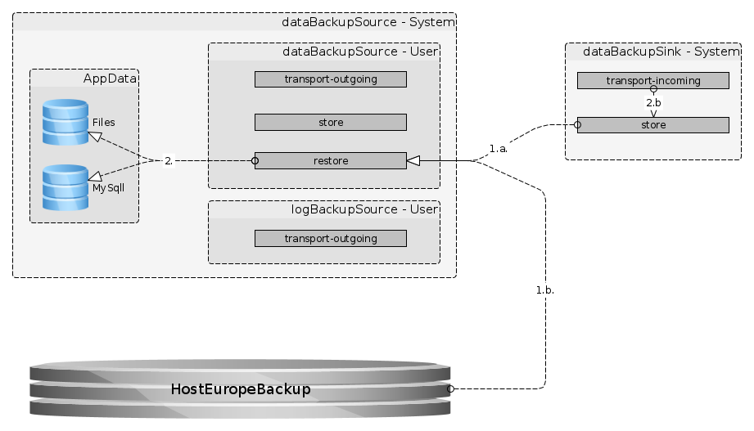

Restore Data Transport (1)
- Source for restores can either be
  - the dataBackupSink (1.a)
  - or the HostEurope Backup (1.b). How to get backuped files back is described at https://kis.hosteurope.de/support/faq/index.php?cpid=16063&in_object=40&searchword=backup
- Access to the system being restored has to be assigned manually.
- Backups to be restored, have to be placed in /home/dataBackupSource/restore. The restore script will take the newest backup available in the restore folder.

Restore (2)
The restore step is part of the system applications' individual procedure.

Backup Source
On nodes serving as backup source, there are two backup users called dataBackupSource and logBackupSource.

Source System Principles
- Backups are pulled from the source systems.
- Process
  - The current day's files are held for transport-outgoing to the backup sink system.
  - After successful transport, files are eventually moved to a local storage folder.
- Access
  - The backup data and the backup log are owned by different users:
    - dataBackupSource
    - logBackupSource
  - Access to the backup source users is managed by
/home/[sourceUserName]/.ssh/authorized_keys.

Transport outgoing Folder
- Folder-name
  - transport-outgoing
- File-name
  - [application name]
  - [backup source type] (eg. file system | mysql)
  - time stamp
- Example:
  - transport-outgoing/dda-owncloud_meissa_mysql_2015-01-28_04-52-01.sql

Local Backup Store Folder
- Folder-name
  - store
- File-name (same as in 4.3.2 Transport outgoing Folder)

Backup Sink

Sink System Principles
- Process
  - The backups are pulled from the source systems and stored to a transport incoming folder
  - After the transport steps are triggered from the sink system:
    - Check successful transport.
    - Execute the source systems after the transport steps.
    - Execute the sink systems after the transport steps.
      - Rotate backup files
      - Do after process analysis
- Access
  - The backup data and the backup log are pulled from different users:
    - dataBackupSink
    - logBackupSink
  - the sink users have to be authorized at the source user,
  - the sink user is managed by /home/[sinkUserName]/.ssh/authorized_keys.

Transport incoming Folder
- Folder-name
  - transport-incoming
  - \source-systems-dns-name
- File-name
  - as named on source system
- Example
  - transport-incoming/owncloud.example.org/dda-owncloud_meissa_mysql_2015-01-28_04-52-01.sql

Backup Store Folder
- Folder-name
  - store
  - \[source-systems-dns-name]
  - \[generation store] (e.g. daily | weekly | monthly)
- File-name as described in 4.4.2 Transport incoming Folder
- Example:
  - store/owncloud.example.org/daily/dda-owncloud_meissa_mysql_2015-01-28_04-52-01.sql

Solution Details

Interface between application and backup
The applications will have their own backup and restore routines.
- Will be located at /usr/lib/[app-name]/bin

Appendix

Solutions for more Advanced Backup

rsnapshot
Rsnapshot uses hardlinks and rsync in order to generate differential backups with the apperance of full backups.

Documentation
- http://wiki.ubuntuusers.de/rsnapshot
- http://www.rsnapshot.org/
- http://how-to.linuxcareer.com/guide-to-rsnapshot-and-incremental-backups-on-linux

bacula
bacula is a full blown BackupSystem. Beside of great scaling abilities, bacula will also provide the feature, that users can inspect and restore single files from the backup.

Documentation
- http://www.bacula.org/
- http://wiki.ubuntuusers.de/Bacula

