Blackberry，a Canadian communications company which was created by Mike Lazaridis and Douglas Fregin and its headquarters is in Waterloo, Ontario, Canada. (The Introduction to Blackberry Marketing Essay, 2015). Blackberry was considered one of the most outstanding smartphone vendors in the world and its security performance is the main features of the product. Until 2009, BlackBerry maker was evaluated by FORTUNE magazine as one of the 100 fastest-growing companies in the world, with income explodes by 84% a year. However, after Apple and Google joining the competition, blackberry’s market share has been thrown away. Nowadays, stock price of Blackberry has collapsed by a rapid decrease of 90% since its peak of June 2008, to its current level of less than $10.

In 1999, the first BlackBerry phone which named RIM 6230 come out equipped with a strong e-mail function and support Push Mail e-mail service (Microsoft Word - RIM History, 2006). At the end of 2010, BlackBerry users in the United States reached a peak at about 21,000,000 users and there were around 20,000 staff globally in the peak period (John, 2011). However, with the touch screen becoming more popular, the trend of the full keyboard led by BlackBerry is no longer meet the needs of users and markets. On June 28 of 2012, BlackBerry announced that it is expected to lose $192 million and will be forced to lay off 5000 people which took up about 40% of its global total staff (Gustin, 2012). In August of 2012, the BlackBerry said it is studying the "strategic choice", including the possibility of selling the company.

In the end of July 2015, the BlackBerry CEO Cheng Shouzong in an interview with foreign media admitted that if the company cannot improve the situation, the BlackBerry may reduce the production of smart phone significantly，and may even stop the production of phone. In addition, 2015 annual report of Blackberry shows that the number of full-time employees fell to 6225 people worldwide (Fiscal 2015-Blackberry, 2015).

Bwana, (2013) mentioned that a company, especially the technical company, should pay more attention to external environment when making strategies. Opponents such as Apple and Google were developing the new devices and operation systems that trying to occupy a part of market. At that moment, BlackBerry should not focus on resources and capabilities of the enterprise only and ignore the external coming threat from the raising new tech company. This internal looking leaded BlackBerry to loose competitiveness and leading position in the market. The enterprise was not necessary to In the end of 2012, Blackberry company directors set up a special committee to evaluate new strategies to speed up the deployment of the BlackBerry 10 system and equipment, including joint marketing with other companies, strategic cooperation and even the sale. Blackberry hoped to use Blackberry 10 to enhance the attractiveness of their own equipment. Unfortunately, this release of this product were delayed several times, which causes that users have defected Android or iPhone, and ultimately Blackberry lost the market and user groups.

In 2015, BlackBerry re-focused its business strategy and began to release two products which were Android-based smartphones：BlackBerry Priv slider and previous success did not guarantee the continuous competitive ability in rapid

would be many problems occurred when using this management form. Jim Balsillie was responsible for company strategy and Mike Lazaridis was in charge of product strategy such as research, development, and manufacturing. Based on the Nash (2014) analysis, the implement of this Co-CEO model had potential to enhance the profits if it can be applied well. But in BlackBerry case, this model had side effect, even led to decline of enterprise. These two CEOs were rarely at the same table when board members hold meeting and discussed the strategy. In results, this situation caused information out of sync and some creative decision would be abandoned. Furthermore, they neglected the market changing and shift of consumer

users due to the significant demands at that moment. The smartphone concept and BlackBerry OS which launched by them increased the working efficiency among the business users and made a huge success. However the BlackBerry did not pay more attention to develop customer applications to ordinary users. The shift demand of consumers and more rivals pushed the revolution products to be established. In results, they did not have enough competitivity compared with opponents such as Apple and Google (Moussi, 2014). Their OS and application not only focused on business user, also they had created new concept of applications that easier to accept and use. At this

lunched by Apple and Google. The IPhone gave a revolutionary smartphone with touched screen and various applications. On the other hand, Google established the open source Android OS, which offered a platform that can be used in many devices. At this moment, BlackBerry missed the greatest launch time of the new generation of smartphones, which was far behind the competitors. At the same time, the company had less innovation of products compared to its rivals. BlackBerry did not have strategic tension as a smartphone company to make appropriate strategies against the competitiveness from other raising smartphone company (Youssef, 2013). The strategy failure was the results from poor leadership and management in

(Research In Motion Ltd. , 2012) (Blackberry Limited, 2013) (Blackberry Limited, 2014) (Blackberry Limited, 2015) (Blackberry Limited, 2016) have been used. The summary of income statements and balance sheets is

restructuring actions.

With regard to balance sheets, total assets of the company were decreased

financial ratios (Rist & Pizzica, 2015) (Zawdie, 2017) were calculated (liquidity, gearing, profitability, investment ratios an Altman’s Z-score) and are presented in the Table 3 and in Figure 3, Figure 4, Figure 5, Figure 6, and Figure 7.

|  |  |  |  |  |  |  |
| --- | --- | --- | --- | --- | --- | --- |
| **Ratios** | 2016 | 2015 | 2014 | 2013 | 2012 | 2011 |
| **Liquidity** |  | | | | | |
| Current ratio | 2.898 | 3.037 | 2.138 | 2.151 | 2.086 | 2.063 |
| Cash Ratio | 0.921 | 0.899 | 0.696 | 0.448 | 0.451 | 0.493 |
| Net assets/Total liabilities | 1.379 | 1.097 | 0.923 | 2.553 | 2.784 | 2.270 |
| Working capital/Total liabilities | 0.848 | 0.894 | 0.657 | 1.074 | 1.014 | 0.980 |
| **Gearing** |  |  |  |  |  |  |
| Debt ratio | 0.286 | 0.338 | 0.314 | 0.025 | 0.022 | 0.033 |
| Debt-equity | 0.401 | 0.512 | 0.458 | 0.026 | 0.023 | 0.034 |
| **Profitability** |  |  |  |  |  |  |
| Net Profit margin | (0.096) | (0.091) | (0.862) | (0.058) | 0.063 | 0.171 |
| Return on capital employed | (0.050) | (0.082) | (1.356) | (0.127) | 0.145 | 0.501 |
| Return on shareholders' capital | (0.070) | (0.123) | (1.976) | (0.131) | 0.148 | 0.519 |
| **Investment** |  | | | | | |
| Earnings per share [USD] | (0.40) | (0.58) | (11.18) | (1.23) | 2.23 | 6.36 |
| Dividend yield | - | - | - | - | - | - |
| Pay-out | - | - | - | - | - | - |
| **Altman's Z-score** | **1.928** | **2.120** | **(0.755)** | **2.801** | **4.057** | **9.113** |

*Table 3 Financial Ratios*

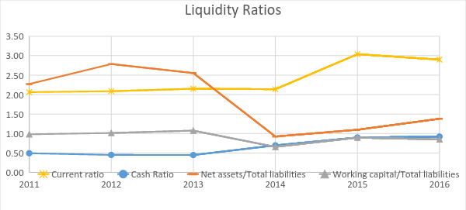

*Figure 3 Liquidity Ratios*

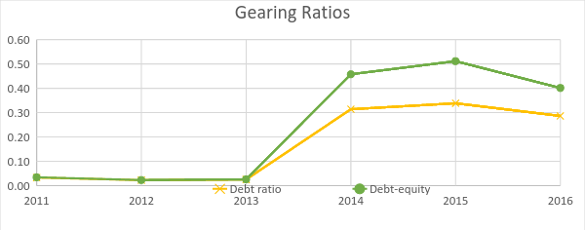

*Figure 4 Gearing Ratios*

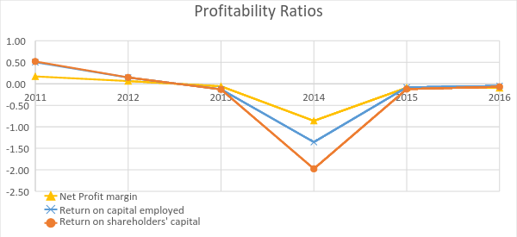

*Figure 5 Profitability Ratios*

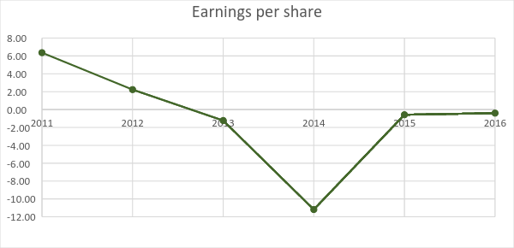

*Figure 6 Earnings per share*

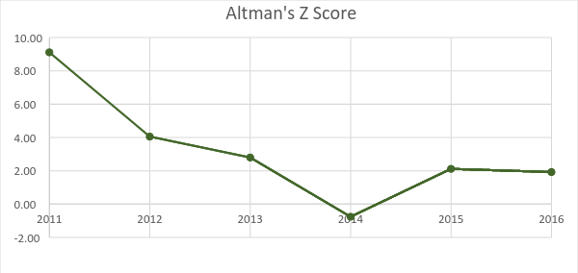

*Figure 7 Altman's Z-score*

## **Performance**

Based on income statements, severe fall of revenue, operating and net income was observed during the last 6 years. Plunging revenue may be the first sign of company’s financial problems. Expenses control, company structure may be relatively easily improved, whereas increasing revenue when company is losing market’s share is extremely difficult.

It is worth to mention that during this time cash and current ratios were improved, however, gearing increased. Possibly, liquidity was recovered based on long-term debt. Net assets to total liabilities ratio reflects this situation, so in this case, it is more valuable to assess company’s liquidity.

Repeatable downslide of profitability ratios illustrates company’s financial situation. Moreover, constant negative profitability seems to be more dangerous than diving one with positive values. Negative earnings per share and lack of dividend caused by permanent losses threatens potential investors.

Altman’s Z-score indicated that company was endangered at the end of 2013 fiscal year, when its value dropped below 3. Despite of taking 5 factors into consideration, the change in Z-score was rapid. Currently, it points out that company may be heading for bankruptcy (Rist & Pizzica, 2015).

It should be emphasised that majority of calculated ratios reflects very poor performance of company in 2014 fiscal year. The reported loss was almost the half of company’s total assets (from the previous year).

* follow their previously successful business strategy of producing business focussed mobile devices which were also popular in mainstream consumer market, this allowed competitors such as Apple to make inroads into the smartphone market.
* In late 2008, BB made attempts to move into the expanding smartphone market through the introduction of the Blackberry Storm device. This device moved away from one of the key aspects of the previous Blackberry produced devices, that of the physical qwerty keyboard. The Storm did not receive positive consumer reviews with many users unimpressed by the technical features and blackberry’s own operating system.
  + Smartphone technology and operating systems was not one of Blackberry’s core competencies and at this stage of the development of the smartphone market, there was no option to outsource this work to specialist/ more competent companies.
* Blackberry then made the strategic decision to move into the emerging markets of South America and Asia with a price-centric approach. By entering this market with the aim of pricing lower than the competitors, Blackberry gained a short lived competitive edge in these markets.
  + A market share of 50% was gained in some of these markets but was eaten into by a number of Asian companies mIaking cheaper devices which were popular with consumers in these price-centric markets.
* In April 2009, Blackberry’s equivalent of Apple’s Appstore, ‘App World’ goes live, nearly a year after the release of Apple’s Appstore in 22 countries.
* In June 2010, Blackberry purchased QNX Software Systems (who were a specialist developer of operating systems) as part of a diversification programme to build on the company’s core competencies and improve in areas where they struggled in the past.
  + Two months later, the BB Torch is released which is based on the previous Storm but has reintroduced BB’s physical keyboard.
  + As part of this diversification programme, they moved into the expanding tablet market through the introduction of the ‘Playbook’ which received similar consumer reviews as that experienced by the Blackberry, Storm (the device which marked the company’s move into the smartphone market)
  + Late in 2010, BB then acquired the user interface specialists ‘The Astonishing Tribe’
* The following June, BB miss their quarterly revenue targets and gives a more pessimistic forecasts and points to a full year outlook of between $5.25 and $6 a share. Decides to slash workforce by 10% and buy back stock.
* RIM offers to manage rival devices such as the iPhone and iPad as an attempt to stop losing its grip on the corporate sector.
* Early 2012, change in leadership takes place as Lazaridis and Basille step down from their shared role as chief executives. Appoint Thorstein Heins as CEO who later promises to implement a new business strategy in an attempt to turn around the company’s fortunes, the new strategy will take advice from appointed bankers. RIM state that the company will now no longer provide financial forecasts.
* Early 2013, RIM release the much anticipated Blackberry 10 devices which use the company’s own BB10 OS. CEO announces that RIM will now change the company name to Blackberry. The following summer, the company announce a first quarter loss following the aunch of the new handsets and forecast a loss in quarter two as well. News of the lack of impact the new BB10 devices have had on company fortunes sends the shares plummenting.
* August 2013, Blackberry set up a committee to explore strategic options, with the sale of the company being one of those possible strategies.

Telegraph (2013)

* Blackberry appoint John Chen as executive chairman and interim CEO in November 2013, responsibility includes heading the company’s strategic direction and goals. First priorities for Chen was to focus on the company’s core business drivers which required moving towards a new operating unit structure: Enterprise Services, Messaging, QNX Embedded business and the devices business. This structure aimed to provide greater focus on services and software which will lead to a more efficient model for the device sector of the company.

Chen also slashed 4,500 jobs in an attempt to reduce the company’s ongoing losses. (FT 2016)

Fiancial Times (September 2016) John Chen – The man whose Blackberry died on him.

John Chen Interview with CNBC (Dec, 2013)

* Under Chen’s direction, Blackberry introuduced a number of handsets but none sold at the sort of numbers required to be deemed successful. This led to the decision in 2016 to pull out of developing hardware and instead move the company’s focus to software and services aimed at the corporate and public sectors with security being the main selling point of the produts/services. (FT, 2016)
  + Blackberry could look at developing security services for the companies already holding massive market share which would provide the sort of device numbers not available to Blackberry previously.
* Monitor the messaging app situation and development, with the view of implementing BB Messenger into any market area which opens.
  + Facebook’s acquisition of the main messenger app Whatsapp, may present opportunities if Facebook implement a future strategy with Whatsapp that customers do not favour. (Security)