

Network Proposal to Ultimate Recruitment

Created by ‘π apple’ Company – <4 Oct 2018>

|  |  |  |  |  |
| --- | --- | --- | --- | --- |
| **Project Manager** | Chengyu Yang | Student Number: **5576477** | 33.33% |  |
| **Project Planners** | Ho LamLuk  Bangyan Liang | Student Number: **5644720**  Student Number: **5494400** | 33.33%  33.33% |

# Executive Summary

This document is made in order to describe our network proposal for ‘Ultimate Recruitment’. The network solution, based on new ICT equipment, will help Ultimate Recruitment company improving the connection efficiency and safety between different departments and business ability for helping customer searching and solving jobs. Our company’s network proposal consists of: brief the background of our company, upgrading old technology equipment, improving communication cost and efficiency, design new recruitment’s office configuration for Wollongong and Kiama office, and calculation of total cost about this plan.

The ‘Ultimate Recruitment Proposal’ outlines the steps of our network design process based on the first two activities of ICT solution. The ‘Hardware Solution’ included in the solution explains the upgrading of old devices and equip new ICT devise which obviously improving the voice and message safety and quality. The solution also includes the ‘Software and Network Solution’ that shows how we solve the remote online meeting between two or more branches and real-time file transfer between different employees and departments. Finally, the ‘Recruitment office configuration’ is mentioned based on different work environment to design network diagram and network devices.

To conclude, this ‘Ultimate Recruitment Proposal’ is the outcome of the process to create a network solution to improving Ultimate Recruitment business ability and efficiency based on the new ICT hardware and software.

Recommendations discussed include:

* The concept of information and communications technology (ICT).
* ICT devices functionality and usability.
* ICT software and network advantages.
* ICT network diagram for office.

# Table of Contents

Executive Summary 1

Table of Contents 2

1. Introduction 2

1.1. About ICT Solution 2

1.2. Ultimate Recruitment Proposal 2

2. Aims & Outcomes of the Project 2

2.1. Overview of Business Concept 2

2.2. Advantages Of The Business Concept 2

3. Company Background 2

3.1. Introduction 2

3.2. History 2

3.3. Mission 2

3.4. Vision 2

3.5. Previous Work 2

4. The ICT Solution 2

4.1. Hardware Solution 2

4.2. Software Solution 2

4.3. Communication Solution 2

4.4. Network Solution 2

4.5. Office Solution 2

4.5.1. Wollongong Office 2

4.5.2. Kiama Office 2

5. Budget Management 2

5.1. Cost Table 2

5.1.1. Hardware Table 2

5.1.2. Contract Table 2

5.1.3. Task Table 2

6. Conclusion 2

7. References 2

8. Glossary 2

9. Appendices 2

# Introduction

## About ICT Solution

In several years, ICT network solution has affected how business work; ICT specialists manage all aspects of information from building and managing systems through to technology and data movement, storage and recovery. According to the issue as well as the potential use of the ICT, our ‘π apple’ company has come up with the idea of creating a new ICT network solution to update the current hardware and software to a more effective and efficient one.

## Ultimate Recruitment Proposal

The ultimate recruitment company’s requirement and objects are necessary to be included as our project’s first step of analysing. The requirement is to upgrade old equipment for wireless operation, replacing devices with problems, real-time communication, working efficiency and safety. And object aims to rebrand their business by showing their professional and technologically focus in operation. We design this network solution based on the information and communication technology which consists of 4 core activities: providing IT support, maintaining data storage, classified networks and servers and interrogating business information system. Our project team has executed the ICT solution which based on these activities.

# Aims & Outcomes of the Project

The information and communication technology have changed rapidly over these years, one of the major aspects is the successful ICT solution on the traditional business company. We investigated the way ICT’s value is created in the network solution and how to take advantage of its potential.

## Overview of Business Concept

We can define ICT as “the use and application of computers, telecommunications and microelectronics in the acquisition, storage, retrieval, transfer and dissemination of information” *(Md. Ashikuzzaman, 2014).*

The new network solution of ours aims to help Ultimate Recruitment establish new ICT network solution in company’s different departments, Wollongong and Kiama office

Our ICT network solution includes 3 main parts: improving the exist communication and operation system, design new network diagram for office, and updating old devices. The focus of our solution is on the employees work efficiency and cost, we will try to maximum decreasing the employees work cost like travel time or devices broken and increasing work quality which means employees will make decision quickly and accurately. By the way, all our budget and designment will based on the real market and we will offer the references for checking.

## Advantages Of The Business Concept

Information and communications technology systems include desktop computers, laptops and tablets, fixed and mobile telephone systems, communications networks and software. Your business can use ICT systems to benefit from improvements such as reducing costs, increasing efficiency, improving decision-making and increasing your competitiveness in the marketplace. An effective ICT investment can make an important contribution to your organization’s success and growth *(Lan Linton, 2018).*

The new ICT network solution is able to assist your business to store, process, analyse and share vast amounts of data. Through working on the information from business data, managers and employees make decisions quickly and accurately, so that operations’ management will be more effectively and respond more rapidly to business opportunities.

Also, ICT solution will provide faster response and higher standard of service to its customers. After upgrading software, employees are able to check and change the document online which means they can deal quickly and efficiently with inquiries, improving customers satisfaction, and providing high quality responding.

By using ICT solution, the project team efficiency will get infinite improvement. Installing new ICT devices will help your employees achieve online meeting and cloud video interoperability. Not only save team members travel time and cost, but also improve their teamwork success rate and competitive advantage.

# Company Background

## Introduction

π apple is a provider of information and communications technology (ICT).

We are focusing on four areas, telecom networks, IT, smart devices, and cloud services. The purpose of our company is to achieve a fully connected, digital and intelligent world to every people, family and organization. The products of our company are highly competitive while ensuring quality. Through a dynamic partnership with our partners, we create sustainable value for our clients, committed to empower people, enrich family life, and inspire innovation in organizations of all forms and sizes.

At π apple, our products focus on customer needs and keep innovate the new products to satisfy the customer. We have invested a lot of resources in basic research, focusing on the development and breakthrough of the world's leading-edge network technologies. There are more than 1,00 employees working in the company, and we have development business in more than 5 countries and regions. Founded in 100, π apple is a private company fully owned by the directors.

## History

|  |  |  |
| --- | --- | --- |
| · | May 2008 | Created Company in Sydney |
| · | June 2010 | Have own office |
| · | October 2010 | Start first project |
| · | January 2011 | Finish first project |
| · | May 2011 | Get second project from the first customer |
| · | April 2013 | Have the company website |
| · | June 2016 | Finish the second project and get the good feedback |
|  | March 2017 | Get third project from company website |
| · | January 2018 | Finished the third project successfully |

## Mission

Focusing on the standards, key technologies and architectures in the ICT field, we hope to provide a wider, smarter, and More efficient and efficient channels to provide a better user experience. In the future, 5G communication, network architecture, computing and storage will continue to innovate and achieve important innovations. At the same time, we will work closely with partners in relevant industries and research institutions to translate research results into practical applications. We have also established a joint innovation center with major operators to transform leading technologies into tangible competitive advantages while achieving commercial success.

π apple focusing on promote network capability opening, Service Chaining and other important topics in SAE/PCC field; promote ICT integration standard ecological environment; promote Carrier SDN Industry incubation; promotes IP/Internet security principles that are more easily interoperable and appropriately enhanced.

## Vision

In the future, we believe that high-speed connections will be as ubiquitous as air. People and people, people and things, things and things will always be based on the connection for real-time intelligent data analysis and communication, in time to meet our various needs. Using a joint will become as natural as breathing, or even completely forget about its existence, and just focus on enjoying a variety of thoughtful applications and services. Also, we will focus on develop the 5G Network Architecture. Today's wireless networks are changing the way humans communicate and access information, and network access anytime and anywhere is driving the transformation of the telecommunications industry. In the future, wireless access will become the main access method. 5G wireless technology will connect all applications, services and things together through a flexible, reliable and secure wireless network, enabling humans to enter the era of mobile Internet.

## Previous Work

|  |  |  |
| --- | --- | --- |
| · | October 2016 | Project about setup the network and the Intranet structure of the whole business |
| · | March 2017 | Project about setup 5G internet of the workplace |
| · | January 2018 | Project about repair the network of the street |

# The ICT Solution

Based on the new information and communication technology, our company provided this ICT network solution which includes 3 main parts: hardware updating, software improving and network plan. We designed this solution based on your requirements and real market exploration, all the devices and software services have been listed as the table and reference for checking.

## Hardware Solution

According to the interview and our research, we found the main problems are most of devices are quite old and can’t satisfy some new technologies like WI-FI, online meeting and so on. Especially, some devices like printer already broken and they are out of warranty. And considering your stuff need to be trained with basic skills, we offered this hardware solution.

Firstly, we focus updating the server and computers, because they are the main devices of stuff working and have directly connection with stuff working efficiency. Comparing with the old server Dell PowerEdge 1850, our recommendation is Dell PowerEdge T30 which equips new generation processors with double size memory than the old one, equip 1TB HDD hard drive, and 290W power supply. The better processors will make server work with higher frequency and efficiency, 8g memory and 290W power satisfy all the calculation of computer. Also, Dell T30 makes it easy to secure your data and files with software RAID and optional backup restore solutions. Considering the computer is the most important device in the work and there is a new office to open, we choose Dell OptiPlex 990, the updating model of OptiPlex 360. As the same as server, OptiPlex 990 equips i5 CPU with double size memory and double size hard disk as the old one which means higher working speed and calculation. However, the prices almost the same as the old one. And as the important improvement, conscious design options featuring 90% efficient power-supply units and the exclusive OptiPlex Eco kit advantage.

Next, we make improvement for replacing broken and eliminate devices. For the printer, our solution recommends HP M477fdw, which supports colour print, scan, copy, fax and email. As the latest printer of HP, M477fdw is built in WFI and stuff can do wireless direct printing and NFC touch-to-print which saved stuff working time and improved efficiency. Beside this, M477fdw has high speed through tasks and will help protect data. For the tape drive backup, our suggestion is IBM TS2250, fifth-generation IBM LTO Ultrium technology. Based on the new technology, TS2250 maximum data transfer rate of up to 140MB/S and providing up to 1.5 TB data cartridge. By using TS2250, company’s data integrity, reliability and availability will get improvement. Meanwhile, it totally satisfied your company’s storage usage, application requirements and work environment.

Finally, all the devices listed in our solution have three-year warranty, some of them includes in the price and some of them we bought from devices’ company which can be checked in the budget table. For IBM devices, they promise replaceable unit and service upgrade for 9x5 business day. For HP devices, they will provide on-site hardware support service.

## Software Solution

According to our research, company use Windows XP as computer system and Windows 2003 for server, and Microsoft office 2007, MYOB AccountRight, Success Recruitment CRM for business. However, the company’s system is too old to support our new devices and technique. Therefore, we provided this software solution for system and software updating.

In fact, our recommended devices server and computer already includes the system which is also the reason for choosing them. The server Dell T30 equip Windows 2012, the sixth release of windows server which is able to offer businesses and service providers a scalable, dynamic, and multitenant-aware cloud-optimized infrastructure. As Windows milestone version, windows 2012 can help organizations connect securely across premises and help IT professionals to respond to business needs faster and more efficiently. Windows 7 Pro as the most popular version system will be installed on the Dell 990, this system’s significant feature is its firewall that has become more than ever secure and outbound firewall rules. Beside this, Windows 7 Pro has the best exploration and compatibility which means almost all the software will be suitable for Windows 7 Pro.

As for the business software, we suggest keep using MYOB and Success Recruitment CRM and there are two reasons. Firstly, you company already paid 24 months for renewing license. Secondly, MYOB AccountRight Premier completely satisfied company’s requirement with online and offline management and flexible to suit business needs.

The most important improvement, we recommend is the updating of Microsoft office software. As we known, 2007 small business edition exits different limitation like repeatability operation, few functions, disabled hot-key and hard operability. Therefore, we provide Microsoft office 365 business version for 24 months to you. Through office 365, stuff can collaborate, share and communicate with flexible tool that go where your team goes, and it’s built in AI tools which supports online file storage and sharing. Based on all these functions, stuff can work online and ignore all the limitation of time, environment and other conditions, which will help company get higher work efficiency and both customer and employee satisfaction.

## Communication Solution

According to the interview, your company expect an economical technology to support online communication between two offices and would like to reduce the phone cost. To solve these questions, we designed communication solution which includes new technology of communication and new devices for supporting.

First of all, we will use the skype business which is included in office 365 to achieve online meetings and communicate across devices. For the online meeting, we will use skype software combine Microsoft surface hub and Jabra speak 510 which provide industry-leading HD video and high-quality voice. With one click, anyone can join online meeting from any device and the leader can choose to meet right away or schedule from Outlook for later which means the meeting URL is personalized just for you. Based on new devices, all the employees in the meeting are able to record meeting with office software, share their screen, uploading files and annotate PowerPoint for real-time collaboration with up to 250 people. By using automatic cropping and head tracking, you will focus more on the people in your call.

As for the phone plan, we will use Yealink SIP-T40P-SFB skype IP phone with skype phone plan which provide unlimited minutes for mobiles and landlines. With skype phone plan, all the stuff can use skype to make unlimited minutes calling includes abroad calling, and they also can do the audio conferencing through any installed skype software devices. The Yealink skype IP phone provide phone system which enables call control and PBX capabilities in office 365, and direct routing which allows stuff to select providers based on where telephony services are needed by global reach. All these techniques will extremely improve customer service and stuff working quality.

## Network Solution

According to our research and interview, your company have the Telstra contract with 9 to 13 usage per month and all the devices only use CAT5 Cabling to connect Netgear GS116 Switch. For current conditions, we thought the devices and contract can’t satisfy our communication technology and new devices which means they also influences stuff’s working speed and operational. Here is our new network solution includes contract and devices updating.

First of all, we will introduce our improvement of network devices: gigabit switch and cable. For the switch, we suggest NETGEAR GS748T, triple ports number than GS116. And comparing GS116 up to 1000Mbps of data throughput, GS748T reached 2000Mbps in full-duplex mode. All these technologies support high transport speed and easy management based on browser management which will obviously simplify stuff managing switch and improve their work efficiency. As the connection of switch and computer, we choose CAT 6 cable which used new material GEL and higher diameter. Based on the new material, CAT 6 can support up to 1000 BASE-TX gigabit ethernet and higher speed with error-free transmission which provide guarantee of high-speed internet operation, fluency and stability of wireless communication. And we considered two office in the solution, so we bought 305M cable which completely satisfied both two office usage.

To provide good quality internet connection, we suggest Telstra business broadband small plan, which offered 500GB per month and includes installing of Telstra business smart modem. Based on this plan and modem, we can set up the WI-FI work environment in both two office and online communication like face-to-face meeting. For the plan, it will provide at least 40Mbps typical speed and suitable for multiple users using the internet and managing a business with an online presence. The Telstra modem is able to satisfy 20M*20M area wireless internet which totally covered both two office. Therefore, your stuff will enjoy high speed and fluency internet connection in the office when they are working.

## Office Solution

Based on our analysis of work offices, we designed office solution to introduce network devices and wires distribution, and some basic information about offices. For both two offices, we equip latest printer and about 10,000 A4 paper, 1 colour ink and 1 black ink for daily work which totally satisfied office requirement.

### Wollongong Office

As the head office of Ultimate Recruitment, we spend about 60% budget on updating devices, build new network and communication technology. To convenience manager, normal and senior recruiter 7 employees’ work, we recommended to equip them with Dell OptiPlex 360 laptop which can support our stuff out-office work. To maximize the wireless cover range, we put the router in the centre work desk. In our solution, there are 9 IP phone in Wollongong office, 5 IP phone are separately equipped in the manager office and meeting room, and 4 phones on the centre working area. Through our new devices, different offices and departments can do the online meeting in the main office with our devices. All the wires and devices distribution details of Wollongong office, you can find in the diagram:

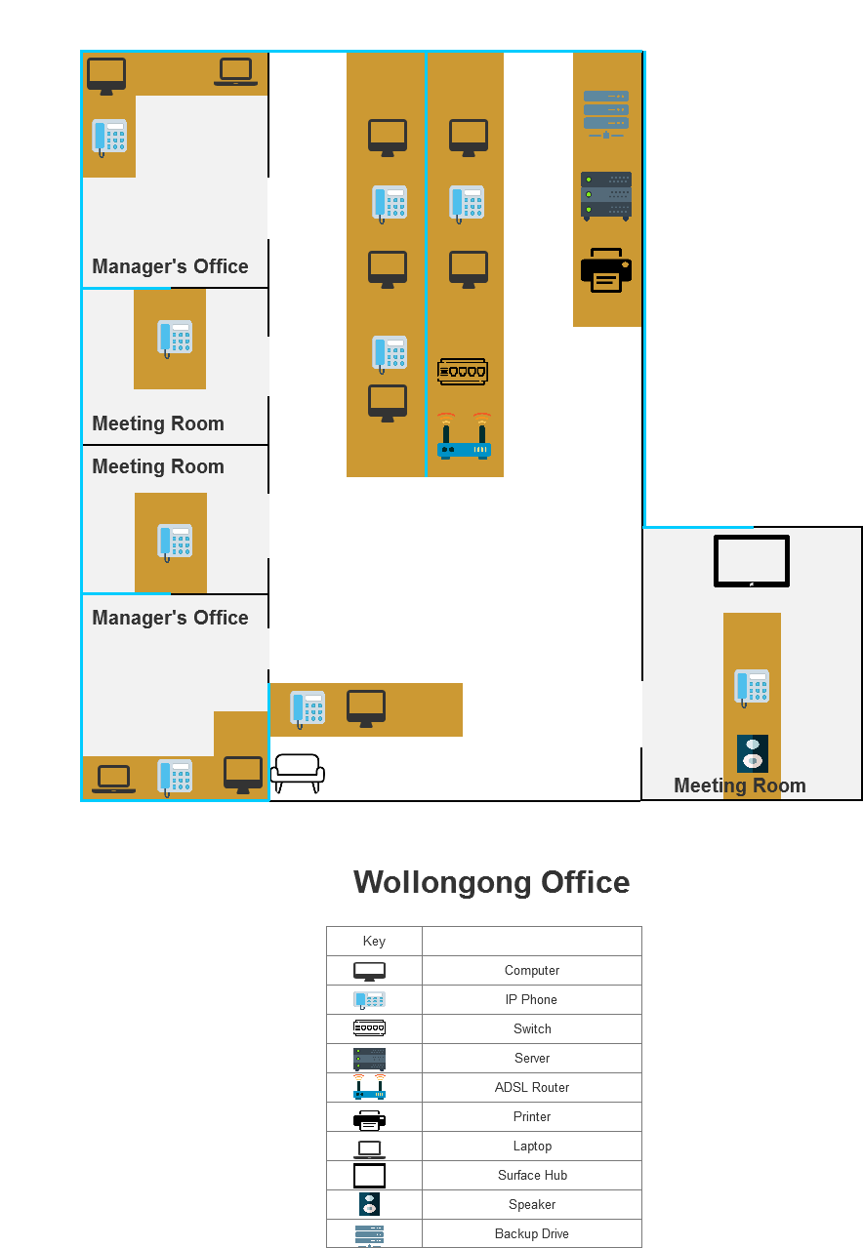

### Kiama Office

As the new office of Ultimate Recruitment, we spend approximately 40% budget on buying devices, build network and communication technology. Excepting basic network devices, we equip 2 computers and 1 laptop to alleviate their daily work pressure. To solve the communication and wireless network, we build communication devices in the meeting room and router on the centre table in the office. We also separate equip 2 IP phone in the office and meeting room, and 1 phone in the centre work area. All the wires and devices distribution details of Kiama office, you can find in the diagram:

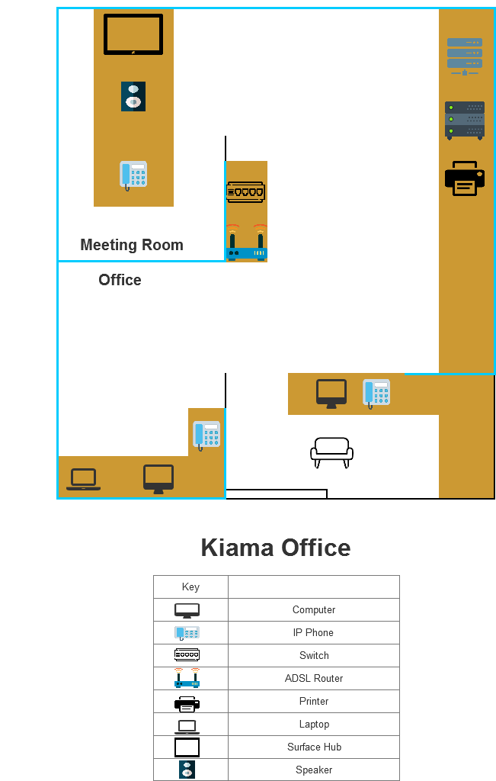

# Budget Management

## Cost Table

### Hardware Table

|  |  |  |  |  |
| --- | --- | --- | --- | --- |
| Hardware | Unit Cost (AU $) | Quantity | Subtotal | Note |
| (Server) Dell PowerEdge T30 | $1,026 | 1 | $1,026 | With 1-year warranty |
| (Computer) Dell OptiPlex 990 Desktop | $199 | 10 | $1,990 |  |
| (Printer) HP Color LaserJet Pro MFP M477fdw | $680 | 2 | $1,405 | Quantity:1 for Wollongong office and one for Kiama office; Subtotal: 1360 and $44.99 for 3-year warranty |
| IBM TS2250 tape drive backup | $1,926 | 1 | $1,943.50 | $1926 + shipping $17.49 $1943.50 total include 3-year warranty |
| CAT6 UTP Cabling | $385.00 | 1 | $385.00 |  |
| Netgear GS748T Port Switch | $539 | 2 | $1,078 | with lifetime warranty |
| (Laptops) Dell OptiPlex 360 | $499 | 8 | $3,992 | with 3-year warranty free shipping include 15’ screen |
| Skype for business Yealink SIP-T40P-SFB IP phone | $139 | 12 | $1,668 | with 1-year warranty |
| Microsoft surface hub core i5 | $13,631 | 2 | $27,262 |  |
| Microsoft speaker phone | $222 | 2 | $444 | with free shipping |
| Total |  |  | $41,193.50 |  |

### Contract Table

|  |  |  |  |
| --- | --- | --- | --- |
| Plans | Monthly cost | Period | Subtotal |
| Telstra Business Broadband ADSL  (includes ADSL Router) | $125.00 | 24 months with unlimited data | $3,000 |
| Skype mobile phone plan | $29.00 | 24 months for 9 staff | $6,264 |
| Office 365 plan | $12.50 | 24 months for 9 phones | $2,700 |
| Total |  |  | $11,964 |

### Task Table

|  |  |  |  |  |
| --- | --- | --- | --- | --- |
| Task | Base hourly rate | Number of workers conduct installation | Time taken | Subtotal |
| Installing Server | 120p/hour | 2 | Wollongong: | $240 |
| 1 hour |
| Installing Switches | 120p/hour | 1 | Wollongong: | $60 |
| 30 minutes |
| Installing Computers | 120p/hour | 2 | Wollongong: | $480 |
| 1 hour |
| Kiama: 1 hour |
| Install Wireless technology and Conference technology | 120p/hour | 2 | Wollongong: | $240 |
| 30 minutes |
| Kiama: |
| 30 minutes |
| Set up Wi-Fi | 120p/hour | 2 | Wollongong: | $360 |
| 1 hour |
| Kiama: |
| 30 minutes |
| Installing Printer | 120p/hour | 1 |  | $120 |
| Buy A4 papers | $25 for 1 box |  | 4*24 months | $2400 |
| Color Ink | $34 |  | 24 months | $816 |
| Black Ink | $33 |  | 24 months | $792 |
| Total |  |  |  | $5,508 |

Total Fee = $41193.5 + $11964 + $5508 = $58665.5

# Conclusion

The information and communication technology have a huge influence in the modern business nowadays. Based on the new ICT, our company decided to design a new network solution for Ultimate Recruitment Company. The network solution aims to help company achieve real-time communication, old devices and software updating. As a result, all the employees’ work efficiency and customers’ satisfaction will get dramatic improvement.

Based on the interview and our market research, we provided the description of network solution, office designment diagram and budget information. For the whole solution, we completely satisfied Ultimate Recruitment company’s requirements and controlled budget in the acceptable range.

The result as our company’s vision said, we aim to help your company built an efficiency, safety and convenient working environment. Hope our ICT network solution can help your company win the advantages in the competition and more cooperation.

# References

*A4 Paper*. (2018, 9 25). Retrieved from https://www.officeworks.com.au/shop/officeworks/p/reflex-ultra-white-80gsm-a4-copy-paper-2500-sheet-box-sprfpropk

Ashikuzzaman, M. (2018, 9 2). *ICT: Concepts and meaning: definition*. Retrieved from LIS BD Network: http://www.lisbdnet.com/ict-concepts-and-meaning-definition/

*CAT6 UTP Cabling*. (2018, 9 16). Retrieved from https://www.4cabling.com.au/cat-6-utp-lan-outdoor-gel-filled-cable-305m-roll-on-a-reel-black.html?utm_source=google_shopping&gclid=EAIaIQobChMI0oGB9Yzi3QIVVa6WCh3XCwlsEAQYASABEgKyy_D_BwE

*Dell Optiplex 360*. (2018, 9 17). Retrieved from https://www.dansdeals.com/shopping-deals/electronics/dell/hot-dell-optiplex-360-mini-tower-desktop-with-3-year-on-site-warranty-for-just-399-shipping-after-385-instant-savings/

*Dell Optiplex 990 Desktop*. (2018, September 11). Retrieved from https://www.knncomputers.com.au/products/dell-optiplex-990-sff-core-i5-cpu-2500-3-2ghz-4gb-250gb-w7p-refurbished?utm_source=Click&utm_medium=Channel&utm_campaign=Google_AU&ref=SFDR_180663399&variant=28031261000&gclid=EAIaIQobChMIxavki_3h3QIViQoqCh027wNHEA

*Dell PowerEdge T30*. (2018, 9 12). Retrieved from https://www.mwave.com.au/product/dell-poweredge-t30-server-intel-e31225v511-8gb-ddr4-1tb-hdd-290w-psu-no-os-ac09351?gclid=EAIaIQobChMI07qhmsDg3QIVyAMqCh15jwqQEAQYASABEgIZbfD_BwE

*HP Color LaserJet Pro MFP M477fdw*. (2018, 9 15). Retrieved from http://www8.hp.com/au/en/products/printers/product-detail.html?oid=7257107

*IBM TS2250 tape drive backup*. (2018, 9 17). Retrieved from https://www.amazon.com/gp/offer-listing/B003HFUUL4/ref=dp_olp_all_mbc?ie=UTF8&condition=all

*information and communication technology capability*. (2018, 9 1). Retrieved from Australian curriculum: https://www.australiancurriculum.edu.au/f-10-curriculum/general-capabilities/information-and-communication-technology-ict-capability/

*Jabra Microsoft speaker phone 510*. (2018, 9 23). Retrieved from https://www.microsoft.com/en-us/p/jabra-speak-510/8psjg55rmbd2?activetab=pivot:overviewtab

Linton, L. (2018, 9 10). *The Benefits of Using ICTs in Business & Finance*. Retrieved from https://bizfluent.com/list-6641121-benefits-using-icts-business-finance.html

*Microsoft office 365*. (2018, 9 24). Retrieved from https://products.office.com/en-us/compare-all-microsoft-office-products?tab=2

*Microsoft Surface Hub*. (2018, 9 21). Retrieved from https://www.insight.com/en_US/buy/product/HP6-00001/MICROSOFT/HP6-00001/SURFACEHUB55%22WITHKEYBOARD,/

*Skype phone plan*. (2018, 9 22). Retrieved from https://secure.skype.com/my/offers/calling?offerHref=%2Foffers%2Fcalling%2Fskus%2Fau-mixed-unlimited%3Frevision%3D1.0%26pricetierRevision%3D1.0%26language%3Den%26currency%3DAUD%26billingCountry%3DAU&cancelUrl=https%3A%2F%2Fsecure.skype.com%2Fcalling-rates

*Telstra Business Broadband plan*. (2018, 9 23). Retrieved from https://www.telstra.com.au/small-business/broadband/plans#adsl

# Glossary

**G**

**5G**: ***5G*** is the fifth generation of [cellular mobile communications](https://en.wikipedia.org/wiki/List_of_mobile_phone_generations). It succeeds the 4G (LTE/WiMAX), 3G (UMTS) and 2G (GSM) systems. 5G performance targets include high data rate, reduced latency, energy saving, cost reduction, higher system capacity and massive device connectivity *(telcomaglobal.com., 2018)*

**P**

**Private Branch Exchange (PBX)**: PBX stands for Private Branch Exchange, which is a private telephone network used within a company or organization. The users of the PBX phone system can communicate internally (within their company) and externally (with the outside world), using different communication channels like [Voice over IP](https://www.3cx.com/pbx/voice-over-ip/), ISDN or analog

**T**

**The Information And Communication Technology (ICT)**: **Information and communications technology** or (**ICT**) is extensional term for [information technology](https://en.wikipedia.org/wiki/Information_technology) (IT) that stresses the role of [unified communications](https://en.wikipedia.org/wiki/Unified_communications)[[1]](https://en.wikipedia.org/wiki/Information_and_communications_technology#cite_note-ICT-D-00-1) and the integration of [telecommunications](https://en.wikipedia.org/wiki/Telecommunications) ([telephone](https://en.wikipedia.org/wiki/Telephone) lines and wireless signals), computers as well as necessary [enterprise software](https://en.wikipedia.org/wiki/Enterprise_software), [middleware](https://en.wikipedia.org/wiki/Middleware), storage, and audio-visual systems, which enable users to access, store, transmit, and manipulate information. *(FOLDOC., 2008)*.

**W**

**Web Conferencing**: Web conferencing enables the real-time sharing of computer screens, individual applications or web-based content among two or more computers or mobile devices *(Margaret Rouse., 2016)*.

# Appendices

**Table X: Work Breakdown Structure (WBS) of ‘**π apple**’ company**

|  |  |  |  |  |
| --- | --- | --- | --- | --- |
| Task ID | Task Description | Member allocated  to task | Task dependent on | Estimated time of completion |
| **1.** | **Network Proposal to Ultimate Recruitment** | | | |
| 1.1. | Team meeting to identify report structure and deliverables | All members |  | 7 days |
| 1.2. | Build Work Breakdown Structure (WBS) | Chengyu Yang | 1.1 | 1 days |
| 1.3. | Report Introduction | Chengyu Yang | 1.1 | 2 days |
| 1.4. | Aims & Outcomes of Business | Chengyu Yang | 1.3 | 3 days |
| 1.5. | Company Background | Bangyan Liang | 1.1 | 7 days |
| 1.6 | The ICT Solution | Chengyu Yang | 1.3-1.4 | 10 days |
| 1.7 | Budget Management | Ho LamLuk | 1.1 | 7 days |
| 1.8 | Conclusion | Chengyu Yang | 1.3-1.7 | 1 days |
| 1.9 | References, glossary and appendices | Chengyu Yang | 1.3-1.8 | 1 days |