# Letter Of Transmittal

***Golden Resident***

***Nguyen Kim Nhat***

***CEO of SmartLaif***

***3A Northfields Avenue***

***Gwynneville, NSW 2500***

***6 September 2018***

***Dir. Steven Worrall***

***Managing Director of Microsoft Australia***

***1 Epping Road***

***North Ryde, NSW 2113***

Dear Dir. Worrall,

I submit to you herewith my new system proposal of which is entitled **‘Smart Real Estate Management System’**. As my project team’s development, our new system will perform as a platform that uses the technology of the **Internet of Things (IoT)** within properties’ smart amenities to consume the data of tenants’ activities and behaviours for the purpose of creating an optimized and efficient real estate management system.

All the issues should be directed to me, if you have any question about the system’s functionality.

I appreciate your consideration to our proposal and look forward to hearing it.

Regards,

Nguyen Kim Nhat.



USER EVALUATION REPORT

Smart REal Estate management system

Created by ‘Golden Resident’ Project Team – <Finish Date>

|  |  |  |
| --- | --- | --- |
| **Project Manager** | Nguyen Kim Nhat | Student Number: **5620272** |
| **Project Planners** | Jehee An  Bangyan Liang | Student Number: **4903900**  Student Number: **5494400** |
| **Project Analysts** | Siyuan Yue  Yang Chengyu | Student Number: **5938776**  Student Number: **5576477** |

# Executive Summary

This document is made in order to describe the ‘Smart Real Estate Management System’ proposal of which our team’s latest project. The new system, as a cloud-based IoT (Internet of Things) system, will create a connection between multiple smart amenities in the rental properties to gather the rentals’ household usage then to make suitable adjustments to the household operations for usability optimization and cost reduction. The aim of this report is to illustrate our team’s user evaluation process which consists of: investigating the background of IoT in real estate management, identifying and prioritizing all potential users/stakeholders taking part in the new system and collect their information to understand their needs to the system and to come up with the list of system requirements afterwards.

The ‘User Evaluation Report’ outlines the steps of our evaluation process based on the first two activities of Human-Centred Design. The ‘Business Domain Investigation’ included in the report explains the environment we tend to work with as well as its potential that we take to create this new system. In addition, a list of stakeholders alongside with each one’s interaction to the management system are indicated in an in-depth ‘Stakeholder Analysis’. The report also includes the ‘Data Gathering Process’ that shows how we collect each group information in order to understand what they think the new system should acquire. Finally, the ‘Requirement Identification’ is mentioned based on the users’ needs to represent the system requirements categorized by their level of importance as the result of the data gathering process.

To conclude, this ‘User Evaluation Report’ is the outcome of the initial process to create a new advanced system of ours that applying the Internet of Things technology to minimize the operations in the current real estate management system.

Recommendations discussed include:

* The concept of cloud-based IoT system.
* ‘Smart Building’ functionality and usability.
* Minimizing utility costs and risks.
* Understanding the key concepts of Real Estate Management System.

# Table of Contents

Letter Of Transmittal

Executive Summary 1

Table of Contents 2

1. Introduction 4

1.1. About Our Project 4

1.2. Our Team’s User Evaluation Report 4

2. Business Domain Investigation 4

2.1. What is The Internet of Things (IoT)? 5

2.2. The IoT in Real Estate and Property Management 5

2.2.1. How Property Management System benefits from the Internet of Things? 6

2.2.2. How we manage to maximize the IoT value 7

3. Stakeholder Analysis 7

3.1. Identifying Potential Stakeholders 7

3.1.1. Smart Device Manufacturers 8

3.1.2. Landlords, Tenants & Real Estate Agents 9

3.1.3. Third-party App Developers 9

3.1.4. External House Services 9

3.2. Stakeholder Categorization and Prioritization 9

4. Data Gathering Process 11

4.1. Our Data Gathering Method 11

4.2. Interview Questions 12

4.2.1. Stakeholder #1 12

4.2.2. Stakeholder #2 12

4.2.3. Stakeholder #3 12

4.3. Questionnaire Structures 12

4.3.1. Stakeholder #1 12

4.3.2. Stakeholder #2 12

4.3.3. Stakeholder #3 12

4.4. Mock Interview Results 12

5. Requirement Identification 12

5.1. Identifying System Requirements 12

5.1.1. Requirement #1 13

5.1.2. Requirement #2 13

5.1.3. Requirement #3 14

5.2. Requirement Classification 14

6. Conclusion 14

7. References 15

8. Glossary 15

9. Appendices 16

# Introduction

## About Our Project

In several years, Industry 4.0 has affected how economics work; the real estate management is one of systems that receives a dramatic change due to the innovation of the modern concepts such as block chain and the Internet of Things (IoT). Understanding the issue as well as the potential use of the IoT, the ‘Golden Resident’ project team has come up with the idea of creating a new real estate management of rental properties as a cloud-based IoT system to update the current management system to a more effective and efficient one.

## Our Team’s User Evaluation Report

The user evaluation process is necessary to be included as our project’s first step of interaction design. The process is to discover and understand the problems and the needs of the current system/users, then to declare the new system requirements that will meet all users’ needs. We design this system based on the **Human-Centred Design (or User-Centred Design)** which consists of 4 core activities: understanding and specifying the context of use, specifying the user requirements, producing design solution and evaluating the design. Our project team has executed the user evaluation process which includes the first two activities.

Therefore, the goal of this ‘User Evaluation Report’, as mentioned, is to clearly define and investigate our working domain which is the Internet of Things in Real Estate and Property Management as well as the potential users/stakeholders in order to identify our new system requirements for future development.

It should be noted that the document heavily focuses on users’ demographic and user interaction within the real estate management system and the Internet of Things. The next report will follow the User-Centred Design’s last two activities: producing and evaluating the design solution for our new system.

# Business Domain Investigation

The real estate and property management system has changed rapidly over the years, one of the major aspects is the revolution of the Internet of Things. We investigated the way IoT’s value is created in the system and how to take advantage of its potential.

## What is The Internet of Things (IoT)?

The Internet of Things (IoT) is a suite of technologies and applications that equip devices and locations to generate all kinds of information and to connect those for instant data analysis and smart actions *(Kejriwal, S., Mahajan, S., 2016)*. Since its invention in the 1990s, the Internet of Things has evolved dramatically thanks to the creation of the ***cloud-based system***.

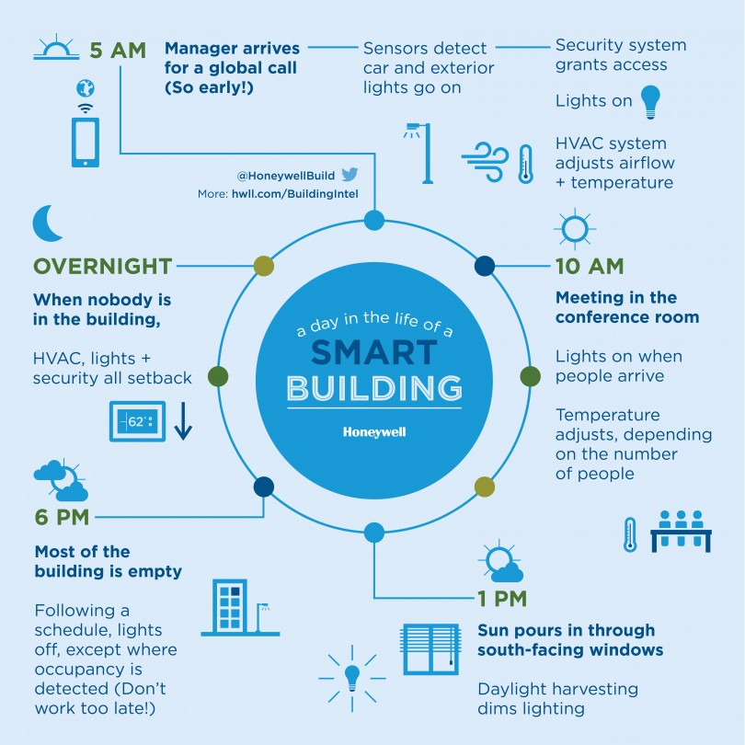One big example for the IoT implementation is the innovation of ‘Smart Building’. All actions performed in the smart buildings are based on and adapted to the users’ usability.

**Figure X: 24 hours in a ‘Smart Building’ *(Glassman, S., 2015)*.**

## The IoT in Real Estate and Property Management

The information that the Internet of Things generated can be used to define the efficiency and effectiveness of properties’ resources based upon users’ interaction and then to manage their usability. The IoT implies devices and physical objects which can utilize the internet backbone to capture users’ data; therefore, the users can act/react based on the data analysis to minimize the utility costs.

### How Property Management System benefits from the Internet of Things?

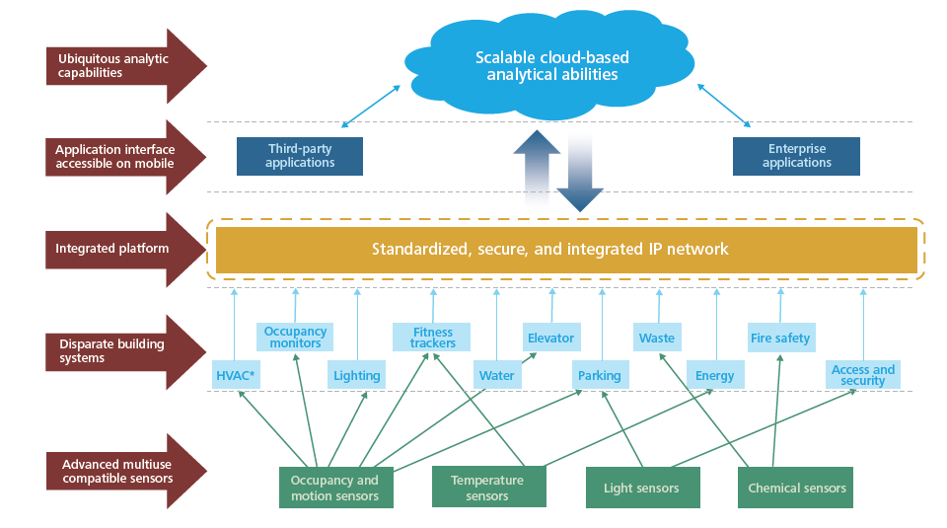In the context of real estate management, the value that the IoT created is from the data within all smart devices communicating with each other by the cloud-based system, and by the cloud, these devices can have efficient adjustments satisfying the tenants’ usage. In fact, the cloud is desirable for the Internet of Things that can decrease costs, increase households’ lifespan, and create high system scalability and availability *(McClelland, C., 2016)*.

**Figure X: IoT information value stack for Corporate Real Estate (CRE) buildings *(Kejriwal, S., Mahajan, S., 2016)*.**

The advanced compatible sensors attached to smart devices are used to capture users’ data; the data then will be uploaded to cloud then will be downloaded to those devices to form the integrated usability. In other words, with the help of the cloud, the IoT system used the data to learn users’ activities and behaviours, therefore create a solution for the best property performance.

With this technology integration and interoperability, the tenants and/or the real estate managers (and/or in the future, the system itself) can react to the data, for example, control the time when the heater and the lights turn on, to optimize tenant’s use of the landlords’ house facilities. This technology can not only safe time and money but also be environmental friendly.

### How we manage to maximize the IoT value

The concept of the Internet of Things nowadays is to place technology into machinery, so it can communicate back to humans on a regular basis; hence, creating an advanced data aggregation and flexible platform which uses common standards and protocols is one way to take advantage of the IoT’s potential *(Kejriwal, S., Mahajan, S., 2016)*.

Based on the model of cloud-based IoT system, our project team planned to develop a new management system which will perform as a software/application to capture and analyse the data gathered from the tenants’ activities by smart devices’ communication. Not only the tenants, landlords and real estate companies can keep track of this source of information, they can also choose multiple actions that will minimize the costs, time and risks while the tenants are living in the rental properties.

This new system of ours is hoped to solve the issue of the current house renting management system and automate its functionality in certain ways.

# Stakeholder Analysis

Alongside with investigating the working domain, it is also important to understand the stakeholders’ interest and influence within the project. Our team has come up with the list of stakeholders whom have significant impact to the system and their classification based on their level of interaction in order to determine their needs to our program.

## Identifying Potential Stakeholders

The project can be successful if and only if there is a good interaction between the system and the users/stakeholders affecting it. Discovering the group of people who would interact to our new program is a must; hence, our project team has gathered the necessary information of each stakeholder. The following table shows each of stakeholder name and the brief description of each group.

**Table X: The list of stakeholders involved in our new system**

|  |  |  |
| --- | --- | --- |
| Stakeholder | | Brief Description |
| **Smart Device Companies** | | Companies that develop smart devices which can collect user’s data then upload to the cloud database. |
|  | **System Managers** | Managers who are in charge of accessing and evaluating the data gathered to the cloud. |
|  | **Manufacturing Faculty** | The faculty that designs smart electronics and devices that can implement to structures to create smart buildings. |
| **Landlords** | | Householders that owns the properties. |
| **Tenants/Rentals** | | Those persons whose data is collected and analysed by the smart devices while living in the landlords’ properties. |
| **Real Estate Companies** | | Companies that own real estate agents that work for the householders in property renting and/or management. |
|  | **Real Estate Agents** | Companies that arrange the renting for their house owners and/or manage the properties using the collected data. |
| **Third-party App Developers** | | The developers that create an application which can utilize the cloud-based data collected from smart devices. |
| **External House Services** | | Services that support and repair/maintain the houses’ facilities. |

### Smart Device Manufacturers

These are companies that provide IoT-based households and/or devices that can utilize the internet backbone to collect and consume users’ data: Google, Apple, Intel Corporation and so on *(Venture Radar, n.d.)*.

Alongside with the hardware manufacturing faculty that designs and creates such devices, system managers, on the other hand, are the ones who oversee the cloud-based data. These persons control the communication of the data in each smart house as well as the data analysis processing after it is uploaded to the cloud. To create an application that can access and utilize the smart devices’ data from the properties, app developers must work with those managers in terms of what and how data can be used.

### Landlords, Tenants & Real Estate Agents

Landlords, tenants and property managers are the three main stakeholders in the property rent management system. However, with the rise of the Internet of Things, the relationship between these stakeholders are automated and enhanced by its technology. While the data is collected from amenities that the tenants are using, the tenants, as well as their landlords and real estate agents, can also keep track of their usage, creating a better household performance and minimizing the risks.

### Third-party App Developers

The third-party app developers are the ones working with our project team, to create a new management system that based on the technology of the IoT. The application that they’ll create will have an ability to collect and communicate the users’ data gathered from smart devices and use it to perform multiple actions (i.e. calling the repair man to fix the facilities, adjusting the light usage, etc.). As mentioned, landlords, real estate agents and tenants will be using this app that will give the best experience to all users.

### External House Services

These external companies have a significant role in our system. While electric, water, gas, and internet companies provide resources for the house to run properly, other services such as cleaning and repair companies will be contacted whenever there has an issue.

With the technology of IoT, the tenants and/or the property managers can now keep track of their electric, water, gas and internet usage, pay the bills digitally and automatically, and call the services for maintenance when receive an alert from the system that some device is malfunctioned.

## Stakeholder Categorization and Prioritization

***In 1987, Eason identified three types of users, they are: primary, secondary and tertiary users. (Abras, C., Maloney-Krichmar, D. & Preece, J., 2004).***

As **the three categories of a user of Eason (1987**), we can categorize the listed potential stakeholders into three groups based on each stakeholder’s level of impact: primary users (who are frequent hands-on to the system), secondary users (who occasionally interact with the system or via an intermediary) and tertiary users (who are affected by the system’s introduction or who influence its purchase). As the result, our project team came up with the following categorization.

**Table X: The three categories of a user *(Eason, 1987)* in the context of our new system**

|  |  |
| --- | --- |
| Category | Users/Stakeholders |
| **Primary Users** | Tenants/Rentals  Real Estate Agents  Third-party App Developers |
| **Secondary Users** | Landlords  Smart Device Companies |
| **Tertiary Users** | External House Services |

In the category of the system’s primary users, we have tenants/rentals, real estate managers and app developers. Apparently, the tenants who commit to rent the properties are the people that usually interact with the system as well as the real estate agents who has responsible for the properties management. Third-party app developers are also in the list because they’ll provide the platform that run our new system; its developments and maintenance depend on these developers.

As for secondary users, although landlords have the same privilege as real estate agents, they don’t have to interact with the system very often; in fact, the profit they benefit is from the work of real estate agents. Smart device companies are the ones who provide hardware and access to customers’ data; however, they don’t particularly affect the system functionality (it’s the developers).

Finally, all the external house services will only interact with our new system by providing resources (i.e. electric, water, internet, etc.) or repairing amenities. Therefore, they are put in the least interactive stakeholder group.

This prioritization method is developed to acknowledge the frequency and the effectiveness of each group’s influence to the new system so that we can manage and keep track of each stakeholder later on as the application development and improvement. Our data gathering process also lies on this categorization so that we can provide better and more relatable questions/interviews for the stakeholders.

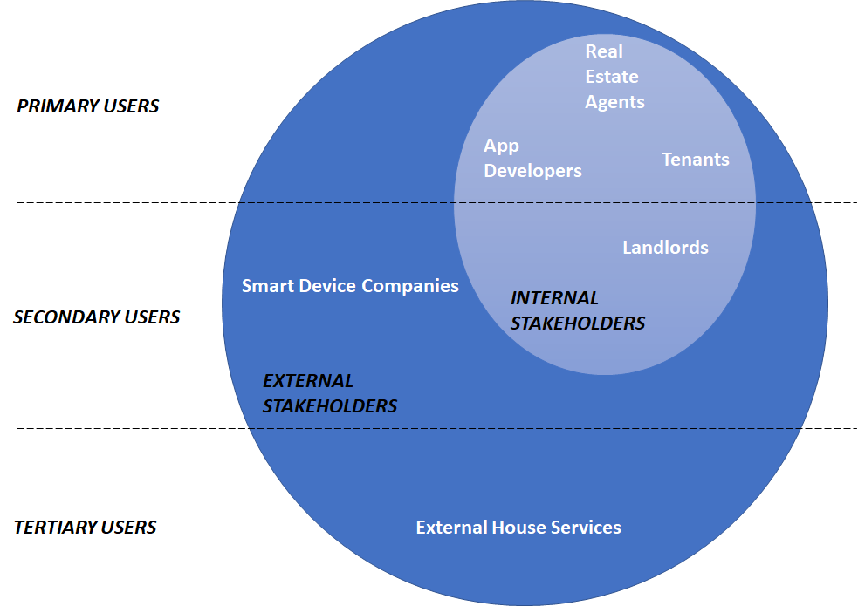

**Figure X: Final stakeholder categorization and prioritization based on the stakeholder’s roles and impact to the new system.**

# Data Gathering Process

***The Data Gathering Techniques include: Questionnaire, Interview, Focus Group, Naturalistic Observation and Studying Documentation. Each technique has unique advantages and disadvantages; therefore, the project team must consider which will be the best approach to which group of stakeholders (Preece, J., Rogers, Y. & Sharp, H., 2015).***

## Our Data Gathering Method

The purpose of data gathering is to collect sufficient, relevant, and appropriate data so that a set of stable requirements can be produced *(Preece, J., Rogers, Y. & Sharp, H., 2015)*. Our project, in order to declare the requirements for the new system, provides a list of questions investigating the users/stakeholders’ needs and what they want our system to acquire. The data gathering techniques we use in the process are (something) and (something else). The reason our team chose these methods is because (reasons).

## Interview Questions

Introduce what we are going to do…

### Stakeholder #1

Describe…

### Stakeholder #2

Describe…

### Stakeholder #3

Describe…

## Questionnaire Structures

Introduce what we are going to do…

### Stakeholder #1

Describe…

### Stakeholder #2

Describe…

### Stakeholder #3

Describe…

## Mock Interview Results

Represent the mock interview results here…

# Requirement Identification

## Identifying System Requirements

After the data gathering process applied to all stakeholder groups, our project team begins to identify and classify the system requirements into different groups and based on their level of importance. To do that, we use the FURPS+ Requirement Model for Project Management. The table below shows all the requirements putting on different categories alongside with their description.

**Table X: Using the FURPS+ Requirement Model, the requirements are made to make sure the new system will be effective and efficient**

|  |  |  |
| --- | --- | --- |
| Requirement Categories  (based on FURPS+ Requirement Model) | | System Requirements and Description |
| **F**unctional | |  |
| **U**sability | |  |
| **R**eliability | |  |
| **P**erformance | |  |
| **S**ecurity | |  |
| **+** | Design |  |
| Implementation |  |
| Interface |  |
| Physical |  |
| Supportability |  |

### Requirement #1

Describe…

### Requirement #2

Describe…

### Requirement #3

Describe…

## Requirement Classification

Categorize them based on their level of impact…

**Table X: Classifying the system requirements based on their level of importance**

|  |  |  |  |  |  |
| --- | --- | --- | --- | --- | --- |
| Level of Importance | Requirement Categories (based on FURPS+ Requirement Model) | | | | |
| **Functional** | **Usability** | **Reliability** | **Performance** | **Security** |
|  |  |  |  |  |
|  |  |  |  |  |
|  |  |  |  |  |
|  |  |  |  |  |
|  |  |  |  |  |
|  |  |  |  |  |

based on their level of importance…

# Conclusion

The Internet of Things has a huge role in the modern real estate management system nowadays. Based on the IoT system that interact with the data via the cloud, our project team decided to develop a new rental management system using that technology. The system is hoped to be an efficient and high-performant management system and will help real estate agents manage their house owners’ properties in the near future.

As the system design is according to the User-Centred Design (UCD), the project team so far has finished the first two core activities which are understanding the working domain and the system users/stakeholders and then define the new system requirements.

Our ‘User Evaluation Report’ has represented the rise of the Internet of Things within the real estate industry as well as identifying the key stakeholders and what should be acquired to design the solution for our new **Smart Real Estate Management System**.

The next report named **‘System Description & Modelling Report’**, as the presentation of the User-Centred Design’s last two activities, will focus on describing the system design, its interfaces and modelling.

# References

Abras, C., Maloney-Krichmar, D., Preece, J., 2004, *User-Centred Design*, viewed 20 August 2018, <<http://www.e-learning.co.il/home/pdf/4.pdf>>

Glassman, S., 2015, *GRAPHIC: 24-hours in a smart building*, viewed 19 August 2018, <<https://buildingcontrols.honeywell.com/buildingintel/graphic-24-hours-in-a-smart-building/>>

Kejriwal, S., Mahajan, S., 2016, *Smart buildings: How IoT technology aims to add value for real estate companies*, viewed 18 August 2018, <<https://www2.deloitte.com/content/dam/Deloitte/nl/Documents/real-estate/deloitte-nl-fsi-real-estate-smart-buildings-how-iot-technology-aims-to-add-value-for-real-estate-companies.pdf>>

McClelland, C., 2016, *What is the Cloud? How does it fit into the Internet of Things?*, viewed 19 August 2018, <<https://www.iotforall.com/what-is-the-cloud/>>

Preece, J., Rogers, Y. & Sharp, H., 2015, *Interaction Design: Beyond Human-Computer Interaction*, 4th edition, Wiley.

SAI Global, 2010, *Ergonomics of Human-System Interaction – Part 210: Human-Centred Design for Interactive Systems (ISO 9241-210:2010)*, viewed 22 Aug 2018, <<https://infostore.saiglobal.com/preview/is/en/2010/i.s.eniso9241-210-2010.pdf?sku=1441363>>

Satzinger J., Jackson R. & Burd S., 2015, *Systems Analysis and Design in a Changing World*, 7th edition, Cengage Learning, Boston.

Venture Radar, n.d., *Top Smart Devices Companies*, viewed 19 August 2018, <<https://www.ventureradar.com/keyword/Smart%20Devices>?>

# Glossary

**C**

**Cloud**: a huge, interconnected network of powerful servers that performs services for businesses and for people *(McClelland, C., 2016)*.

**H**

**Human-Centred Design (or User-Centred Design)**: Human-Centred Design is an approach to interactive systems development that aims to make systems usable and useful by focusing on the users, their needs and requirements, and by applying human factors/ergonomics, and usability knowledge and techniques. This approach enhances effectiveness and efficiency, improves human well-being, user satisfaction, accessibility and sustainability; and counteracts possible adverse effects of use on human health, safety and performance *(SAI Global, 2010)*.

**I**

**Interaction Design**: designing interactive products to support people in their everyday and working lives *(Preece, J., Rogers, Y. & Sharp, H., 2015)*.

**T**

**The Internet of Things (IoT)**: a suite of technologies and applications that equip devices and locations to generate all kinds of information and to connect those for instant data analysis and smart actions *(Kejriwal, S., Mahajan, S., 2016)*.

**Other shit**

Interview

Questionnaire

# Appendices

Style Guide and/or Member Breakdown of Tasks.

**Table X: Work Breakdown Structure (WBS) of ‘Golden Resident’ project team**

|  |  |  |  |  |
| --- | --- | --- | --- | --- |
| Task ID | Task Description | Member allocated  to task | Task dependent on | Estimated time of completion |
| **1.** | **User Evaluation Report** | | | |
| 1.1. |  |  |  |  |
| 1.2. |  |  |  |  |
| 1.3. |  |  |  |  |
| 1.4. |  |  |  |  |
| 1.5. |  |  |  |  |

***Work Breakdown Structure (WBS) is an organized list of tasks that used to distribute the workload to every member of the project team (Satzinger J., Jackson R. & Burd S., 2015).***