The given probabilities are shown below. All the values are considered as failure rate per hour in the process of building fault trees. Besides, the failure probability of HT/SD detectors is taken as 0.05 and all loss of power supplies have been ignored in this case.

In addition, it is assumed that 25% of the pipe work is after FV1 and 75% is before FV1. Therefore, for pipe work after FV1, the failure rate of pipework broken or damaged is 7.75E-9 and the failure rate of pipework blocked is 3.9E-9. For pipe work before FV1, the failure rate of pipework broken or damaged is 2.33E-8 and the failure rate of pipework blocked is 1.17E-8.

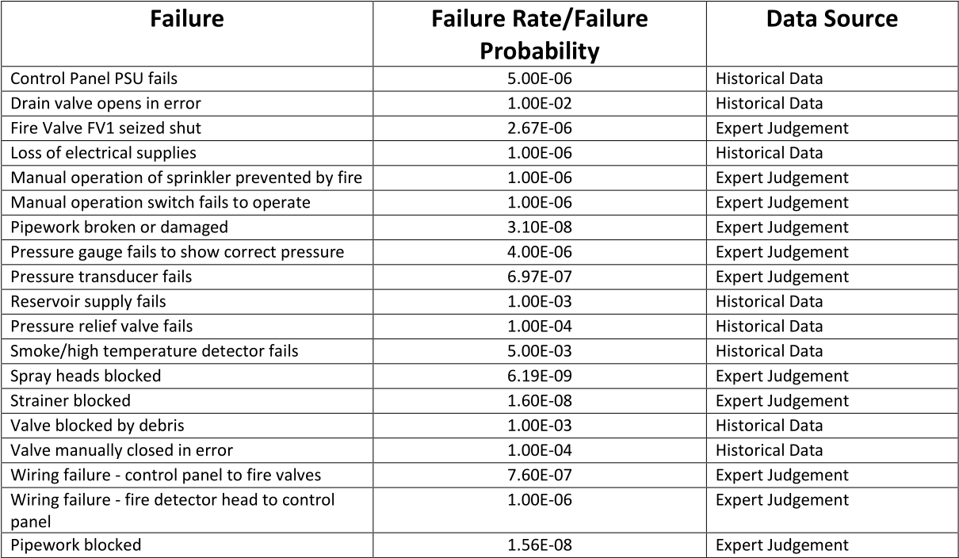

Fig. 1 Probabilities of failures in the system

As is shown in the figure below, a fault tree has been built to study the probability of sprinkler system fails on demand. Since the pressure transducer (PT1) only trigger an alarm at the control panel and is irrelevant to the top event (sprinkler system fails on demand), PT1 would be considered in the Event Tree analysis later.

There are mainly 3 ways to cause sprinkler system fail: control system fails, pipe system fails and reservoir supply fails. Control system fails includes which are after FV1. Besides, FV1 failure is contained in the after FV1 part. Most of the pipes and valves may suffer from leakage or blockage, which make the water pressure lower and disable the sprinkler system. Details of how the pipes and valves failure affects the whole sprinkler system can be control panel PSU fails, fire detecting system fails and wires fail. In this case, the sprinkler system is set off when one of the three HT/SD sense a fire which means the fire detecting system would fail if only all the detectors fail at once. In terms of pipe system fails, the pipe system is considered as 2 part: pipes, valves and a strainer (S1) before FV1 and pipes, valves and spray heads

## *2.1 Statement of assumptions and consequences*

As there is approximately 1 fire per year, there should be 1/(365*24)=1.141E-4 fire per hour. A fake alarm is detected 1.826E-4 times per hour. The failure rate of pipe work before FV1 is 2.33E-8+1.17E-8=3.495E-08 times per hour. PT1 fails at 6.97E-07 times per hour. Sprinkler system fails on demand probability is 0.005732 as calculated in the Fault Tree.

Four consequences can be summarised as below:

1. RESTAURANT ON FIRE: lose £20000 with one fatality
2. SPRINKER SYSTEM WORKS ON DEMAND: lose £4000
3. NO FIRE AND DAMAGE ON COMPUTER (SPURIOUS FIRE): lose £2500
4. NO LOST: zero cost

## *2.2 Structure of Event Tree and explanation*

The Event Tree is about incidents in the restaurant. Pipe system before FV1 failure and PT1 failure is considered in the Event Tree. If there is a fire when pipe before FV1 and PT1 fail simultaneously, the water supply is not sufficient to put out the fire, thus consequence 1 happens. Also, if pipe before FV1 fails while PT1 works, maintainer would try to fix the pipe issue quickly. In this happens when sprinkler system works on demand.

On the other hand, if no fire emerges in the restaurant and a fake alarm goes off, consequence 4 happens when sprinkler system fails on demand, whereas consequence 3 happens when sprinkler system works on demand. Finally, if case, consequence 1 happens when sprinkler system fails on demand, whereas consequence 2 happens when sprinkler system works on demand. If the pipe system before FV1 works when there is a fire, similarly, consequence 1 happens when sprinkler system fails on demand, whereas consequence 2

There are mainly 3 ways to cause sprinkler system fail: control system fails, pipe system fails and reservoir supply fails. Control system fails includes which are after FV1. Besides, FV1 failure is contained in the after FV1 part. Most of the pipes and valves may suffer from leakage or blockage, which make the water pressure lower and disable the sprinkler system. Details of how the pipes and valves failure affects the whole sprinkler system can bThere are mainly 3 ways to cause sprinkler system fail: control system fails, pipe system fails and reservoir supply fails. Control system fails includes which are after FV1. Besides, FV1 failure is contained in the after FV1 part. There are mainly 3 ways to cause sprinkler system fail: control system fails, pipe system fails and reservoir supply fails. Control system fails includes which are after FV1. Besides, FV1 failure is contained in the after FV1 part. Most of the pipes and valves may suffer from leakage or blockage, which make the water pressure lower and disable the sprinkler system. Details of how the pipes and valves failure affects the whole sprinkler system can bmake the water pressure lower and disable the sprinkler system. Details of how the pipes and valves failure affects the whole sprinkler system can b

There are mainly 3 ways to cause sprinkler system fail: control system fails, pipe system fails and reservoir supply fails. Control system fails includes which are after FV1. Besides, FV1 failure is contained in the after FV1 part. Most of the pipes and valves may suffer from leakage or blockage, which There are mainly 3 ways to cause sprinkler system fail: control system fails, pipe system fails and reservoir supply fails. Control system fails includes There are mainly 3 ways to cause sprinkler system fail: control system fails, pipe system fails and reservoir supply fails. Control system fails includes which are after FV1. Besides, FV1 failure is contained in the after FV1 part. Most of the pipes and valves may suffer from leakage or blockage, which make the water pressure lower and disable the sprinkler system. Details of how the pipes and valves failure affects the whole sprinkler system can bMost of the pipes and valves may suffer from leakage or blockage, which There are There are mainly 3 ways to cause sprinkler system fail: control system fails, pipe system fails and reservoir supply fails. Control system fails includes which are after FV1. Besides, FV1 failure is contained in the after FV1 part. Most of the pipes and valves may suffer from leakage or blockage, which make the water pressure lower and disable the sprinkler system. Details of how the pipes and valves failure affects the whole sprinkler system can bThere are mainly 3 ways to cause sprinkler system fail: control system fails, pipe system fails and reservoir supply fails. Control system fails includes which are after FV1. Besides, FV1 failure is contained in the after FV1 part. Most of the pipes and valves may suffer from leakage or blockage, which make the water pressure lower and disable the sprinkler system. Details of how the pipes and valves failure affects the whole sprinkler system can bmainly 3 ways to cause sprinkler system fail: control system fails, pipe system fails and reservoir supply fails. Control system fails includes which are after FV1. Besides, FV1 failure is contained in the after FV1 part. Most of the pipes and valves may suffer from leakage or blockage, which make the water pressure lower and disable the sprinkler system. Details of how the pipes and valves failure affects the whole sprinkler system can bhow the pipes and valves failure affects the whole sprinkler system can b