Belison, Frey Chrysteand D.

LE2

Users Table:

Posts Table:

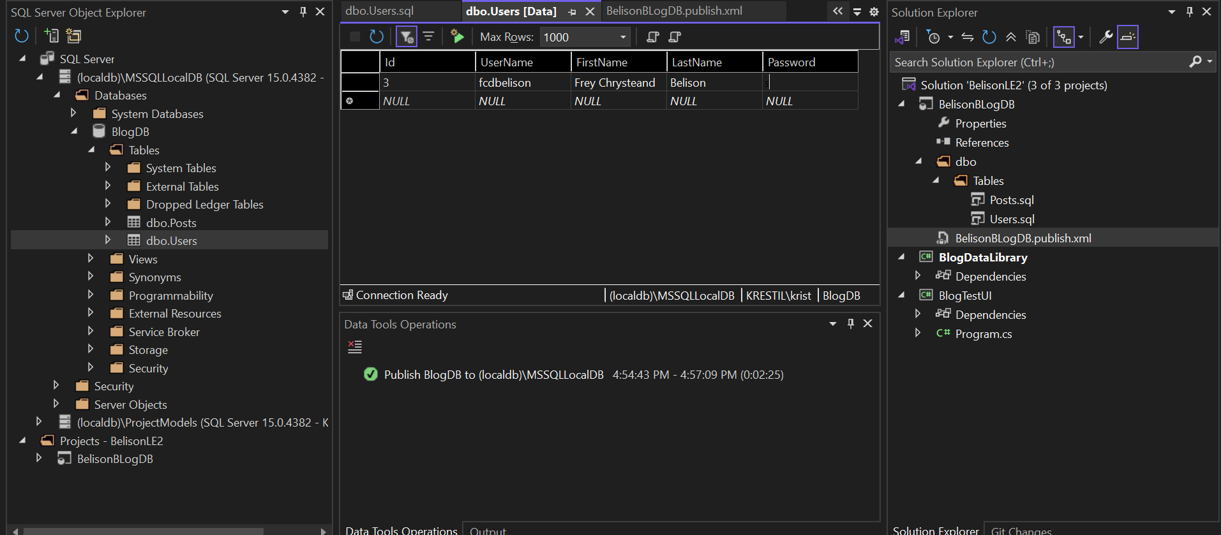

Codes:

SqlData.cs:

SqlDataAccess.cs

ListPostModel.cs

PostModel.cs

Usermodel.cs:

