**MED Associates -> Arduino -> Optogenetics**

Parts:

1x DIG-726 Superport card: <http://www.med-associates.com/product/superport-16-output-module/>

*Optional* 1x Breakout Box for Superport DB25 to female BNC and connecting cable: (Contact Matt Verber) Pins 1-16 = output, Pin 22 = common ground, Pins 17-21 & 22-25 = Inactive

1x Arduino Duemilanove board or equivalent (see UNO, look for atmega328 chipset): <http://www.amazon.com/Arduino-Duemilanove-Board/dp/B004A7L3NC/ref=sr_1_1?s=electronics&ie=UTF8&qid=1464023228&sr=1-1&keywords=arduino+duemilanove>

1x 9v DC 650mA power supply for Arduino: <http://www.amazon.com/Wall-Adapter-Power-Supply-650mA/dp/B003XZSZWO/ref=pd_bxgy_147_img_2?ie=UTF8&refRID=0DNJN759T0Z3Z7VFYCB8>

1x USB A to B cable for Arduino (may be included with board): <http://www.amazon.com/AmazonBasics-USB-2-0-Cable--Male/dp/B00NH11KIK/ref=sr_1_4?s=electronics&ie=UTF8&qid=1464023517&sr=1-4&keywords=usb+a+to+b>

1x Arduino enclosure: <http://www.amazon.com/ENCLOSURE-ARDUINO-MEGA-DUEMILANOVE-3-4x2-5x1-1/dp/9827012088/ref=sr_1_13?ie=UTF8&qid=1464027132&sr=8-13&keywords=arduino+enclosure>

18-20 gauge solid copper wire: <http://www.amazon.com/Shaxon-SO18-100RD-Solid-Copper-100-Feet/dp/B00IN83C6U/ref=sr_1_1?s=lamps-light&ie=UTF8&qid=1464021056&sr=1-1&keywords=copper+wire&refinements=p_n_feature_keywords_browse-bin%3A3605500011%2C4876285011>

2x BNC-BNC coaxial cables (~6ft or more): <http://www.amazon.com/Belkin-Thin-Coaxial-Cable-6-Foot/dp/B00004Z5KG/ref=sr_1_5?ie=UTF8&qid=1464021366&sr=8-5&keywords=BNc+cable>

1x 1k ohm resistor: http://www.amazon.com/E-Projects-25EP5141K00-Ohm-Resistors-Pack/dp/B0185FC5IG/ref=sr_1_1?ie=UTF8&qid=1464021551&sr=8-1&keywords=1+kohm+resistor

Heat shrink for 16-20 gauge wire: <http://www.amazon.com/uxcell%C2%AE-Polyolefin-Insulation-Shrink-Tubing/dp/B008DFW8JA/ref=sr_1_sc_1?ie=UTF8&qid=1464022153&sr=8-1-spell&keywords=3mm+heat+shrinkl>

3x female BNC connectors with wire terminals: <http://www.amazon.com/Screw-Terminal-Coaxial-Female-Connector/dp/B00N41BFP6/ref=sr_1_4?ie=UTF8&qid=1464022643&sr=8-4&keywords=female+bnc+connector>

1x FRJ 1x2 FC-2FC fiber optic rotary joint (commutator): <http://doriclenses.com/life-sciences/fiber-optic-rotary-joints/809-frj-1x2-intensity-division.html>

1x Mount for fiber optic commutator: <http://doriclenses.com/life-sciences/accessories/819-holder-for-frj1x2-frj1x4-ledfrj.html>

1x 105 um, 0.22 NA, FC/PC-FC/PC fiber patch cable, 1m long (200 um, 0.22 NA cables will work as well): <https://www.thorlabs.com/thorproduct.cfm?partnumber=M43L01>

2x 200um core, 0.22 NA, FC/PC to 2.5mm ferrule patch cables, 1m long: <https://www.thorlabs.com/thorproduct.cfm?partnumber=M80L01>

*For Halo/ARCH Only* 1x 532nm Green DPSS laser with fiber coupler (TA-FC), ~300mW (at least 200): <http://www.lasercentury.com/product.asp?id=470>

*For ChR2 Only* 1x 472nm Blue DPSS laser with fiber coupler (T8), ~500mW (at least 200): <http://www.lasercentury.com/product.asp?id=612>

Uncleaved optical fibers in 2.5mm ceramic ferrules, 200um core, 0.22NA: <https://www.thorlabs.com/thorproduct.cfm?partnumber=CFMC22U-20>

¼ in heat shrink: <http://www.amazon.com/Heat-Shrink-Tube-Feet-Pack/dp/B01BSZIVV0/ref=sr_1_3?ie=UTF8&qid=1464027896&sr=8-3&keywords=1%2F4+in+heat+shrink>

Ceramic 2.5mm ferrule mating sleeves: <https://www.thorlabs.com/thorproduct.cfm?partnumber=ADAF1-5>

Tools:

1x Heat gun: <http://www.amazon.com/Weller-6966C-Watts-Electric-Industrial/dp/B000ICGMN4/ref=sr_1_25?ie=UTF8&qid=1464022491&sr=8-25&keywords=heat+shrink+gun>

1x Soldering Iron: <http://www.amazon.com/Weller-WLC100-40-Watt-Soldering-Station/dp/B000AS28UC/ref=sr_1_7?s=hi&ie=UTF8&qid=1464022983&sr=1-7&keywords=soldering+iron>

1x Wire cutter/stripper: <http://www.amazon.com/Tools-VISE-GRIP-Stripper-Crimper-2078309/dp/B000JNNWQ2/ref=sr_1_4?s=hi&ie=UTF8&qid=1464023109&sr=1-4&keywords=wire+stripper>

1x Fiber optic scribe: <https://www.thorlabs.com/thorproduct.cfm?partnumber=S90R>

1x Dremel 4200: <http://www.amazon.com/dp/B00LN74KGO>

1x Dremel 545 diamond cutting wheel: <http://www.amazon.com/Dremel-545D-545-Diamond-Wheel/dp/B00004UDI9/ref=sr_1_2?ie=UTF8&qid=1464026386&sr=8-2&keywords=dremel+545>

1x PM100USB power and energy meter interface: <https://www.thorlabs.com/thorproduct.cfm?partnumber=PM100USB>

1x S121C photodiode power sensor, Si, 400-1100nm, 500 mW: <https://www.thorlabs.com/thorproduct.cfm?partnumber=S121C>

1x helping hand tool: <http://www.amazon.com/Helping-Hand-01902-with-Magnifier/dp/B000P42O3C/ref=sr_1_1?ie=UTF8&qid=1464026753&sr=8-1&keywords=helping+hand+tool>

Solder: <http://www.amazon.com/Alpha-AT-31604-60-40-Solder-Ounces/dp/B00030AP48/ref=sr_1_1?s=hi&ie=UTF8&qid=1464023067&sr=1-1&keywords=solder>

1. **Configure DIG-726 SuperPort Output Module with MED system**
   1. 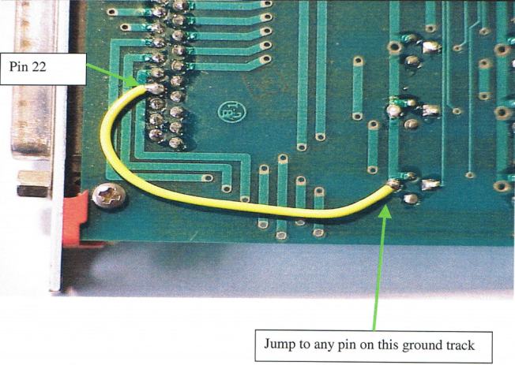Be sure that PIN 22 of db25 connector is hardwired to earth ground (standard on 726-G cards)
      * 1. 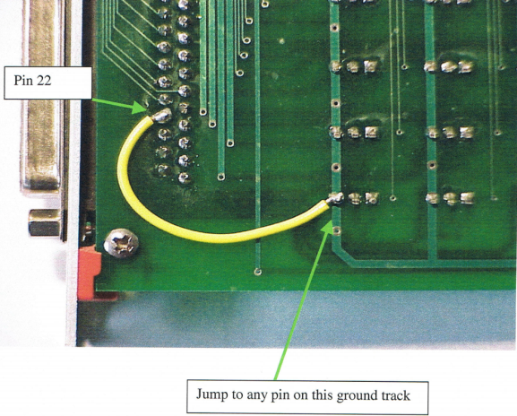See images for example (left: new cards, right: old cards)
   2. Configure jumpers on card to 794 & 795 on J1, none on J2
   3. Insert card into rack
   4. Load MED hardware configuration utility
   5. Open Define-Outputs(custom)
   6. Set Superport card to the first open output(s), usually 17 or 33
      1. Enter card address for above output as follows
         1. Rack 1
         2. Port 794
         3. Offset 0 (use offset 1 for outputs 9-16)
         4. Bit 1,2,4,8,16 etc. for boxes 1,2,3,4,5 etc. (newer MED systems use Output 1,2,3,4,5,6,7,8 etc. instead)
   7. Activate the laser in your MED programs by calling up the output defined above
2. **Break out Superport db25 connector to one or more female BNC connectors**
   1. This can be done with a breakout box/cable (see parts) or simply run copper wire (strip ends) from pin 22 (ground) on the DB25 Superport connector and another from the pin corresponding to the output for the box you want to use to a female BNC connector
   2. After this step, you should have a grounded female BNC connector for each box you want to drive a laser in, label these accordingly and always test your outputs!
3. **Configure and connect Arduino *If you do not need pulsed laser light, connect a BNC-BNC coaxial cable directly between the output from the Superport card and the back of the laser and skip to step 3.9\***
   1. Install Arduino software/drivers (<https://www.arduino.cc/>) on a computer and connect the Arduino via USB
   2. Program the Arduino to deliver the desired laser frequency in response to TTL outputs from med
      1. Use the following program as a template for 20 hz stimulation:

int ledPin = 13; // Laser is connected to pin 13

int switchPin = 2; // med associates is connected to pin 2

int val; // variable for reading the pin status

void setup() {

pinMode(ledPin, OUTPUT); // Set the LED pin as output

pinMode(switchPin, INPUT); // Set the switch pin as input

}

void loop(){

val = digitalRead(switchPin); // read input and store in val

if (val == LOW) { // check if external trigger is present

digitalWrite(ledPin, HIGH); // turn Laser on

delay(5); // 5 ms pulse duration

digitalWrite(ledPin, LOW); // turn Laser off

delay(45); //change this to change the frequency

}

}

* + 1. Once a program is successfully loaded, the yellow LED on the Arduino should blink rapidly
  1. Cut 4 lengths of copper wire, and strip both ends, solder a resistor on to one of the wires and cover with small heatshrink
  2. Connect the copper wire with resistor to pin 13 and the + terminal on a BNC connector, connect another copper wire to the - terminal on that connector and the adjacent GND pin; label this BNC Output
     1. See below image, “OUT” for reference
  3. Connect the remaining copper wires to pin 2 and the + terminal, and pin POWER GND and the - terminal on another BNC connector; label this BNC Input
     1. 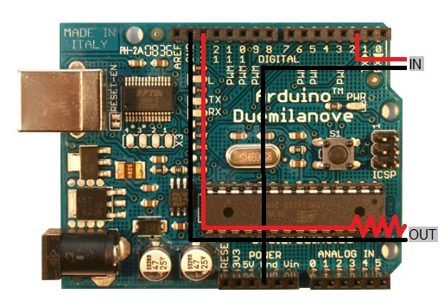See below image, “IN” for reference
  4. Secure the wired Arduino in its box (you may have to break off extra mounting pins), then move near the behavioral chamber and plug it in to its power supply
  5. Connect a BNC-BNC coaxial cable between the Input connector on the Arduino and BNC connector for that behavioral chamber broken-out from the Superport card
     1. The yellow LED on the Arduino should stop flashing, if not check your connections
     2. When the appropriate output (see above) is triggered in MED, the yellow led on the Arduino should begin flashing again; always confirm this is working before running animals!
  6. Connect a BNC-BNC coaxial cable between the output connector on the Arduino and BNC connector on the back of the laser for that behavioral chamber
  7. On the back of the laser, set the input to TTL
     1. Once the laser is powered up, it should not produce light by default, only triggering the output in MED should produce (pulsed) light.

1. **Configure laser to deliver light to behaving animals**
   1. Mount optical commutator above behavioral chamber
   2. Connect optical commutator to laser with fc/pc fc/pc patch cable
   3. Connect tether (these are currently built in house from coiled plastic/metal tubing and cannula caps) to optical commutator with tape, be sure that the tether terminates right around the floor of the chamber
   4. Connect fc/pc to ferrule patch cables to commutator and run these into the behavioral chamber
   5. Test and calibrate patch cables
      1. Install USB sensor on a nearby computer, open PMID utility
         1. Make sure the wavelength corresponds to the laser you are using
      2. Place sensor in behavioral chamber and use the helping hand tool to position one patch cable directly above it
      3. Adjust the laser power until you have the desired wattage
         1. Account for loss of implanted fibers (see below)
      4. Confirm that the other patch cable is within 10-20% of the output, if not replace one or both patch cables until you find a better match
   6. Coil patch cables until they are the same length as the tether in the chamber, securely tape the remaining patch cables to the commutator and tape the patch cables to the tether approximately 1/3rd of the way from the bottom
   7. Cut 1-2 inches of ¼ in heatshrink and place around ferrules on patch cables
2. **Construct and implant optical fibers in rats**
   1. Cut optical fibers in ferrules to the desired length for implantation with fiber scribe
      1. It is best to score the fibers and then flick or pull them apart, avoid cutting all the way through
   2. Score the fiber side of the ferrules with the Dremel diamond cutter
   3. Test light output of optical fibers
      1. Using the light sensor (step 4.5.1), determine the baseline output of a patch cable
      2. Connect a scored/cut fiber to the patch cable, position above sensor with helping hand tool, and record the output to determine the loss of that fiber
   4. Find two fibers within 5% loss of each other and implant these during surgery
      1. Be sure to record the loss of each fiber or average loss of fibers for each animal
   5. Implants should be positioned slightly above (.1-.2mm) the ROI to account for light spread
   6. If rats are not being prepared for electrophysiology as well, be sure to cement threading for a cannula or whichever connector your tethers use on the rat during surgery
3. **Connect rats to laser for behavioral testing**
   1. Always retest light delivery and calibrate patch cables as in steps 4.5 and 3.7 before connecting rats
   2. First connect the tether from the commutator to the rat
   3. Next, connect the patch cables to the ferrules on the rat’s head, be sure the heat shrink is on the cables and slide it down to cover the connection
   4. Start your behavioral program in MED
      1. Periodically confirm that your animals have not become unplugged