StateBench: Working State for Reliable Multi-Step Tool Use
  - Representative FuncBenchGen reproduction and controlled Qwen3.6-27B extension
  - LebNet Tech Fellows 2026 | Academic Paper Option | Domenico Labaki

1. Project Title & Abstract
Abstract. Reliable tool-using language models must infer valid call sequences while preserving intermediate values across multiple turns. StateBench reproduces a representative subset of Maekawa et al.'s FuncBenchGen, which generates synthetic hidden function-dependency graphs with controllable depth and distractors, and extends it by comparing five representations of observed working state. A paper-style Qwen3.6-27B calibration reproduced the qualitative depth effect but reached a zero-success floor on deep and connected tasks. I therefore applied one model-compatible interface consistently across 15 frozen graphs. The original four-strategy panel contained 60 executions: full history achieved 12/15 exact successes, paper restatement 13/15, and JSON plus static dependency pruning 15/15 each. Static pruning nevertheless retained the same 404.7 cumulative state bytes as JSON. A post hoc, mechanism-driven live filter added 15 executions and achieved 13/15 while averaging 156.9 state bytes, a 61.2% reduction from JSON. It remained perfect on easy and deep tasks but fell to 3/5 with connected distractors. The results therefore support explicit structured state while exposing a compression-reliability trade-off for aggressive public-schema pruning.

2. Introduction & Problem Statement
Tool-augmented language models are increasingly expected to call APIs in workflows where later arguments depend on earlier outputs. A model can understand every function schema and still fail by selecting the wrong dependency path, calling a function before its inputs exist, or reusing an incorrect or stale value. Evaluation is difficult because realistic tool benchmarks are expensive to curate, expose only a few fixed difficulty levels, and can be contaminated when public tasks appear in training data or become searchable at test time.
FuncBenchGen addresses these limitations by casting tool use as traversal over a hidden directed acyclic graph (DAG). Nodes are synthetic single-output functions; edges encode type-compatible dependencies. The model sees initial values, randomized tool schemas, and a target variable, but not the graph. Difficulty can be controlled through required core functions, maximum dependency depth, and irrelevant functions. Connected irrelevant nodes (CINs) are especially challenging because they share compatible types with the solution graph. The paper also reports that value-not-yet-known errors dominate execution traces and proposes restating all known variables after each call. StateBench asks the same core question while adding a focused extension: when tasks, model, schemas, call budget, and seeds are fixed, does the representation of observed working state change reliability and context cost?
Paper finding | Original result | StateBench outcome
Dependency depth | Success falls as depth increases. | Paper-style calibration: easy 2/5, deep 0/5. Qualitatively reproduced.
Connected distractors | CINs are more harmful than no-extra or disconnected settings. | Paper-style deep and connected both reached 0/5, so the incremental effect was not testable there. Under the compatible protocol, full history fell from 5/5 deep to 3/5 connected.
State-tracking errors | Using values not yet known is the most common error family. | Sixteen value-not-yet-known events occurred across final traces; explicit errors allowed several runs to recover.
Known-value restatement | Restating all known values often improves reliability, although gains vary by model. | Restatement improved only from 12/15 to 13/15 and stayed 3/5 on connected tasks. This is a qualified, not large, reproduction of the mitigation effect.
Table 1. Relationship between the published findings and this representative reproduction.

3. Methodology (Approach / Reproduction Details)
Reproduction foundation. The project vendors the official FuncBenchGen code release at commit 0718d1cf25b601d0b25fbbbbd064525536cea876. It preserves graph generation, hidden dependencies, type/subtype matching, deterministic target values, exact-answer evaluation, five graph seeds per setting, randomized function order, and the paper's maximum call budget of twice the minimum required calls. No external static dataset is used: graphs are generated synthetically and then frozen so every state strategy receives the identical graph, functions, initial values, target, and tool ordering.
The paper-style calibration used opaque descriptions and the upstream behavior in which wrong inputs execute and return an incorrect value. With full history, Qwen3.6-27B achieved 2/5 on easy depth, 0/5 on deep depth, and 0/5 with connected distractors. This reproduces the qualitative depth decline, but the zero deep baseline prevents a faithful estimate of CINs' additional effect. It is therefore reported separately from the final extension rather than mixed with it.
For the controlled extension, every strategy used the same model-compatible interface: descriptions exposed variable names, premature calls returned an explicit error, the model made one tool call per response, and it was instructed to use only observed values. The hidden DAG, target path, ground-truth values, correctness labels, and unobserved state remained unavailable. Qwen3.6-27B was accessed through Groq with temperature 0, top-p 1, default reasoning enabled, a 4,096-token completion allowance, and the same two-times-minimum call budget.
Condition | Core | Depth | Distractors | Purpose
Easy | 5 | 1 | 0 | Basic tool selection and value propagation
Deep | 5 | 4 | 0 | Longer hidden dependency chain
Connected distractors | 5 | 4 | 10 CINs | Type-compatible irrelevant branches
Table 2. Final paired extension: five frozen graph seeds per condition.
State strategies. Full history adds no state suffix. Paper restatement appends every known value, and JSON serializes the same values as a compact object. Legacy dependency pruning retains values whose types are consumed anywhere in the visible schema set; every observed type remained globally consumable, producing the 404.7-byte null result. Live dependency pruning instead computes a conservative backward frontier from the public target and type signatures, retains one non-conflicting value per still-needed exact type, does not retire failed calls, and emits no suffix after target completion. Neither pruning strategy consults hidden edges, node labels, ground-truth values, or the hidden target path.
Measures. Primary outcomes are exact target success and total request-level prompt tokens. Secondary measures are completion tokens, tool calls, prompt tokens per success, success per 1,000 prompt tokens, cumulative bytes added by state suffixes, and trace-level failure codes. A trial may contain a recoverable intermediate error and still succeed, so error occurrences are not mutually exclusive final outcomes.

4. Implementation Details & Results
StateBench is implemented in Python 3.11 around the pinned generator/evaluator, with NetworkX for graph reconstruction, an OpenAI-compatible Groq provider, pandas for aggregation, and Matplotlib for figures. Each raw trial is written atomically as JSON. Resume logic skips completed pairs, short-window rate limits are retried without discarding the active conversation, and daily quota exhaustion stops safely for a later run. Stored traces include requests, tool calls, arguments, results, token counts, state suffix size, and canonical failure codes.
Strategy | Success | Prompt  tokens | Completion  tokens | Calls | State  bytes | Success /  1k prompt
Full history | 12/15 | 7,515 | 6,357 | 4.67 | 0.0 | 0.106
Paper restatement | 13/15 | 8,631 | 5,460 | 4.87 | 1,227.7 | 0.100
JSON state | 15/15 | 8,887 | 5,780 | 5.27 | 404.7 | 0.113
Dependency pruning | 15/15 | 8,744 | 5,542 | 5.20 | 404.7 | 0.114
Live dependency pruning | 13/15 | 7,484 | 5,297 | 4.67 | 156.9 | 0.116
Table 3. Aggregate final results across 15 tasks. State bytes are cumulative added-state suffix bytes per trial.
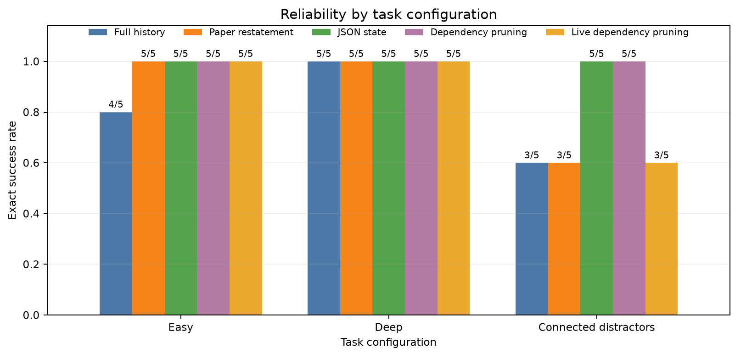
Figure 1. Exact success by condition across five strategies; live pruning reached 3/5 on connected distractors.
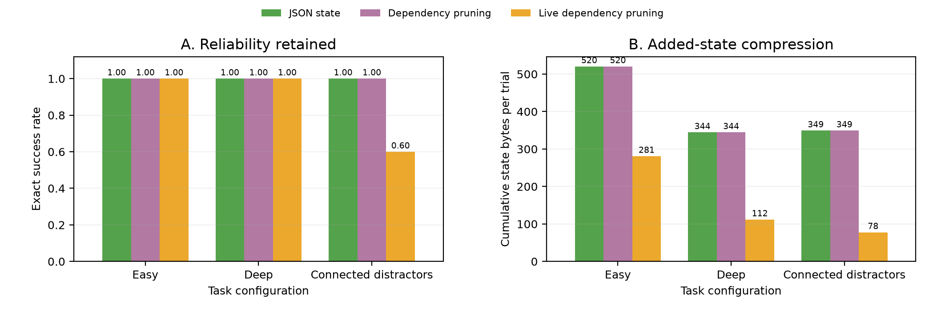
Figure 2. Reliability and added-state size for JSON, static dependency pruning, and live dependency pruning. Bytes measure cumulative suffix content added during a trial.
Across 75 primary executions, live dependency pruning achieved 13/15, compared with 15/15 for JSON and legacy dependency pruning, 13/15 for paper restatement, and 12/15 for full history. Its average cumulative state suffix was 156.9 bytes versus 404.7 for JSON (61.2% lower), and it used 8,636 prompt tokens per success. Both live-pruning failures occurred on connected distractors and ended through reasoning-budget exhaustion. Prompt totals remain descriptive because failed trials can terminate early and hosted inference trajectories may differ even at temperature zero.

5. Discussion & Analysis
The strongest result is conditional rather than universal. On easy tasks, full history failed one seed while every original explicit-state strategy succeeded. On deep tasks without distractors, the original four strategies reached 5/5. Adding ten connected irrelevant functions reduced full history to 3/5, reproducing the paper's qualitative claim that type-compatible distractors confuse dependency selection. JSON and static dependency pruning remained 5/5, recovering both connected full-history failures and the single easy failure. Live dependency pruning achieved 13/15 overall and 3/5 on connected tasks.
Paper restatement produced only a small aggregate gain: 13/15 versus 12/15. In the connected condition it succeeded on a full-history failure at seed 300 but failed a different seed 100, while both failed seed 400; its net result remained 3/5. This qualifies the paper's mitigation finding. Simply repeating every value was not sufficient for this model under the stress condition, whereas a compact machine-readable map was. Because the sample is small, this should be treated as evidence for further testing rather than proof that JSON formatting is intrinsically superior.
Trace behavior clarifies the mechanism. Sixteen value-not-yet-known events and seven thinking-budget exhaustion events occurred across the five strategies, echoing the paper's state-availability and reasoning-capacity concerns. Under the compatible interface, the executor exposed premature calls instead of silently propagating a fabricated value, and compact-state runs sometimes recovered. The unsuccessful live-pruning runs both reached the 4,096-token per-turn allowance without producing another tool call or the target. This is a valid outcome under the fixed protocol, but it does not prove that pruning alone caused the looping behavior. Absolute success rates cannot be compared directly with the paper's model table.
The follow-up resolves the implementation cause of the original pruning null. The static rule asked whether a type was consumed anywhere, so stale values survived after their relevant consumer had completed and distractor-only consumers widened the allow-list. Live dependency pruning used only public schema information to retire types outside the still-unresolved target frontier. It reduced average added-state bytes from 404.7 to 156.9 (61.2%). That compression did not preserve reliability: it achieved 13/15 overall and 3/5 on connected distractors, versus 15/15 and 5/5 for JSON and static pruning. The result suggests that reducing external reminders can increase the model's burden to reconstruct the path internally. Because there are only five fixtures per condition, this trade-off is descriptive rather than statistically established.

6. Reflection on Learnings

This project and fellowship as a whole were a great dive into theory that I have been missing. As someone who has been building with AI, developing AI tools and leveraging agents, this look behind the scenes was extremely valuable. I discovered that deepening my understanding simply had to come from a step back into the basics, and a step forward into innovation. And while reproducing a research paper first felt like simply running experiments and code that was already written, attempting to look for an extension was the part where I understood that the attempt is what matters when trying to come up with something new. Perserverance eventually leads to breakthrough, and sometimes the breakthrough is in the mind.

The most rewarding part was turning an initial all-failure local run into a controlled experiment without hiding negative findings or changing the core question. Rate limits, reasoning-budget exhaustion, and resumability were major implementation challenges. I tried running models locally, and ran the experiment with a Qwen3-8B model, unsuccessfully, so I went back to the API. Frozen fixtures, viability gates, atomic checkpoints, and trace logging made the experiment recoverable. The static pruning null also taught me to inspect whether an intervention actually activates: rather than overclaiming, I traced the global-type rule, designed a public-schema liveness filter, and measured the follow-up separately. The activated filter demonstrated real compression, but its two connected-task failures reinforced that a smaller state is not automatically a better state.

References
[1] Maekawa, S., Hassell, J., Pezeshkpour, P., Mitchell, T., and Hruschka, E. (2026). Towards Reliable Benchmarking: A Contamination Free, Controllable Evaluation Framework for Multi-step LLM Function Calling. ICLR 2026; arXiv:2509.26553v2.
[2] Megagon Labs. FuncBenchGen code release, commit 0718d1cf25b601d0b25fbbbbd064525536cea876. Model: qwen/qwen3.6-27b via Groq.

