Supporting Information

Size control and Characterization of Wustite (Core)/Spinel (Shell) Nanocubes Obtained by Decomposition of Iron Oleate Complex

Hoang Tri Hai*, Hai Tao Yang, Hiroaki Kura, Daiji Hasegawa, Yasunobu Ogata, Migaku Takahashi and Tomoyuki Ogawa
Graduate School of Engineering, Department of Electronic Engineering, Tohoku University, 6-6-05 Aza-Aoba, Aramaki, Aoba-ku, Sendai 980-8579, Japan.

*Corresponding author: phai@ecei.tohoku.ac.jp

Figure S1. TEM images of the nanocubes prepared without any addition of OA and at different FeOL/NaOL molar ratios of (a) 1, (b) 2, (c) 3.5. It is clear that only NaOL could not well protect fresh-formed nanoparticles from aggregation and chaotic growth.

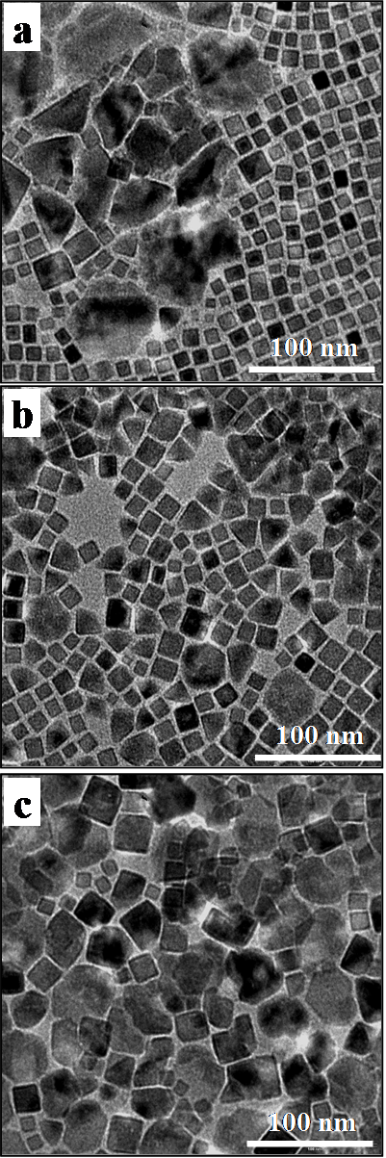

Figure S2. The size distribution of (a) 9 nm, (b) 16 nm and (c) 22 nm nanocubes. The solid line is fitted by log-normal distribution function.

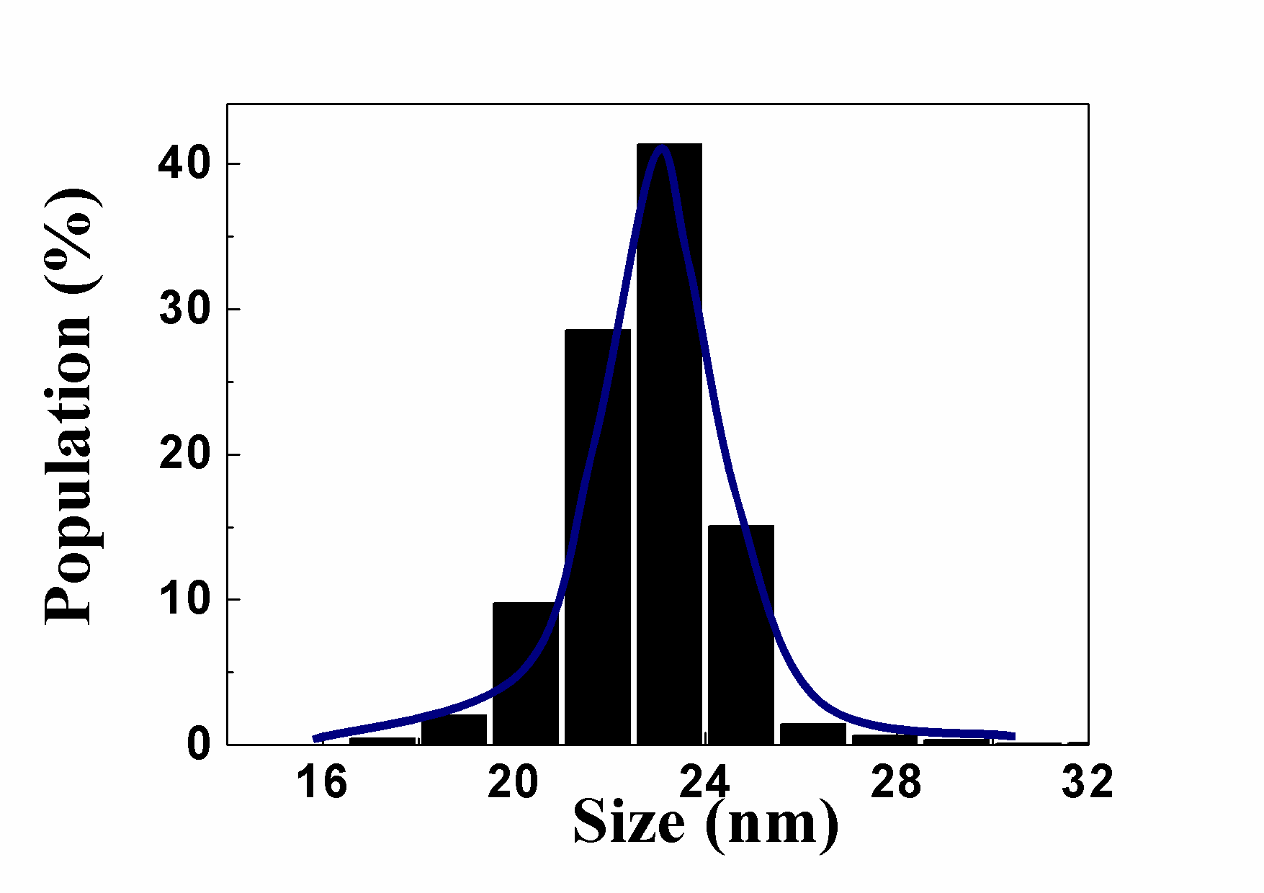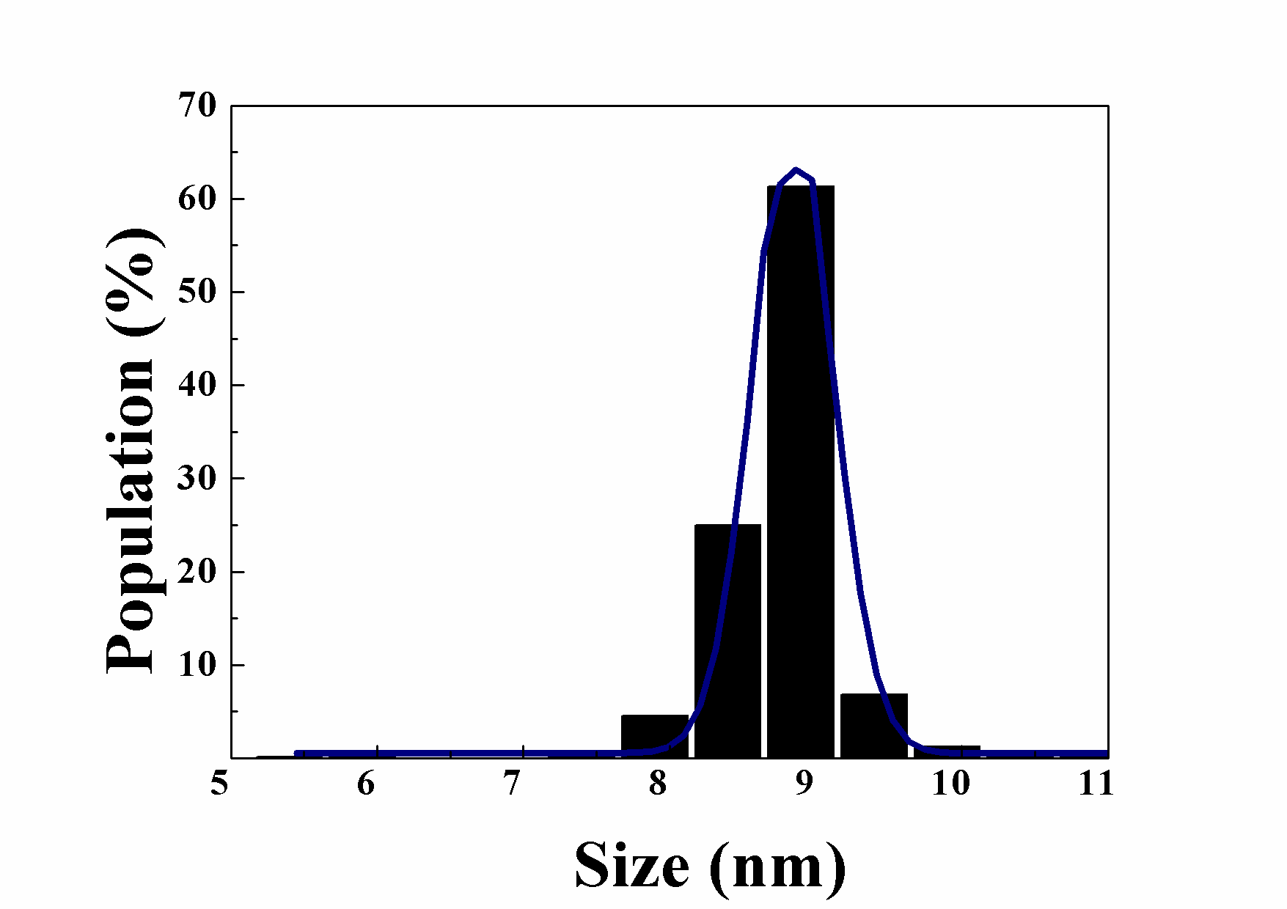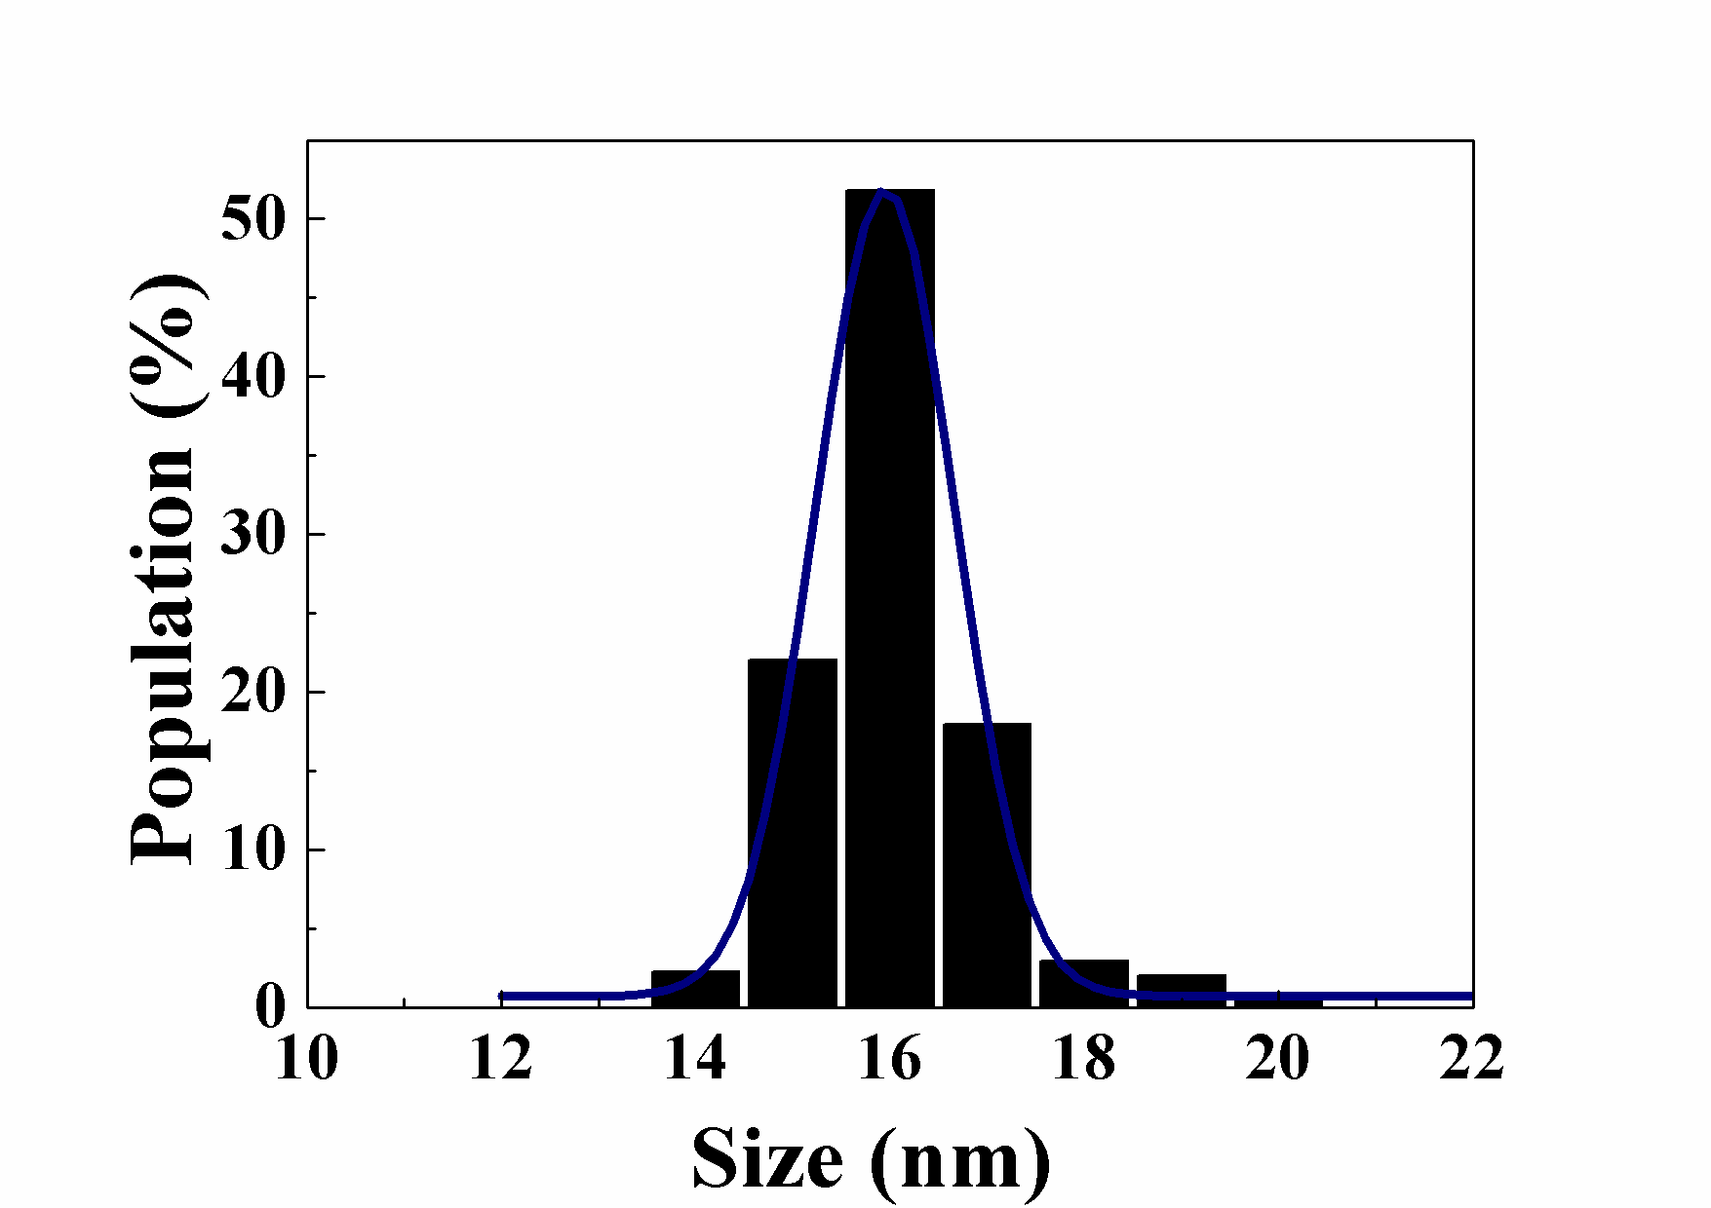
δ < 10 %
(c)
(a)
(a)
δ < 5 %
(b)
δ < 7 %

Figure S3. TGA spectra of the original FeOL, mixtures of FeOL and NaOL with different FeOL/NaOL molar ratios ranging from 1 to 10, and as-received NaOL salt. Herein, contribution of NaOL weight on TGA spectra of the FeOL-NaOL mixtures was easily subtracted because the weight loss of NaOL salt is nearly zero below about 370ºC as indicated in its TGA spectra. The inset shows a diagram describing the heating mode in TGA analysis. According to the TGA spectra, the lower FeOL/NaOL molar ratio is, the slower weight loss is reduced. On the other hand, NaOL strongly enhances the stability of FeOL complex.

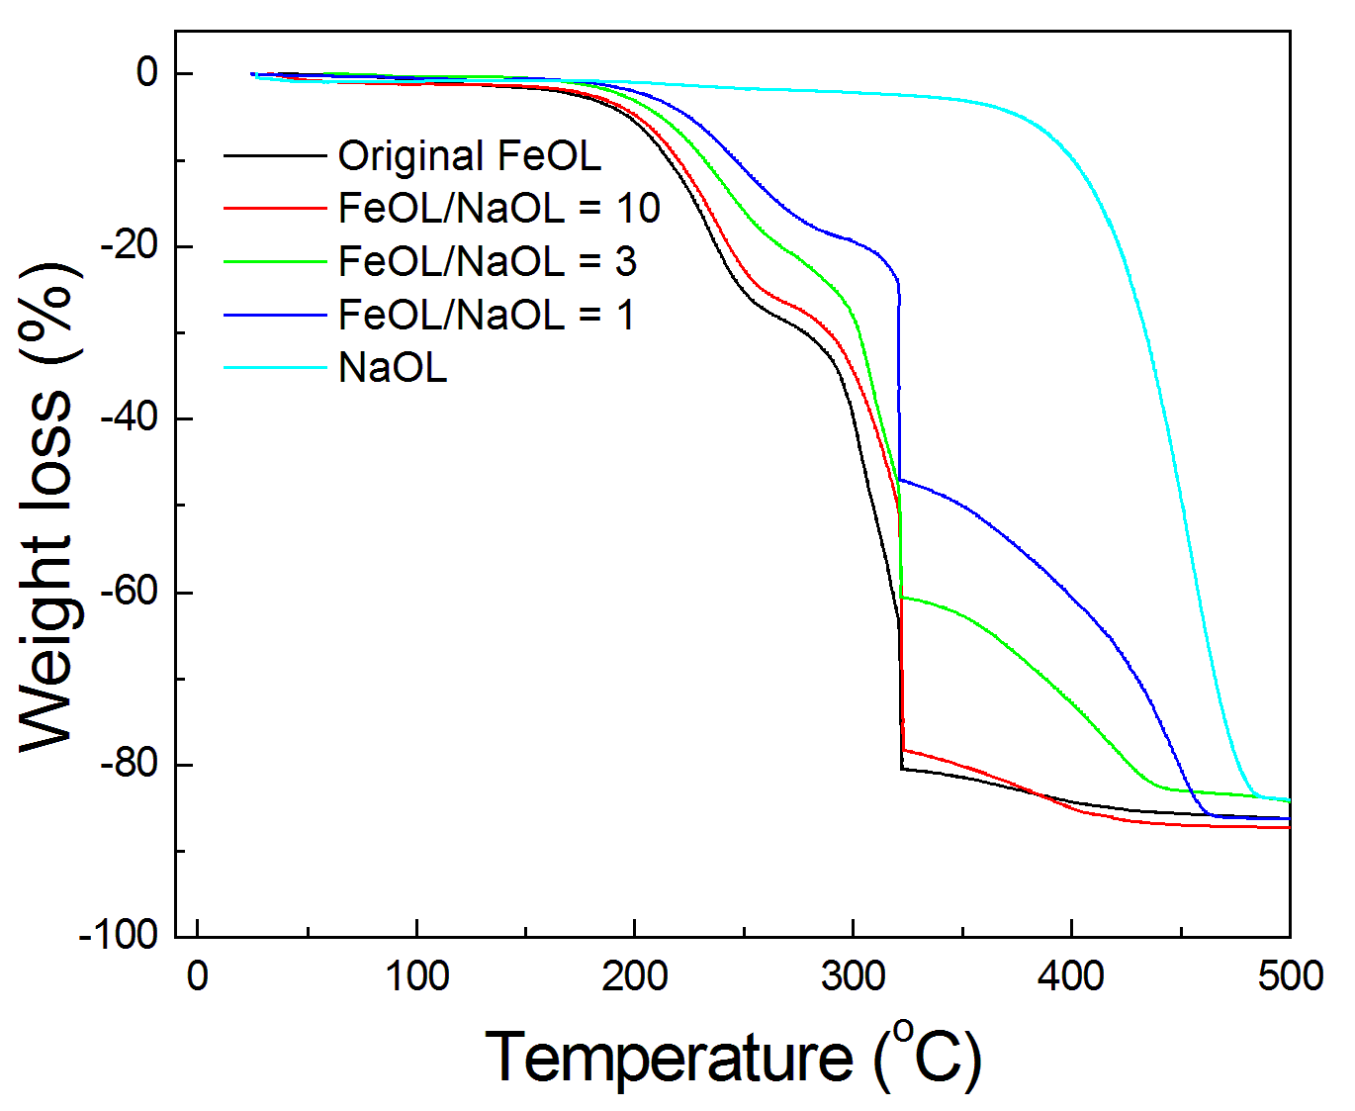
Time
Temp.
500ºC
315ºC
30min

Figure S4. FTIR spectra of original FeOL, mixtures of FeOL and NaOL with different molar ratios ranging from 1 to 10. The band at 1710 cm⁻¹ can be assigned either to the carbonyl group of oleic acid, or to asymmetric vibrations of unidentate carboxynate, which has been known as a weak ligand. Whereas, the peaks at 1432 cm⁻¹, 1525 cm⁻¹ and 1589 cm⁻¹ are due to the presence of two coordination modes: bidentate and bridging, the stable ligands [10]. As indicated in the FTIR spectra, at higher NaOL concentration or lower FeOL/NaOL molar ratio, lesser portion of unidentate ligand (1710 cm⁻¹) exists in the mixture.

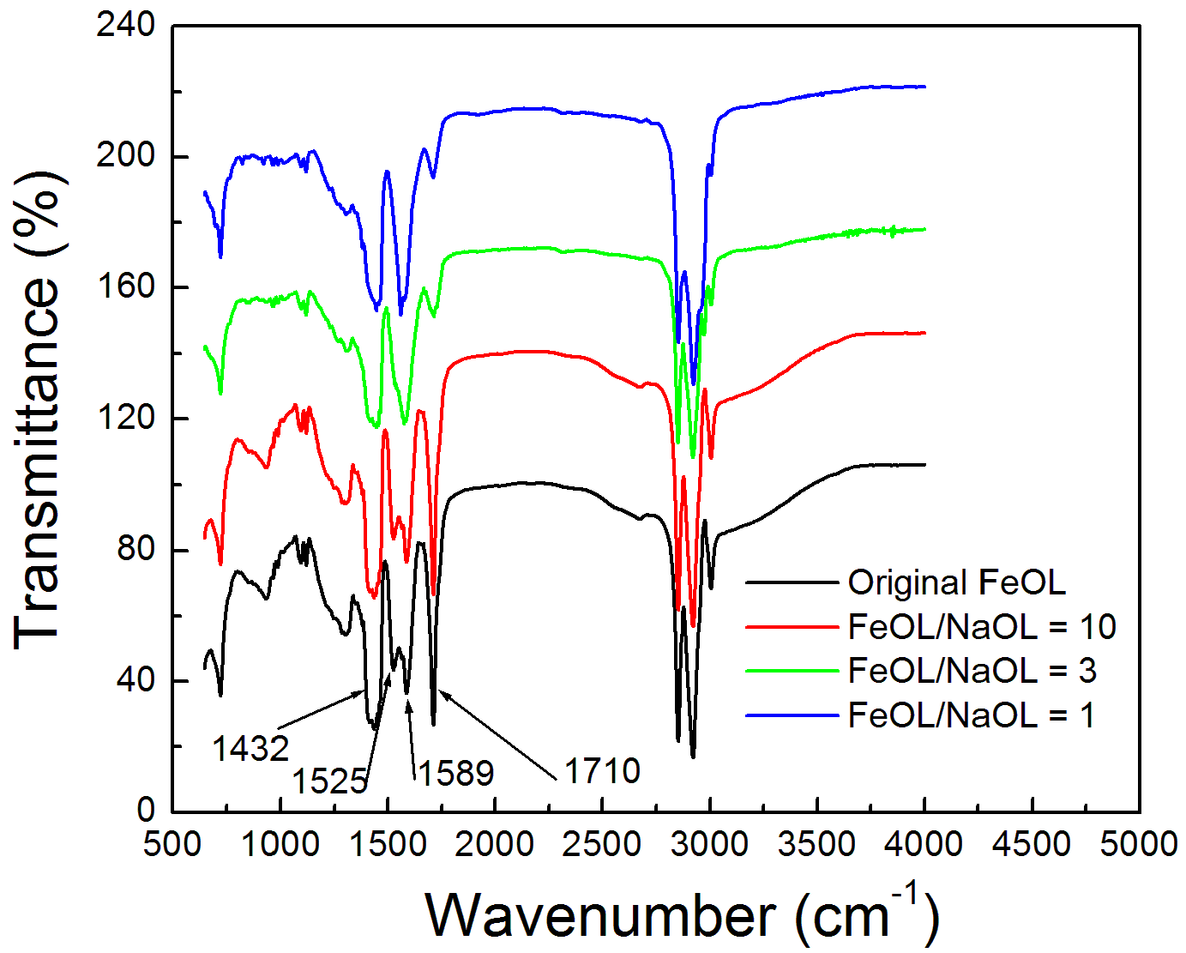

Figure S5. XRD patterns of 9 nm, 16 nm, and 22 nm nanocubes

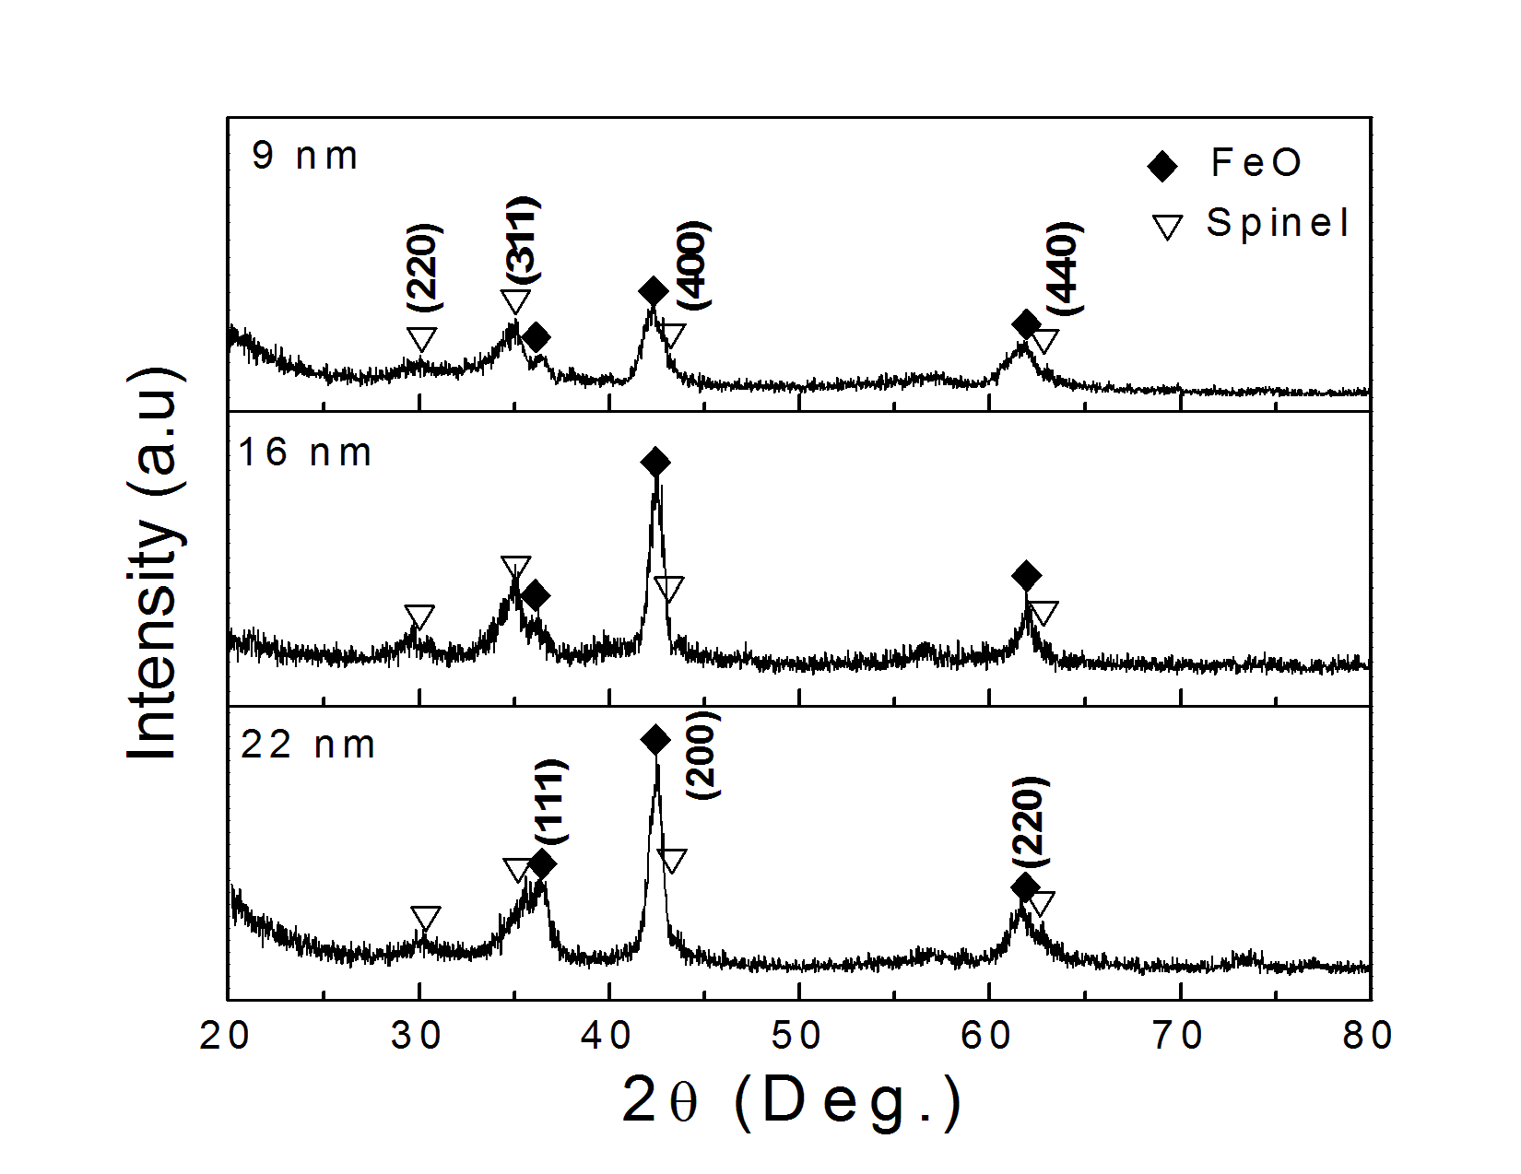

Figure S6. XRD patterns of the nanocubes as they are randomly deposited (upper) and self-assembled (below) by applying the convective self-assembly technique [2] on the non-reflective silicon substrate. These demonstrate clearly that particle shape can indeed induce texture in a self-assembled particle superlattices.

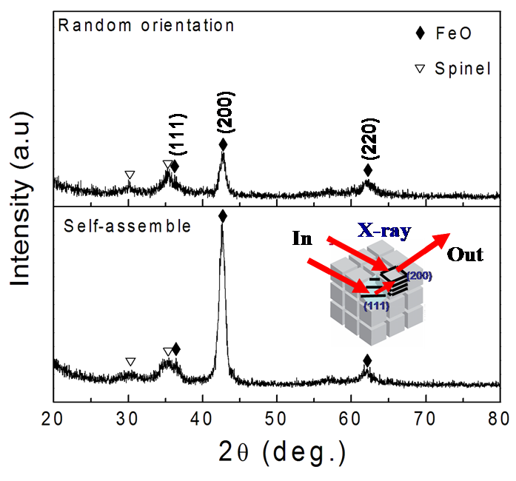

Figure S7. The temperature-dependent ZFC/FC magnetizations of the 16 nm as-synthesized nanocubes. This data reveals the Neel temperature (T_{N}) of the antiferromagnetic phase in the as-synthesized nanocubes is about 198 K and equal to T_{N} of FeO.

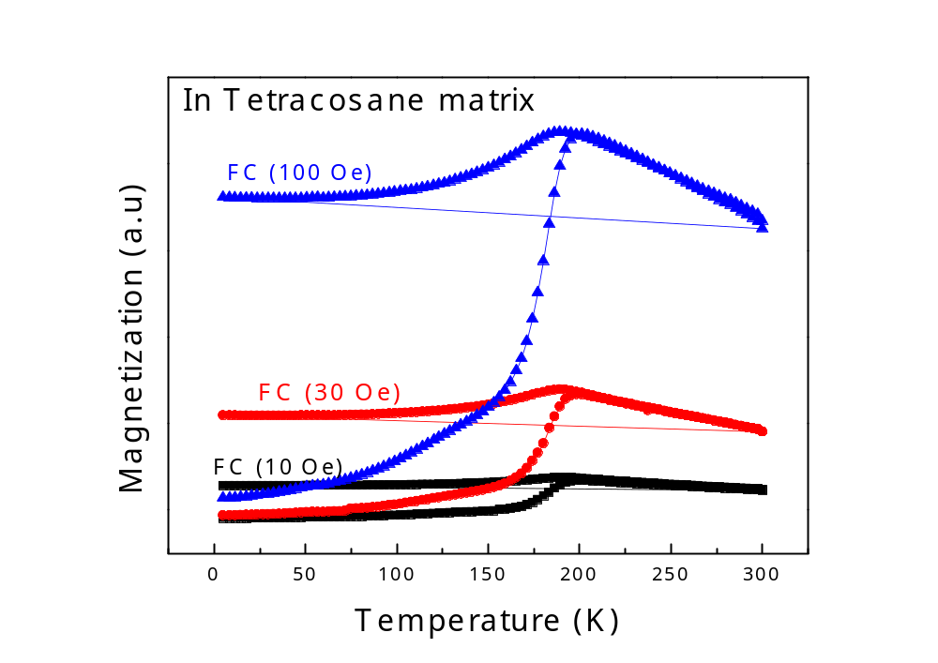
T_{N}(FeO) = 198 K

Figure S8. Hysteresis loops measured at 5 K after field-cooled (FC) procedure of the γ-Fe₂O₃ nanocubes which were obtained by fully oxidizing the 9 nm, 16 nm, and 22 nm as-synthesized nanocubes with purging of oxygen at 200ºC for 30 minutes.

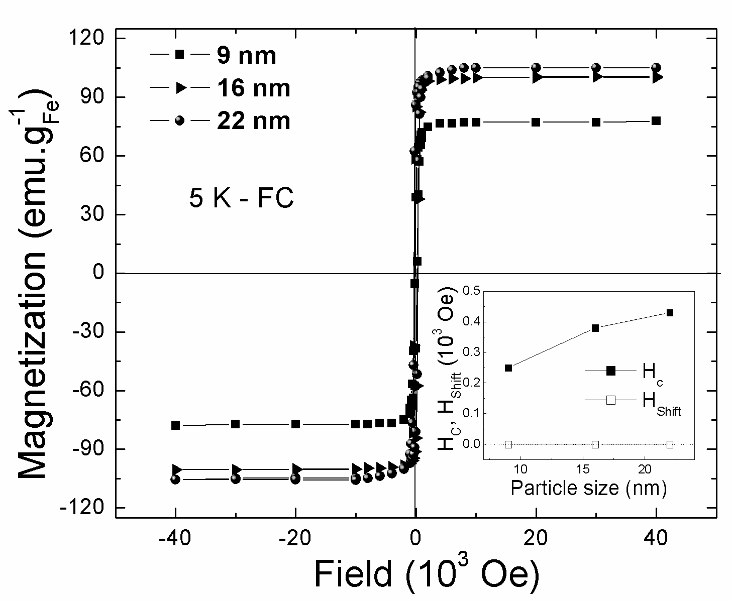

Figure S9. TEM image and XRD pattern of the nanoparticles produced from the typical procedure but at higher temperature. In this case, eicosane (bp. 357ºC) was used as solvent instead of 1-octadecene (bp. 315ºC). Beside Fe₃O₄ and FeO, α-Fe is also formed as demonstrated by the well-defined peaks (110) and (200). This indicates that at higher temperature, CO can reduce Fe³⁺ ions to Feº state.

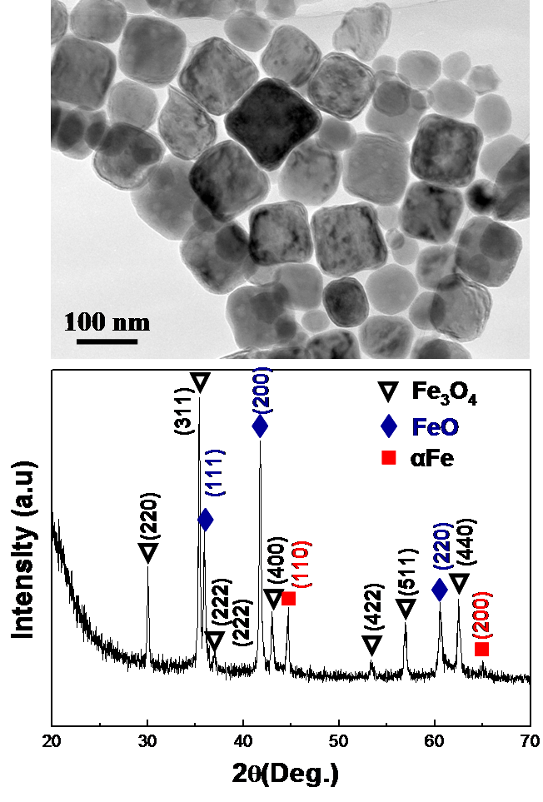

The following equations describing the incomplete and complete combustion reactions of organic substances:
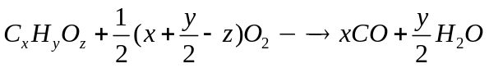 (Incomplete combustion reaction)
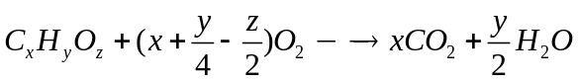 (Complete combustion reaction)

Appendix
Estimation of the effective size of the FeO core in FeO/spinel core/shell nanocubes
The effective volume of the FeO core in the nanocubes can be calculated from magnetic measurements based on the following equations:
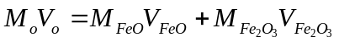 (1)
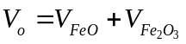 (2)
M_{o} and V_{o} are the observed saturation magnetization in Fig. 2 and the total volume, which is estimated from the size of the nanocubes from TEM (Fig. 1a - c), respectively.
M_{FeO} and V_{FeO} are the saturation magnetization (M_{FeO} = 0) and the effective volume of the FeO core in the as-synthesized nanocubes, respectively.
M_{Fe2O3} and V_{Fe2O3} are the observed saturation magnetization in Fig. S8 (SI) and the effective volume of the γ-Fe₂O₃ shell in the as-synthesized nanocubes, respectively. (It is assumed that the spinel phase in the nanocubes is γ-Fe₂O₃).
Substituting (2) into (1) we obtain: 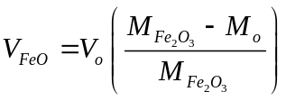 (3)
In order to calculate the effective size of the FeO core in the nanocubes using Eq. (3), it is assumed that the FeO core has a perfect cubic shape, thus: 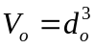 and 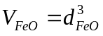, where d_{o} and d_{FeO} are the sizes of the entire nanocube and the FeO core, respectively.
Thus, we obtain: 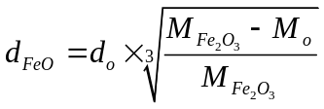 (4)
The core sizes are 4.5, 13, and 19 nm for the 9, 16 and 22 nm as-synthesized nanocubes, respectively. Herein, it was assumed that the nanocubes have perfect cubic cores and that the spinel phase in the nanocubes is γ-Fe₂O₃ and is preferentially distributed in the shells. This structure is far from similar with which was directly observed from the dark-field image (Fig. 4d). This difference indicates that with respect to magnetic properties, the as-synthesized nanocubes with sizes of 9, 16, and 22 nm are equivalent to the same size nanocubes that have perfect cubic FeO cores with effective sizes of 4.5, 13, and 19 nm, respectively.

