# Capstone Project – Phase 6 Report

## 1. Objective

The purpose of this phase is to implement database interaction using PL/SQL. This includes the development and testing of stored procedures, functions, packages, and cursors to manipulate and retrieve data in a modular, reusable, and secure manner. It also demonstrates transaction handling and proper use of DML and DDL operations.

## 2. Stored Procedures Implemented

- **AddProduct:** Inserts a new product into the Products table

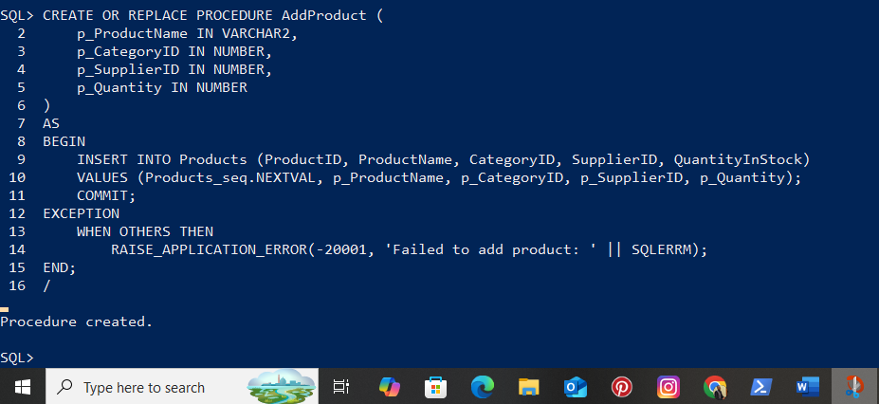  
- **RecordTransaction:** Records stock IN/OUT and updates stock levels

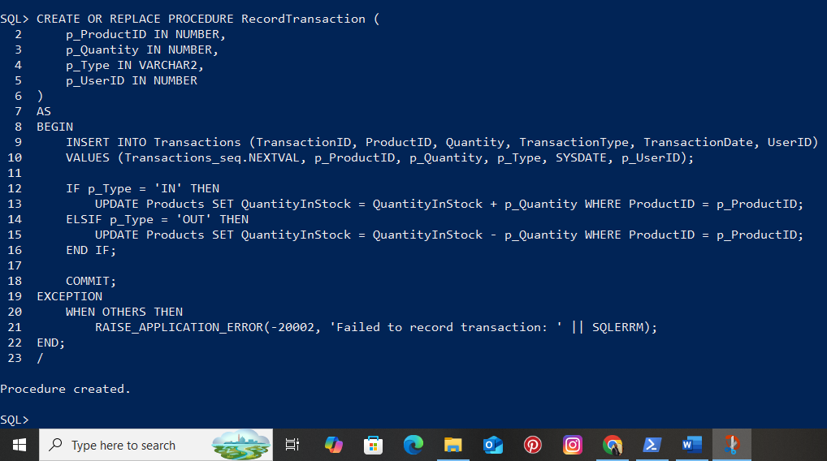  
- **UpdateProduct**: Updates an existing product

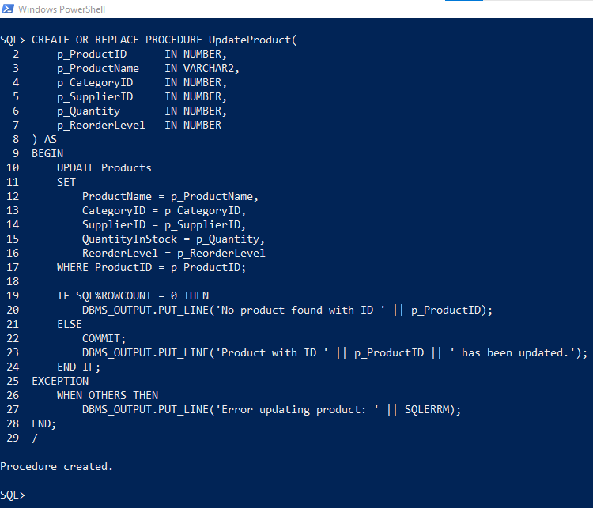  
- **DeleteProduct:** Removes a product by ProductID

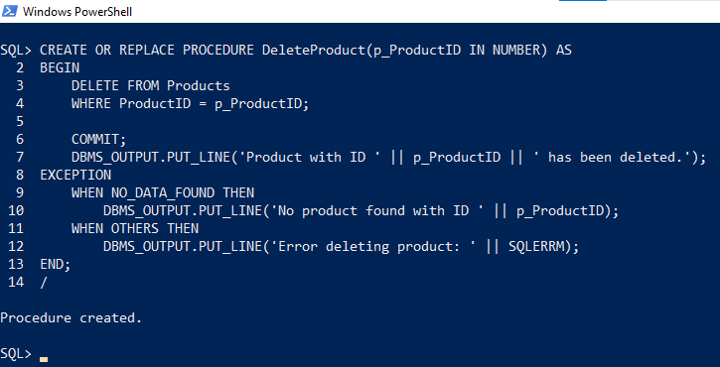

## 3. Functions Used

- VerifyLogin: Compares hashed passwords for login validation  
- GetLowStockProducts: Returns a SYS_REFCURSOR with products below reorder level

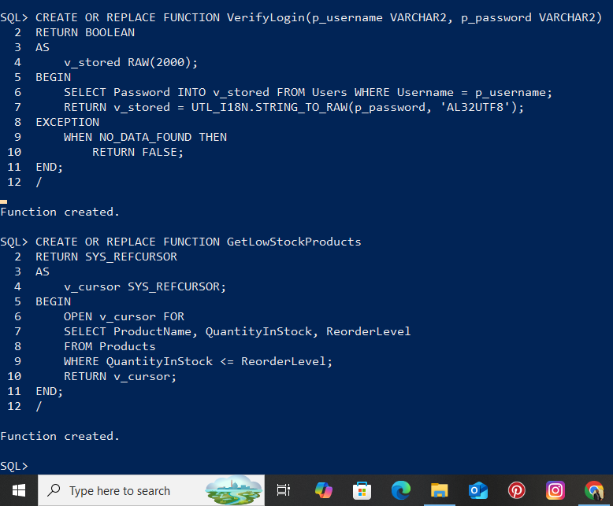

## 4. Packages

A package named InventoryPkg was created to group procedures and functions. It contains AddProduct, RecordTransaction, VerifyLogin, and GetLowStockProducts.

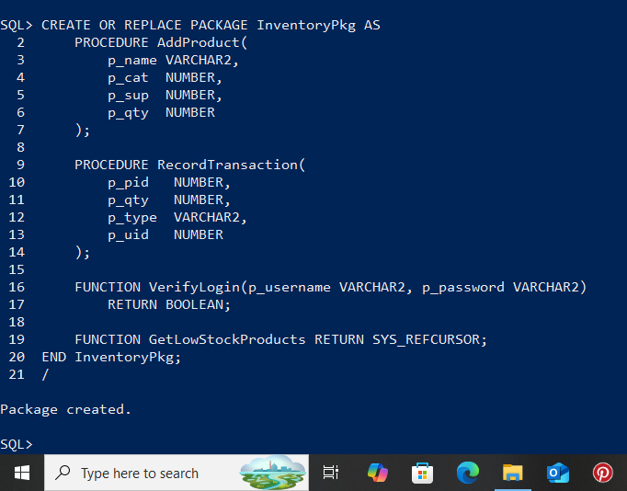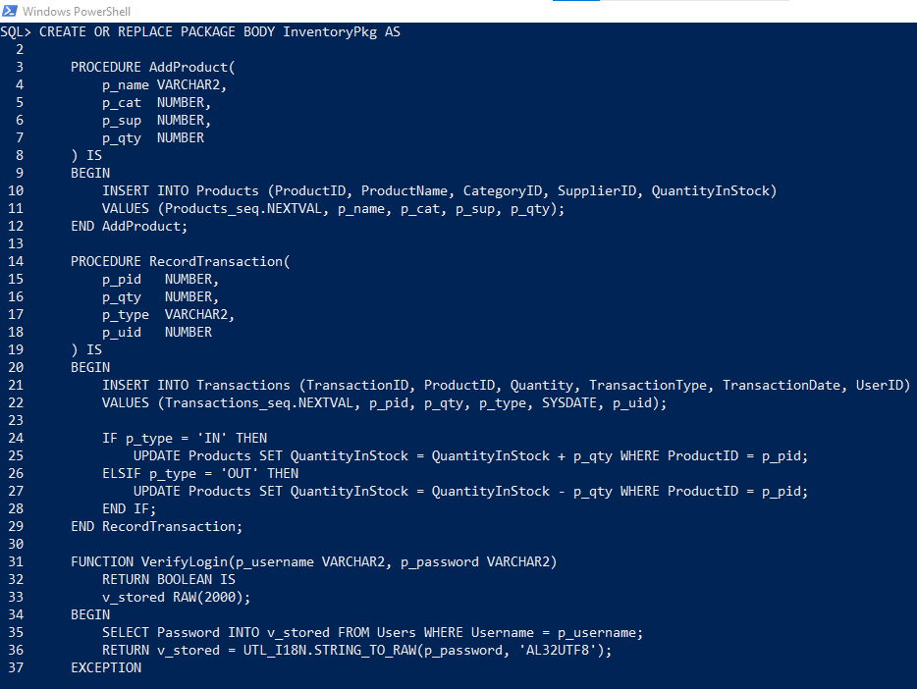

## 5. Cursor Usage

The function GetLowStockProducts returns a SYS_REFCURSOR. A loop is used to fetch the result row by row and display ProductName and QuantityInStock using DBMS_OUTPUT.

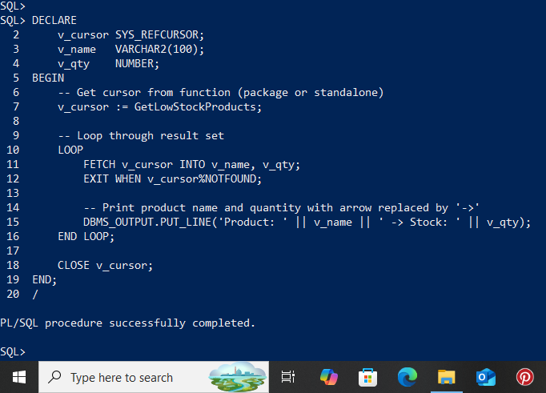

## 6. Transaction and Exception Handling

All procedures include COMMIT statements for saving transactions. Exception blocks with RAISE_APPLICATION_ERROR are used to handle errors in a user-friendly way

## 7. Test Cases

- TestCase 01: AddProduct procedure  
- TestCase02: RecordTransaction with type OUT  
- TC03: VerifyLogin success and failure

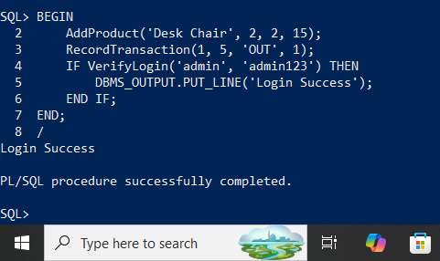

## 8. Database Operations (DDL & DML)

DDL operations were demonstrated using a test table (Users_Test). Commands like CREATE, ALTER, and DROP were executed.

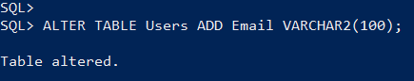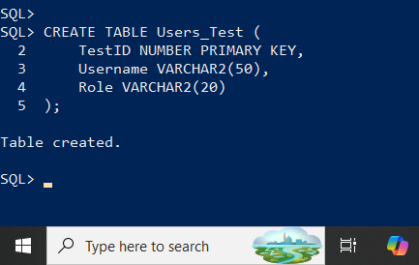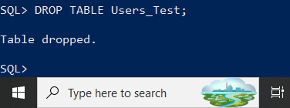  
DML operations included INSERT into Categories, UPDATE of Products, and DELETE from Transactions. 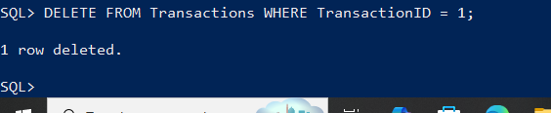

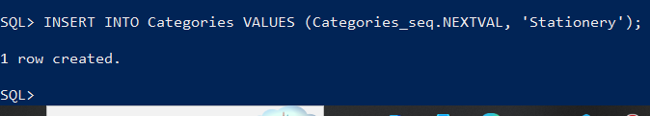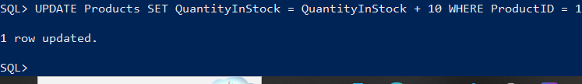

## 9. Conclusion

Phase 6 successfully implemented PL/SQL-based database interaction for the Inventory Management System. The system includes robust procedures, reusable functions, secure login verification, and functional cursor-based queries. All components are tested and working as intended.