Bu

**VYSOKÉ UČENÍ TECHNICKÉ V BRNĚ**

**BRNO UNIVERSITY OF TECHNOLOGY**

**FAKULTA INFORMAČNÍCH TECHNOLOGIÍ**

**FACULTY OF INFORMATION TECHNOLOGY**

**ÚSTAV POČÍTAČOVÉ GRAFIKY A MULTIMÉDIÍ**

**DEPARTMENT OF COMPUTER GRAPHICS AND MULTIMEDIA**

**ZUBNÍ KŘÍŽ PRO STOMATOLOGICKOU AMBULANCI**

**DENTAL CHART FOR DENTAL AMBULANCE**

**BAKALÁŘSKÁ PRÁCE**

**BACHELOR’S THESIS**

|  |  |  |
| --- | --- | --- |
| **AUTOR PRÁCE** | **DOMINIK KALÁB** |  |
| **AUTHOR** | **Ing. VÍTĚZSLAV BERAN, Ph.D.** |  |
| **VEDOUCÍ PRÁCE** |  |
| **SUPERVISOR** |  |  |

**BRNO 2020**

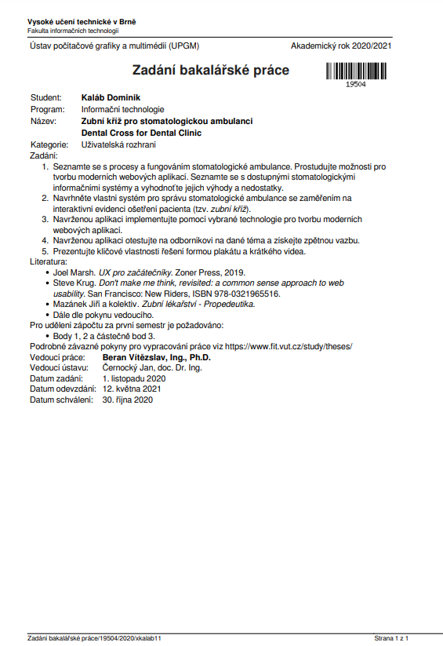

**Abstract**

The goal of this work is to develop a prototype web application which will offer a convenient environment for stomatological records keeping with the main focus being the interactive dental chart. This prototype will be based on a study of user experience design, a study of modern web application development, a study of basic stomatology, an analysis of existing solutions, and will be consulted with a professional dentist. My design will focus on the fewest steps possible solution of often required user goals, relevant information display and it will be inspired by editor applications user interface design. The prototype will be developed using PostgresSQL, .NET API, and Vue.js javascript library. The prototype will then be tested by users and my efforts evaluated.

**Abstrakt**

Cílem této práce je vyvinout prototype vebové aplikace, která bude nabízet stomatologům praktické prostředí pro evidenci stomatologické dokumentace se speciálním zaměřením na interaktivní rozhraní zubního kříže. Tento prototyp bude založen na studiu designu user experience, studiu technologií pro tvorbu moderních webových aplikací, studiu základů stomatologie, analýze existujících řešení a bude konzultovám s profesionálním stomatologem. Můj návrh se zaměří na řešení často prováděných úkonů v co nejméně krocích, zobrazování relevantních informací a bude inspirováno designem uživatelského rozhraní editorových aplikací. Prototyp bude vyvinut za použití technologií PostgresSQL, .NET API, a Vue.js javascriptové knihovny. Poté nechám uživatele otestovat tento prototyp a vyhodnotím výsledky svého snažení.

**Keywords**

Stomatology, dental chart, tooth localization, medical documentation, user interface, user experience, web application, software, vue.js

**Klíčová slova**

Stomatologie, zubní kříž, lokalizace zubů, zdravotní dokumentace, uživatelská rozhraní, uživatelský prožitek, webová aplikace, software, vue.js

**Citace**

KALÁB, Dominik. *Zubní kříž pro stomatologickou ambulanci*. Brno, 2020. Bakalářská práce. Vysoké učení technické v Brně, Fakulta informačních technologií. Vedoucí práce Ing. Vítězslav Beran, Ph.D.

**Zubní kříž pro stomatologickou ambulanci**

**Prohlášení**

Prohlašuji, že jsem tuto bakalářskou práci vypracoval samostatně pod vedením pana Ing. Vítězslava Berana, Ph.D. Další informace mi poskytli MUDr. Tomáš Machač a MUDr. Michaela Friedová. Uvedl jsem všechny literární prameny, publikace a další zdroje, ze kterých jsem čerpal.

.......................

Dominik Kaláb

28. prosince 2020

**Poděkování**

V této sekci je možno uvést poděkování vedoucímu práce a těm, kteří poskytli odbornou pomoc (externí zadavatel, konzultant apod.).

**Obsah**

Obsah

1. Introduction 7

2. Theoretical knowledge 8

2.1. A short introduction into dentistry 8

2.1.1 Dentist’s work and record-keeping 8

2.1.2 Standard dentist appointment 9

2.1.3 Tooth localization 11

2.2. UX design 12

2.3. Web application development 13

3. State of dental medical records in the Czech Republic and evaluation 15

3.1. General state 15

3.2. Specific software evaluation 16

3.2.1 PC DENT 16

3.2.2 PC DENT 17

4. Suggested solution 18

4.1. List of identified dentist needs 18

4.2. UI Concept 20

4.3. Data model 23

4.4. Design Concept 24

5. Development of the solution 27

5.1. Used technologies 27

5.2. Database 27

5.3. Backend 27

5.4. Frontend 27

5.5. Results and testing 27

6. Conclusion 27

# Introduction

Dentist ambulances constitute roughly 30 % of all outpatient care in the Czech Republic („Stomatologie Jan Ležovič a kolektiv“ paraphrased own translation). Therefore, it is only logical that the market with information systems and electronic solutions for dental ambulances is heavily developed. These solutions need to suit legislation, implement a wide spectrum of functionalities, and accommodate to institutional nuances. Therefore, they take years to develop, are colossal, rigid, and expansive. These systems are often developed using long-outdated technologies and their application in modern ambulances is problematic.

This work aims to design and to develop a prototype of an innovative and modern system of recording medical documentation in dental ambulances. I will closely observe a dentist’s work, I will analyze the processes which are essential to a dental ambulance and I will present outcomes of my discussion with dentists. For the sake of simplicity, I will concentrate on practical dentists and will not take into considerations the wide range of specialised ambulances like dental surgery. My main focus will be the core process of dentist appointments: the examination and treatment of patients and recording of these actions into the dental system via an interactive dental chart.

Based on my understanding of these processes, I will evaluate the efforts of other dental systems to accommodate this process. Then I will propose, develop and test my solution. This solution will be based on an interactive dental chart which will allow convenient record creation and will provide a visual representation of the state of a patient’s denture. This solution will be web-based, created with modern technologies and will be expandable.

Then I will present my solution to experts, I will accumulate feedback and will evaluate my efforts.

# Theoretical knowledge

In this chapter, I will briefly summerise basic theoretical information from a few areas of interest. Firstly we will take a look at the short introduction into dentistry, then I will present some basic theory about UX design, lastly, I will present information about today‘s standards of web application development.

## A short introduction into dentistry

In this chapter, I will summerise very basic theoretic information about how dentists work and how

dental ambulances operate. This chapter should summarise information on around which I centred the rest of this work but does by no means provide a complete knowledge base for this work neither for dentistry as a whole. This chapter is based on information acquired in „Stomatologie Jan Ležovič a kolektiv“, „Zubní lékařství – Propedeutika“ and from my consultation with MUDr. Tomáš Machač and MUDr. Michaela Friedová.

### 2.1.1 Dentist’s work and record-keeping

The main focus of a practical dentist is to prevent, diagnose and treat dental issues. Most patients have one practical dentist, who regularly checks state of their denture and either treats issues or refers the patient to a specialist for treatment. Therefore, dentist has to keep complete records of patients denture history. These records are:

* diagnoses like teeth decay or inflammation
* procedures to which the patient was treated

To treat the patient correctly, a dentist also has to keep a summary of the patient‘s medical history known as an anamnesis. This anamnesis usually contains:

* Personal anamnesis – important diseases and medical events in the patient's life
* Allergies – an overview of the patient‘s allergies and his reactions
* Pharmacological anamnesis – an overview of medicaments used by a patient
* Toxicological anamnesis – a summary of patients drug usage (mainly smoking and alcohol)

The anamnesis can also contain information about medical history of patient’s family members, his living conditions or work environment if deemed important by the dentist.

Dentist also keeps basic personal information about the patient, like:

* a personal identification number
* a name
* an address
* contact information like email address and phone number
* his health insurance information

Each dentist appointment results in a medical report. This medical report contains:

* transcription of the patient‘s subjective feelings
* diagnoses
* procedures
* prescribed medication
* recommended therapy or referrals to other specialists
* other information deemed important by the dentist

This medical report is then unchangeable and is a definitive transcript of the appointment.

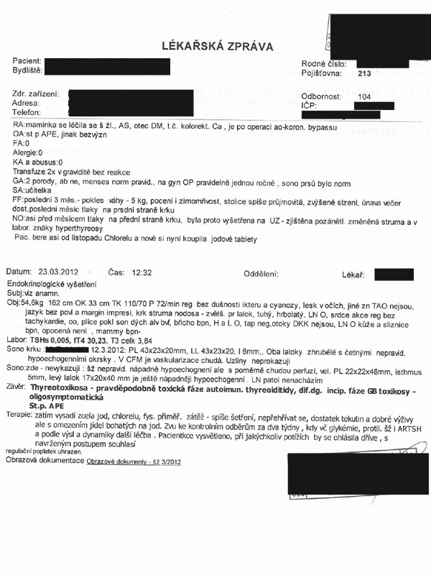

Anonymized example of a medical report (<https://www.dub.cz/ohlasy/509-01.gif>, 28.1. 2021)

### 2.1.2 Standard dentist appointment

In this chapter, I will describe a standard course of a dentist appointment. Understanding this process is vitally important for designing a convenient and intuitive system.

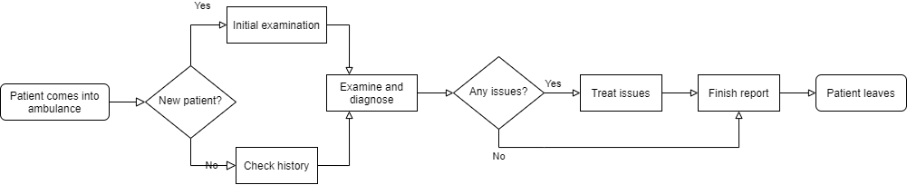

Initial examination

If the patient has never been examined by the dentist, there are a few important steps to be done before the examination can begin. The dentist first has to fill out the patient‘s personal information. Then the dentist records patient’s anamnesis based on information provided by the patient. Afterwards, the dentist records the state of patients denture.

Check history

If the patient is not new, the dentist quickly checks the history of the patient’s denture to get the context needed to examine the patient better and to be able to look for potential changes.

Examine and diagnose

The patient is seated and the examination can begin. The dentist with the use of his diagnosing tools examines the denture from the first to the fourth quadrant (more about teeth localization in 2.3.). When an issue is found, the dentist reports it to a nurse who immediately records it.

Treat issues

The dentist then treats the issues diagnosed in the previous step. After the treatment is finished, he records all procedures he has done.

Finish report

The dentist writes the report. He records the diagnoses and procedures. He also mentions important information about the appointment. He suggests therapy including medication and refers the patient to other specialists if needed. The report is then printed out for the patient if the patient wishes so.

### 2.1.3 Tooth localization

The diagnoses and procedures are often localized, e.g. to record a tooth decay, the dentist should mention the tooth and if possible also the surface on which the decay is located.

In the Czech Republic, the most widely used teeth localization notation is FDI notation. Other notations exist, such as Zsigmondy and Palmer notation (widely spread in the UK) or ADA notation (used in the USA). These are however not commonly used among practical dentists in the Czech Republic so I will not cover them in this work.

In „Zubní lékařství: Propedeutika Mazánek a kolektiv“, the FDI notation is described as follows: „The whole denture is split into 4 quadrants which are numbered clockwise. The numbering begins in right upper quadrant and ends in right lower quadrant (from the view of the patient). Numbers from 1 to 4 represent permanent denture while numbers from 5 to 8 represent deciduous teeth (milk teeth).“ (own translation, added notes).

|  |  |  |
| --- | --- | --- |
|  | Permanent | Deciduous |
| Upper-Right | 1 | 5 |
| Upper-Left | 2 | 6 |
| Lower-Left | 3 | 7 |
| Lower-Right | 4 | 8 |

Teeth numbering for each quadrant then begins from the middle of the denture to the sides from 1 to 8 for permanent teeth and from 1 to 5 for deciduous teeth.

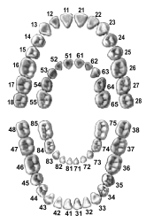

FDI notation (Mazánek a kolektiv: Obr. 2.4 Schémata značení zubů (převzato z J. Klepáček, J. Mazánek a kol.: Klinická anatomie ve stomatologii, Grada Publishing, 2001)

Each tooth is further divided into surfaces.

* Labial – The surface facing the lips, specific for teeth 1, 2, 3.
* Distal – The surface that is away from the midline of the face.
* Buccal – The surface towards the cheeks, specific for teeth 4, 5, 6, 7, 8.
* Incisal – The biting edge of an anterior tooth, specific for teeth 1, 2, 3.
* Lingual – The surface that faces the tongue, specific for quadrants 3, 4 and 7, 8.
* Palatal – The surface facing the palate, specific for quadrants 1,2 and 5, 6.
* Mesial – The surface that is closest to the midline of the face.
* Occlusal – The chewing surface of posterior teeth, specific for teeth 4, 5, 6, 7, 8.

(<https://www.dentalcare.com/en-us/professional-education/ce-courses/ce500/surfaces-of-the-teeth> edited)

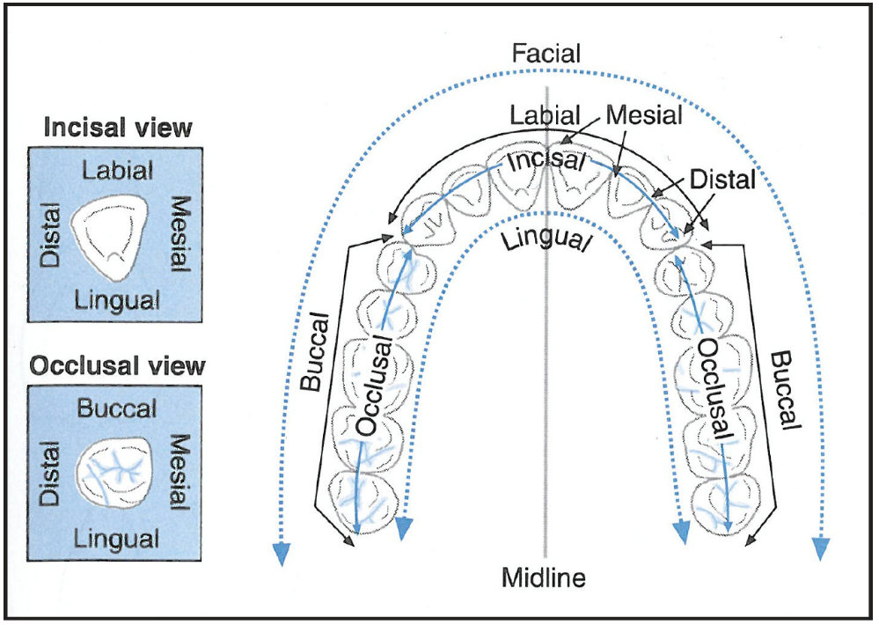

Surfaces for quadrant 3,4 (1,2 have palatal instead of lingual) (<https://adaa.cdeworld.com/courses/21595-dental-anatomy-a-review> Figure 14 – Surfaces of the Teeth (Courtesy of Mosby’s Comprehensive Dental Assisting: A Clinical Approach, Finkbeiner, BL and Johnson, CS). Diagram of surfaces of the teeth.

Closer localization can be achieved by using a combination of these surfaces‘ names to identify edges between these surfaces, e.g. distal-palatal edge.

## UX design

This chapter will be a short summary of the principles of UX design. Most of this chapter will be paraphrased from the „UX for beginners“ by Joel Marsh.

„UX describes how, when and why people interact with a product or service – and how they feel about their experience.“ (<https://copyhackers.com/2019/11/ux-copywriting/>, 21.1. 2021)

A good design communicates three things:

1. What is this?

Each part of the design should clearly communicate why it exists and what is its purpose.

1. What’s in It for me?

User should be motivated to use the design. He should be aware of the advantages of using our design.

1. What do I do?

At every moment of using our system, the user should know the steps to do to achieve his current goal.

UX contains of 5 main ingredients

1. Psychology – Is considering user’s complex mind. Asking questions such as:

* What is the user’s motivation to use our system?
* How does the user feel using our UI?
* What does the user expect when clicking this button?

1. Usability – analyzing if all goals a user could possibly want to achieve are achievable and how effectively. We are asking questions such as:

* Are we being clear and direct?
* Are there any mistakes we could prevent?
* Could we get the job done with less input?

1. Design – design in UX is much less artistic than other design areas. The UX design is about how UX works and is something provable rather than subjective. Questions we should ask when reviewing UX design:

* Do users like the design? Do they trust it?
* Does it communicate its purpose and function?
* Does it represent the brand?

1. Copywriting – Asking questions such as:

* Does it motivate the user to complete their goal? Is that what we want?
* Does it sound confident and tell the user what to do?
* Does it reduce anxiety?
* Is it clear, direct, simple and functional?

1. Analysis – how to use data to improve our design. When analysing, we ask questions such as:

* Are we using data to prove that you are right or to learn the truth?
* Are we looking for subjective opinions or objective facts?
* Are we looking for bad results too? Why not?
* Are we looking at absolute numbers or relative improvements?
* How can we use this analysis to make improvements?

Joel Marsh also identifies two key categories of goals that UX should follow.

* User goals are desires of users to not be bothered by the UI and desires to make their lives easier and to work more efficiently. User goals vary and are difficult to assume.
* Business goals are goals of the system‘s owner which describe metrics by which the quality of the system is judged. These goals are usually primary reasons for the creation of the system and are clearly defined.

The goal of the UX designer is to align these two categories of goals and aim to fulfil them.

As an UX designer, you need to be aware of two things:

* You want things that don’t matter to the user.

As UX designers, we need to focus on user and organisation goals, we have to empathise and control our ambition for creating overcomplicated and flashy UI which would look good in our portfolio but would not benefit our users.

* You know things that don’t matter to the user.

Empathy is the keyword. We need to design the UX with average knowledge of the potential user of our system in mind. We have to assume that users know less than us.

Keeping these few basic principles in our mind all the time should allow us to develop quality UX and thus develop a quality system.

## Web application development

Web applications are applications running on remote servers. Users can access these applications conveniently via their browsers. Web applications have numerous advantages against their counterpart desktop applications:

* They have very low hardware requirements - Anything that can run a browser can access the application
* They are universally accessible – You can access the application from any device with a browser and there is no need to have the specific application installed.
* They are multiplatform – the application is not bound to a specific OS nor needs to have multiple versions for different OS.
* They are easier to base on subscription payment basis and there is low to none risk of piracy
* Minimized version and compatibility issues – all users have the same version

Naturally, they also have some disadvantages:

* They require internet access
* They can use only limited resources – resource-demanding apps (such as large games) can’t be effectively run in a browser.
* Limited integration of keyboard
* They are easier to exploit by hackers than desktop apps.

(<https://searchcloudcomputing.techtarget.com/definition/web-application-development>)

(<https://blog.stackpath.com/web-application/>)

(<https://www.jacapps.com/blog/web-apps-vs-native-apps-advantages-disadvantages>)

Most modern web applications use client-server architecture. The client is the user’s browser which displays the UI to the user and accordingly to the user’s interaction with the client executes business logic which communicates with the server. The server usually contains some form of SQL database with persistent data, which it provides or modifies according to the client's requests. The means of communication between the client and the server are called web API (from now on just „API“). Most modern APIs are based on „Representational state transfer“ (REST) standard using HTTPS (or outdated insecure HTTP) protocol.

Server-side code can be written in any language that has the capability to receive and respond to HTTP requests. Often used server-side languages include:

* PHP
* Java
* Node.js (JavaScript)
* Python
* .NET (C#)

To simplify the interaction with the database, Object-Relational Mapping (ORM) frameworks are often used. ORMs abstract the database and allow to build code-first databases as a part of the server-side code. The development team, therefore, has no need to interact directly with the database via SQL queries and can interact with the OMR only.

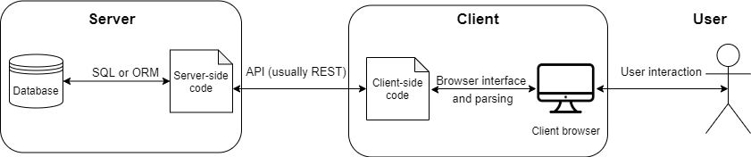

Web application client-server architecture

Client-side code languages are more limited. Browsers can parse only a limited amount of languages. „At a minimum, any modern browser can parse HTML, CSS, and JavaScript.“ (<https://websitebuilders.com/how-to/glossary/parsing> ). HTML serves as a structure describing markup language, while CSS describes the appearance of the page. Javascript is a language in which the functionality and interactivity of the page are programmed. There are however multiple platforms which allow you to write the code in other languages than Javascript and then compile into Javascript. The role of Javascript, in this case, is similar to the role of assembly languages in desktop apps (the Javascript serves as the basic language into which other languages are compiled into). Framework working on this principle is for example DotVVM, which allows you to easily develop web applications in MVVM architecture by writing business logic in .NET. A similar tool for Python is Skulpt. There are three main approaches to client-side programming regarding interactivity and rendering.

First and the most outdated one is the static approach. Pages rendered using this approach are fixated in appearance and contain static non-personalized information. To interact with the site, the client has to change URL (by clicking buttons in navigation for example) and the site has to be rerendered. Because of nearly non-existent interaction, sites written using this approach cannot be called web applications but are rather called websites.

Dynamic rendering uses server-side logic to generate dynamic HTML pages which it then sends via HTTP response to the client. The site then reloads and the client can render the newly generated dynamic page. This approach is also not ideal for high interactivity web applications but can be utilized in sites such as e-shops.

The most modern and advanced approach is the so-called Single Page Application (SPA). This approach relies on Javascript heavy client-side code which dynamically changes the appearance of the site based on user interaction. The client asynchronously fetches data when required via techniques such as AJAX which are used to interact with the server without a need to reload the page. This approach is best suited for developing high interactivity applications such as information systems or social networks. Because the process of dynamically updating the HTML page is rather complicated and would require a lot of code, many frameworks have been developed over the years to handle the hard work for us. The big three trendy Javascript frameworks as for 2020 are:

* Vue
* React
* Angular

Each of them has its advantages and disadvantages and is better suited for different tasks. Javascript framework relevancy is also heavily affected by trends.

# State of dental medical records in the Czech Republic and evaluation

## General state

Dental systems are systems which help dentists to effectively execute their work and run the ambulance. These systems usually implement sets of these functionalities:

* accounting
* document management
* insurance company reports
* appointment management
* electronic signature
* medication administration
* medical record keeping
* business intelligence

The list of possible functionalities is fairly extensive. Dental systems are therefore usually complex and expansive. Development teams are creating these solutions for numbers of years and have very specific know-how. Each system implements a different set of these functionalities with variable levels of quality. Many ambulances also use more than one system to cover a wider range of functionalities (e.g. Dental system in conjunction with the accounting system).

Extensive research about the state of dental systems not only in the Czech Republic has been conducted by Bc. Vendula Nováková in her work „The Comparison of Software Systems in Dentists Usage“.

As a summary of her findings, she wrote: „Dental systems are a unique chapter even in the Czech Republic. They contain special records, unique to dentists. Some of the dental systems have been developed as dependent systems on existing ambulatory systems. Main representants of this category are solutions of CompuGroup Medical (CGM) Czech Republic s.r.o. (MEDICUS Stomatolog, PC DENT, DENTIST+). Another two Czech providers have focused on dental systems only and have developed standalone systems. Previously mentioned products by a company named CGM and system Stomatolog by a company named HoboSoft Ing. Rubáše are built to be installed directly into a PC on a workplace. System XDENT allows usage without an installation functioning on a cloud-based architecture. For accessing the system, the dentist logs into the web-page of the provider. An advantage of this approach is the possibility to work from home or a multi-device access. The only required condition is stable internet access.”

( NOVÁKOVÁ, Vendula. *The Comparison of Software Systems in Dentists Usage*. Kladno, 2017. Diplomová práce. ČVUT - Fakulta Biomedicínského Inženýrství - Katedra biomedicínské techniky. Own translation)

There is a wide spectrum of systems in the Czech Republic. Dentists have a variable choice of functionality sets, type of implementation and scope. The ideal choice is dependent on many factors:

* How large is the ambulance?
* Is the ambulance standalone or a part of a hospital?
* What is the budget?
* Does the dentist have access to IT department and his own server?
* Does the dentist require devices to be integrated (X-rays and others)?

Choosing the right software is therefore a complicated process.

## Specific software evaluation

To represent the possible approaches to developing dentist systems, I have chosen to present two dental systems with very different architectures. PC DENT is a desktop on-premise installed (installation on a server owned by the client) dentist extension of the existing medical system, whileXDENT is cloud-based and dentist only software. In this subchapter, I will take a closer look at both of them.

### PC DENT

PC DENT is older software built as a modification of a system for general practitioners PC DOKTOR. It is developed by CompuGroup Medical. It is a desktop application and allows local installation and on-premise installation. The fact that this software is a modification of existing software is immediately visible. The system presents us with a generous amount of tabs not applicable for dentists and a wide range of tools not practical and usable for the dentist. The application is very robust and is hard to navigate. The user manual has 520 pages. Design is very old school reminiscent of WinForms. The program offers a wide range of keyboard shortcuts which is a notable advantage of desktop applications.

The dental chart of PC DENT is complicated and hard to navigate. It offers 3 ways of recording diagnoses and procedures. The chart’s interactivity is limited by the technology used.

The pricing system of PC DENT is complicated with one time purchases, monthly support payments and purchasable extensions.

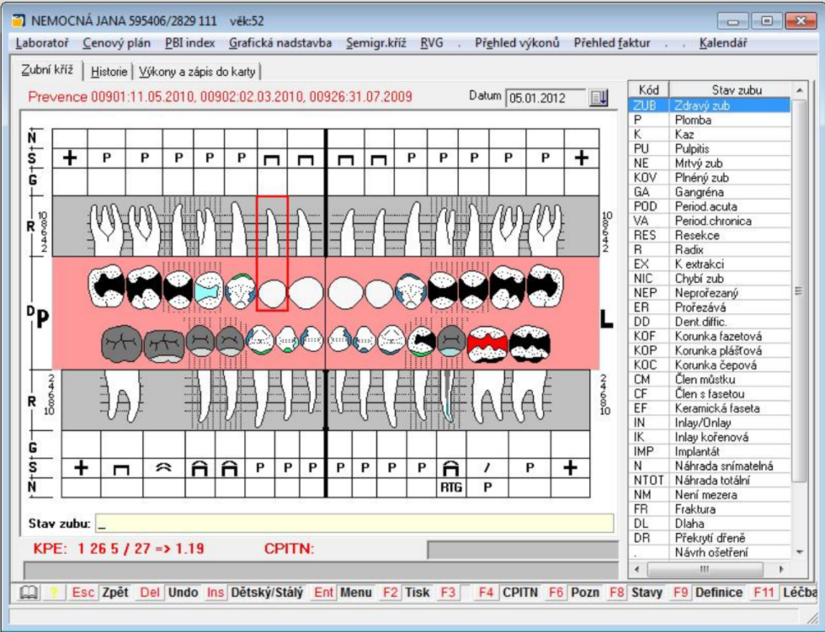

PC DENT dental chart (PC DENT user guide)

In conclusion, PC DENT is a very robust on-premise system. It is complicated, outdated and rather expensive. However, because of its age, it is often installed in older ambulances which yet have to upgrade their systems. PC DENT can work well for ambulances which are part of bigger medical complexes (allergologist and dentist in one hospital can have nearly identical software installed and access the same records, which removes integration problems) which have its own server and IT department.

### PC DENT

XDENT is a fairly new modern software designated purely for dentists. It is a purely cloud-based web application and offers a wide variety of functions. XDENT offers a well made, interactive calendar for organising patient appointments, a simple patient form with personalised data fields and a timeline with patient’s medical reports. XDENT also provides an extremely well-made accounting interface with integrated medical insurance calculations, invoice generations, patient debt tracking and financial statistics. XDENT also provides advanced medical report generation functions and rich-text editing.

Dental chart of XDENT is anatomical but very simple. To create new records, the dentist has to open the chosen tooth record and only then can he record diagnoses and procedures. This is rather inconvenient. The dental chart has advanced graphical changes and good dental history view.

XDENT claims to be installed by more than 300 dentists. The basic monthly payment is 1466 CZK (56EUR as for 25.1.2021).

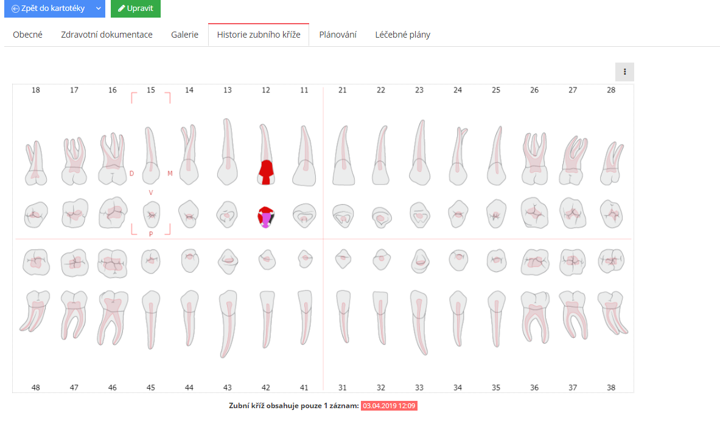

XDENT – dental chart (provided by a consulting dentist)

Overall, XDENT is a very good all-around software for standalone dental ambulances with advanced capabilities amplified with a modern interface and a cloud-based service. Regarding the competitive pricing, XDENT is one of the best available systems in ČR.

# Suggested solution

## List of identified dentist needs

Before we suggest a solution, we must first closely observe and analyse details of dentists‘ work. In this part, I will aspire to define goals of the dentist.

In our case, the user and business goals closely correspond. This is caused by the fact that the user and the business owner are the same person. The dentist himself. For example, recording a diagnose effectively does not only fulfil the dentist‘s desire to treat patients well, but he can also make more money by treating more patients in the same amount of time (business goal).  
 This section will expand on section 2.2. We will take a closer look at how exactly the dentist needs to interact with the system, what he expects to see, and what his goal is at each part of the process.

Initial examination

The dentist needs to be able to quickly access the „New patient“ functionality. In one click, he has to be able to get into the „New patient“ form. The form has to have the key information immediately accessible and this information has to have the „required“ flag (more about the recorded information in 2.1). The dentist should have a possibility to fill in optional information, but this information doesn‘t have to be as quickly accessible. The new patient form has two logical sections:

The general information contains patients’ name, phone number, email and other key information as mentioned in 2.1.

The anamnesis consists of personal anamnesis, allergies, pharmacological anamnesis, toxicological anamnesis which are all important pieces of medical information and should be recorded prior to any treatment of the patient. They are however categorically different from general information, therefore they should be optically divided.

Check history

The dentist needs to quickly find the record of the patient. This would be usually achieved by searching for the patients‘ national ID number on the patients’ insurance card (which is borrowed by the nurse when the patient enters the waiting room or is scanned by a specialized device in the waiting room). On the patient's record, the dentist has to be presented with the patient’s general information, anamnesis or current state of the patient’s denture.

The visualisation of the current state of the patient’s denture is one of the main focuses of this work. To effectively display all the important information, the classic simple table of records won’t suffice. The display should be:

* graphic
* familiar – for the user to adapt well and quickly to the UI, the user should feel comfortable in our system
* representative of the real denture – so the view on the screen and the view in the patient’s mouth are comparable
* should prioritize the most important information – the dentist should first notice the most critical information
* should be interactive – the amount of information the dentist could need greatly exceeds the space available, the dentist should therefore be able to fetch detail information by interacting with the UI

Examine and diagnose

The diagnoses need to be precisely localized to ensure the quality of the treatment. Dentists usually diagnose very few diagnoses types (tooth decay being the most prominent). Therefore, some often used diagnoses should be easier to diagnose than other rarer diagnoses.

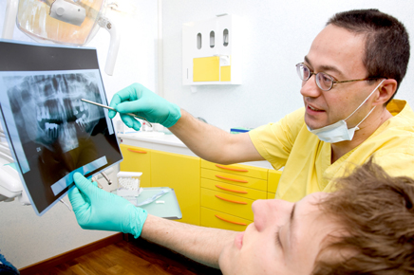

Dentist showing his patient printed results of his X-ray. A functionality which should be implemented in the dental system. (<https://www.futurity.org/wp/wp-content/uploads/2009/12/nyucd-dentist2.jpg>, 28.1.2021)

Treat issues

After treating the issues, the dentist records the treatment. The treatment can be connected to a previous diagnosis. As with diagnoses, there are some procedures which the dentist records regularly. Therefore, some procedure codes have to be easier to access than others. Dentists also have to have the ability to record procedures done by other dentists (so they have accurate denture record) without asking compensation.

Finish report

When writing the report, the dentist should not repeat what he has done in previous steps of the process. All records should automatically move into the report. The dentist should then add the text into a simple text field and be able to print the report if possible. Then the whole record has to be locked to remain unchanged.

## UI Concept

There are two main approaches to dentist system design. In this part, I will analyze them and suggest my own modification.

Classical record-keeping system

The standard lines and tables style of keeping records without any graphical interface.

Pros:

* fast to develop
* organized
* usually cheap
* can have high information density

Cons:

* slow convey of information
* limited means of information prioritizing
* hard to transfer into a comprehensive overview of reality

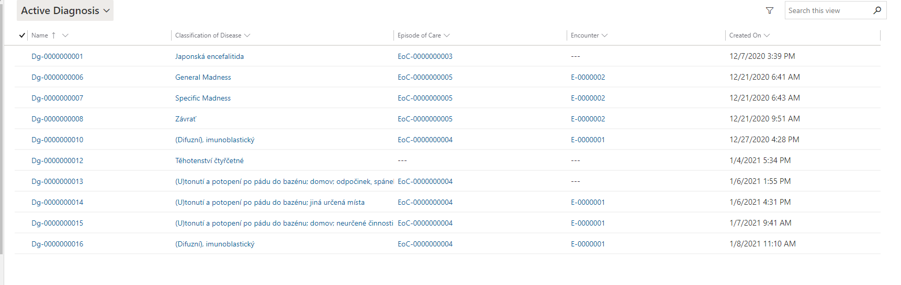

List of diagnoses (NaClin system Navertica a.s.)

Needless to say, most dentists who use this kind of systems, use them primarily because of their lower price or because they haven’t yet found a suitable system to replace it.

Dental chart

Most of the quality, dedicated dental systems use some form of a dental chart. It is a graphical representation of the state of the denture.

Pros:

* Organized if done well
* Easy to transfer into a comprehensive overview of reality
* Can prioritize information
* Fast in conveying information if done well
* Can be interactive

Cons:

* Hard to design well
* Hard to implement well
* Each dentist has a different perception of its function
* Has a learning curve (associating visual changes with information)

Some form of this approach is usually the prefered one by dentists if convenience and effectivity are the main factors of the decision.

Some systems use a dental chart without interactivity built-in. Records are recorded by a classical form filling and the dental chart is used as a visualisation tool only.

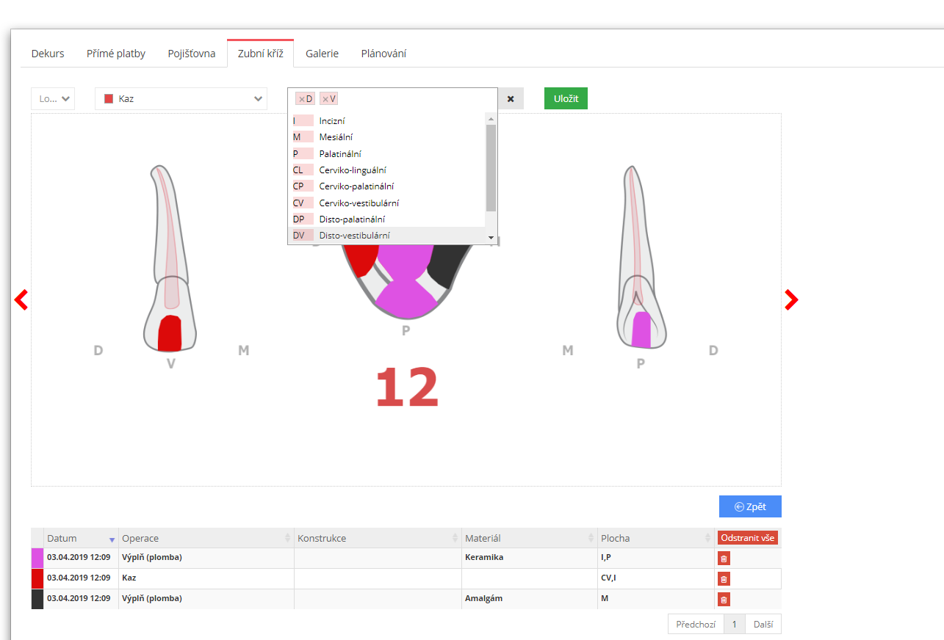

Form filling in Xdent (provided by a consulting dentist)

If interactivity is implemented, selecting localization usually prefills the form. This is good, but not ideal since this kind of a solution limits the possibility of prioritization and does not represent the flow of the encounter. Because the encounter can be divided into 3 stages of interaction with the dental chart, the interactivity can be optimized. The 3 stages are the following:

* Information acquiring
* Recording the diagnoses – in this stage most of the time, dental decay is the most prominent diagnoses. The dentist also needs to be able to write notes for future treatment.
* Recording the procedures – the most prominent treatment corresponds with the most prominent diagnoses. The most prominent procedures are white and amalgam fillings.

In each of these stages, the dentist is expected to repeat actions. Before I suggest my solution concept, let’s think about the role of the dentist. The dentist is not just observing, examining and diagnosing like for example practical practitioner. He does not usually prescribe medications, refer to other specialists, record feedback and suggest other actions. Most of the time, he is diagnosing and then actively treating the state of the patient’s denture in a rather quick and irreversible manner. More than an observer and a coordinator, he is actively fixing and editing the state of the patient’s denture.

Therefore a concept that I’m suggesting is to conceptualize the system as a software editor not dissimilar from the ones for photos or illustrations. I suggest that we imagine the dental chart as a canvas and the diagnoses and procedures as the editor's toolbox.

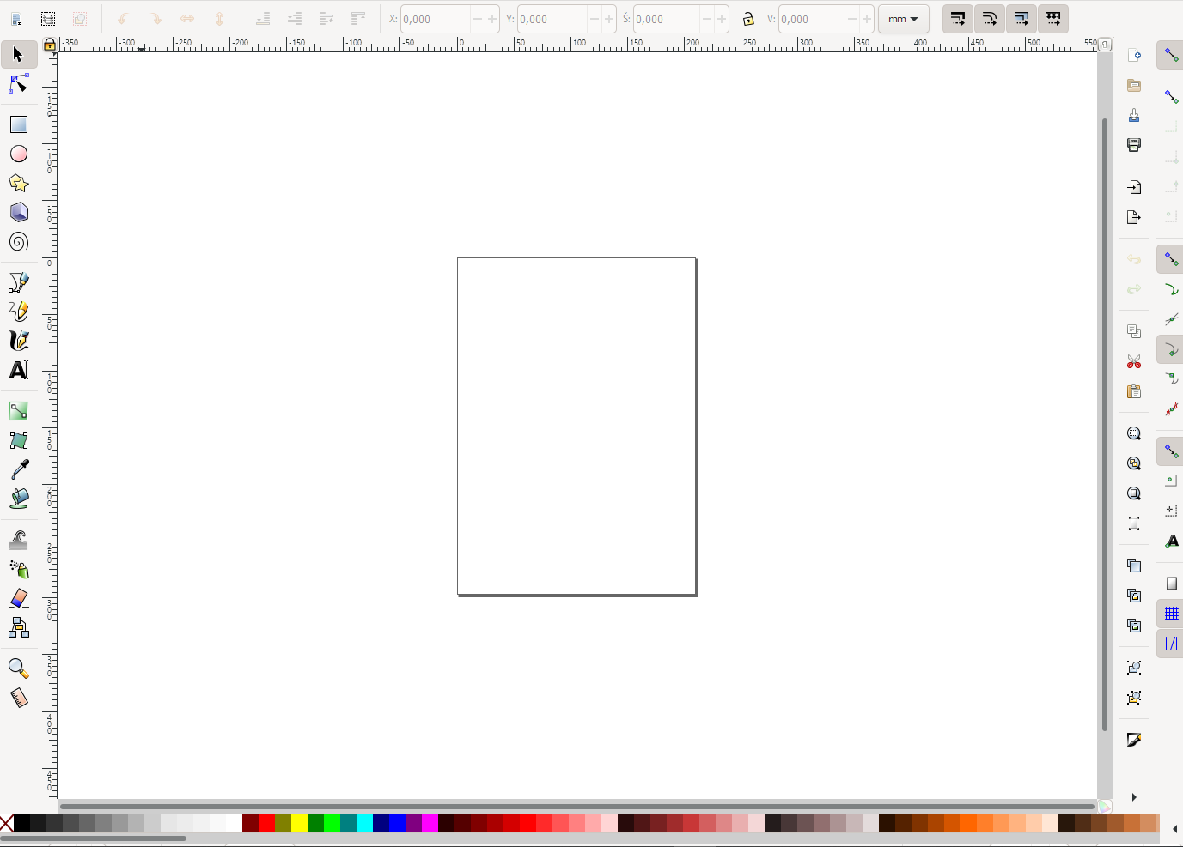

Inkscape – typical vector editor with toolboxes and canvas

Using this idea will not only allow us to group many identical actions into fewer clicks (the dentist will select the tool and then apply it as many times as he likes). It will also allow us to prioritize some actions over others. It will also closer logically correspond with the role of the dentist. The system will not be presented as a simple recording system, but rather it will be a denture editor.

## Data model

In this section, I will present the data model for my solution. Apart from obvious entities (such as a patient), I will explain their meaning. 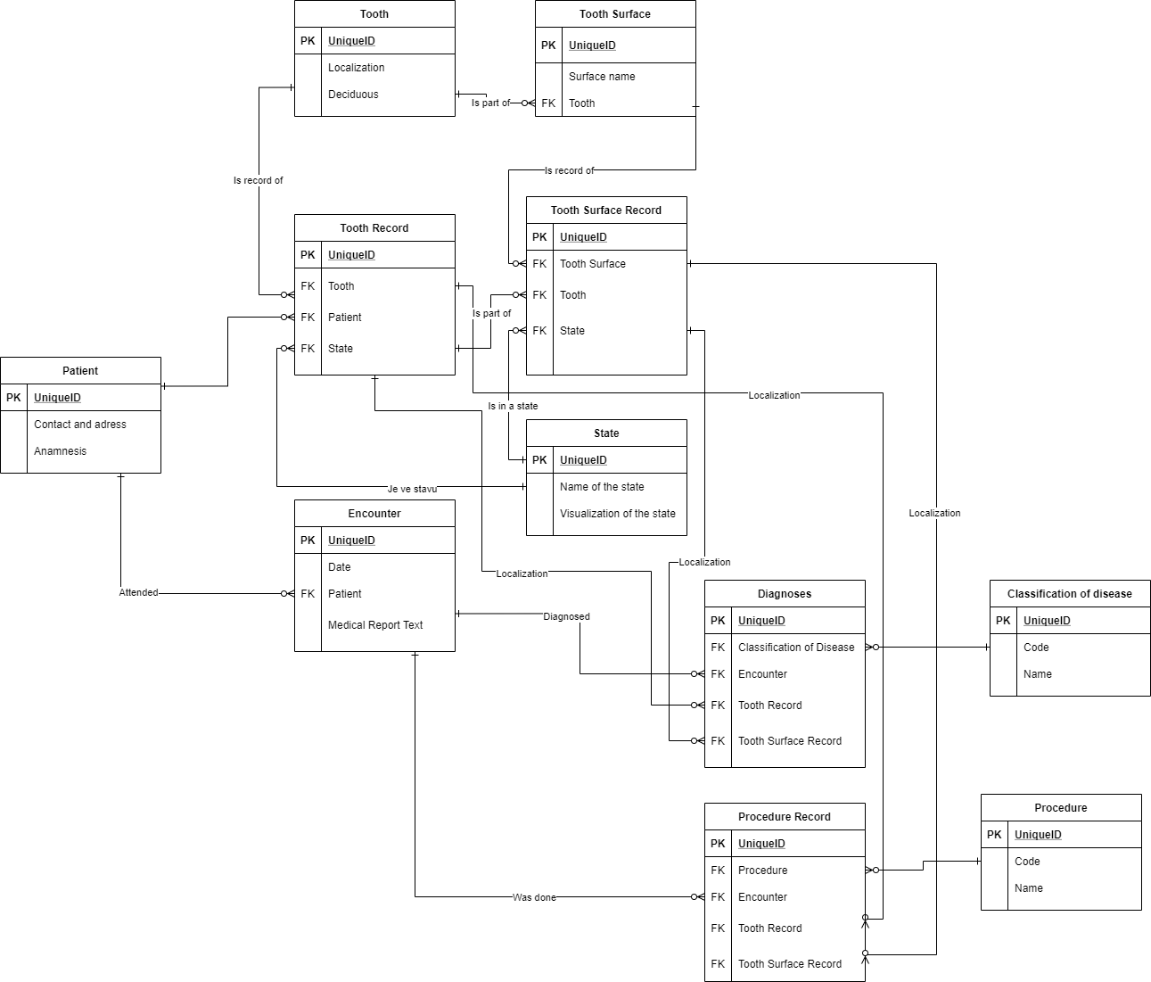

Entity-relationship diagram of the data model

Encounter

A record of the patient’s visit. Groups records under a single date.

Procedure, procedure record

„Procedure“ is a code entity which contains all codes of possible procedures in the healthcare system of the dentist. „Procedure record“ is the record of the code with associated localization and encounter.

Classification of disease, diagnoses

„Classification of disease“ is a list of codes which are valid as diagnoses in the healthcare system. Dentists usually use a limited subset of these. „Diagnoses“ is a record of the disease code with associated localization and encounter.

State

An entity which will result in a visual change of the dental chart (change of colour or texture). Is a system entity for the dental chart functionality. Diagnoses records or procedures record can result in a change of state of their localized surface or tooth.

Tooth, tooth surface

Lists all existing teeth and for each tooth records its associated surfaces.

Tooth Record, Tooth Surface Record

A record of tooth and tooth surfaces associated with a patient. Should be generated from „Tooth“ and „Tooth Surface“ configuration.

## Design Concept

In this part of the work, I will focus on the design aspect of the concept. I will present a series of wireframes and I will describe the ideas behind them.

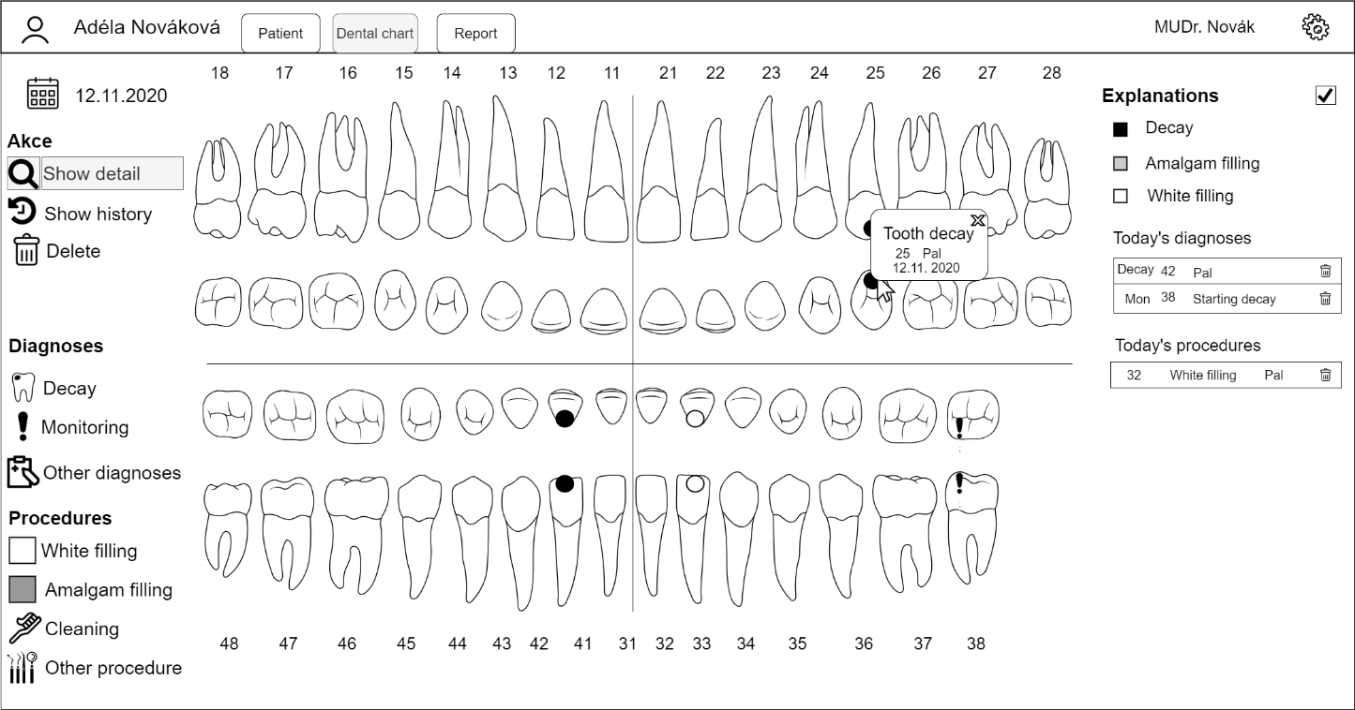

In this wireframe, we can see a visualisation of the dental chart editor with „Show detail“ tool used. the main feature is the dental chart itself. The dental chart is divided into four quadrants and displays all the tooth records and surfaces of the patient. Each surface (or whole tooth) has its state which is displayed by the chart (for example tooth 38 is extracted so it’s not visible). On the left of the chart, we can see the toolbox of the doctor. It is divided into actions, diagnoses and procedures sections. Actions serve to fetch information and general tools. On the right of the chart, we can see the summary of all the diagnoses and procedures done on this encounter and the explanations to the graphical displays of the chart. These can be turned off once the dentist is familiar with the system. The encounter does not have to be explicitly created, but rather is automatically created when either diagnoses or procedure is created. If no diagnoses or procedures have been created, the encounter is generated with the report. On hover on the diagnoses and procedures summary, the records are highlighted.

The show detail tool is the default tool selected. On click it will open details about the tooth, the surface, the diagnoses or procedure clicked. It will allow the dentist to fetch information

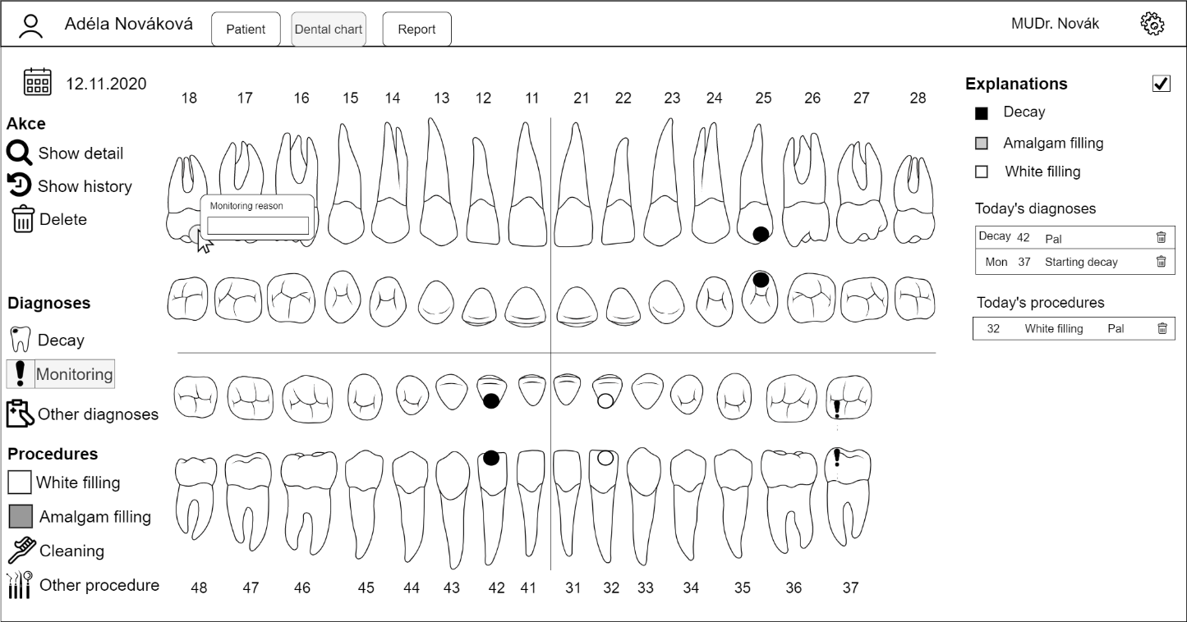

Using monitoring icon requires additional note. Therefore, on selecting the localization with the monitoring tool selected, the dentist is presented with a prompt asking to fill in the additional info. If no additional information is required, the change is immediately performed.

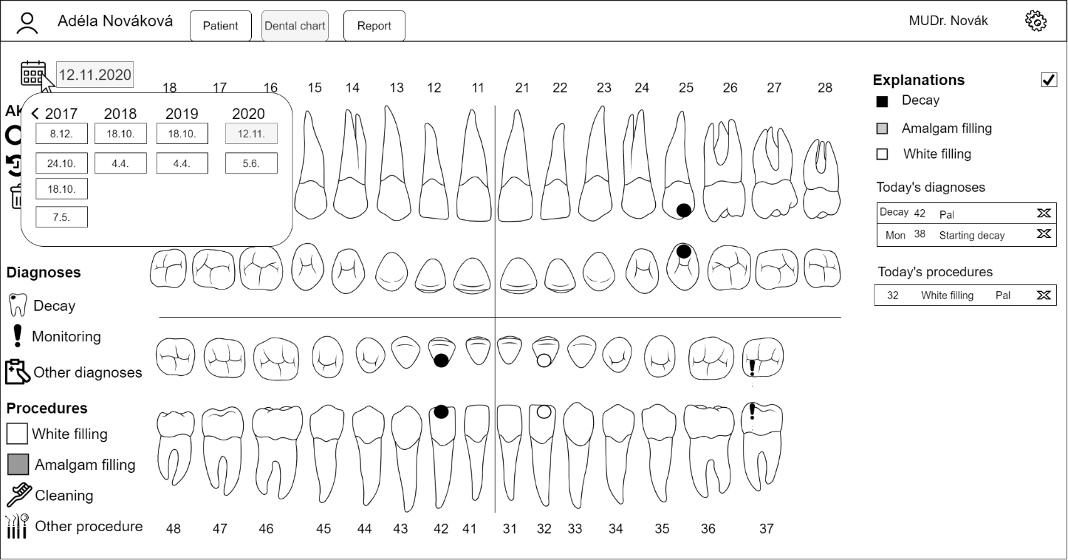

By clicking on the calendar icon, the dentist can easily switch to a different encounter and view old patient‘s encounters in read-only mode (the report is already generated and cannot be changed).

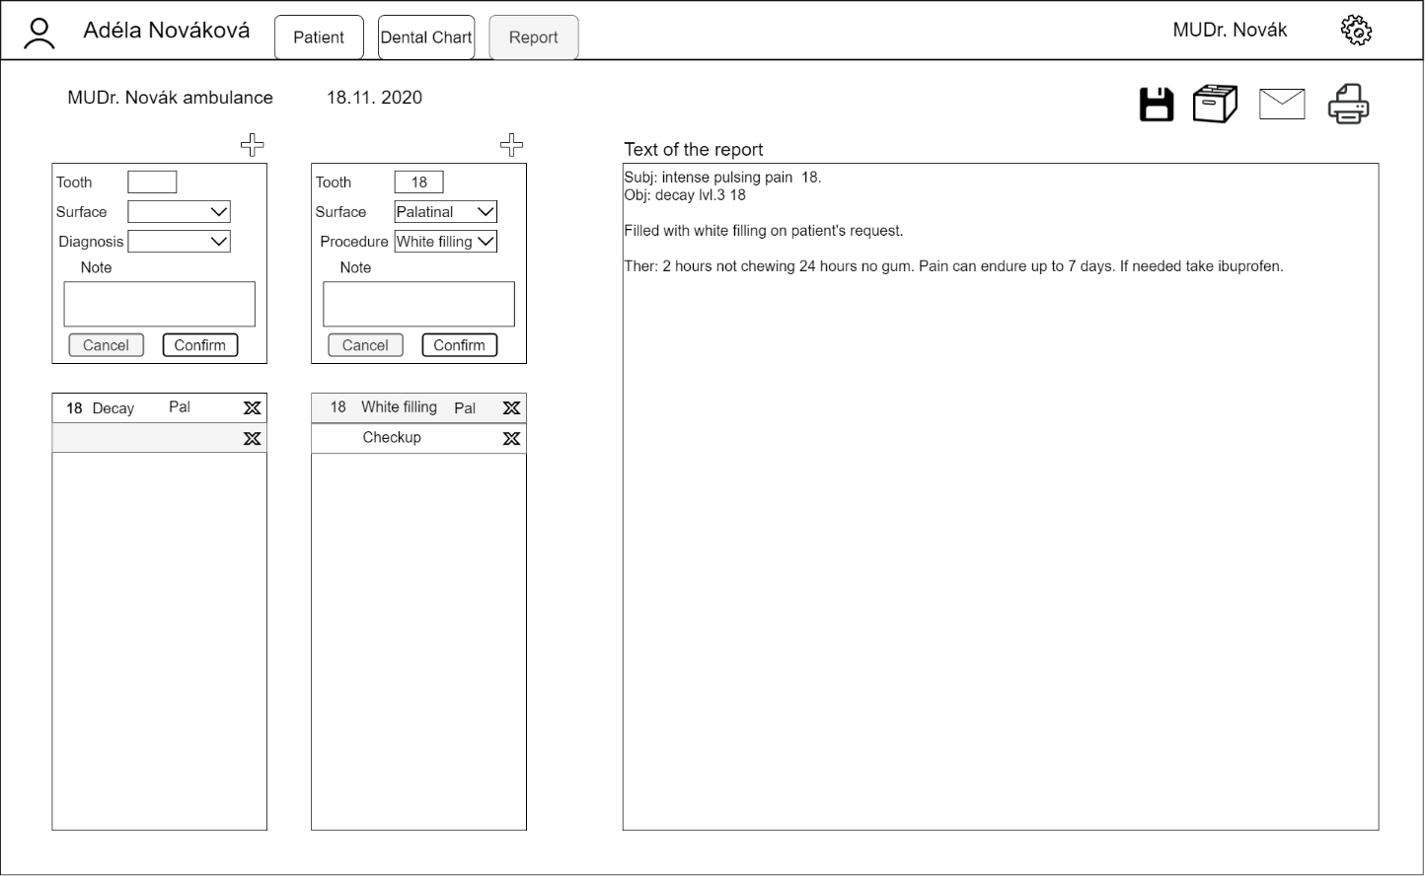

In the report view, we can see all the diagnoses and procedures done on this encounter. The dentist can edit them, remove them and also add new ones. The dentist also can write the text of the report into the block of text. After the report is written, the doctor can save the report, archive the report (which locks the encounter) email the report to the patient, or print the report.

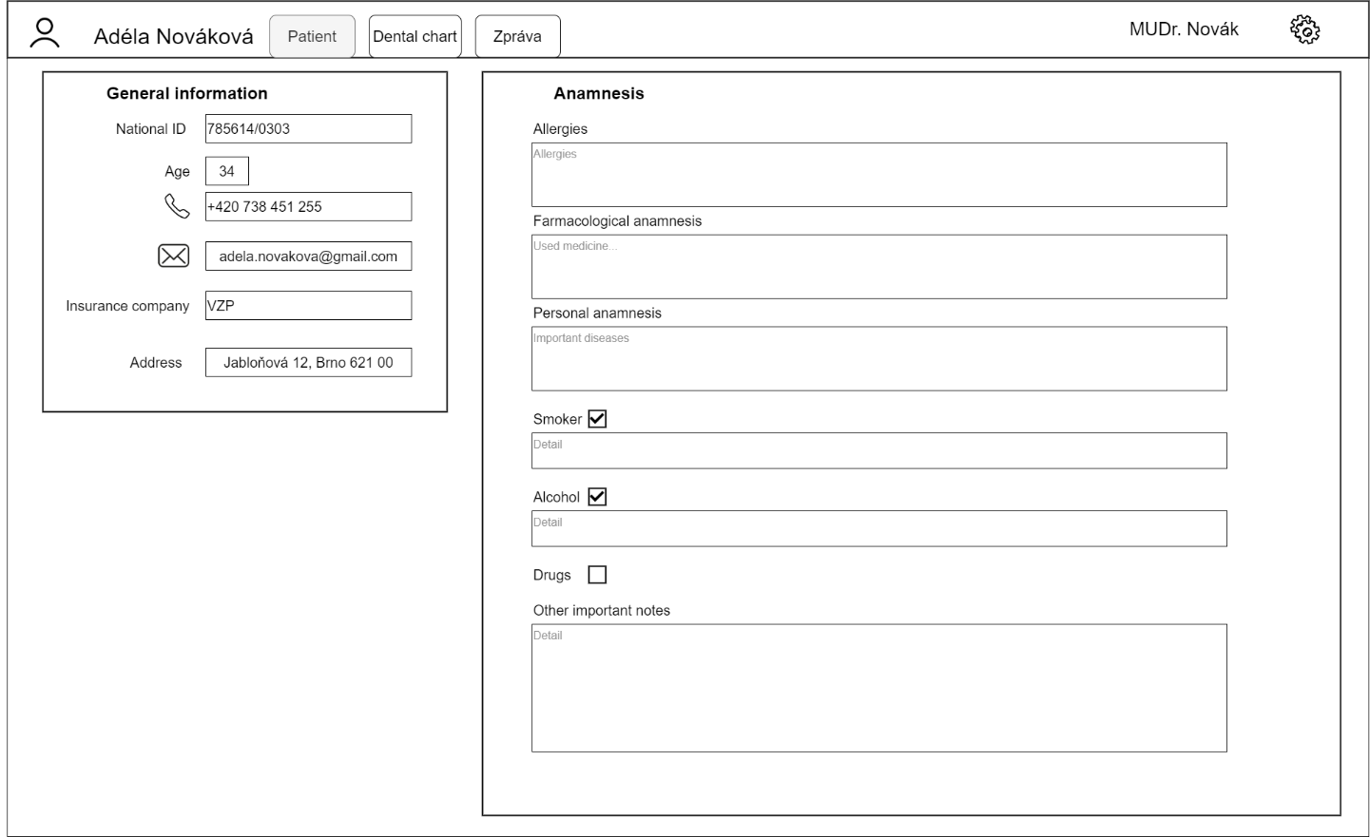

The patient view is simple. It does not need to contain a lot of information. Only basic general information and text blocks for anamnesis are needed. If the patient is not a smoker or does not drink, we can hide the text blocks.

# Development of the solution

## Used technologies

## Database

For the purposes of the prototype, I have used a basic PostgreSQL database in Visual Studio. With which I interact via Entity Framework ORM.

## Backend

The backend is developed using .NET 5.0 API and EntityFramework ORM. I’ve chosen these technologies because they are well documented, effective and EntityFramework is one of the best ORMs for building code first databases. I also utilize a technology called swagger which allows me to conveniently test, debug and document the function of my API. The project is called „DentistAPI“ and contains of few main directories and files:

* Models – These are classes representing entities of our database. All strong entities inherit from EntityBase.cs which contains the ID primary key property.
* Controllers – Classes of functions which receive and handle API requests.
* Seeds – sample data and lists of codes, which will be seeded into a freshly created database.
* DentistAPIContext.cs – Class of database context. This class configures the entity framework ORM, entities in the database and relationships. This class also handles the seeding of the database.

## Frontend

The frontend is developed using Vue.js with the router dependency installed. With the help of axios library I have connected my API with the application. In the folder components I have mine designed Vue.JS components. The folder „services“ contains classes with access to the API. This will allow me simple modification of the API connection or even complete replacing of my API. The folder „Views“ contains the routing pages. The dental chart itself is a SVG directly inserted into the page. By this approach I can easily map the SVG objects and interact with them dynamically.

## Results and testing

# Conclusion