Domince Aseberos,
Kyndel Roy Suarzer,
John Marc Pañamogan

GanapPH
AI-Powered Livelihood Guidance Platform for Tagum City Residents

Statement of the Problem
Many residents in Tagum City are unemployed or underemployed, not because they lack skills, but because they lack access to the right information, guidance, and opportunities. Workers often rely only on Facebook posts, referrals, or walk-ins when searching for jobs or livelihood programs. Many are unaware that they already qualify for free TESDA training, DOLE assistance, PESO referrals, or local livelihood programs available in Davao del Norte. Existing government websites are difficult to navigate and are not designed for ordinary users with low digital literacy. Opportunities exist, but there is no simple system that tells users what programs fit their situation, what steps to take first, and how to improve their income based on their skills. GanapPH aims to become the bridge between people and opportunity in Tagum City.

Objectives
• Help unemployed and underemployed Tagum City residents discover jobs, training, and livelihood opportunities.
• Generate personalized livelihood roadmaps using AI based on the user’s skills, location, and goals.
• Simplify access to government livelihood programs such as TESDA, DOLE, PESO, and DTI support services.
• Provide beginner-friendly guidance in Filipino/Bisaya using a mobile-first design.
• Support local employment and microbusiness growth in Tagum City.
• Create a scalable platform that can later expand across Davao Region.

Solution
GanapPH is a web-based AI livelihood guidance platform designed specifically for unemployed and underemployed residents in Tagum City. The platform asks users simple onboarding questions such as their skills, location, work preference, and target income. Using AI, GanapPH generates a personalized livelihood roadmap that recommends TESDA programs, DOLE assistance, local job opportunities, and possible microbusiness paths. The goal is to transform confusing government information into a clear, step-by-step action plan anyone can follow.

Product Logo Concept


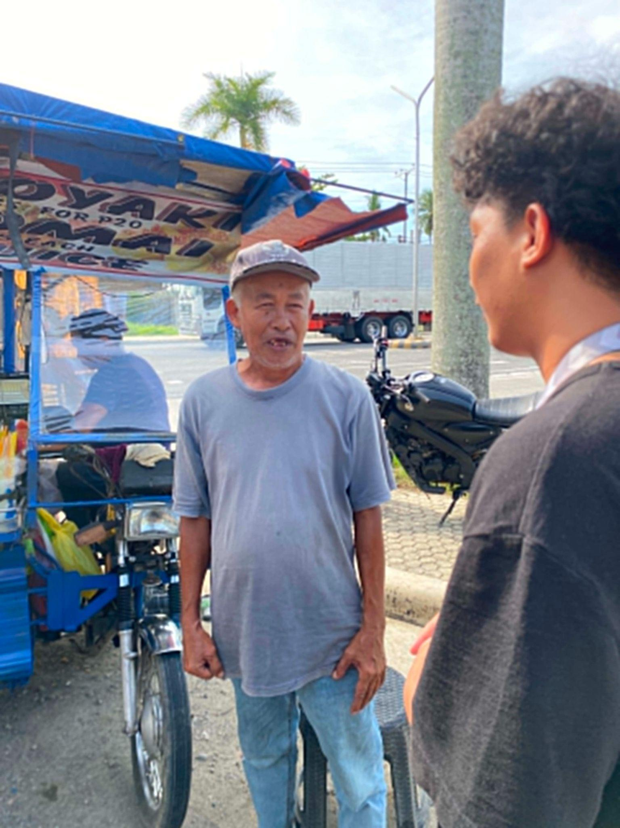

Primary Persona — Vendor
Name: Anthony Mansit
Age: 62 years old
Location: Macopa, Visaya
Civil Status: Married
Occupation: Vendor at UMTC - Visayan, Former Security Guard
Background:
Tatay worked for several years as a security guard.
He has also experience in carpentry, basic electrical work,
cement mixing, and small repairs.
Pain Points:
• Jobs referral from friends
• Struggles finding stable income
• Finds government processes confusing
• Limited digital literacy
Goals:
• Find stable employment
• Improve technical skills
• Earn ₱15,000–₱20,000 monthly
• Support his family consistently

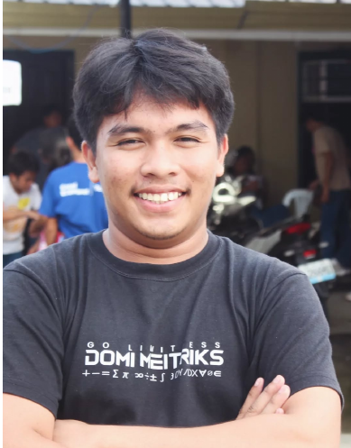

Secondary Persona — Student and Part-timer
Name: Wilmar Escobas Asis
Age: 21 years old
Background:
Wilmar is currently a college student and part-time worker in
Tagum City. He balances his studies while searching for flexible
job opportunities to help support his daily expenses and future
goals. He is familiar with using social media and online platforms,
but still struggles finding clear and reliable directions toward
stable employment.
Pain Points:
• Struggles finding flexible work schedules compatible with school
• Unsure where to start applying for jobs
• Wants clearer direction toward stable employment after graduation
Goals:
• Find flexible part-time opportunities
• Gain work experience while studying
• Build stable income after graduation



Tertiary Persona — Local Business Owners
Names: Noel and Cherly Bangoy
Age: 50 and 48 years old
Local Business Owners • Tagum City
Background:
Noel and Cherly manage a local business in Tagum City and
regularly look for workers to support daily operations.
They often rely on referrals and Facebook postings when
hiring employees.
Pain Points:
• Struggle finding workers that match their required skills
• Hiring process is inconsistent and time-consuming
• Limited access to organized local applicant matching
Goals:
• Find more reliable and qualified workers
• Simplify local hiring and recruitment
• Connect with applicants that fit their business needs
• Support local employment within Tagum City

Prototype

1. Landing Page
2. Onboarding
3. AI Roadmap Page
4. Matched Jobs Page
5. Program Finder

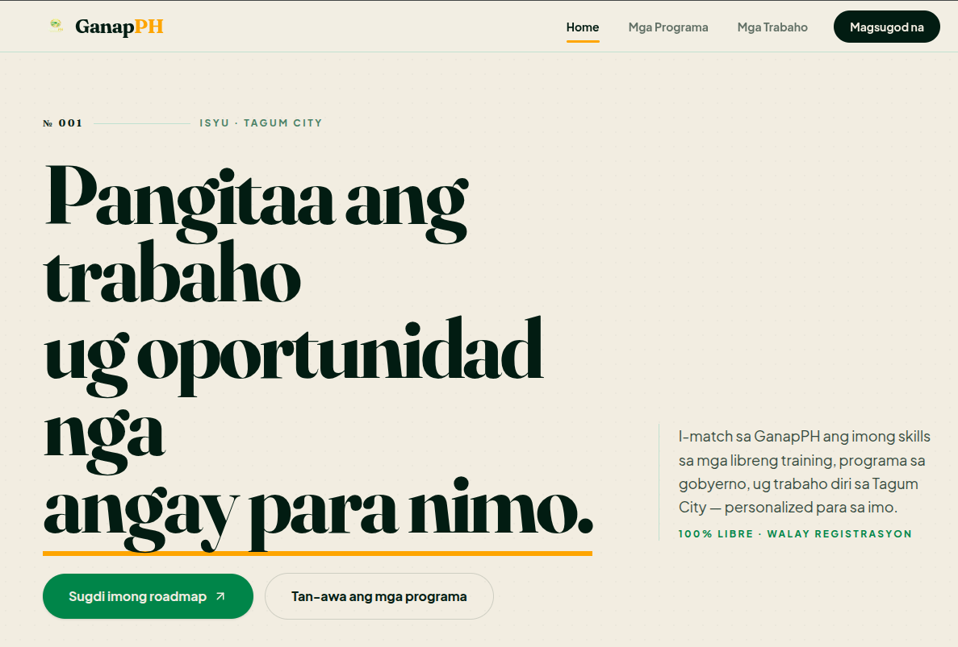

TAM • SAM • SOM

TAM (Total Addressable Market)
GanapPH addresses the nationwide challenge of unemployment and underemployment in the Philippines.
According to the Philippine Statistics Authority (PSA), approximately 2.26 million Filipinos were unemployed as of December 2025.
This creates a potential nationwide market of over 8 million+ Filipinos who may benefit from livelihood guidance and government opportunity access.
Source:
Philippine Statistics Authority – Labor Force Survey
SAM (Serviceable Addressable Market)
GanapPH initially focuses on communities within Davao Region.
According to the 2024 Census of Population by the Philippine Statistics Authority, Davao Region has a population of 5,389,422 residents.
Source:
Philippine Statistics Authority – Davao Region Population 2024 Census
SOM (Serviceable Obtainable Market)
GanapPH begins with a local-first approach focused on Tagum City, Davao del Norte.
According to regional population reports, Tagum City has an estimated population of 300,042 residents.
For its pilot implementation, GanapPH initially aims to reach 500–1,000 potential users from selected barangays in Tagum City.
Source:
Philippine Information Agency – Davao Region Population Report

