UM TAGUM COLLEGE
BACHELOR OF SCIENCE IN COMPUTER SCIENCE
Department of Computing Education
Visayan Village, Tagum City, Philippines

Course Requirements in
CS17/ L SOFTWARE ENGINEERING 2
CUTshier: A POS and Inventory Management System for Cutsy Coffee

Submited to:

Eduardo Jr. Catahuran

Submitted by:
Aseberos, Domince Jabonite, Dick Angelo Nillas, Nina Kristina Suarez, Kyndel Roy
Submitted at:
May 16, 2026
Table of Contents
- Business Requirements 1
- User Requirements 3
- System Requirement Specification 4
- Activity Diagram 5
- Use Case Diagram 6
- F.1 Context Diagram 7
  - Data Flow Diagram 8
- Software Process Methodology 10
  - Methodology 10
  - Low-Fi Sample 12
Business Requirements
- Business Background
Cutsy Café is a friendly neighborhood café located at Purok A, Suaybaguio Street,
Barangay Magugpo North, Tagum City. It offers a wide range of beverages and trendy food options that appeal to today’s tastes. And currently, the café uses a manual process for taking orders, recording sales, managing inventory which leads to inefficiency during peak hours.

- Problem Statement
The current manual process on tracking inventory and sales needs improvement particularly on monitoring daily sales report, tracking inventory and stamp cards. Which needs modernization for automation for better accuracy and efficiency. There is also a need for product sales analysis to identify best-selling and low-performing items, helping the business determine which products to prioritize for restocking. And automation is needed for manual checking
every message on Facebook messenger for deliveries and reservations.

- Business Objectives
  - To automate business process
  - To provide real-time sales report, tracking of orders and stamp cards
  - To minimize human error
  - To generate product sales analysis for improved inventory and restocking decisions
  - To allow customers to reserve and place orders online for convenience and faster service

- Value Proposition
The proposed POS (Point of Sale System) for Cutsy Coffee aims to improve efficiency by automating order taking, sales and loyalty points tracking, inventory management, and customer reservations. It minimizes human error, provides accurate real-time data, and supports better
decision-making through sales analysis. The system also enhances customer convenience by allowing online reservations and orders, leading to faster and more reliable service.
- Scope

The system will cover the following:
  - Automation of sales transactions and order processing
  - Real-time generation of daily and monthly sales reports
  - QR-based stamp cards are added for customers
  - Inventory tracking and automatic stock updates
  - Product sales analysis to identify best-selling and slow-moving items
  - Online reservation feature for customer convenience
  - User access for the owner and staff to manage transactions and monitor operation

The system will not cover the following:
  - Financial accounting and payroll management
  - Third-party delivery or courier service integration
- Stakeholders

Stakeholder | Role/Description
Admin / Owner | Responsible for overseeing café operations and making business decisions, utilizing reports and analytics as  primary tools.
Café Staff / Cashier | Uses the system to process orders, record sales, track loyalty stamp cards, and manage daily transactions and inventory.
Customers | Place orders and make reservations online or in-store for a faster and more convenient service experience.
System Developer / Project Team | Responsible for designing, developing, and maintaining the POS system.

User Requirements
The Point of Sale (POS) system for Cutsy Café will be used by the café admin staff, and customers. Each user group has specific needs to ensure that the system provides accurate data, improves daily operations, and offers a convenient customer experience.
- Admin - is responsible for managing the café’s overall operations. The system must
allow the admin to view accurate daily, weekly, and monthly sales reports to track performance. It should also provide tools for monitoring inventory levels and sending alerts when stocks are low. In addition, the system must include a product sales analysis feature to help the owner identify best-selling and low-performing items for better restocking decisions. The owner should also have secure access to update product details, manage pricing, and generate reports. The admin must be able to view, add, remove and modify products and inventory.

- Cashier - handles daily transactions and customer orders. The system must provide an easy-to- use interface to record orders, process payments, track loyalty stamp cards, and issue receipts
efficiently, especially during peak hours. It should automatically update inventory quantities after each sale to reduce manual work and human error. Staff must also be able to view order history, manage dine-in and take-out transactions, and accommodate online reservations of customers.

- Customers - the system should allow them to browse the café’s menu, reserve tables, and place orders online. Customers should also receive confirmation of their reservations or orders and be assured that their information is securely handled. The interface must be simple, responsive, and easy to navigate, even for first-time users.
System Requirements Specification
Functional Requirements
Customer Requirements
- The customers shall be able to create account and sign in to the web portal
- The customer shall be able to view the website and menus without logging in.
- The customers shall be able to view live status of cafe if there are vacant seats seats
- The customer shall be able to reserve seats online at a specific time and input number of guests coming and given a choice if they’ll sign in as guest to submit a form or log in
- The customer must need to pre-order and upload screenshot of payment or reference id to submit a reservation.
- The customers must create of login to account to be able to view their loyalty stamp progression and generate QR-Code for recording of loyalty points for every successful purchase of eligible products that has points and get rewards if conditions are met. After successful purchase, customers can leave a rating, product and service review optionally.
- The customers with CATSY account shall be able to view their purchase history and leave a feedback after a successful purchase of CATSY products.
- The customers shall be able to view the location of the cafe on online map.
Staff Requirements
- The staff must log-in before accessing the POS application.
- The staffs shall be able to process sales for every successful orders and generate receipt.
- The staff shall be able to modify orders before finalizing order/s.
- The staffs shall be able to scan or input QR-code to record loyalty score of customers.
- The staffs shall able to to view and manage reservations.
- The staff shall able to update current number of seats available at the cafe.
- The staff shall be able to view current stocks available and notified if there’s shortage in stocks in inventory.
- The staff shall be able to view order history and transactions.

Admin
- The admin must log-in before accessing the admin panel.
- The admin shall be able to modify and update cafe schedules.
- The admin shall be able to do CRUD actions on inventory, product and list of staffs
- The admin shall be able to view performance and prediction of possible high-performing products for the every month cycle.
- The admin shall be able to download the installer for the POS application.
- The admin shall receive a notification for inventory stock alerts, negative feedback and reservations.
- The admin should also be able to view all transaction history.

Non-Functional Requirements
- The system must have an intuitive and user-friendly interface that can be easily navigated by both staff and customers with minimal training.
- The system should process transactions quickly and respond to user actions within 5 seconds, even during peak business hours.
- The system should function consistently with minimal downtime and ensure that all stored data is accurate and up to date.
- All user credentials, transactions, and customer data must be protected using appropriate security measures such as password encryption and access control.
- The system must be accessible through desktop and mobile web browsers to accommodate different users and devices.
- The system should be easy to update or modify for future enhancements and fixes.
- The system should support an increasing number of transactions and users as the café grows.
Activity Diagram
The activity diagram illustrates the workflow of the Cutsy Café POS System, showing the interactions between the Customer, Café Staff / Cashier, Manager / Owner, and the System. The process begins when the customer accesses the ordering platform, either for an on-site order or an online reservation. A decision node determines the order type.
For on-site orders, the staff records the order, processes the payment, and the system automatically updates sales and inventory records. For online reservations, the customer submits reservation details, and the system saves the information and sends a confirmation message. The owner or staff can review upcoming reservations through the system.
The process concludes with the owner viewing sales and reservation reports. Overall, the diagram demonstrates how the system automates order and reservation processes, improving accuracy and efficiency in café operations.
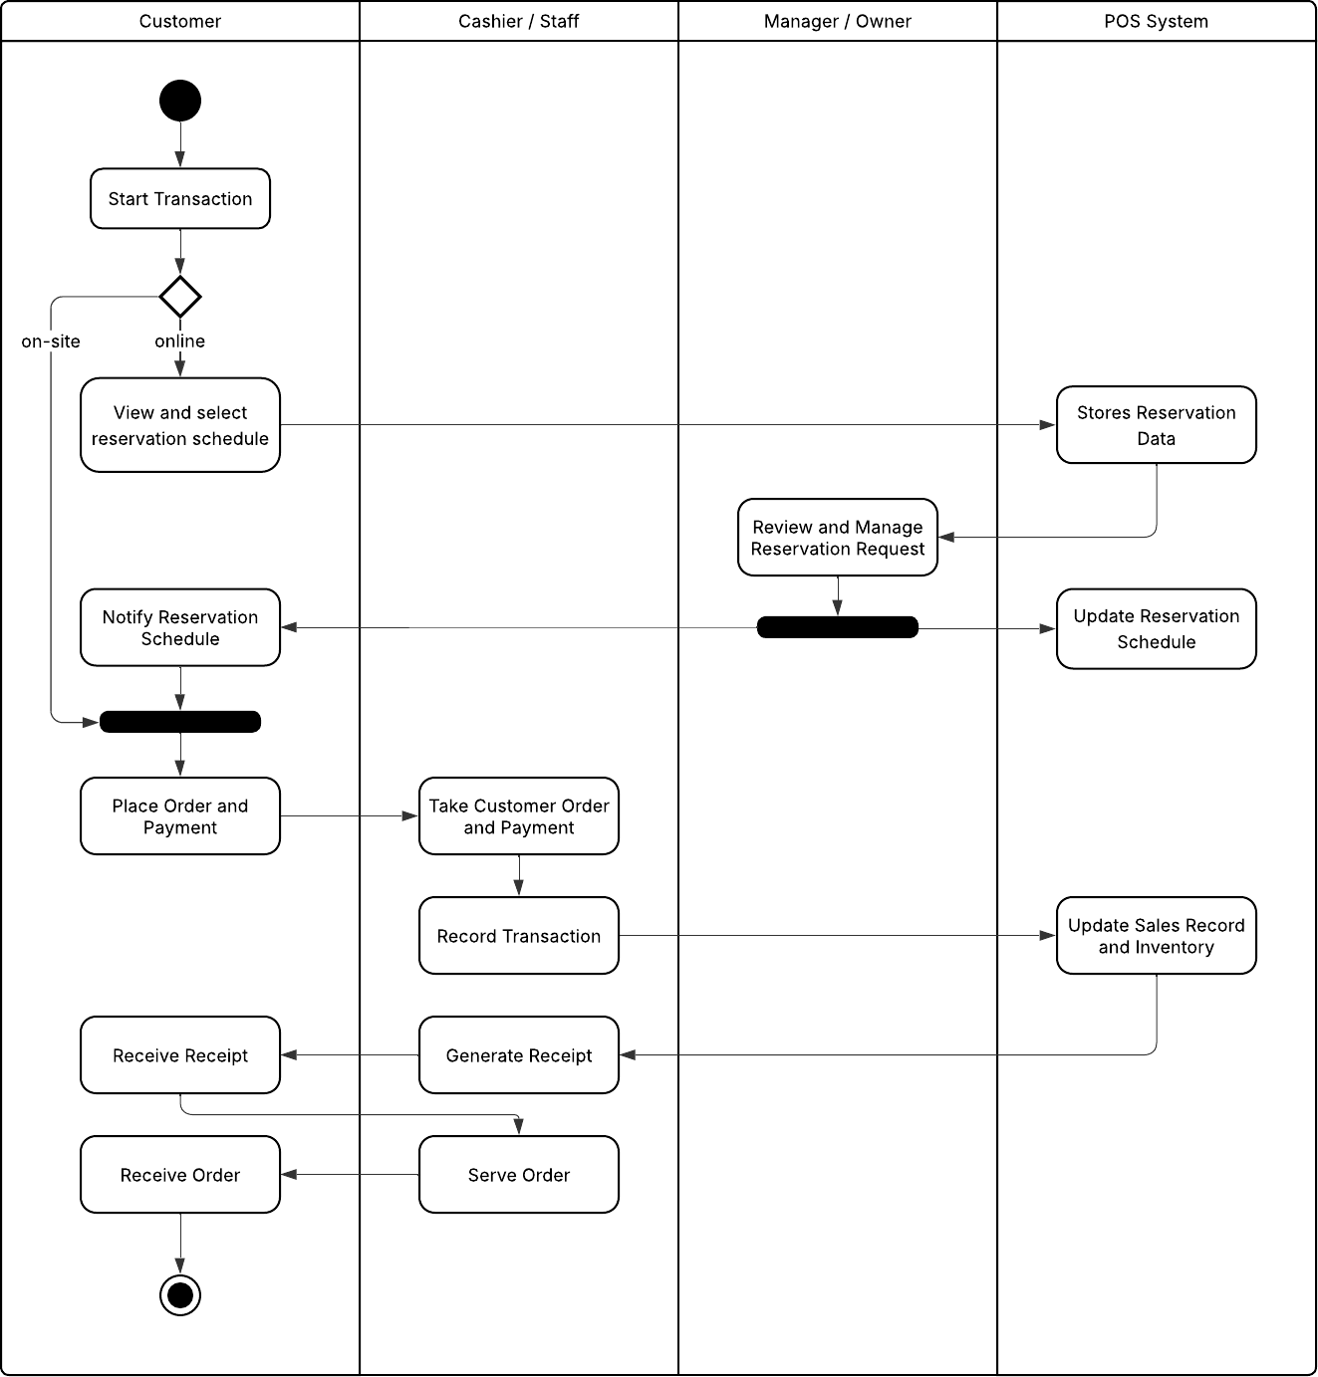

Figure 1. Activity Diagram
Use Case Diagram
The use case diagram illustrates the interactions among the system’s main actors: the customer, café staff
/ cashier, manager, and the system itself. Customers can view, select, and confirm reservations, which are processed by the admin for approval. The admin can log in to manage reservations, sales, and inventory, while the cashier handles on-site transactions such as recording orders, processing payments, tracking loyalty stamp cards, and issuing receipts. The system automatically sends confirmation messages after approval, ensuring a streamlined and efficient workflow in café operations.
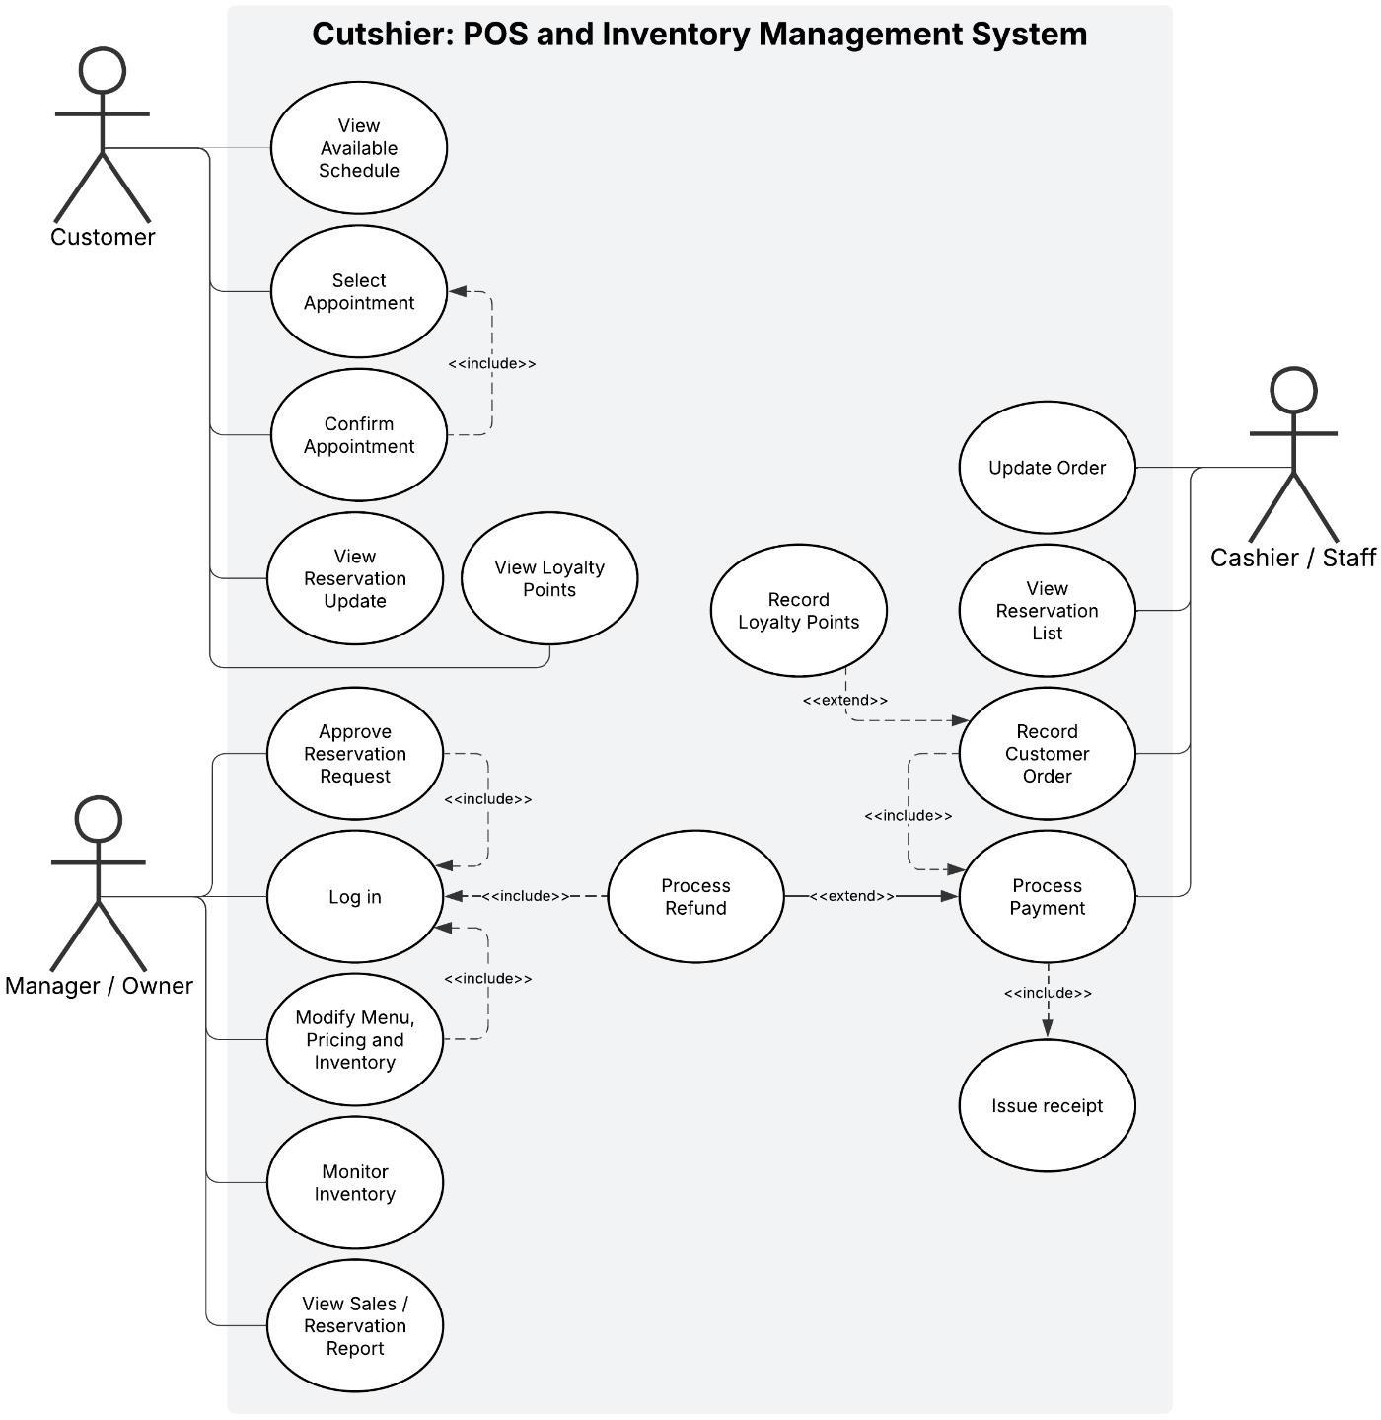
Figure 2: Use Case Diagram
Context Diagram
The Context Diagram illustrates the overall interaction between the Café POS and Reservation System and its external entities — the Customer, Cashier/Staff, and Manager/Owner. It presents how data flows in and out of the system, providing a clear picture of its main functions. Customers can place on-site orders or submit online reservations, which are then received and processed by the system. For on-site transactions, the cashier records the order, processes the payment, and the system generates a receipt while updating sales and inventory data automatically.
Meanwhile, the manager or owner can access reports and analytics generated by the system to monitor performance and sales trends. The diagram also shows how reservation details are confirmed and stored for future reference. Overall, the context diagram defines the system’s boundaries, highlighting how it connects customer service, staff operations, and managerial oversight into one automated and efficient café management system.

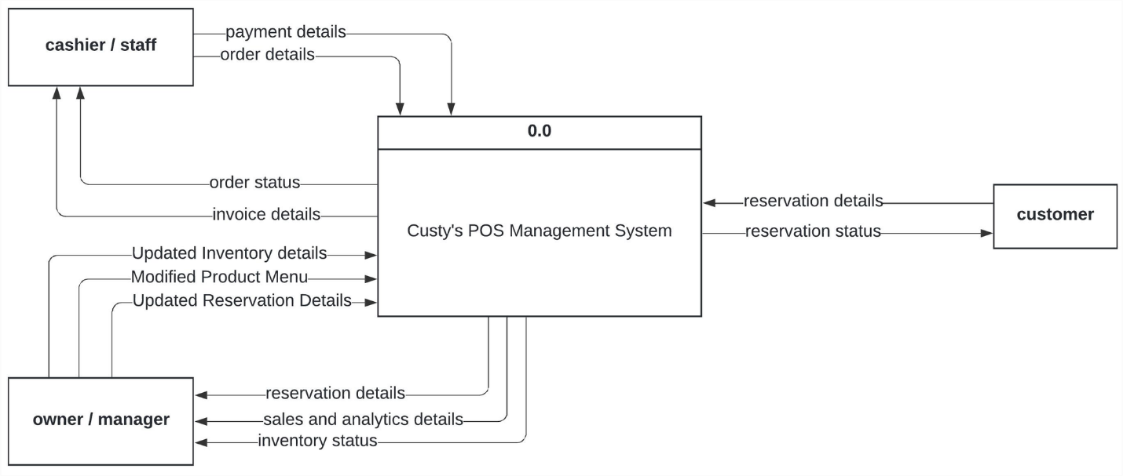
Figure 3: Context Flow Diagram
Data Flow Diagram
The Data Flow Diagram illustrates the overall flow of data within the POS, providing a comprehensive understanding of how information is exchanged between processes, data stores, and external entities. The system's primary functions include reservation management, order processing, inventory control, and analytical reporting.
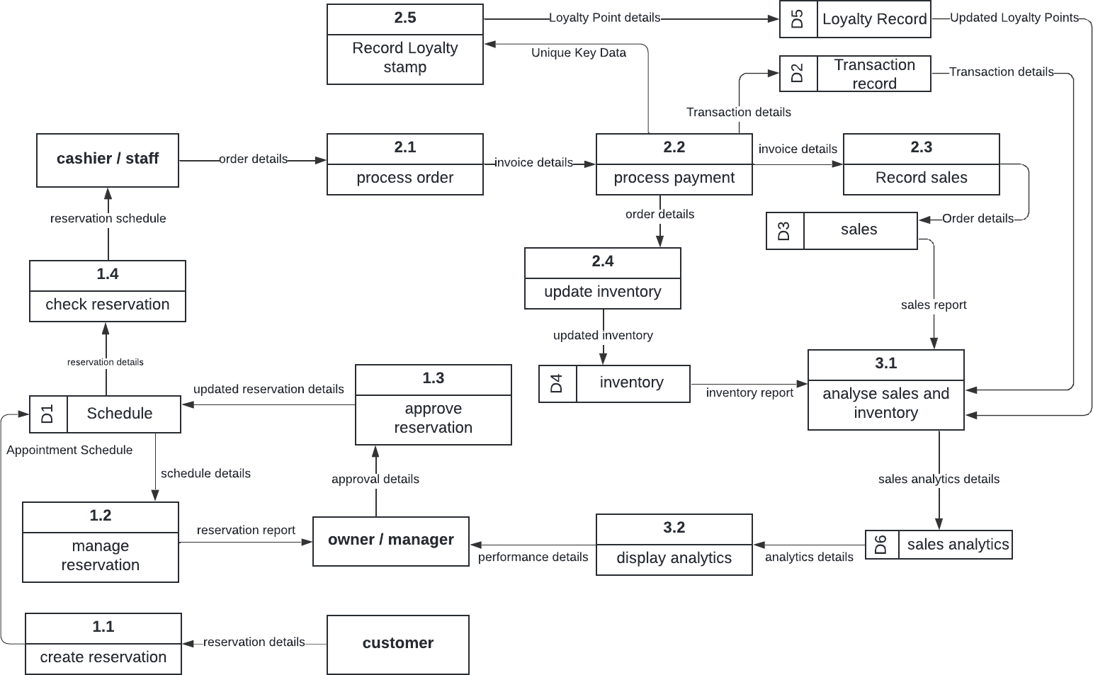

Figure 4: Data Flow Diagram

Create Reservations (1.1). When the customer enters their reservation information into the system through website, the procedure starts. All reservation and appointment data is stored in the "Schedule" data store (D1), where these particulars are entered. This guarantees that every client reservation is accurately recorded for further handling.
Manage Reservation (1.2). The system maintains an updated record in the "Schedule" data store (D1) and confirms schedule availability when the reservation is created. Conflicts are prevented and bookings are arranged thanks to the procedure. A reservation report for management review may also be produced by the system.
Approve Reservation (1.3). After reviewing the reservation information, the manager or owner either authorizes them or makes any required changes. The "Schedule" data store (D1) receives approved reservations as updated reservation information. Order creation and service scheduling are also based on the approved data.
Check Reservation (1.4). The cashier or employee pulls the relevant appointment schedule from the "Schedule" data store (D1) after verifying the reservation status. This enables employees to verify client appointments and process orders based on confirmed reservations.
Process Order (2.1). The customer's order is processed by the cashier or staff on-site.
Process Payment (2.2) customer transactions and confirms successful payments. Once payment is completed, it triggers the Record Sales and Record Loyalty Stamp processes while updating the Inventory Data Store and saving transaction details in the Transaction Record Data Store (D2).
Record Sales (2.3) process stores the details of each completed order into the Record Sales Data Store (D3). It ensures that all transaction information from the order process is properly saved for generating reports and tracking daily sales performance.
Update Inventory (2.4). The inventory is instantly updated to reflect the sale as soon as the order and payment have been completed. The system updates the "Inventory" data store (D4) after subtracting the sold products from the stock. The most recent inventory data guarantees precise stock level monitoring and initiates refilling as required.
Record Loyalty Stamp (2.5) process updates the customer’s loyalty record after a completed order. It stores the transaction details in the Loyalty Record Data Store (D5), ensuring accurate tracking of stamp rewards and customer points
Analyze Sales and Inventory (3.1). In order to conduct analytical evaluations, this procedure gathers data from the Transaction Record (D2), Sales (D3) Inventory (D4), as well as the Loyalty Record data store (D5). Sales patterns, product performance, and inventory turnover rates are all determined by the analysis. The "Sales Analytics" data store contains the resulting insights (D6).
Display Analytics (3.2). Presenting the analytical findings to the manager or owner is the last step. Data- driven decision-making about marketing, inventory control, and sales tactics is made possible by the visual insights into business performance that may be obtained from the "Sales Analytics" data store (D6).
Software Process Model (Methodology)
The Waterfall Model was used in this project. It follows a step-by-step process where each phase is completed before the next begins. This method ensures organized development and clear progress for the café’s POS and reservation system
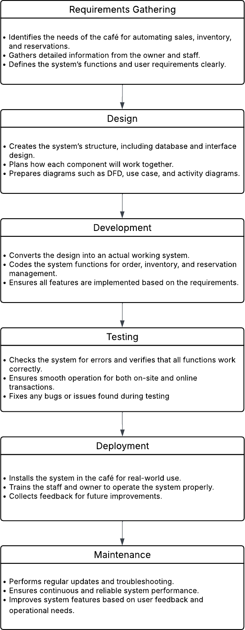

Figure 5: Waterfall Model Methodology
- Requirements Gathering phase focused on understanding the café’s operational needs and challenges. Information was collected through interviews and observations with the owner and staff to identify issues in sales tracking, inventory management, and reservation handling. The results of this phase guided the identification of system requirements, ensuring the developed system meets the café’s goals for accuracy, efficiency, and automation.
- The Design Phase involved creating the system’s overall structure and layout based on the gathered requirements. This included designing the database, user interface, and system flow to ensure smooth interaction between users and the system. Diagrams such as:
  - Activity Diagram
  - Use Case Diagram
  - Context Diagram
  - Data Flow Diagram
  - Low-Fi Prototype
  - Architectural Pattern (Layered Architecture)
  - System Architecture (Monolithic Architecture)
- Development phase focused on building the system based on the design. Key features such as order processing, inventory tracking, sales reporting, and online reservations were coded and integrated to ensure the system works as intended. To develop the system, the team will use the following tools for their development:
  - Programming Language: Python, Typescript
  - Front End: HTML, CSS, Javascript
  - Frameworks: React, Tailwind CSS, Node.js, React Native, Flask
  - Database: Supabase - PostgreSQL
  - Collaboration: Github
  - Version Control: Git
  - Hosting: Render
- The Testing Phase involved checking the system for errors and verifying that all features function correctly. This included testing order processing, inventory updates, sales reporting, and online reservations to ensure the system operates smoothly and meets the café’s requirements.
- The Deployment Phase puts the system into operation at the café, accessible via staff and customer mobile devices. Staff and the owner are trained to use the system, which manages orders, inventory, sales, online reservations, and the QR-based stamp card system efficiently.

- The Maintenance Phase ensures the system continues to operate smoothly after deployment. Updates and troubleshooting are performed as needed, maintaining the functionality of order processing, inventory tracking, sales reporting, online reservations, and the QR-based stamp card system.
Low-Fi Prototype Sample
The Low-Fidelity sample shows the initial layout of the system’s interface. These images illustrates the basic structure of pages for orders, inventory, sales, and reservations before creating the final design.
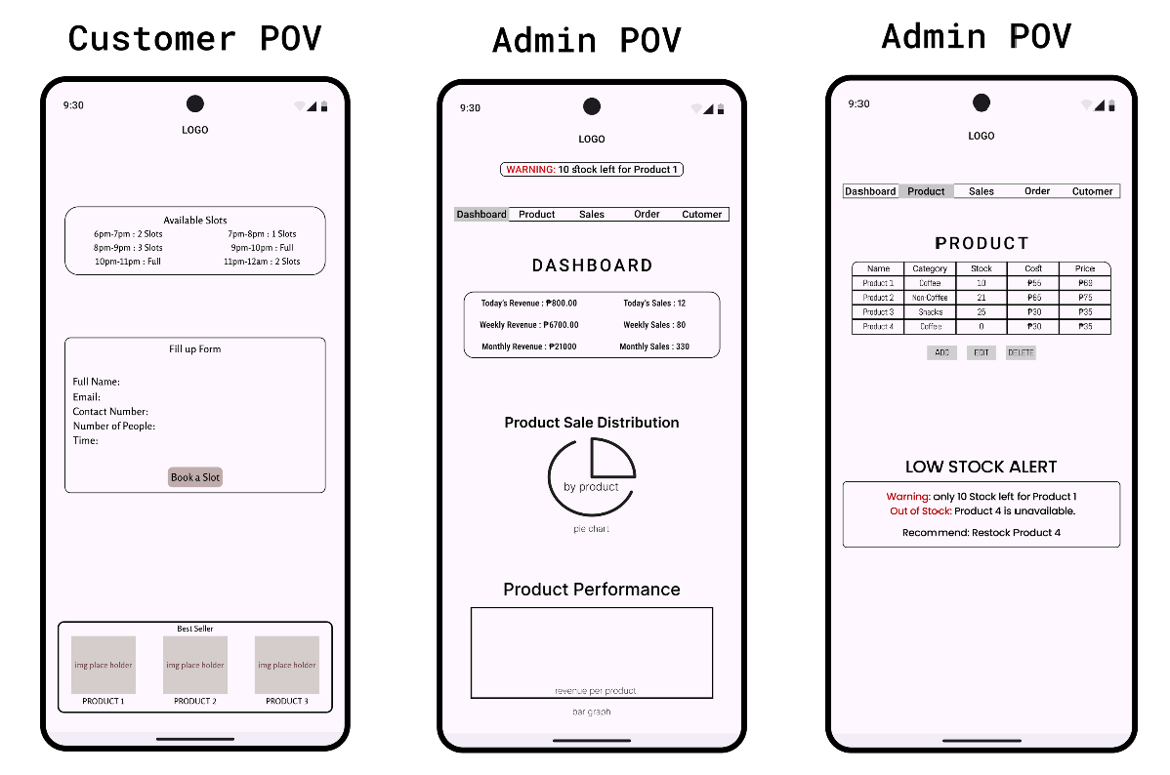
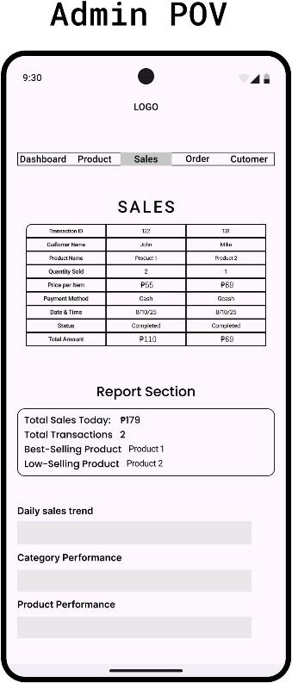
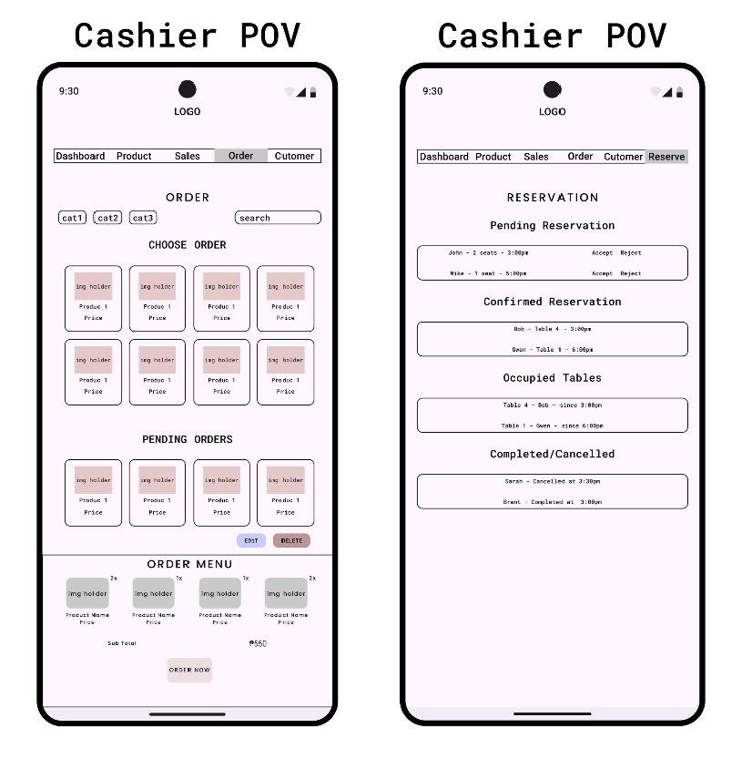

Figure 6: Low-Fi Samples

Architectural Pattern
CATSY uses a layered 3-Tier client-server with Offline-First Mobile Sync architecture. The mobile POS and web application act as client interfaces, while the FastAPI backend handles business logic, authentication, validation, and communication with Supabase. Supabase serves as the central database, while the mobile app also uses local SQLite storage for offline-first operations.
This architecture is suitable because it separates the user interface, business logic, and data storage into clear layers. It improves maintainability, keeps shared rules centralized in the backend, and supports both real-time web operations and offline mobile POS syncing.
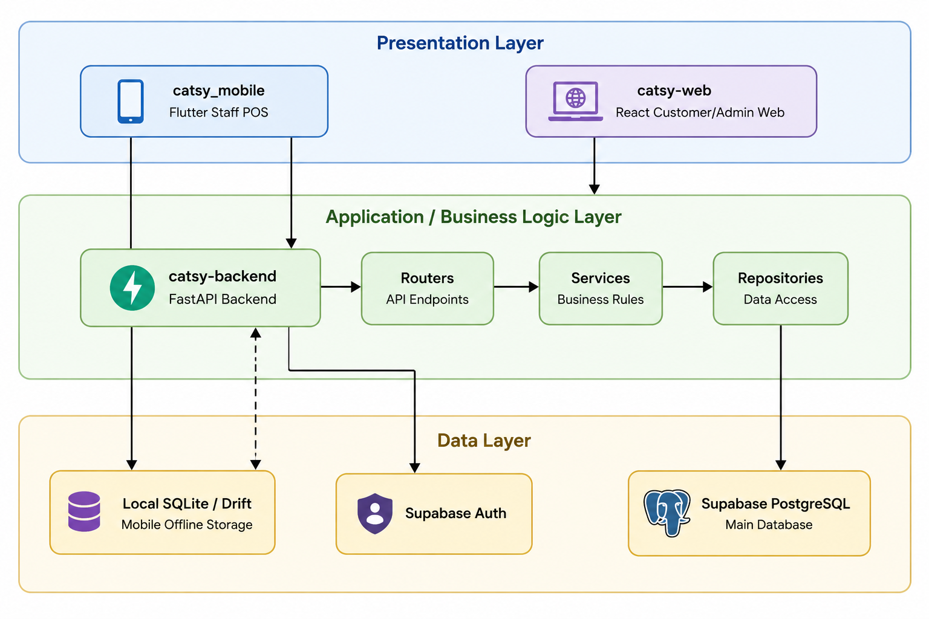
Figure 7: Presentation Layer
Presentation Tier (Clients):
- Mobile POS: Built with Flutter following Clean Architecture (Domain, Data, Presentation layers). It uses Riverpod for reactive state management and Drift to interface with SQLite.
- Web Portal: Built with React and Vite. It serves customers (reservations, loyalty profiles) and administrators (inventory, recipes, and sales analytics).

System Architecture: 3-Tier Client-Server Architecture
The CATSY system is composed of client applications, backend services, and data storage. Customers and administrators use the React web application, while staff use the Flutter mobile POS application. Both clients connect to the FastAPI backend through secure API requests.
The backend manages authentication, order processing, reservations, inventory, loyalty, reports, and notifications. It connects to Supabase, which stores the central system data. The mobile POS also uses local SQLite storage so staff can continue working during poor network connection and sync data once the connection returns.
The system has no dedicated hardware layer. It runs on user devices and cloud-hosted services. Network communication uses HTTPS between the clients and backend, while real-time updates are supported through server-sent events and notifications.
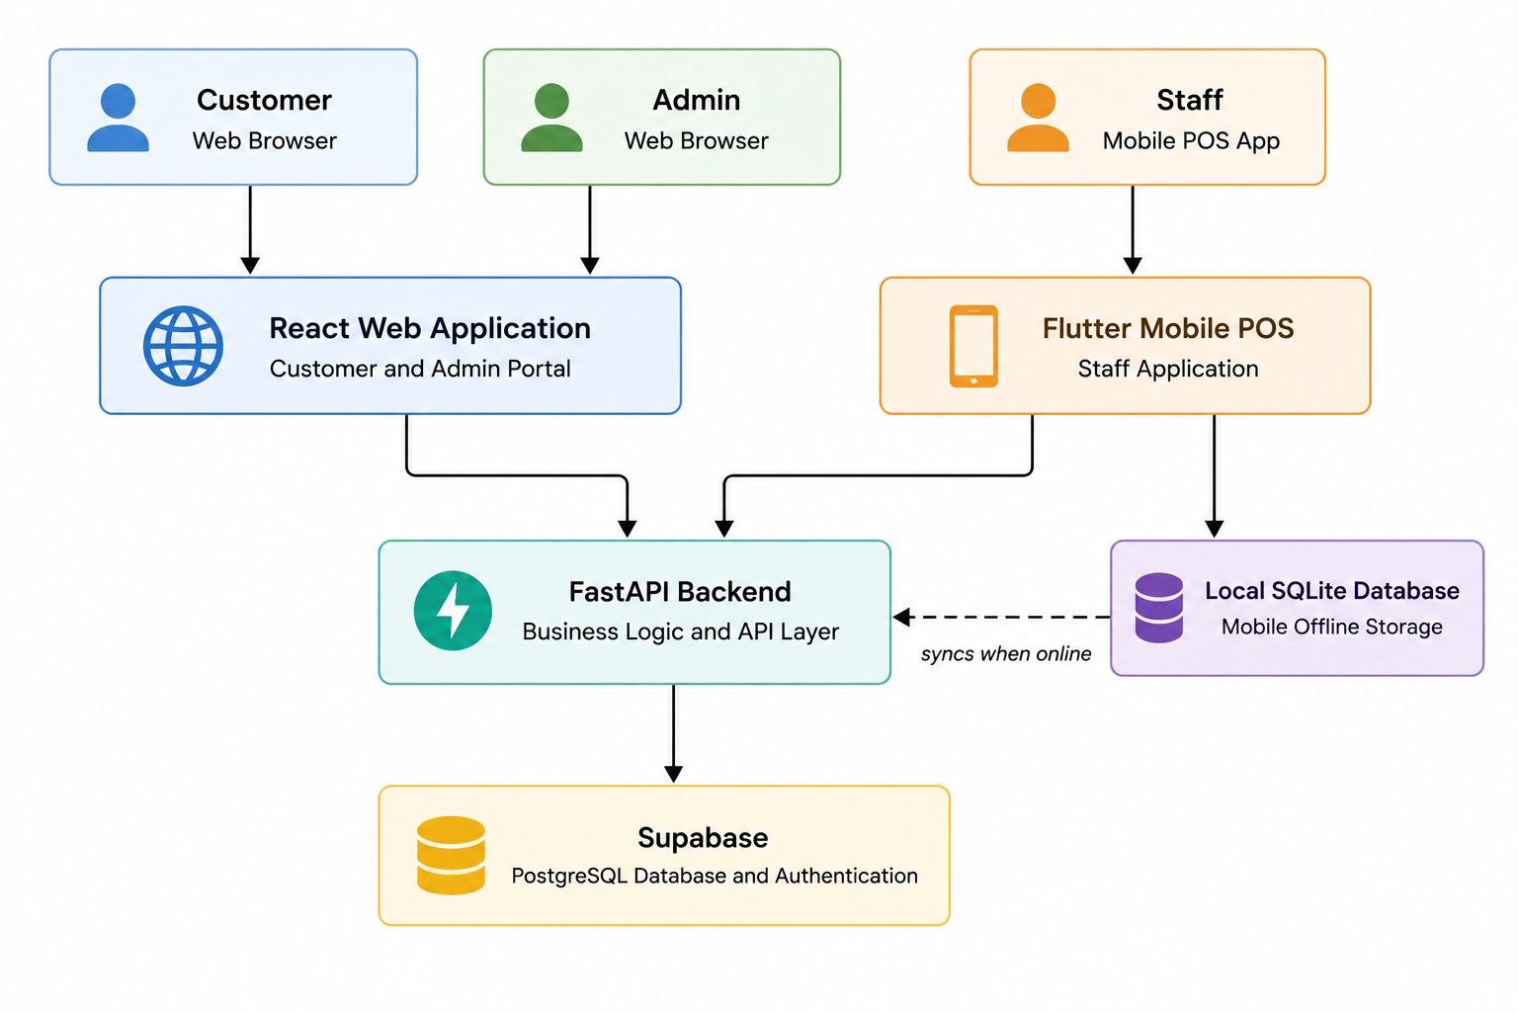
Figure 8:

