Project: Calculator

General task to complete:

Build a simple calculator that can add, subtract, multiply and divide and has a graphical user interface.

Graphical user interface mock-up:

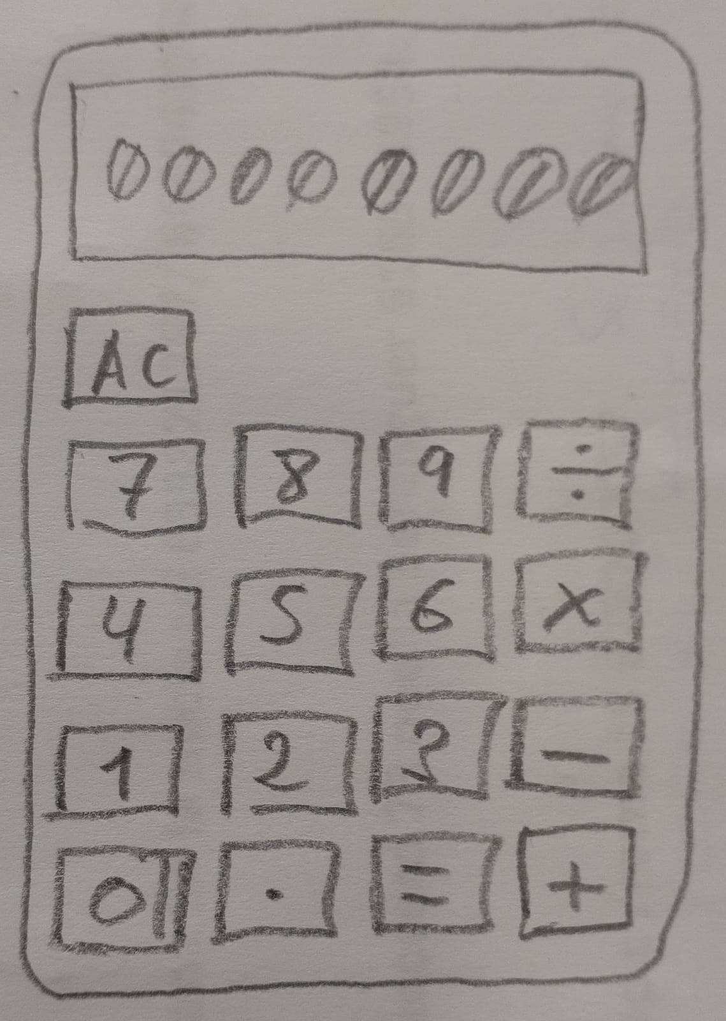

Features to implement:

- Ability to add, subtract, multiply and divide. One function for each.
- Basic HTML graphical UI:
  - A screen. With max. 8 digits + 1 decimal point.
  - Buttons:
    - 1 for each digit
    - 1 for each function
    - Equals key
    - Clear key
    - Decimal key (.)
- A calculator operation will consist of number + operator + otherNumber. One variable for each.
- An operate function that takes an operator and 2 numbers and then calls one of the functions on the provided numbers.
- Functions that populate the display when you click a number button. Store the display value in a variable for using in the next step.
- Store key presses (numbers and operator) for using in operation when ‘=’ key is pressed. Figure out how to store all the values and call the operation function with them.
- Ability to string together several operations (15 + 15 – 5 * 2 = 50), evaluating each pair of values at a time (like this). Do NOT evaluate more than a pair of values at a time.
- Round results with long decimals so that they do not overflow the screen.
- Avoid problems for pressing ‘=’ before having the 2 numbers + operator.
- Clear button should clear all the data.
- Display a snarky error message if the user tries to divide by 0… and don’t let it crash your calculator!
- Don’t let the user type more than one decimal point.
- Make operation buttons a different color from the digit buttons.
- Add backspace button to undo last number.
- Add keyboard support. Check this to avoid problems with key default behavior.

Basic flowchart:
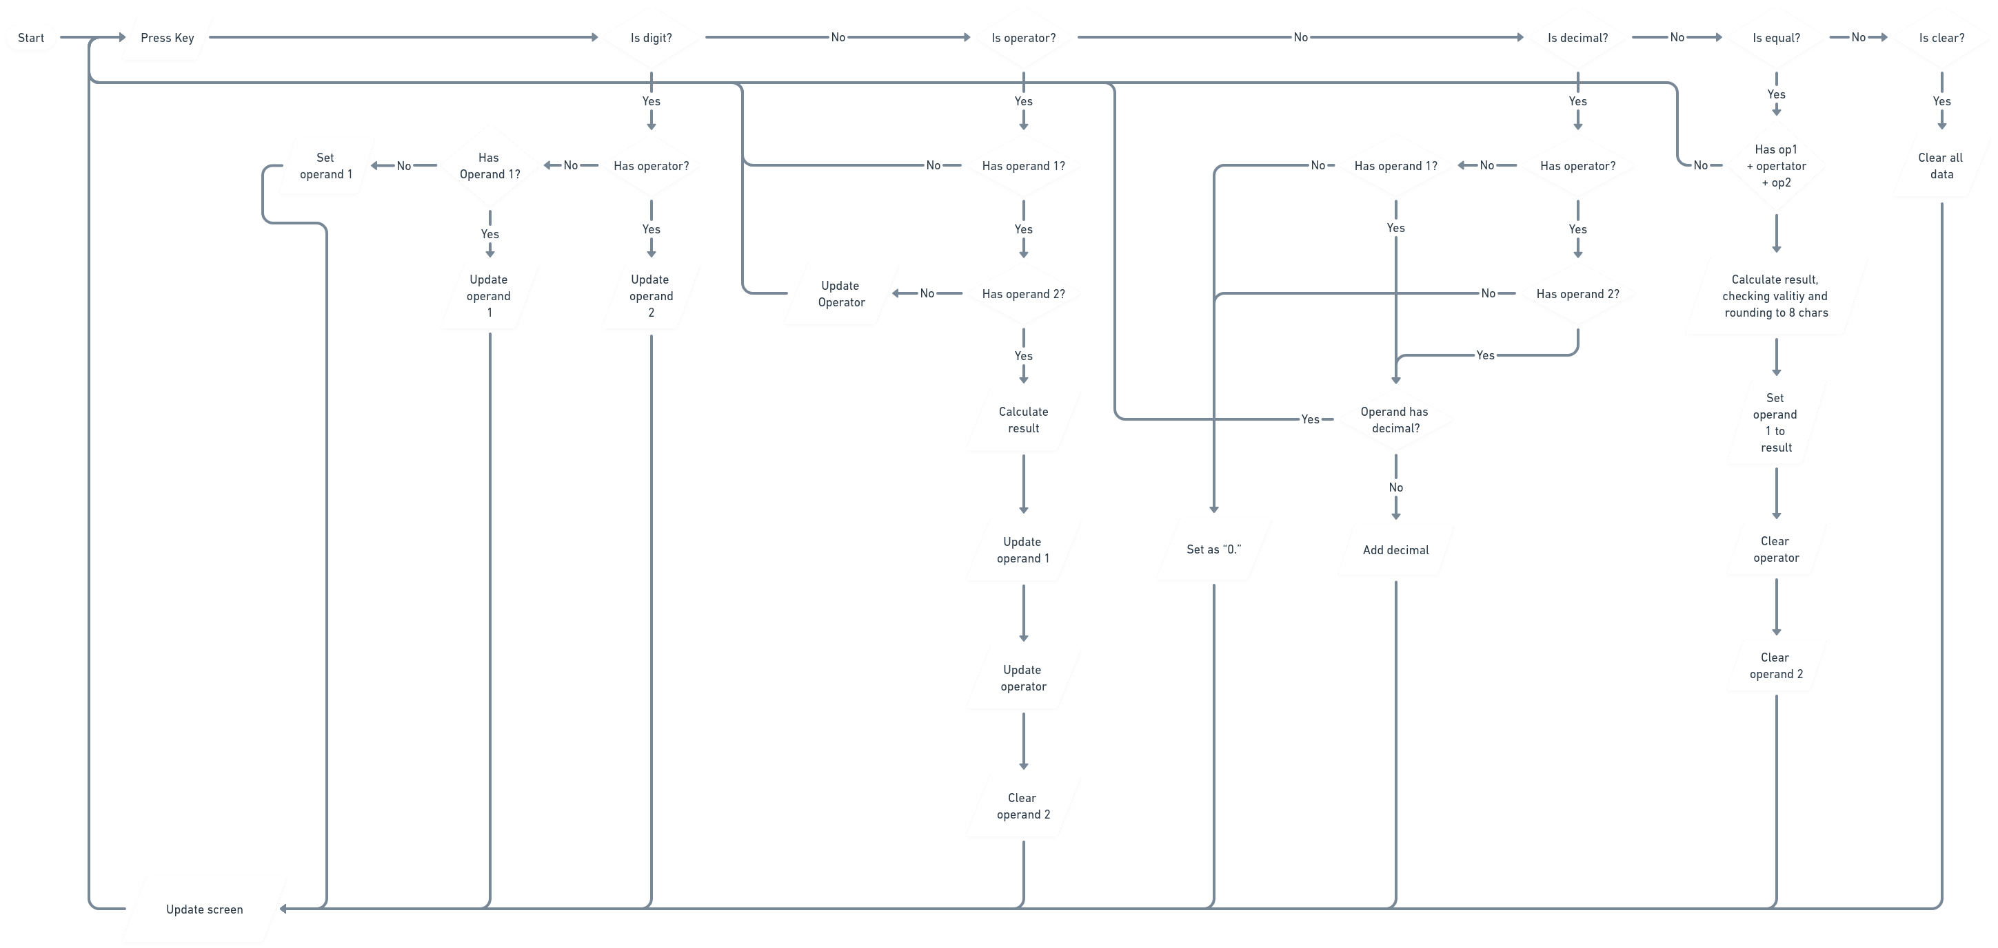

Pseudocode (JavaScript functionality):
User types a key
Create a keyPressed object with “type” and “value” properties
if (keyPressed.type = “digit”) {
if (!hasOperator) {
if (hasOperand1) {
update operand1
} else {
set operand1
}
}
else {
update operand2
}
} else if (keyPressed.type = “operator”) {
if (hasOperand1) {
if (!hasOperand2) {
update operator

} else {
calculate result
update operand1
update operator
clear operand2
}
}
} else if (keyPressed.type = “decimal”) {
if (!hasOperator) {
if (hasOperand1) {
if (operand1 does not have decimal) {
add decimal to operand1
}
}
}
} else if (keyPressed.type = “equal”) {
if (has both operands and operator) {
calculate result (checking validity and rounding to 8 caracters)
set operand1 to result
clear operator
clear operand2
}
} else if (keyPressed.type = “clear”) {
clear operand1
clear operator
clear operand2
}

updateScreen

