Toolbox filled out

Toolbox mid render

Toolbox finished

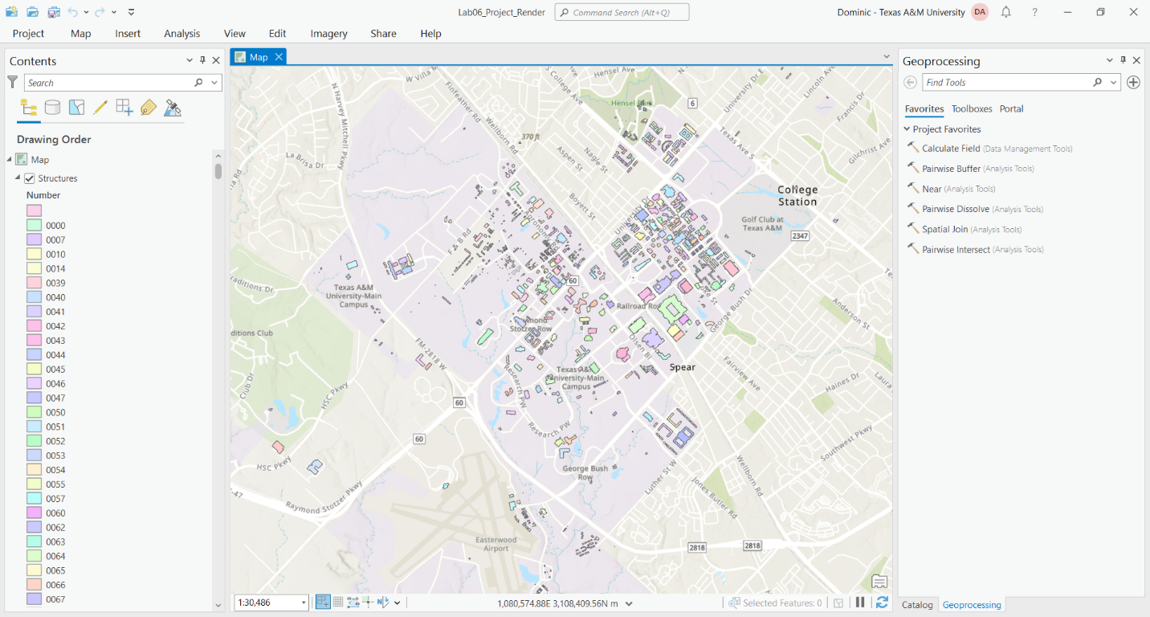

1st Project

2nd Project

Link: <https://github.com/Dominic-Ayon/GISProgramming/tree/main/Lab_6>